A simple demonstration of a template :

{m: 'dh1.gif'.myTemplate()}

End of demonstration.

{m:template public myTemplate(name:String)}

{m: name.asImage().setWidth(200)}

Static Image:

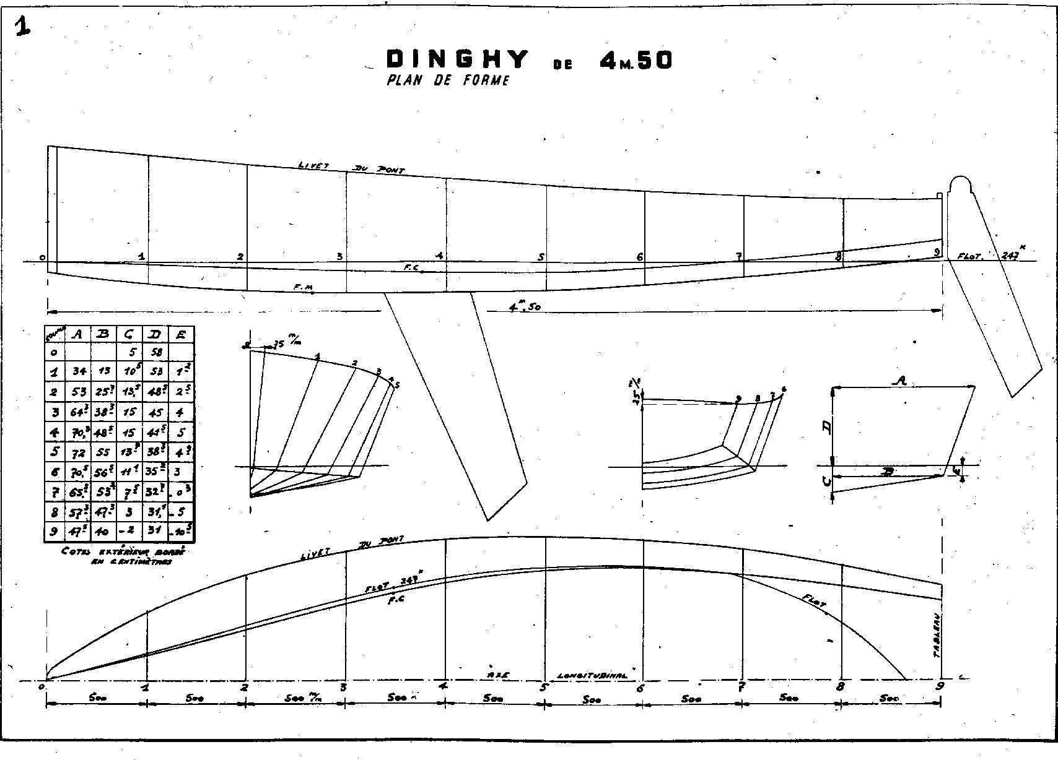

{m:endtemplate}