A simple demonstration of a template :

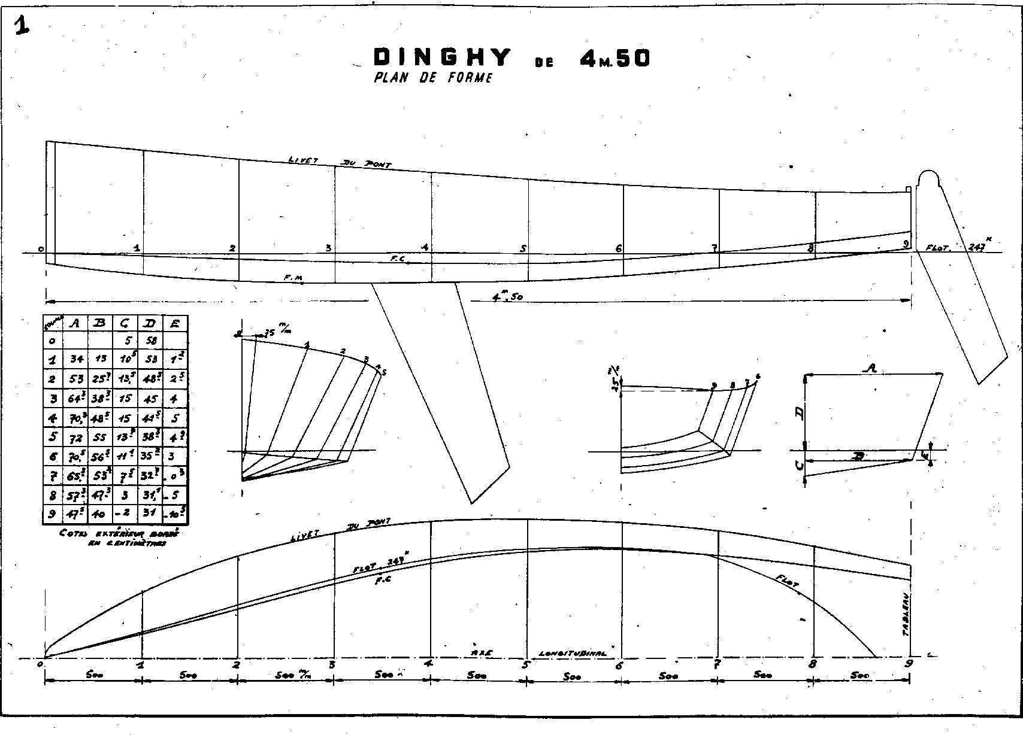

Static Image:



End of demonstration.