Imported version = 0.1.87.

from featurewiz import FeatureWiz

wiz = FeatureWiz(verbose=1)

X_train_selected = wiz.fit_transform(X_train, y_train)

X_test_selected = wiz.transform(X_test)

wiz.features ### provides a list of selected features ###

############################################################################################

############ F A S T F E A T U R E E N G G A N D S E L E C T I O N ! ########

# Be judicious with featurewiz. Don't use it to create too many un-interpretable features! #

############################################################################################

Skipping feature engineering since no feature_engg input...

Skipping category encoding since no category encoders specified in input...

**INFO: featurewiz can now read feather formatted files. Loading train data...

Shape of your Data Set loaded: (6009, 7)

Loaded train data. Shape = (6009, 7)

Some column names had special characters which were removed...

No test data filename given...

#######################################################################################

######################## C L A S S I F Y I N G V A R I A B L E S ####################

#######################################################################################

Classifying variables in data set...

6 Predictors classified...

No variables were removed since no ID or low-information variables found in data set

GPU active on this device

Tuning XGBoost using GPU hyper-parameters. This will take time...

After removing redundant variables from further processing, features left = 6

No interactions created for categorical vars since feature engg does not specify it

#### Single_Label Regression problem ####

target labels need to be converted...

#######################################################################################

##### Searching for Uncorrelated List Of Variables (SULOV) in 6 features ############

#######################################################################################

there are no null values in dataset...

Removing (2) highly correlated variables:

['USDrate', 'MAX']

Following (4) vars selected: ['Location', 'type', 'MIN', 'Date']

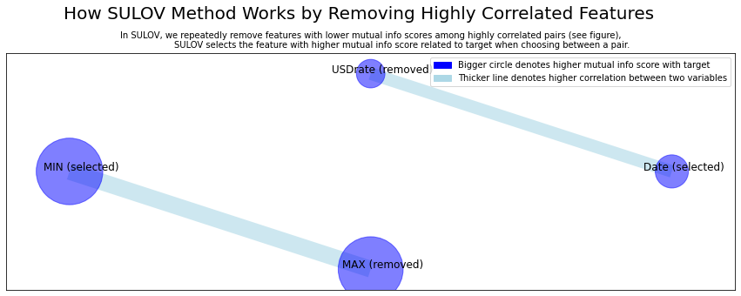

Time taken for SULOV method = 1 seconds

Adding 0 categorical variables to reduced numeric variables of 4

Final list of selected vars after SULOV = 4

Readying dataset for Recursive XGBoost by converting all features to numeric...

#######################################################################################

##### R E C U R S I V E X G B O O S T : F E A T U R E S E L E C T I O N #######

#######################################################################################

using regular XGBoost

Train and Test loaded into Dask dataframes successfully after feature_engg completed

Current number of predictors = 4

XGBoost version: 1.6.1

Number of booster rounds = 100

using 4 variables...

Time taken for regular XGBoost feature selection = 1 seconds

using 2 variables...

Time taken for regular XGBoost feature selection = 2 seconds

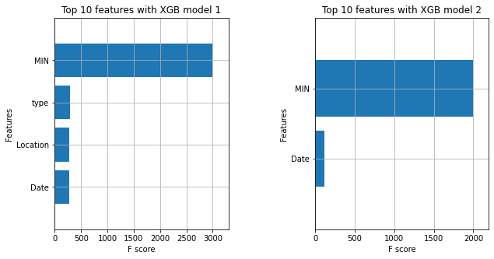

Total time taken for XGBoost feature selection = 2 seconds

#######################################################################################

##### F E A T U R E S E L E C T I O N C O M P L E T E D #######

#######################################################################################

Selected 4 important features:

['MIN', 'type', 'Location', 'Date']

Time taken for feature selection = 3 seconds

Returning 2 dataframes: dataname and test_data with 4 important features.