Lab 4 DevOps

Make building Git
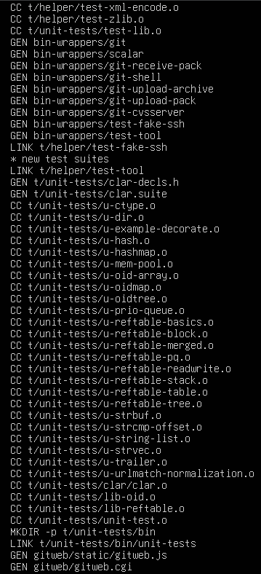

Additional Screenshots
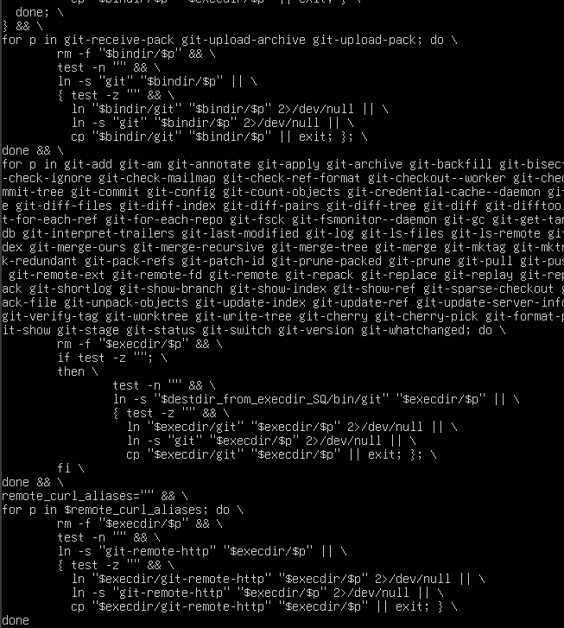

Git Version:

Link to GitHub with the Makefile and C files for the Conway game
https://github.com/Nebr1s/DevOps

all other labs are under a different branch (I’m having issues with the VM that keeps crashing my laptop, so it’s been a bit unstable to upload everything however under the vagrant branch, all previous labs should be there)

