Overview of WickyDB

# Processing flow

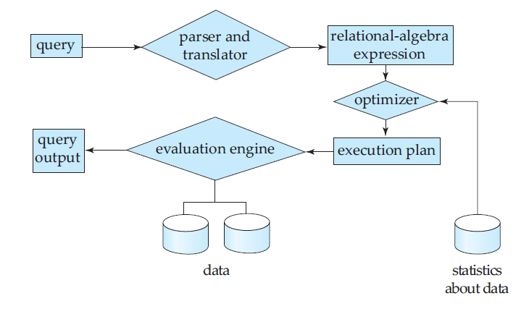

Given a query, which is a string, and it will be parsed by a Parser to the relational-algebra expression that will be presented as a class Expression. And then, an optimizer would deal with the expression, turning it to a plan, also presented by class Plan. Finally, the Evaluator would execute the plan and get the result, which is denoted by a class ResultSet.

In order to hold those components together, we would implements a framework to make sure that the workflow would be completed correctly, which emerge as a Class, WickyEngine. Thus, the overall framework would appear as the following form.



# WickEngine

The framework, which would hold all components together, would make sure the workflow is carried out appropriately.

# Parser

The Parser is in charge of parse the query string and turn it into Expression, and, of course, take care of the syntax checking.

# Expression

The wrapper of relational-algebra, generated by a parser, would be the feasible internal form of Sql instruction.

# Optimizer

# Plan

# Evaluator

# ResultSet

# Appendix 1-relational-algebra