**COMP 3004B Team Project (Team 26)**

**Kheri Hughes 101146084**

**Badral Khurelbaatar 101166852**

**David Katz 101157096**

**Jay Reid 101146559**

# Use Case Model:

|  |
| --- |
| **Putting the device on (UC1)** |
| Primary Actor:   * Device user   Precondition:   * User has the device on hand. * Device is off.   Main success scenario:   1. Plug the CES cable to the CES output jack. 2. Dampen earlobes with a small amount of water, saliva, saline solution, or gel. 3. Attach the black ear clip on the CES cable to the left earlobe. 4. Attach the red ear clip on the CES cable to the right earlobe.   Postcondition:   * User set up and put on the device.   Extensions:   * 3a User does not put the ear clip on their ear   + The device will not receive a good connection and will not run the session * 4a User does not put the ear clip on their ear   + The device will not receive a good connection and will not run the session |
| **Turning the device on (UC2)** |
| Primary Actor:   * Device user   Precondition:   * User set up and put on the device successfully. * Device is off.   Main success scenario:   1. Push and hold the power button. 2. Device turns on (green light above the power button lights up).   Postcondition:   * The device turns on.   Extensions:   * 2a. Device does not turn on.   + 2a1. Check if the battery is inserted correctly.   + 2a2. If 2a1 is checked, replace the battery.   + 2a3. If 2a2 is checked, contact customer service, and get assistance.   Note:   * After the device is turned on, lights on the bar graph will light up indicating the battery level. |
| **Select a session length (UC3)** |
| Primary Actor:   * Device user   Precondition:   * Device turned on.   Main success scenario:   1. Press the power button until the correct session length is chosen.   Postcondition:   * Session length chosen successfully.   Extensions:   * 1a. If user designated session length is chosen, user press up or down button on the right to select the duration.   Note:   * Press the power button once to select a 20-minute session length. * Press the power button twice to select a 45-minute session length. * Press the power button thrice to select user designated session length. * User designated duration is from 5 minutes to 180 minutes. User can only select minutes divisible by 5 (5,10,15…,175,180). |
| **Select a session type (UC4)** |
| Primary Actor:   * Device user   Precondition:   * Session length is chosen.   Main success scenario:   1. Press the up or down button. 2. Designated session is highlighted.   Postcondition:   * Designated session is selected.   Extensions:   * 2a. Designated session is not highlighted.   + 2a1. Press the up or down button until the designated session is highlighted.   Note: There are 4 sessions in total. |
| **Start session (UC5)** |
| Primary Actor:   * Device user   Precondition:   * Session is selected.   Main success scenario:   1. Press the checkmark button. 2. Connection test will start. 3. Number will blink to confirm selection.   Postcondition:   * Session is started.   Extensions:   * 2a. Bad connection   + 2a1. 7 and 8 bars will blink. * 2b. Good connection   + 4,5,6 bars will turn on solid for few seconds * 2c. Excellent connection   + 1,2,3 bars will turn on solid for few seconds * 3a. Wrong section selected.   + Turn off the device and select again. |
| **Adjust the intensity (UC6)** |
| Primary Actor:   * Device user   Precondition:   * Session is started.   Main success scenario:   1. Press or hold the up and down arrows. 2. Stimulation is barely feeling.   Postcondition:   * Stimulation is barely felt   Extensions:   * 2a. No stimulation is felt.   + 2a1. Press or hold the up arrow until stimulation is barely felt. * 2b. Stimulation is felt much more.   + 2b1. Press or hold the down arrow until stimulation is barely felt. |
| **Turn device off (UC7)** |
| Primary Actor:   * Device user   Precondition:   * Device is turned on.   Main success scenario:   * + Device turns off automatically when a running session ends.   + Does a softOff.   + No session is selected for 2 minutes.   + Device turns off for inactivity.   + Press and hold the power button   + Device turns off.   + Battery dies   + Device turns off   Postcondition:   * Device turned off.   Extensions: |
| **Record therapy (UC8)** |
| Primary Actor:   * Device user   Precondition:   * Session is started.   Main success scenario:   1. Press record session button while session is running 2. Therapy is recorded.   Postcondition:   * Therapy is recorded and saved to history of therapies.   Extensions:   * 1a. Intensity is changed during the session after the record therapy button is pressed.   + 1a1. Last selected intensity level is chosen for the record. |

# Use Case Diagram

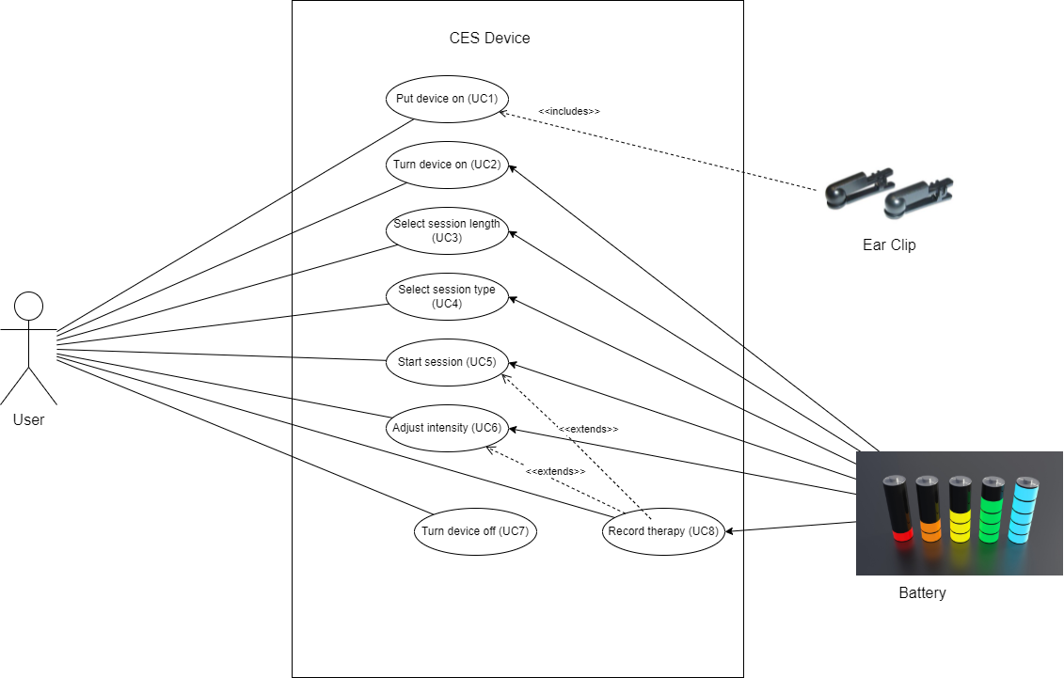

# UML Diagram :

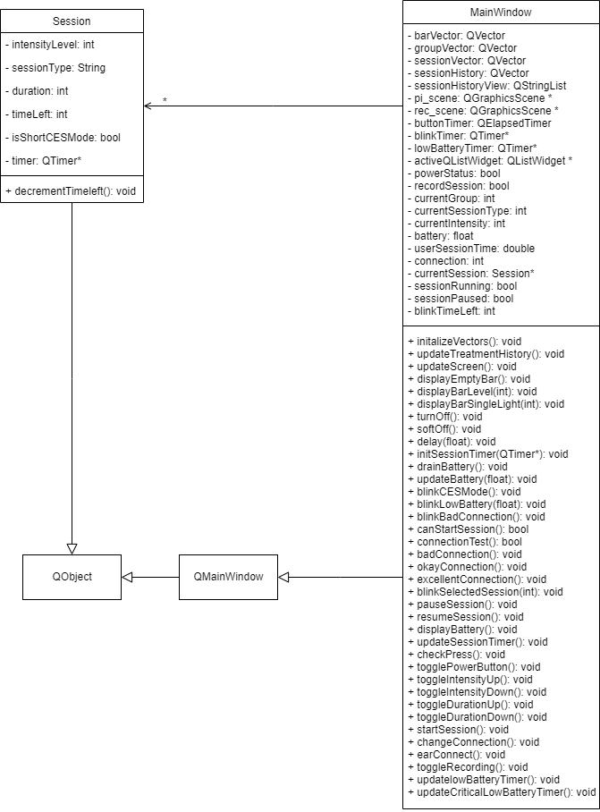

# Sequence Diagram:

TODO

## State Diagrams

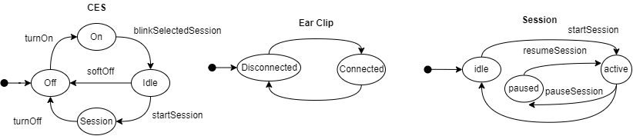

## Activity Diagram

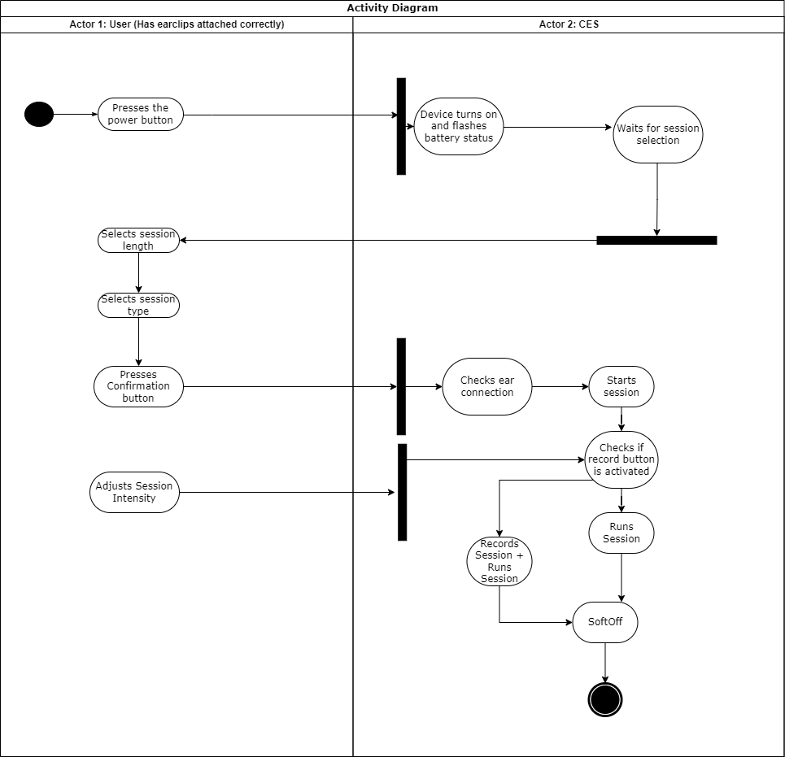

## Testing

For testing our program, we used the UAT (User Acceptance Testing) method. All team members manually tested the following scenarios:

* T1: Regular use (Excellent ear connection)
* T2: Regular use (Good ear connection)
* T3: Regular use (Bad ear connection)
* T4: Ear disconnected
* T5: Session recording
* T6: Pausing the session
* T7: Resuming session
* T8: Low battery
* T9: Critically low battery
* T10: Turn off while the session is running

*At least 2 members tested each scenario to ensure accuracy across different instances of the program.*

# Traceability Matrix

|  |  |  |  |  |  |
| --- | --- | --- | --- | --- | --- |
| ID | Requirement | Related Use Case | Fulfilled By | Test | Description |
| 1 | Turn On | UC1 | MainWindow | All Tests T1-10 | The device is turns on if the power button is pressed for more than 1 seconds and **when the finger is released**. |
| 2 | Turn Off | UC7 | MainWindow | All Tests T1-10 | The device is turns off if the power button is pressed for more than 1 seconds and **when the finger is released**. |
| 3 | Ending session | UC7 | MainWindow | T1, T2, T3 | Session ends when int timeLeft member becomes 0. The graph will scroll from 8 to 1 to  confirm that Soft Off™ is in progress. |
| 4 | Battery level | UC2, UC3, UC4, UC5, UC6, UC8 | MainWindow | T1, T2, T3, T4, T5, T6, T7, T8, T9 | Max battery is 100 and battery is shown using (qCeil(battery/12.5)) qCeil == ceiling. |
| 5 | Low Battery warning | UC2, UC3, UC4, UC5, UC6, UC8 | MainWindow | T8 | When a session is running and battery is depleting, if the battery goes below 25%, the 2 bars blink low battery warning for a few seconds. |
| 6 | Critically low battery warning | UC2, UC3, UC4, UC5, UC6, UC8 | MainWindow, | T9 | When a session is running and battery is depleting, if the battery goes below 12.5%, the 1 bar blinks critically low battery warning for a few seconds and turns the device off. |
| 7 | The application battery level is dependent on the function of time and intensity of a session. | UC5, UC6, UC8 | MainWindow  Session | T1-9 | Battery will drain battery -= currentIntensity*0.0347; per second |
| 8 | Selecting session duration from 3 options | UC3 | MainWindow | T1-3 | User can choose session duration from 5 to 180 minutes with 5 minute skipping (5,10,15,...175,180) |
| 9 | Selecting session type from 8 options | UC4 | ​​MainWindow | T1-3 | User can navigate between sessions using intensity up and down buttons. |
| 10 | Starting session | UC5 | MainWindow  Session | T1-3 | If the session duration and session type is selected, press start session button and it will start connection test. |
| 11 | Connection test | UC5 | MainWindow | T1-4 | After start session is pressed, the device will perform connection test and show connection on the bars. |
| 12 | Change Intensity | UC6 | MainWindow  Session | T1-4 | Press the intensity up button to increase intensity.  Press the intensity down button to decrease intensity. |
| 13 | Record session option | UC8 | MainWindow  Session | T5 | Press the record button while a session is running. Green light will turn on to indicate the session is being recorded. |
| 14 | Pause session | UC5 | MainWindow  Session | T6 | Take off the ear clip and session will pause. |
| 15 | Resume session | UC5 | MainWindow  Session | T7 | Put on the ear clips and the connection will change to good or excellent and the session will continue. |
| 16 | View recorded sessions | UC8 | MainWindow | T5 | After a recorded session has ended, the device will turn off. Turn on the device again and the previous recorded session will show. |