**Ansible Practical Task**

Azure Infrastructure:

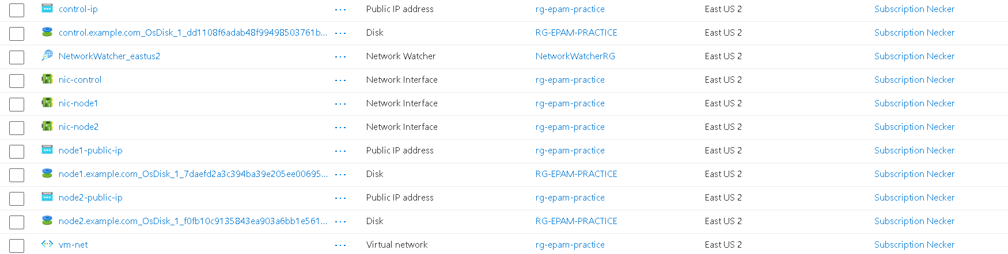

Task 1:

Setup Infra:

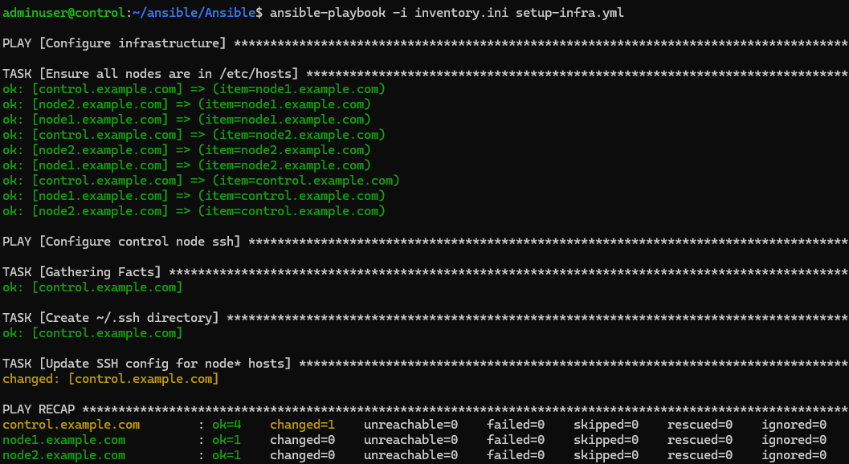

Step 1: Ansible installation:

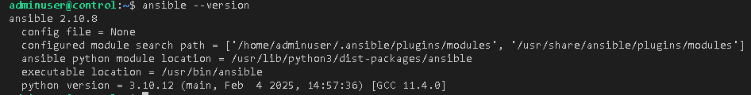

Step 2: Test Response using ping

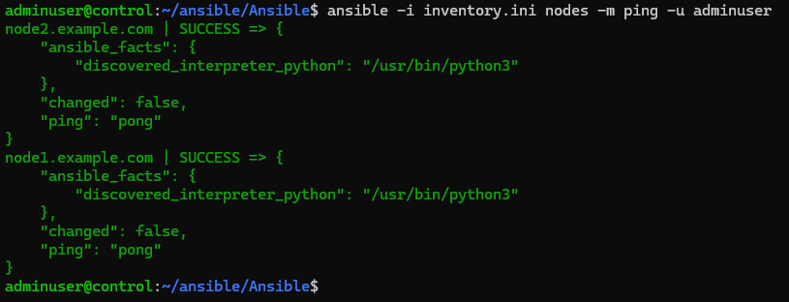



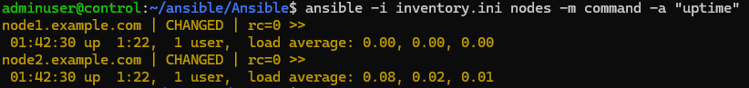

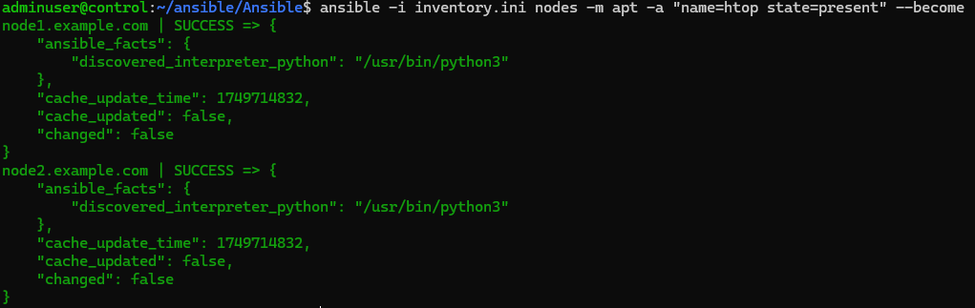

Step 3. Add managed nodes:

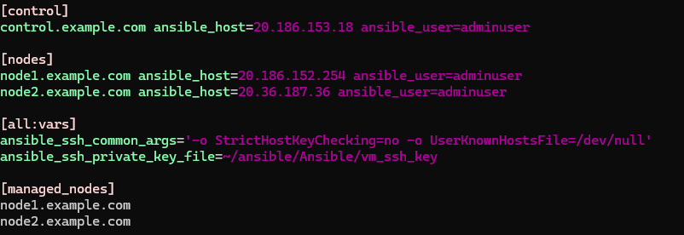

Step 4: Verify with ad hoc commands

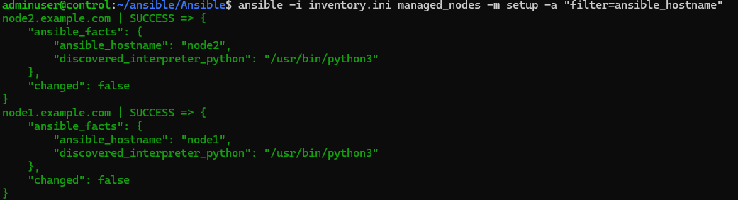

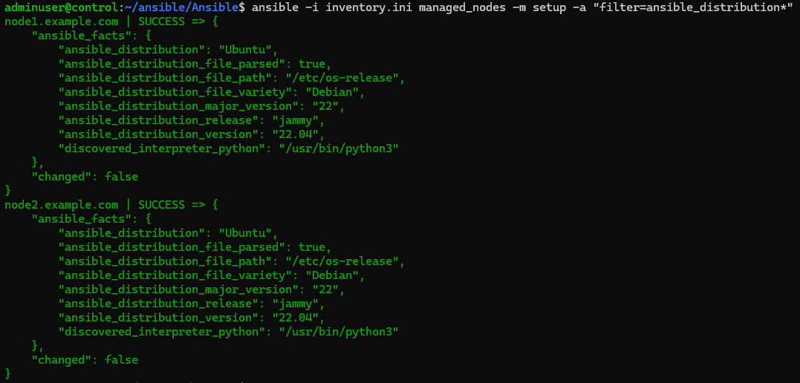

Step 5: Create a playbook for network interfaces

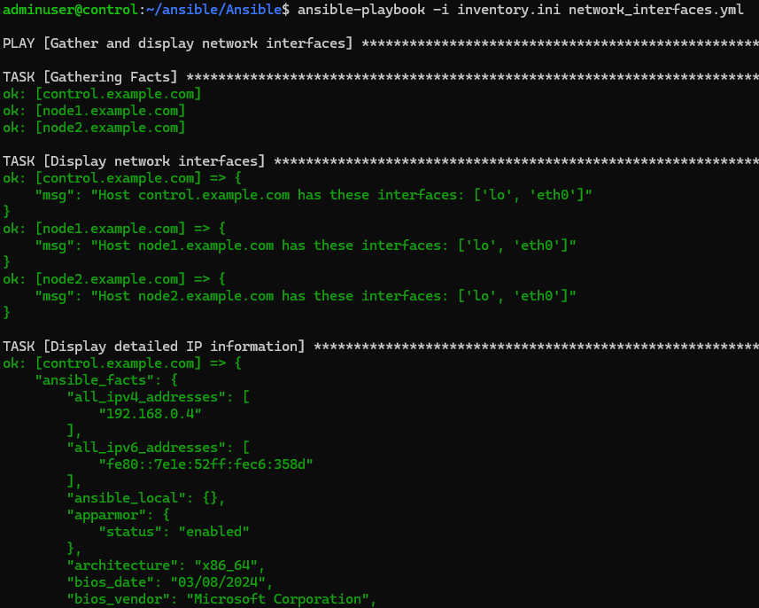

Task 2: Ansible role; use variables, handlers, and conditions; deploy your first software; and configure an OS with Ansible.

Step 1: Execute the playbook

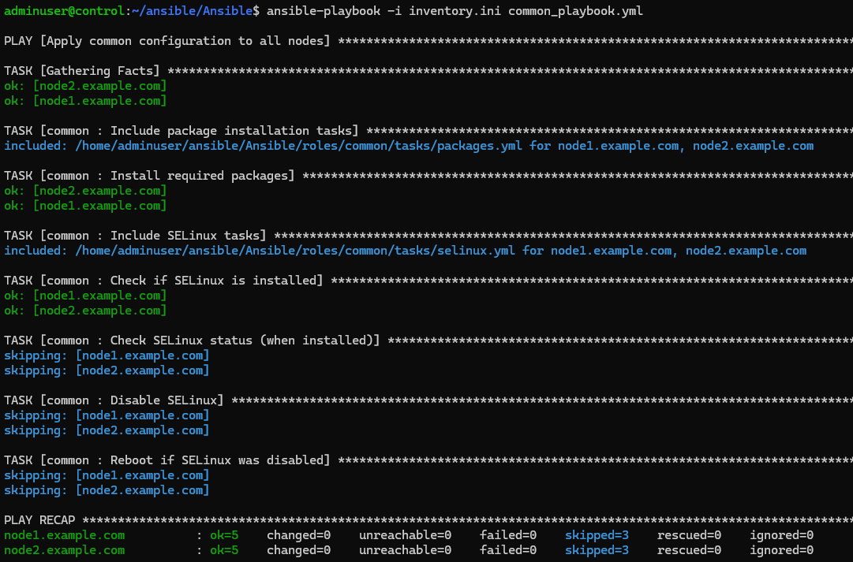

Verification

Step 1: Check installed packages:

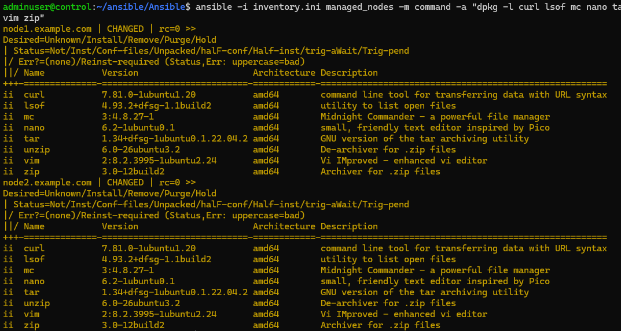

Step 2. Check SELinux status:

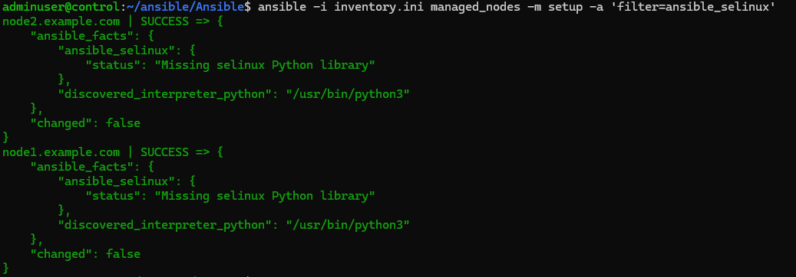

Step 3: Check if nodes were rebooted (look at uptime):

