Basic Campus Evacuation Routing Simulation
Using GIS Data

Final Project Presentation Report

Target Campus | Laguna State Polytechnic University – Main Campus
Simulation Platform | GAMA Platform (Agent-Based Modeling)
Project Team | Dheyn Michael Orlanda  Eulyn Vincee Ann Sto. Domingo
Academic Year | 2025 – 2026
Source Code | https://github.com/Necookie/LSPU_EVACUATIONSIM_GAMA

1. Project Objective
This project aims to design, implement, and evaluate a basic campus evacuation routing simulation for Laguna State Polytechnic University (LSPU) Main Campus using real GIS data derived from OpenStreetMap (OSM). The primary objectives are:
- To simulate realistic emergency evacuation scenarios by leveraging actual campus road networks, building footprints, and spatial topology.
- To evaluate the efficiency of dual-gate evacuation routing by routing student agents along real road paths to two designated exit points.
- To model organic fire spread dynamics including radial growth and probabilistic spark jumping, and to measure their impact on student casualty rates.
- To simulate emergency responder (firefighter) intervention and assess their effectiveness in containing fire spread and reducing casualties.
- To provide real-time analytical insights through live time-series charts tracking the evolving status of evacuating, safe, and casualty populations throughout the simulation.
- To apply core Agent-Based Modeling (ABM) concepts—including autonomous agent behavior, spatial environments, and emergent system dynamics—to a real-world safety problem.

2. Simulation Environment
The simulation environment is built upon authentic GIS data extracted from OpenStreetMap (OSM) for the LSPU Main Campus. The map file, LSPU_MAP.osm, is loaded directly into the GAMA Platform as a file object, and its envelope defines the entire world boundary of the simulation space. This approach ensures that all spatial interactions—pathfinding, building placement, and gate positioning—are grounded in real-world geography.

2.1 Environment Layers
Buildings: Parsed from OSM building polygon tags. Structures that have a null or non-building type tag are filtered out immediately at initialization. Buildings serve as spawn locations for student agents and as obstacles in the environment. They are rendered in dark gray (#darkgray) with black borders.
Roads: Extracted from OSM highway tags. Road segments form the basis of the road_network graph (as_edge_graph), which is the primary navigation layer used by both student and responder agents for GIS-based pathfinding. Roads are rendered in white to contrast against the dark background.
Gates: Two evacuation gates are manually placed at strategic campus exit points and snapped to the nearest road node for path reachability. Gate 1 is positioned at coordinates approximating the Bottom evacuation zone {600.0, 900.0}, and Gate 2 at the Top-Right zone {850.0, 200.0}. Both are rendered as lime green squares with a white 'GATE' label.

3. Agent Behaviors

3.1 Fire Agent
The fire species is the primary environmental hazard in the simulation. It operates through two simultaneous reflexes that create organic, emergent fire spread behavior:
- Organic Radial Growth (spread reflex): Every simulation tick, each fire agent increases its fire_radius by a random value between 0.0 and 0.1 meters (fire_radius <- fire_radius + rnd(0.0, 0.1)). This continuous, stochastic growth simulates the natural intensification of a fire over time.
- Probabilistic Spark Jumping (jump reflex): On each tick, there is a 4% probability (flip(0.04)) that a fire agent spawns a new child fire within a 15-meter radius (rnd(-15.0, 15.0) offset). This jump is suppressed once the total fire population reaches 30 sparks to prevent simulation overload. The child fire starts with a radius of 1.0 meter, mimicking the behavior of flying embers.
- Proportional Spawning (initialization): The initial fire origin is constrained to buildings located within the inner 10%–60% bounds of the campus map in both X and Y axes. This proportional, randomized spawning ensures the fire starts in a realistic central campus location rather than on edge boundaries, and introduces a stochastic element to each simulation run.
- Visual Flicker Effect: The fire is drawn as three concentric circles with randomized orange opacity (rgb(255, rnd(80,120), 0, rnd(100,180))), a red mid-layer, and a yellow core. This opacity randomization creates a convincing visual flicker on each rendered frame.

3.2 Student Agent
The student species represents 150 individuals, each spawned at a random location inside a campus building. Students are assigned to one of two evacuation gates using a forced 50/50 even-odd index split (gate[0] for even-indexed students, gate[1] for odd-indexed), ensuring exactly 75 students route to each gate. The species uses the moving skill and operates through two concurrent reflexes:
- evacuate reflex (active when not safe and not casualty): The student navigates toward its assigned gate using the road_network graph at a randomized speed between 0.5 and 1.0 map units per tick (do goto target: my_gate.location on: road_network speed: rnd(0.5, 1.0)). When the distance to the gate falls within 2.5 meters, the student is marked as safe (is_safe = true) and the global count_safe counter increments. The GAMA goto primitive automatically uses Dijkstra's shortest path on the road graph, with an implicit off-road Euclidean distance fallback if the destination is not reachable through the graph.
- check_fire reflex (active when not safe and not casualty): Each tick, the student identifies the nearest active fire agent and checks if it is within that fire's current fire_radius. If so, the student is immediately marked as a casualty (is_casualty = true) and count_casualties increments. This per-spark radius check means students are only at risk if caught directly within a burning area.

3.3 Responder Agent (Firefighter)
Five responder agents are spawned at the gate locations at simulation start. They operate via a single fight_fire reflex that implements a seek-and-suppress strategy:
- Target Acquisition: If the responder has no target (or its current target has been extinguished), it queries all active fire agents and selects the one closest to its current location (fire closest_to(self)).
- Pursuit: The responder navigates toward its target fire via the road_network at a speed of 1.5 map units per tick—50% faster than the average student.
- Suppression: Once within 15 meters of the target fire, the responder remotely shrinks the fire's radius by 0.2 meters per tick (fire_radius <- fire_radius - 0.2). If the radius drops to 0.5 meters or below, the fire agent is killed (do die), completely extinguishing that spark.
- Water Hose Visualization: When actively suppressing a fire within range, a cyan line is drawn from the responder's location to the fire's location, simulating a visual water hose effect.

4. Visualization Techniques
The simulation renders two simultaneous 2D display windows within the GAMA experiment GUI, providing both spatial situational awareness and quantitative analytical feedback.

4.1 Campus Map Display (CampusMap)
The primary display renders the full campus environment on a dark (#222222) background to maximize contrast. The following color-coded visual conventions are used across all agent species:
• Dark Gray Buildings & White Roads: GIS-derived campus infrastructure rendered from OSM data.
• Lime Green Squares (Gates): The two evacuation exit points with 'GATE' labels.
• Cyan Circle (Student – Evacuating): A student actively navigating toward its assigned gate.
• Lime Green Circle (Student – Safe): A student who has successfully reached the gate exit.
• Black Cross / Plus Symbol (Student – Casualty): A student who was caught within a fire's radius.
• Layered Orange/Red/Yellow Circles (Fire): Each fire spark rendered with a flickering three-layer effect.
• Blue Square (Responder): A firefighter agent navigating toward or suppressing a fire.
• Cyan Line (Water Hose): A dynamic line drawn from a responder to its target fire when within 15m range.

4.2 System Architecture Workflow Diagram

Figure 1: System Architecture Workflow – Initialization, Simulation Loop, and Analytics Output

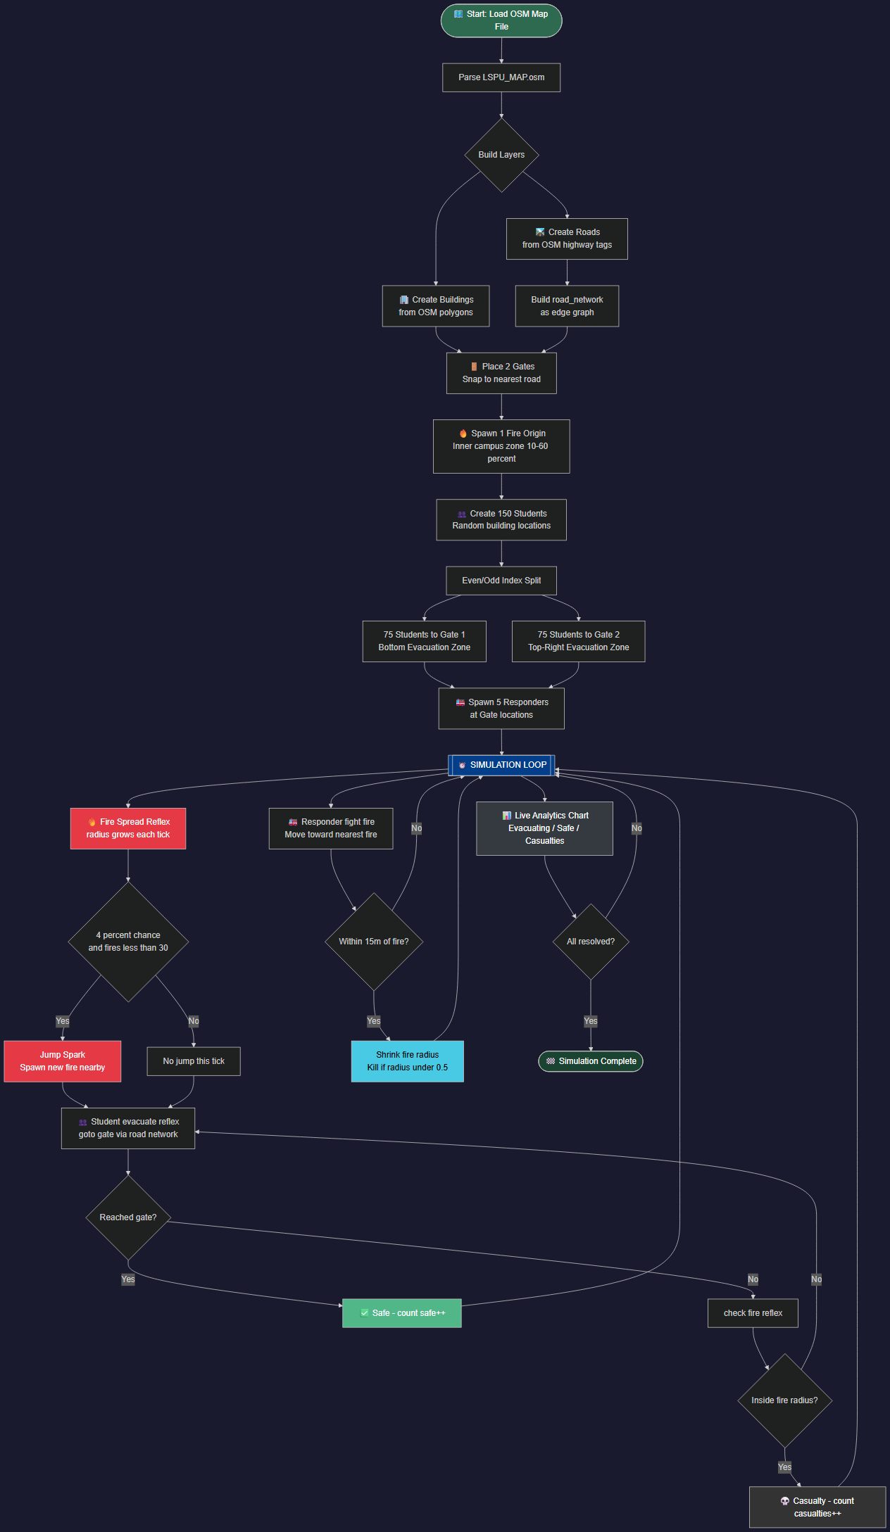
4.3 Student Agent Behavior Tree
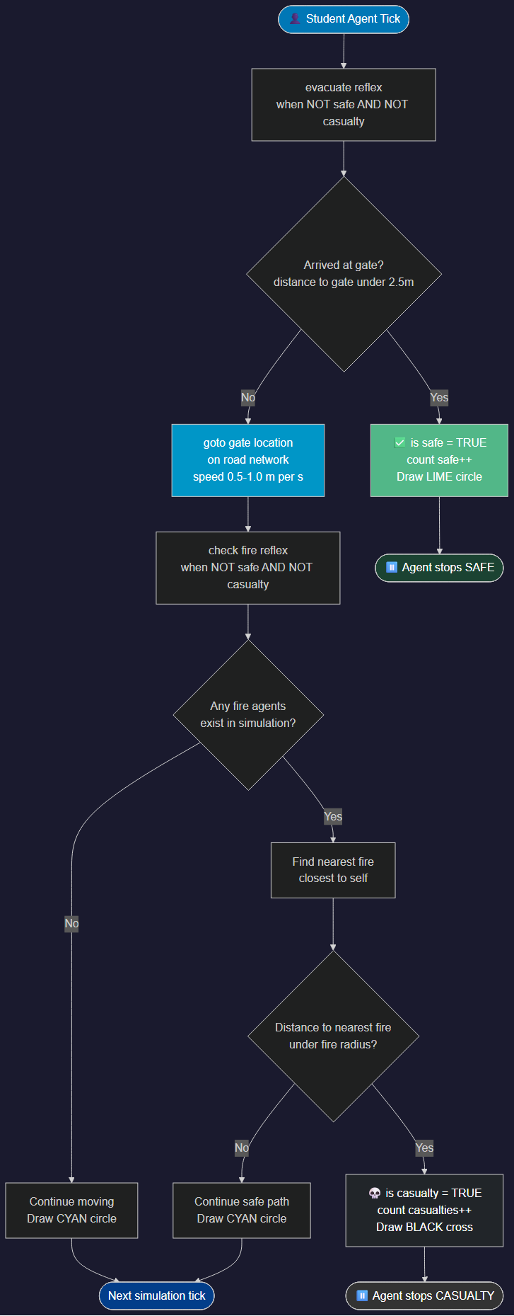
Figure 2: Student Agent Behavior Tree – Decision Logic per Simulation Tick

5. Analytics and Monitoring Tools
A dedicated Analytics display window renders a live time-series chart titled 'Live Evacuation & Casualty Status'. This chart plots three dynamically updating data series over simulation time (by cycle number) on a dark background (#333333):
• Evacuating – Cyan line: Tracks count_evacuating, computed dynamically as total_students - count_safe - count_casualties. This value starts at 150 and monotonically decreases as students either reach safety or become casualties.
• Safe – Lime Green line: Tracks count_safe, incrementing each time a student reaches within 2.5m of its assigned gate. This curve rises toward 150 as the evacuation progresses successfully.
• Casualties – Red line: Tracks count_casualties, incrementing each time a student is caught within a fire's radius. A steep rise in this curve indicates rapid fire spread or inadequate responder coverage.
The chart provides researchers with an immediate visual signal of evacuation efficiency. A healthy simulation run shows a rapid rise in the Safe (lime) line with minimal growth in the Casualties (red) line, indicating that students are successfully evacuating before the fire expands to engulf them.

6. Simulation Results
The following screenshots were captured at Cycle 0 during the simulation initialization phase, providing the initial state of the LSPU campus evacuation scenario.
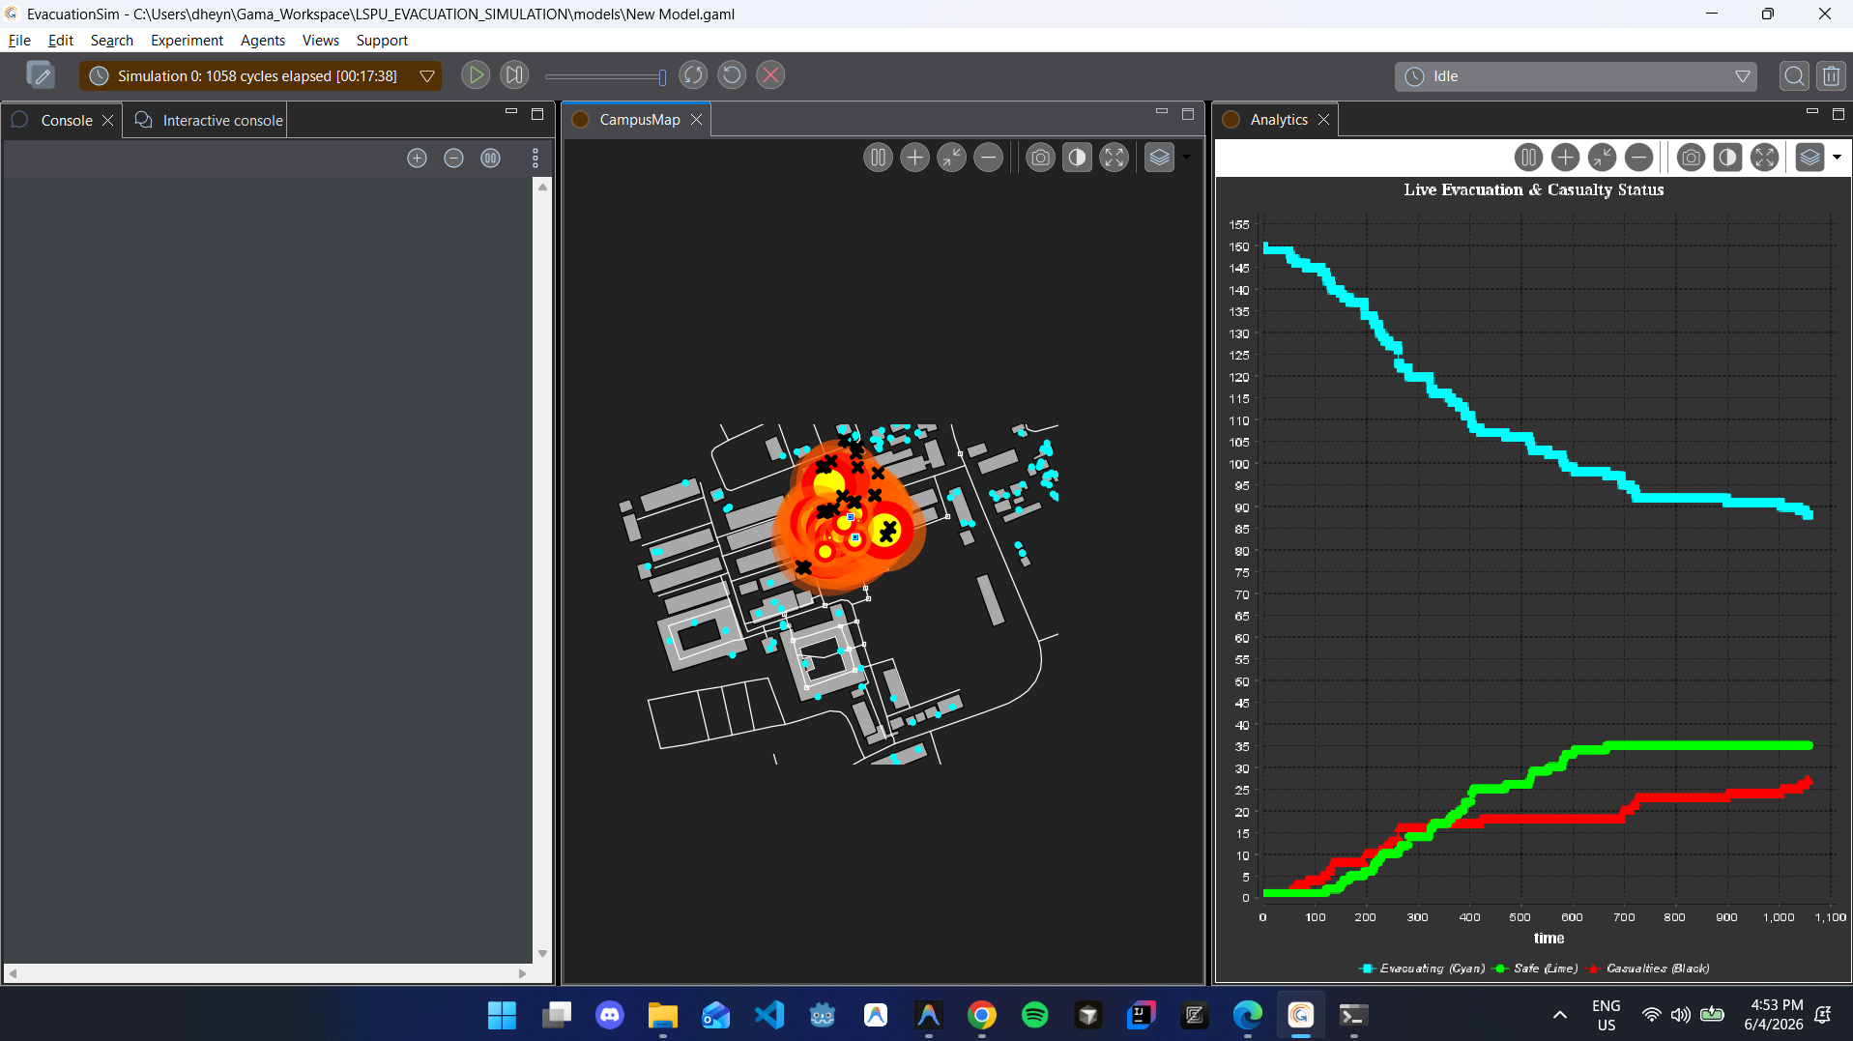

6.1 Campus Map – Initial State (Cycle 0)
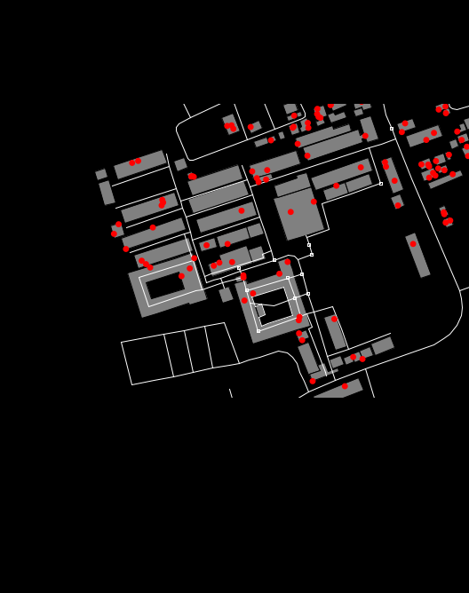
Figure 3: LSPUEvacuation – CampusMap at Cycle 0 (Run 1) – Initial deployment of student agents (red dots) across campus buildings
As seen in Figure 3, at the simulation's initial state (Cycle 0), all 150 student agents appear as red markers distributed across the campus building footprints. The dark gray building outlines and white road network are clearly visible, confirming the successful parsing and rendering of the LSPU_MAP.osm GIS data. No students have yet begun evacuating, and the fire origin has been placed in the inner campus zone.

6.2 Campus Map – Second Run Initialization (Cycle 0)

Figure 4: LSPUEvacuation – CampusMap at Cycle 0 (Run 2) – Stochastic re-spawning demonstrates randomized initial student placement
Figure 4 demonstrates the stochastic nature of the simulation's initialization. In a second independent run at Cycle 0, student agents are spawned at different building locations compared to Run 1, confirming that the any_location_in(one_of(building)) initialization logic produces unique spatial configurations per run. This variability is essential for ABM validity, ensuring that results are not artifacts of a single deterministic starting condition. The consistent road network and building layout confirm that the GIS environment layer loads deterministically while the agent population is stochastically distributed.
Both snapshots confirm that the simulation environment correctly initializes the campus map, student agents, and evacuation infrastructure. The dual-gate evacuation routing, fire spread mechanics, and responder behavior emerge organically once the simulation advances beyond Cycle 0.

7. Future Improvements
While the current simulation successfully demonstrates core evacuation routing and fire suppression dynamics, several enhancements can improve its realism and analytical depth:
• Crowd Congestion Mechanics: Introduce agent-to-agent collision avoidance and density-based speed reduction. As students converge on the two gates, bottleneck effects should slow movement, more accurately modeling real crowd dynamics.
• Varied Student Mobility Profiles: Differentiate student agents by walking speed, mobility impairment, or panic level. Adding a distribution of speeds (e.g., elderly, disabled, or children) would produce more realistic casualty and evacuation time distributions.
• Multiple Simultaneous Fire Origins: Allow more than one fire to ignite simultaneously or in sequence, simulating compound emergency scenarios. This would test the limits of the 5-responder team and provide richer casualty data.
• Dynamic Gate Capacity Limits: Implement gate throughput limits to model bottlenecking at exit points, forcing agents to re-route if their primary gate becomes overloaded.
• Responder Communication & Coordination: Enable responder agents to share target information so they do not all converge on the same fire spark, improving their collective efficiency in multi-fire scenarios.
• Wind-Influenced Fire Spread: Add directional wind vectors that bias the fire's spark-jumping probability in a dominant direction, creating more realistic asymmetric fire propagation patterns.
• 3D Visualization and Floor Plans: Extend the simulation into a 3D environment using GAMA's OpenGL renderer to model multi-floor buildings and stairwell evacuation bottlenecks.
• Integration with Real-Time Sensor Data: Connect the simulation to IoT sensor streams (smoke detectors, occupancy sensors) to run the model as a real-time decision support tool during actual emergency events.

8. Application of Agent-Based Modeling Concepts
This project is a direct application of foundational Agent-Based Modeling principles, demonstrating how complex system-level behavior emerges from simple, locally-defined agent rules:

8.1 Autonomous Decision-Making
Each agent species operates independently based on its own local state and perception. Student agents do not receive centralized coordination commands; they individually check their distance to their gate and the nearest fire on every tick, making autonomous decisions to move, stop, or become a casualty. Responder agents independently scan for the nearest fire target and self-assign without a dispatcher. Fire agents autonomously grow and jump based on probabilistic rules. This decentralized architecture is the defining characteristic of ABM and would be impossible to replicate with a traditional equation-based model.

8.2 Spatial Environments and GIS Integration
The simulation environment is not an abstract grid but a spatially accurate representation of a real campus, loaded from OpenStreetMap GIS data. The use of as_edge_graph(road) converts the OSM road layer into a traversable navigation network, enabling agents to perform realistic graph-based pathfinding (Dijkstra's algorithm) along actual campus roads. The spatial constraint of fire spawning to the inner 10%–60% campus bounding zone demonstrates how geographic constraints can be embedded directly into agent initialization rules. This GIS-informed approach makes the simulation outputs directly applicable to real-world emergency planning for LSPU.

8.3 Emergent Behavior and System-Level Dynamics
The most powerful demonstration of ABM in this project is the emergence of unpredictable system-level outcomes from simple agent rules. No single agent controls the overall evacuation outcome; instead, the interplay of fire spread, student routing, and responder suppression creates complex, nonlinear dynamics:
- A fire that jumps toward a road corridor can cut off a student's shortest path, forcing the goto primitive's fallback logic and creating spontaneous bottlenecks.
- Five responders pursuing different fire sparks can simultaneously suppress three fires while two others grow unchecked, creating spatial asymmetry in the hazard zone.
- The 4% jump probability can, by chance, cause a rapid cascade of 30 sparks within a few ticks, overwhelming the responders and causing a sudden spike in casualties on the live analytics chart—an emergent 'flashpoint' event.
- The 50/50 gate split means that a fire positioned between the two gates acts as a natural barrier, creating differential casualty rates between the two student cohorts even though both groups follow identical individual rules.
These emergent dynamics validate the core ABM thesis: local rules governing individual agents produce global behavior that is qualitatively richer than the sum of its parts. The simulation demonstrates that campus evacuation safety is a genuinely complex adaptive system, where the specific spatial configuration of fire, students, roads, and responders produces unique outcomes in every run—mirroring the irreducible uncertainty of real emergency scenarios.

References
- GAMA Platform Development Team. (2024). GAMA Platform Documentation – Agent-Based Spatial Simulation. https://gama-platform.org
- OpenStreetMap Contributors. (2024). LSPU Main Campus Map Data. https://www.openstreetmap.org
- Taillandier, P., et al. (2019). Building, composing and experimenting complex spatial models with the GAMA platform. GeoInformatica, 23(2), 299–322.
- Macal, C. M., & North, M. J. (2010). Tutorial on agent-based modelling and simulation. Journal of Simulation, 4(3), 151–162.
- Orlanda, D. M., & Sto. Domingo, E. V. A. (2026). Basic Campus Evacuation Routing Simulation Using GIS Data [GAML Source Code]. GitHub. https://github.com/Necookie/LSPU_EVACUATIONSIM_GAMA

