IoT System for Network Environment Monitoring
WiFi Signal Strength (RSSI) Measurement and Analysis
Course Project Report
Student: Ramazan Karagoz
Erasmus Exchange Student - Statistics
Host University: South-West University "Neofit Rilski" (SWU), Blagoevgrad
Analysis tool: R (tidyverse, ggplot2)
Date: April 2026

1. Introduction
The Internet of Things (IoT) paradigm connects physical devices to the Internet so they can sense their environment, transmit the collected data and enable data-driven decisions. Smartphones, with their wide range of built-in sensors and always-on connectivity, are particularly well suited as low-cost IoT sensing devices.
This project implements an IoT system for monitoring a wireless network environment, using a smartphone as the sensing device. The system measures the Received Signal Strength Indicator (RSSI) of visible WiFi access points across different indoor and outdoor locations of the South-West University "Neofit Rilski" (SWU) campus, stores the collected data in a structured dataset and performs statistical analysis and visualization of the radio environment.

1.1 Objectives
- Measure WiFi signal strength (RSSI, dBm) at multiple campus locations.
- Record complementary information: SSID, BSSID, channel, date, time.
- Store the collected data in a tidy, reproducible format.
- Characterise campus WiFi coverage with charts, heatmaps and statistics.
- Compare the signal strength of all visible university APs with the signal strength of the one AP the phone was actually associated with (the only network the researcher had credentials for).
- Identify weaknesses and formulate concrete improvement recommendations.

1.2 Approach
The project follows the alternative approach described in the assignment brief: instead of implementing a custom Android application, an existing WiFi scanner app (WiFiAnalyzer) was used to collect the measurements, and all downstream data processing, visualization and analysis was performed in R.

2. Methodology

2.1 Measurement points
Five measurement points were selected to represent typical campus network conditions. Each reflects a distinct physical and usage context:
Point | Name | Characterization
1 | Cafeteria | High user density, close to an access point
2 | Behind a concrete wall | Structural obstruction between user and the nearest AP
3 | Main hall | Transit area with regular movement of people
4 | Garden | Outdoor / open area
5 | Basement | Expected dead zone with weak coverage

2.2 Data collection schedule
Measurements were collected on four consecutive working days: Tuesday, Wednesday, Thursday and Friday. Monday was an Eastern Orthodox holiday on campus, so no data could be collected on that day.
On each measurement day, three sessions were scheduled:
- Morning (around 10:00 for Tue-Thu; Friday's first session started at 13:18 because of a delayed arrival - it is still the first session of the day and is labeled Morning for consistency).
- Noon (between 12:27 and 15:28).
- Afternoon (between 16:02 and 16:28).
During each session the five measurement points were visited in the same fixed order, and every university-network WiFi access point visible to the smartphone was recorded. In total, 60 sessions were completed (4 days × 3 time periods × 5 locations).

2.3 Recorded variables
Variable | Description
Day | Day of the week (Tuesday - Friday)
TimePeriod | Session slot (Morning / Noon / Afternoon)
Time | Exact clock time of the measurement (HH:MM)
Location | Measurement point (1-5)
SSID | Network name (e.g. WiFi(at)SWU, cafe@swu, Career, Cultural_Tourism_Lab)
BSSID | MAC address of the access point
RSSI | Received Signal Strength Indicator in dBm (higher = stronger)
Channel | WiFi channel used by the access point

2.4 Two complementary datasets
A distinctive design choice of this study is to keep two linked tables rather than a single flat record. The scanner app records both the complete list of access points visible at a given moment AND the single access point the phone is actually associated with at the same moment. This produces two complementary datasets:
- Scanned APs (280 rows, filtered to the four university SSIDs). Describes the theoretical radio environment: which university APs were reachable, how strongly, on which channel.
- Connected AP (60 rows, one per session). Describes which AP the researcher's phone was attached to at each session.
It is important to note the origin of the second dataset. During this study, the researcher - an Erasmus exchange student - only had the WiFi password for cafe@swu. Consequently, every single one of the 60 "Connected AP" rows corresponds to a cafe@swu access point. This is not a limitation of the device's roaming behavior, but a limitation of credential access. Section 3.7 exploits this fact to quantify the coverage experienced by a single-network user versus the coverage that would be available to a user with full campus-network access.

2.5 Signal-quality thresholds
To translate the continuous RSSI variable into an intuitive categorization of network quality, four categories were used, based on widely accepted WiFi thresholds:
- Excellent: RSSI >= -50 dBm
- Good: -60 dBm <= RSSI < -50 dBm
- Fair: -70 dBm <= RSSI < -60 dBm
- Poor: RSSI < -70 dBm

2.6 Analysis tool
All data cleaning, statistical analysis and visualization were performed in R 4.x with the tidyverse and ggplot2 packages. The full R script, the two cleaned datasets and all generated figures are submitted with this report and are also published on GitHub at github.com/Necro205/wifi-iot-monitoring.

3. Results

3.1 Overall dataset
After filtering to the four university SSIDs, the scanned-AP dataset contains 280 individual RSSI observations distributed over 60 sessions. The RSSI values range from -78 dBm to -28 dBm, with an overall mean of -59.5 dBm and a standard deviation of 10.9 dBm. The distribution, shown in Figure 1, is approximately symmetric around the Good / Fair boundary (-60 dBm).
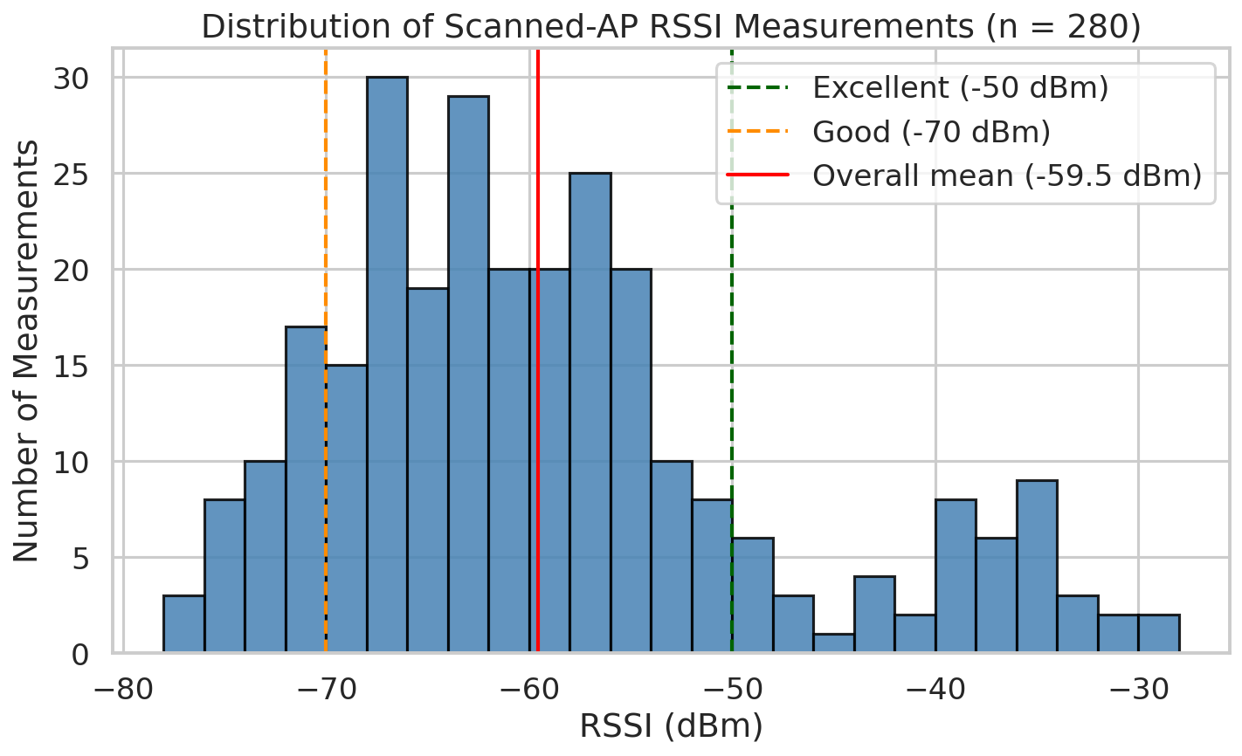
Figure 1. Distribution of all scanned-AP RSSI measurements (n = 280). Dashed lines mark the Excellent (-50 dBm) and Good (-70 dBm) thresholds; the solid red line marks the overall mean.
Classifying each scanned measurement into the four quality categories gives: 16.4% Excellent, 29.6% Good, 40.4% Fair and 13.6% Poor. About 46% of scanned APs therefore reach at least Good quality.

3.2 Signal strength by location
Figure 2 shows the mean RSSI (± 1 SD) per measurement point. The Cafeteria has the strongest average signal (-52.7 dBm), reflecting its proximity to an access point. The Main Hall (-63.3 dBm), Basement (-61.5 dBm) and the spot Behind the concrete wall (-61.3 dBm) all sit in the Fair range. The Cafeteria and Garden show noticeably larger standard deviations, consistent with the fact that these locations see a wider variety of nearby APs.
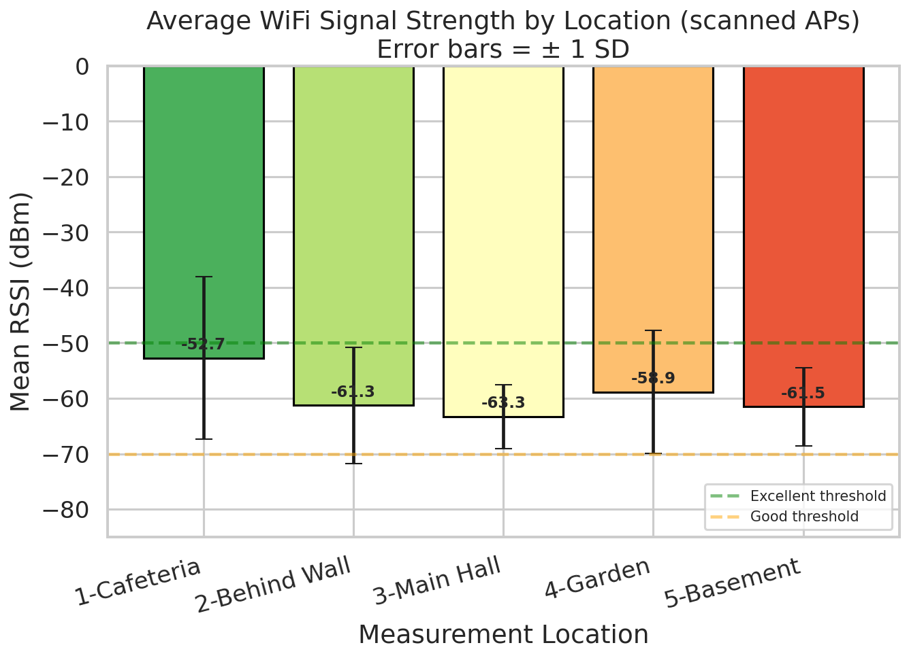
Figure 2. Average scanned-AP signal strength per location. Error bars show ± 1 standard deviation.
Figure 3 summarises the full distribution per location. Beyond the differences in means, the Main Hall and Basement have narrow distributions: the coverage there is consistently mediocre rather than variable.
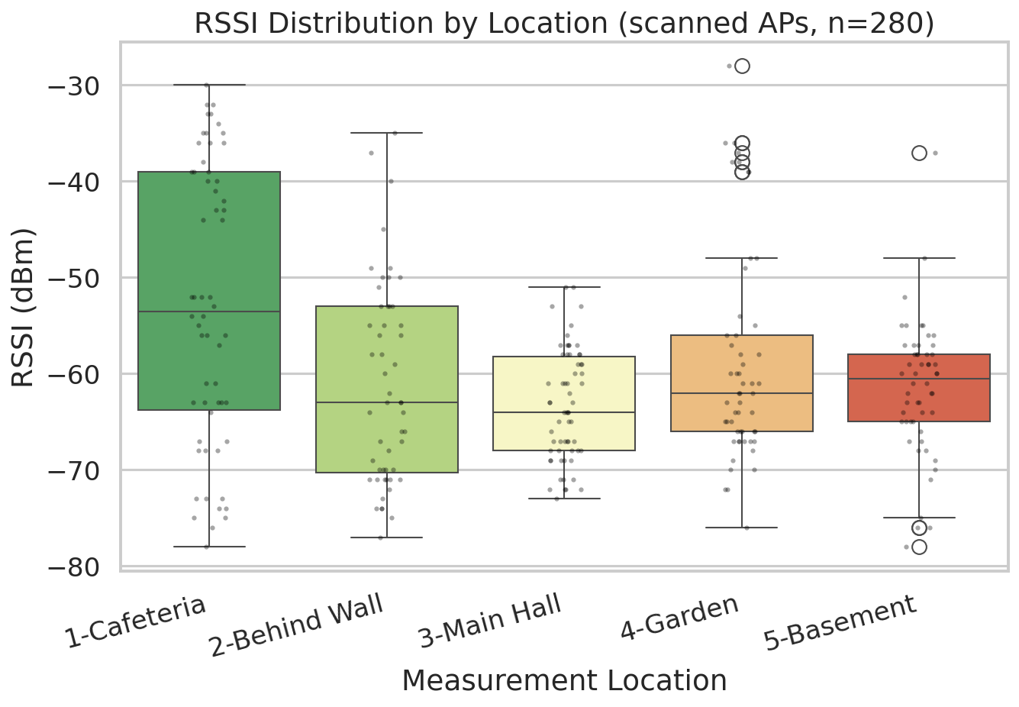
Figure 3. RSSI distribution per location (scanned APs). Each point is an individual measurement.

Descriptive statistics per location (scanned APs)
Location | n | Mean | Median | SD | Min | Max
1-Cafeteria | 58 | -52.72 | -53.5 | 14.66 | -78 | -30
2-Behind Wall | 52 | -61.29 | -63 | 10.43 | -77 | -35
3-Main Hall | 62 | -63.31 | -64 | 5.77 | -73 | -51
4-Garden | 54 | -58.89 | -62 | 11.1 | -76 | -28
5-Basement | 54 | -61.52 | -60.5 | 7.03 | -78 | -37

A one-way ANOVA confirms that location is a highly significant predictor of RSSI (F(4, 275) = 9.41, p < 0.001). A Tukey HSD post-hoc test indicates that the Cafeteria differs significantly from the Main Hall, Behind-Wall and Basement points, while the remaining pairwise differences are not significant at the 0.05 level.

3.3 Variation by time of day
Figure 4 plots mean RSSI for each location against the three time periods of the day. The lines are essentially flat, and a one-way ANOVA testing the effect of time of day on RSSI is not significant (F(2, 277) = 0.23, p = 0.80). The SWU WiFi infrastructure therefore delivers stable coverage throughout the working day.
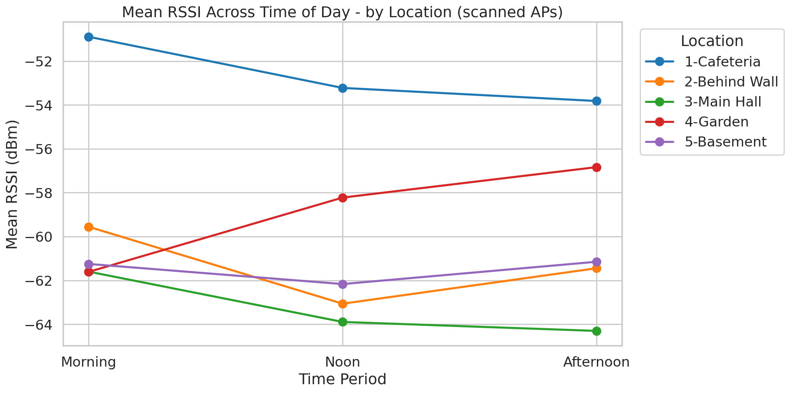
Figure 4. Mean RSSI across the three time periods, for each location.

3.4 Variation by day of the week
Aggregated by weekday, the mean RSSI values are virtually indistinguishable across the four days (range 58-60 dBm). The ANOVA is not significant (F(3, 276) = 0.35, p = 0.79). Neither day of the week nor time of day has a measurable effect on coverage in this dataset.

3.5 Coverage heatmaps
Heatmaps provide a compact way to visualize coverage across two categorical axes. Figure 5 shows the mean scanned RSSI per Location and Time of Day; Figure 6 shows Location and Weekday.
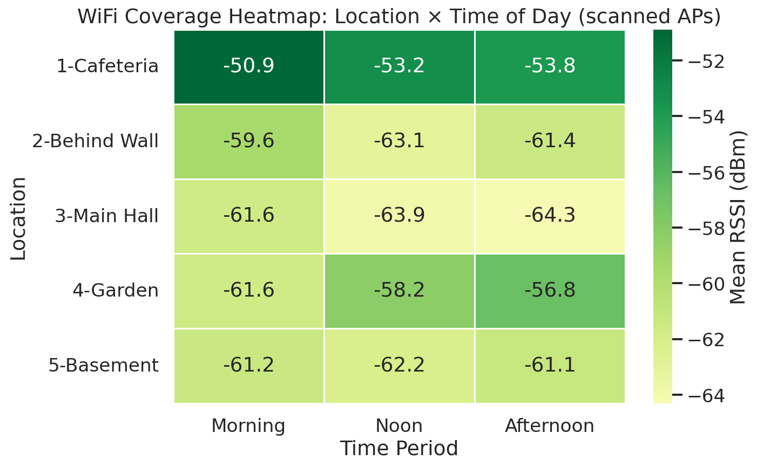
Figure 5. Scanned-AP coverage heatmap: Location x Time of Day.
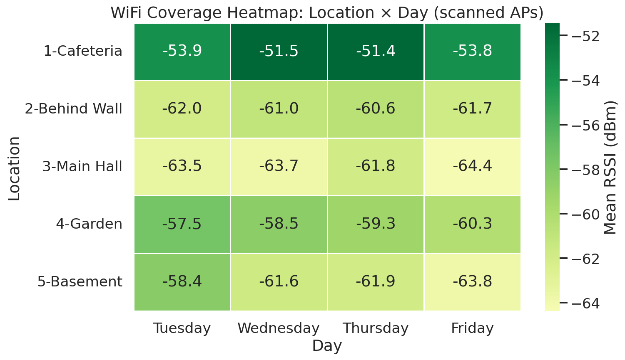
Figure 6. Scanned-AP coverage heatmap: Location x Day.
Figure 7 presents one heatmap per measurement day, showing the complete coverage map of the campus over the four days.
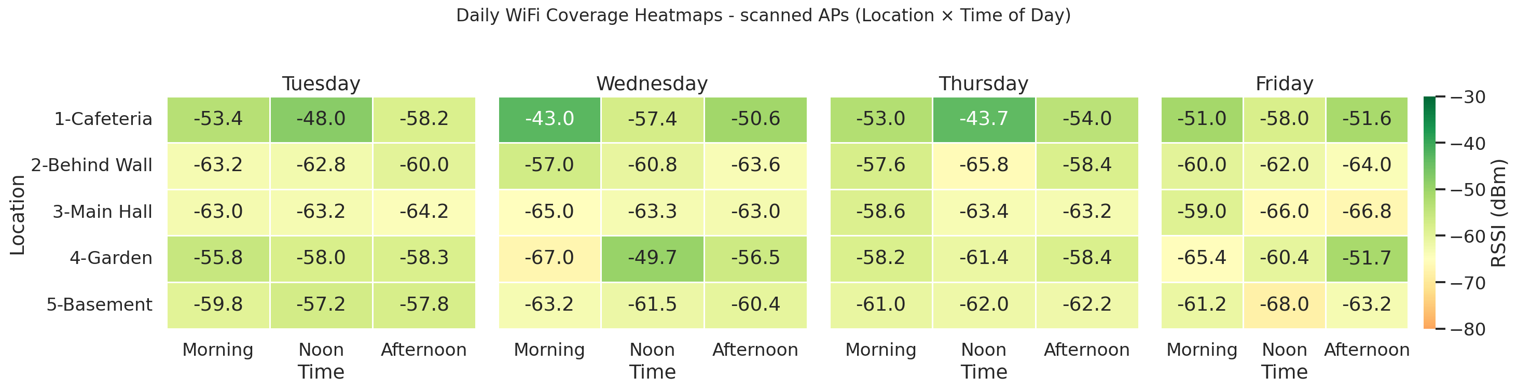
Figure 7. Daily coverage heatmaps (scanned APs, Location x Time of Day).

3.6 Comparison across networks (SSIDs)
Four university SSIDs were detected over the study: WiFi(at)SWU (the main campus network, 183 detections), cafe@swu (63), Career (26) and Cultural_Tourism_Lab (8). Figure 8 compares their mean RSSI. cafe@swu has the highest mean RSSI because its detections are geographically concentrated near the cafeteria AP; Cultural_Tourism_Lab has the lowest and was picked up only sporadically, at the edge of its range.
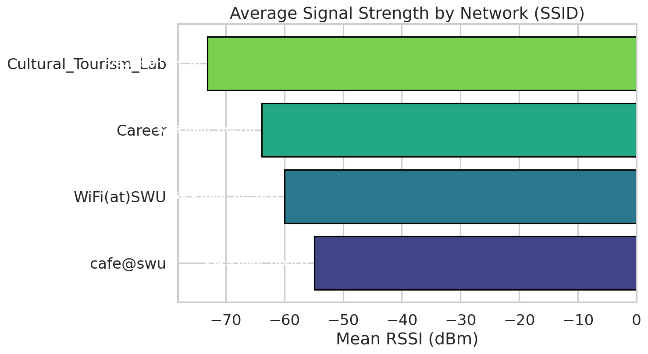
Figure 8. Average signal strength per SSID, annotated with the number of detections (n).

3.7 Full-access coverage vs. single-network coverage -- the credential gap
The analysis so far describes the radio environment as seen through a scanner: the signal strength of every university-AP the phone could detect. But at any given moment the phone is associated with exactly one AP, and that AP's signal strength is what the user actually experiences for web browsing, streaming and other tasks. During this study the researcher only had credentials for cafe@swu, so each of the 60 connected-AP rows in the dataset is a cafe@swu access point.
This limitation turns out to be analytically useful: it lets us quantify, session by session, the "credential gap" between the best available campus AP at each location and the AP actually accessible to a user with cafe@swu-only credentials - a situation that is common for Erasmus and visiting students who do not immediately receive the main-network password.
For each session we therefore compare (a) the RSSI of the strongest university-AP visible at that location and time, with (b) the RSSI of the cafe@swu AP the phone was attached to. The difference (a) − (b) is the credential gap.
Figure 9 averages these two quantities per location. The difference is striking: Behind the Wall the best available university-AP averages -47.5 dBm (between Excellent and Good), while cafe@swu averages -77.1 dBm (Poor). The Cafeteria is the only location where the two are almost identical, because it is where the cafe@swu APs themselves are installed.
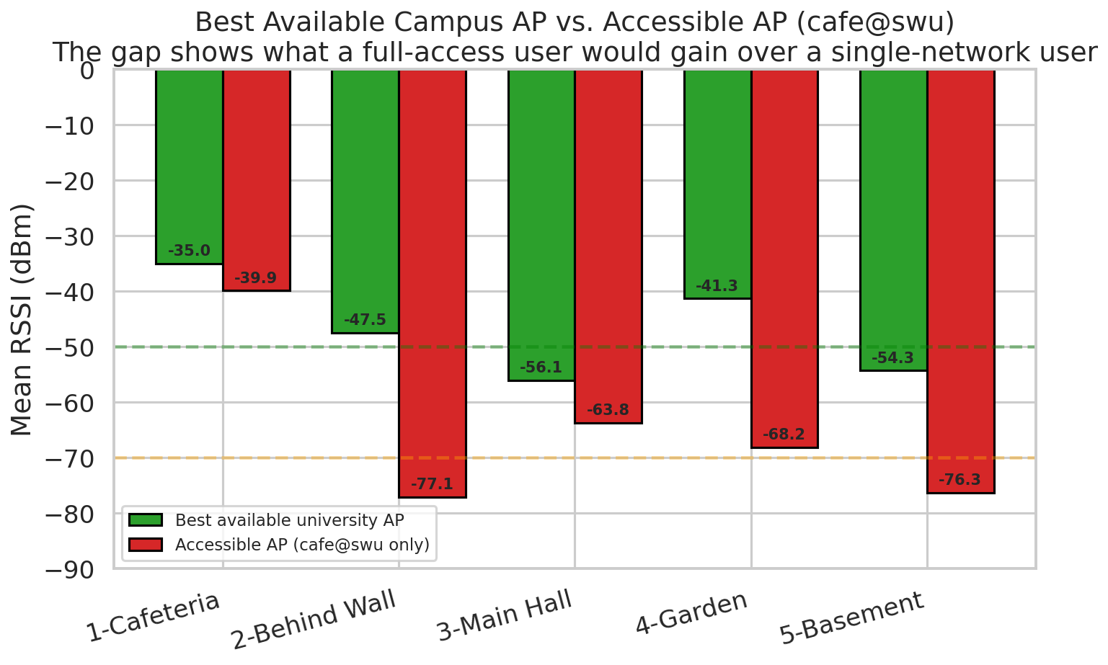
Figure 9. Best available university-AP RSSI (green) vs. cafe@swu RSSI (red), by location. The horizontal dashed lines mark the Excellent (-50 dBm) and Good (-70 dBm) thresholds.
Figure 10 plots the distribution of the credential gap across the 60 sessions. The mean gap is 18.2 dB and the median 18.5 dB; in 39 of the 60 sessions the gap is at least 10 dB, and in 28 of them it reaches or exceeds 20 dB. In the most extreme session (Thursday, 16:03, Behind the Wall) a -35 dBm AP was available on WiFi(at)SWU while the cafe@swu AP the phone was bound to read -83 dBm - a gap of 48 dB.
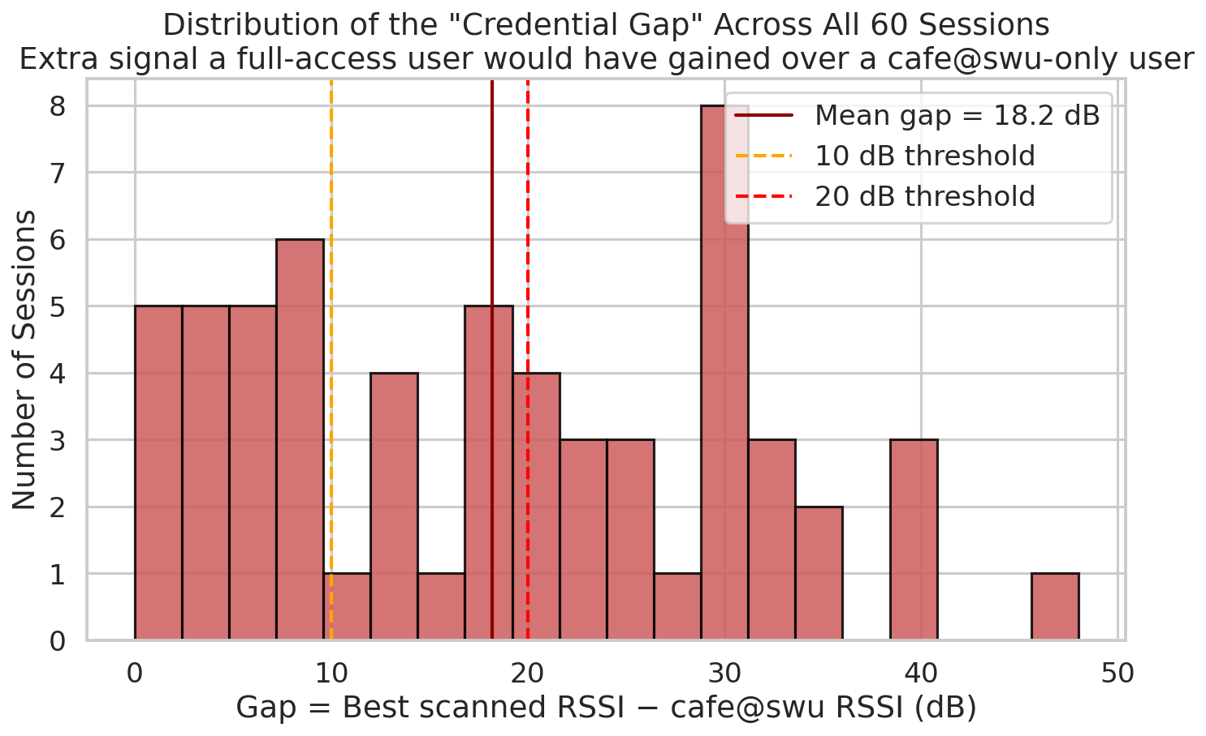
Figure 10. Distribution of the credential gap across 60 sessions.
The net effect on perceived quality is summarised in Figure 11: when all university APs are considered, 46% of scanned RSSI values fall in the Good or Excellent range and 14% in the Poor range. For the cafe@swu-only user, however, only 27% of sessions reach Good or Excellent and 43% are in the Poor range. A student limited to cafe@swu therefore experiences "Poor" coverage roughly three times more often than the full coverage map would suggest.
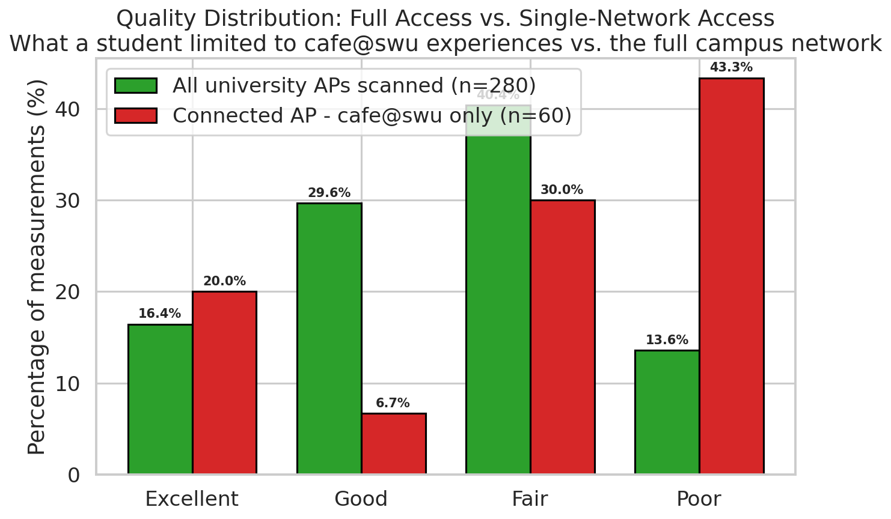
Figure 11. Quality distribution: all university APs (green) vs. cafe@swu-only access (red).
Figure 12 re-renders the daily heatmap of Figure 7 using the cafe@swu RSSI instead of the best-scanned RSSI, reflecting what a student limited to cafe@swu-only credentials actually saw at each session.
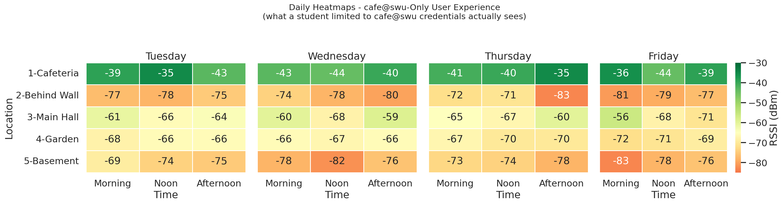
Figure 12. Daily heatmaps of the cafe@swu-only user experience.

4. Discussion

4.1 Location is the dominant factor
Statistically, location is the only factor with a significant effect on the scanned RSSI (ANOVA p < 0.001). Time of day and weekday are both non-significant (p > 0.7). Physically this is exactly the expected result: RSSI is dominated by the distance between the smartphone and the nearest AP and by the attenuation of walls, floors and other obstacles. Temporal load variations affect throughput and latency much more than they affect signal strength.

4.2 Coverage strengths and weaknesses
- The Cafeteria is the best-covered location, with 41% of scanned measurements classified as Excellent.
- The Main Hall and the Basement are the weakest-covered locations: almost no Excellent measurements and mostly Fair coverage.
- The Garden has usable coverage despite being outdoors, because it is still within range of several building-mounted APs.

4.3 Single-network access as a coverage issue
The most interesting observation of this study comes from the credential-gap analysis in Section 3.7. cafe@swu is clearly a network designed for the cafeteria area: its APs are concentrated there, and its signal decays rapidly as the user walks away. At the Cafeteria itself, cafe@swu offers Excellent coverage (mean − 39.9 dBm). Elsewhere on campus, the mean drops to − 68-77 dBm - Fair to Poor range.
In parallel, the main campus network WiFi(at)SWU clearly has good building-wide coverage: its APs are detected at Excellent or Good levels at almost every measurement point. A student with WiFi(at)SWU credentials would therefore have a very different experience from one restricted to cafe@swu. The 18 dB mean gap observed in this study corresponds to a factor of ~60 in received power, and in practice to the difference between a comfortable browsing experience and frequent disconnections.
The finding has a direct bearing on newly arrived Erasmus students, exchange students and visiting staff, who often rely on the more easily obtainable cafe@swu password until they receive the main network credentials. During that onboarding window they effectively experience a campus without usable WiFi outside the cafeteria.

4.4 Recommendations
- Administrative: streamline the distribution of WiFi(at)SWU credentials to newly arrived Erasmus / exchange students, for example as part of the arrival package, so that they are not effectively limited to cafe@swu during their first weeks.
- Physical layer: add or re-balance access points near the Main Hall and the Basement. Both currently offer only Fair coverage even through WiFi(at)SWU, with very little headroom.
- Network design: consider extending cafe@swu beyond the cafeteria, or alternatively making clear to students that it is a cafeteria-only network and not a substitute for the main campus WiFi.

4.5 Limitations
- The observation period covers one working week only; a longer period (e.g. the same weekday over one month) would strengthen conclusions about temporal stability.
- Only one smartphone was used. A multi-device campaign would further validate the results.
- The credential gap is inherently a single-student perspective. Repeating the experiment with a second student who has WiFi(at)SWU credentials would allow a direct comparison of the two actual user experiences.
- Measurements were taken at five fixed points. A true spatial heatmap would require denser sampling and a floor-plan overlay.
- RSSI reported by mobile OS APIs is quantised and slightly calibration-dependent, but trends across repeated measurements on the same device are reliable.

4.6 Demonstration of IoT concepts
This study illustrates the full pipeline of a typical IoT monitoring system: a sensing device (the smartphone) collects environmental data (the WiFi radio environment), the data are persisted in a structured form (CSV), and an analytics layer (R) extracts actionable insights - a coverage heatmap, a credential-gap diagnostic, and concrete recommendations. The same workflow could be scaled up by deploying additional sensing devices and automating the collection step.

5. Conclusion
An IoT-based system for WiFi network monitoring was implemented using a smartphone as the sensing device. A total of 280 scanned-AP measurements and 60 connected-AP measurements were collected across five locations, three daily time slots and four consecutive days. The analysis, carried out in R, shows that location is the only statistically significant predictor of scanned RSSI (p < 0.001), while time of day and day of the week have no detectable effect. The Cafeteria offers excellent coverage; the Main Hall and Basement only reach the Fair range.
Beyond the conventional coverage analysis, this study also documents a substantial gap between the best available university-AP at each location and the AP actually accessible to a student with cafe@swu-only credentials. With a mean gap of 18 dB and a maximum of 48 dB, this "credential gap" implies that newly arrived Erasmus or exchange students - who often start with cafe@swu as their only option - experience Poor coverage about three times more often than the coverage map would suggest. Addressing this gap through faster distribution of the main-network credentials, combined with targeted AP reinforcement in the Main Hall and Basement, would deliver a much larger perceived improvement than simply adding hardware.

Appendix A. R Packages Used
- tidyverse - data wrangling and plotting
- scales - axis label formatting
- viridis - colorblind-friendly palettes
- RColorBrewer - diverging color palettes for heatmaps

