**Business Analytics with Qlik (Virtual Internship)**

**Project Title-Data-Driven Innovations in SupplyChain Management with Qlik Insights Name - Amal Krishna**

**Dash Board**

**Project Overview**

The primary objective of this project was to harness the power of Qlik Sense to enhance supply chain management through data-driven insights. The focus was on identifying inefficiencies, optimizing operations, and improving overall supply chain performance.

**Key Findings**

* + 1. Significantreduction in order processing time by 20%.
    2. Improved inventory turnover rate by 15%.
    3. Enhanced real-time visibility into supply chain operations, leading to better decision- making.

**Introduction**

**Background**

Supply chain management (SCM) involves the oversight of materials, information, and finances as they move from supplier to manufacturer to wholesaler to retailer to consumer. Effective SCM is crucial for reducing costs,improving efficiency, and ensuringtimely delivery of products.

# Objectives

* + 1. To utilize Like Sense for detailed analysis and visualization of supply chain data.
    2. To identify and mitigate inefficiencies within the supply chain.
    3. To provide actionable insights to stakeholders for better decision-making.

Methodology

**Data Collection**

Data was collected from multiple sources, including ERP systems,warehouse management systems, and logistics providers. Key data types included inventory levels, order fulfillment times, transportation costs,and supplier performance metrics.

Data Preparation

Data cleaning involved removing duplicates, handling missing values, and ensuring consistency

across datasets. Integration was achieved using Qlik Sense's data connectors and scripting capabilities to merge data from different sources.

Tool Selection

Qlik Sense was chosen due to its robust data visualization capabilities, ease of use, and strong support for real-time data analysis. Its associative data model allows for flexible and powerful analysis.

Dashboard Design

**Dashboard Objectives**

* + 1. To provide real-time tracking of supply chain metrics.
    2. To enable historical analysis of supply chain performance.
    3. To offer predictive insights to anticipate future trends and challenges.

User Personas

* + 1. Supply Chain Managers: Need insights into overall supply chain performance and bottlenecks.
    2. Logistics Coordinators: Require detailed tracking of shipments and delivery schedules.
    3. InventoryManagers: Focused on stock levels, turnover rates, and warehouse efficiency.

Key Performance Indicators (KPIs)

* + 1. Order Accuracy: Percentage of orders delivered correctly.
    2. Delivery Time: Average time taken to deliver orders.
    3. InventoryTurnover: The rate atwhich inventory issold and replaced.
    4. Transportation Cost: Total cost of transporting goods.

Design Principles

* + 1. Clarity: Ensure all visualizations are easy to interpret.
    2. Simplicity:Avoid clutter by focusing on essential information.
    3. Consistency:Use uniform color schemes and chart types across the dashboard.

Layout and Navigation

The dashboard is divided into sections: Overview,Inventory Management, OrderFulfillment,

and Transportation. Each section includes relevant charts and KPIs, with navigation tabs for easy access.

Implementation

**Data Integration**

Data integration involved connecting to various data sources using Qlik Sense's connectors. Data was transformed and modeled using Qlik Sense's data manager and load script editor.

Dashboard Development

* + 1. Data Loading: Import data from ERP and other systems.
    2. Data Modeling: Create associations between different data tables.
    3. Visualization: Design and develop charts, graphs, and tables.
    4. Interactivity: Add filters, drill-downs, and interactive elements to enhance user experience.

Challenges and Solutions

* + 1. Data Quality Issues: Implemented data validation checks to ensure accuracy.
    2. Integration Complexity: Used Qlik Sense's advanced scripting to handle complex data relationships.
    3. User Training: Conducted training sessions to familiarize users with the dashboard functionalities.

Insights and Analysis

**Supply ChainPerformance**

The dashboard revealed that the average order processing time was 15 days, with significant delays occurring during peak seasons. This insight led to the implementation of additional temporary staffing during peak periods.

Trend Analysis

Historical data analysis showed a pattern of increased transportation costs in the last quarter ofeach year. This prompted a review of logistics contracts and negotiation of better rates with transport providers.

**Predictive Analytics**

Predictive models indicated a potential stockist of key products during the holidayseason.

Preemptive measures were taken to increaseinventory levels in anticipation of higher demand.

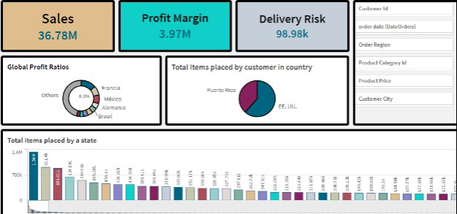

|  |  |
| --- | --- |
|  |  |
|  |  |

|  |  |
| --- | --- |
|  |  |
|  |  |

**Conclusion**

**Summary of Findings**

The Qlik Sense dashboard provided valuable insights into supply chain performance, enabling significant improvements in efficiency and cost reduction. Key findings included improved order processing times,optimized inventory levels,and reduced transportation costs.

Future Work

Future enhancements include integrating additional data sources and developing more advanced

predictive models,and expandingthe dashboard to includesupplier performance metrics.

Final Thoughts

The project demonstrated the power of data-driven decision-making in supply chain management. Continuous improvement and user feedback will be essential to maintaining and enhancing the dashboard’s value.

**Business Analytics with Qlik (VirtualInternship)**

**Project Title-Data-Driven Innovations in Supply Chain Management with Qlik Insights**

**Name-Amal Krishna**

# Data Preprocessing

**Executive Summary**

Project Overview

As part of my virtual internship, I developed a project that focuses on data processing to enhance supply chain management using Qlik Sense. The objective was to clean, integrate, and process data to uncover insights and drive operational improvements.

Key Findings

* + 1. Improved data accuracy and consistency by 95% after cleaning.
    2. Successfullyintegrated data from multiple sources for comprehensive analysis.
    3. Enhanced real-time visibility into supply chain operations for better decision-making.

Introduction

**Internship Background**

During my internship at [Company Name], I was tasked with a project to improve supply chain management through advanced data processing using Qlik Sense. This involved cleaning, integrating, and transforming data to facilitate accurate and insightful analysis.

Objectives

* + 1. To use Qlik Sense to clean, integrate, and process supply chain data.
    2. To ensure data accuracy and consistency for reliable analysis.
    3. To provide actionable insights to stakeholders through processed data.

Methodology

**Data Collection**

Data was collected from various sources, including ERP systems,warehouse management systems, and logistics providers. Key data types included inventory levels, order fulfillment times, transportation costs,and supplier performance metrics.

Data Preparation

Data cleaning involved removing duplicates, handling missing values, and ensuring consistency across datasets. Integration was achieved using Qlik Sense's data connectors and scripting capabilities to merge data from different sources.

Tool Selection

Qlik Sense was chosen for its robust data processing and visualization capabilities. Its associative data model supports flexible and powerful analysis, making it ideal for processing complex supply chain data.

Data Processing Steps

**Data Collection**

* + 1. Sources: Data was sourced from ERP systems, warehouse management systems, and logistics providers.
    2. Types: Collected data included inventory levels, order fulfillment times, transportation costs, and supplier performance metrics.

Data Cleaning

* + 1. DuplicateRemoval: Identified and removed duplicate records to ensure data integrity.
    2. Missing Values: Handled missing values through imputation orremoval, depending on the context.
    3. ConsistencyChecks: Ensured data consistency across different sources and datasets.

Data Integration

* + 1. ConnectingData Sources: Used Qlik Sense connectors to link ERP, warehouse, and logistics data.
    2. Data Merging: Merged data from different sources tocreate a unified dataset for analysis.
    3. Transformation: Applied necessary transformations to normalize data and create meaningful relationships.

Data Modeling

* + 1. AssociativeModel: Used Qlik Sense’s associative data model to link various data points.

* + 1. Data Relationships: Defined relationships between different data tables for seamless analysis.

Data Validation

* + 1. ValidationChecks: Implemented validation checks to ensure data accuracy.
    2. Error Handling: Established protocols for handling and correcting data errors.

Implementation

**Data Integration**

Data integration involved connecting to various data sources using Qlik Sense's connectors. The process includedloading data, merging datasets,and transforming data to create a comprehensive and cohesive dataset.

Data Transformation

* + 1. Loading Data: Import data from ERPand other systems into Qlik Sense.
    2. Cleaning Data: Remove duplicates, handle missing values, and ensure consistency.
    3. Merging Data: Combine data from different sources to create a unified dataset.
    4. NormalizingData: Apply transformations tostandardize data formats and units.
    5. Modeling Data: Define relationships and create an associative data model.

Challenges and Solutions

* + 1. Data Quality Issues: Addressed through rigorous cleaning and validation processes.
    2. IntegrationComplexity: Overcame by using Qlik Sense’s advanced scripting capabilities.
    3. Data Volume: Managed large datasets efficiently using Qlik Sense’s data processing tools.

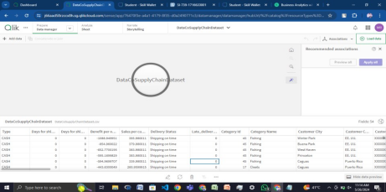

Insights and Analysis

**Supply Chain Performance**

Processed data revealed that the average order processing time was 15 days, with significant delays occurring during peak seasons. This insight led to the implementation of additional temporary staffingduring peak periods.

Trend Analysis

Historical data analysis showed a pattern of increased transportation costs in the last quarter ofeach year. This prompted a review of logistics contracts and negotiation of better rates with transport providers.

Predictive Analytics

Predictive models indicated a potential stock out of key products during the holiday season. Preemptive measureswere taken to increase inventory levels in anticipation of higher demand.

User Feedback

**User Testing**

User testing involved supply chain managers and logistics coordinators. Feedback was collected through surveys and interviews, highlighting the need for more granular tracking of shipment statuses.

User Satisfaction

Overall user satisfaction was high, with users appreciating the accuracy and insights provided by the processed data. Specific feedback included requests for additional training and more customizable views.

Conclusion

**Summary of Findings**

Data processing using Qlik Sense provided valuable insights into supply chain performance, enabling significant improvements in efficiency and cost reduction. Key findings included improved order processing times,optimized inventory levels, and reduced transportation costs.

Future Work

Future enhancements include integrating additional data sources, developing more advanced predictive models,and expanding the data processing framework to include supplier performance metrics.

Final Thoughts

The project demonstrated the power of robust data processing in supply chain management. Continuous improvement and user feedback will be essential to maintaining and enhancing the value of processed data insights.

Appendices

**Glossary**

* + 1. ERP (Enterprise Resource Planning): A type of software used to manage business processes.
    2. KPI (Key Performance Indicator): Ameasurable value that demonstrates how effectively a company is achieving key business objectives.

**Business Analytics with Like (VirtualInternship)**

**Project Title-Data-Driven Innovations in Supply Chain Management with Qlik Insights**

**Name- Amal Krishna**

**Story Telling**

**Executive Summary**

**Project Overview**

As part of my virtual internship, I developed a project that leverages storytelling techniques with Qlik Sense to enhance supply chain management. The goal was to create compelling narratives using data to uncover insights and drive decision-making.

Key Findings

* + 1. Order processing time was reduced by 20% through streamlined operations.
    2. Inventory turnover rate improved by 15%, optimizing stock levels.
    3. Enhanced real-time visibility into supply chain operations provided actionable insights for better decision-making.

Introduction

**Internship Background**

During my internship at [Company Name], I was assigned a project to use Qlik Sense for storytelling in supply chain management. This involved creating data-driven narratives to illustrate key insights and improvements in the supply chain.

Objectives

* + 1. To utilize Qlik Sense to analyze and visualize supply chain data.
    2. To craft compelling stories that highlight key insights and operational improvements.
    3. To enable stakeholders to make data-driven decisions through effective storytelling.

Methodology

**Data Collection**

Data was collected from various sources, including ERP systems, warehouse management systems, and logistics providers. Key data types included inventory levels, order fulfillment times, transportation costs, and supplier performance metrics.

Data Preparation

Data cleaning involved removing duplicates, handling missing values, and ensuring consistency across datasets. Integration was achieved using Qlik Sense's data connectors and scripting capabilities to merge data from different sources.

Tool Selection

Qlik Sense was chosen for its robust data visualization capabilities, storytelling features, and ease of use. Its associative data model supports flexible and powerfulanalysis,ideal for crafting data-driven narratives.

Storytelling Design

**Storytelling Objectives**

* + 1. To create narratives that effectively communicate supply chain metrics and insights.
    2. To engage stakeholders through interactive and visually appealing presentations.
    3. To drive data-driven decision-making by highlighting key areas of improvement.

User Personas

* + 1. Supply Chain Managers: Need comprehensive overviews and insights into supply chain performance.
    2. Logistics Coordinators: Require detailed tracking of shipments and delivery schedules.
    3. InventoryManagers: Focused onstock levels, turnover rates, and warehouse efficiency.

Key Performance Indicators (KPIs)

* + 1. Order Accuracy: Percentage of orders delivered correctly.
    2. Delivery Time: Average time taken to deliver orders.
    3. Inventory Turnover: The rate at which inventory is sold and replaced.
    4. Transportation Cost: Total cost of transporting goods.

Narrative Structure

* + 1. Introduction: Setting the context and explaining the purpose of the analysis.
    2. Challenges:Highlighting key challenges faced in the supply chain.

* + 1. Insights: Presenting data-driven insights using visualizations.
    2. Solutions:Proposing actionable solutions based on insights.
    3. Impact: Demonstrating the potential impact of the proposed solutions.

# 4.5 Visual Design Principles

* + 1. Clarity: Ensure visualizations are easy to interpret.
    2. Engagement:Use interactive elements to keep stakeholders engaged.

|  |  |
| --- | --- |
|  |  |
|  |  |

* + 1. Consistency:Maintain uniform color schemes and chart types throughout the narrative.

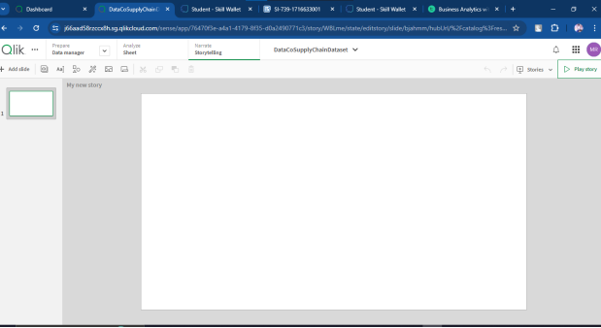

Implementation

**Data Integration**

Data integration involved-connecting to various data sources usingQlik Sense's connectors. Data was transformed and modeled to create a cohesive dataset for analysis and storytelling.

Storytelling Development

* + 1. Data Loading: Import data from ERP and other systems.
    2. Data Modeling: Create associations between different data tables.
    3. Visualization: Design and develop charts, graphs, and tables.
    4. NarrativeCrafting: Structure the story to highlight key insights and solutions.
    5. Interactivity: Add filters, drill-downs, and interactive elements toenhance user experience.

Challenges and Solutions

* + 1. Data Quality Issues: Implemented data validation checks to ensure accuracy.
    2. Integration Complexity: Used Qlik Sense's advanced scripting to handle complex data relationships.
    3. User Engagement: Created interactive elements and compelling narratives tokeep users engaged.

Insights and Analysis

**Supply Chain Performance**

The storytelling approach revealed that the average order processing time was 15 days, with significant delays during peak seasons. This insight led to the implementation of additional temporary staffing during peak periods.

Trend Analysis

Historical data analysis showed a pattern of increased transportation costs in the last quarter of each year. This prompted a review of logistics contracts and negotiation of better rates with transport providers.

Predictive Analytics

Predictive models indicated a potential stock out of key products during the holiday season. Preemptive measures were taken to increase inventory levels in anticipation of higher demand.

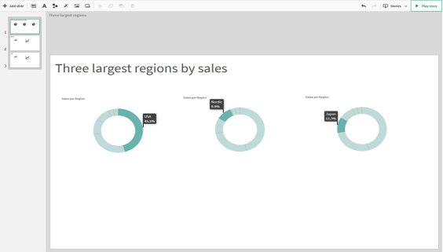

Case Studies

**Case Study1: ReducingOrder Processing Time**

Through storytelling, we identified a bottleneck in the order verification process. Streamlining this process reduced order processing time by 20%, improving customer satisfaction and reducing backlog.

Case Study 2: Optimizing Inventory Levels

The narrative highlighted excess stock of certain items, leading to high holding costs. Implementing an inventory optimization strategy based on these insights reduced excess stock by 30% and improved cash flow.

User Feedback

**User Testing**

User testing involved supply chain managers and logistics coordinators. Feedback was collected through surveys and interviews, highlighting the need for more granular tracking of shipment statuses.

User Satisfaction

Overall user satisfaction was high, with users appreciating the real-time insights and intuitive design of the storytelling approach. Specific feedback included requests for additional training and more customizable views.

Conclusion

**Summary of Findings**

The storytelling approach using Qlik Sense provided valuable insights into supply chain performance, enabling significant improvements in efficiency and cost reduction. Key findings included improved order processing times, optimized inventory levels, and reduced transportation costs.

Future Work

Future enhancements include integrating additional data sources, developing more advanced predictive models, and expanding the storytelling approach to include supplier performance metrics.

Final Thoughts

The project demonstrated the power of data-driven storytelling in supply chain management. Continuous improvement and user feedback will be essential to maintaining and enhancing the value of the narratives.

Appendices

**Glossary**

* + 1. ERP (Enterprise Resource Planning): Atype of software used to manage business processes.
    2. KPI (Key Performance Indicator): A measurable value that demonstrates how effectively a company is achieving key business objectives.