**What is Batch Script?**

* Batch Script is a scripting language that simplifies the process of executing repetitive tasks or commands on Windows machines. It allows users to write a series of commands in a plain text file with a .bat or .cmd extension, which can then be executed as a single script.

**Basic Commands in Batch Script:**

**Echo**: Displays messages on the screen.

**Rem**: Adds comments in the script (remarks).

**Set**: Assigns a value to a variable.

**If**: Executes a command conditionally based on the result of a comparison.

**For**: Loops through a set of items and executes a command for each item.

**Goto**: Redirects the execution flow to a specific label within the script.

**Call**: Calls another batch file from within the current script.

**Pause**: Pauses the execution of the script until a key is pressed.

**Exit**: Exits the script.

* These are some of the basic commands used in Batch Scripting. With these commands, you can perform a wide range of tasks from simple file manipulation to complex system administration tasks on Windows.

**What is Shell Scripting?**

* Shell scripting is the process of creating and running scripts written in a shell language.
* The shell is a command-line interpreter that provides a user interface for accessing the operating system's services.
* The most common shell on Unix-like systems is Bash (Bourne Again Shell), although other shells like Zsh (Z shell) and Ksh (KornShell) also exist.

**Here's a brief overview of how you can create and execute shell scripts on Ubuntu:**

**Create a Shell Script:**

* You can create a shell script using any text editor. Here's a basic example:

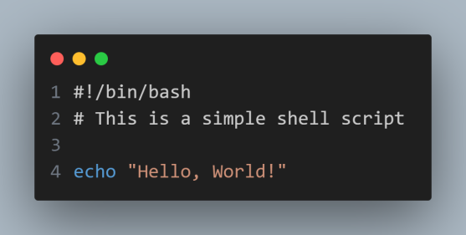

**Make the Script Executable:**

* Before you can run the script, you need to make it executable. You can do this using the chmod command:

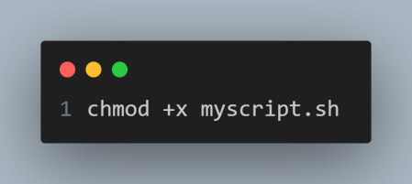

**Run the Script:**

* You can run the script by typing its name preceded by ./ in the terminal.

**Error Handling:**

* You can use the (**set -e**) option to automatically exit the script if any command fails, ensuring robust error handling

**Shebang (#!):**

* The shebang is the first line of a script and specifies the interpreter to use. For Bash scripts, the shebang line typically looks like this:

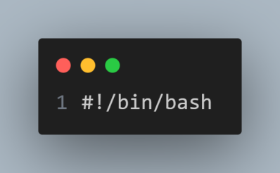

**using Variables and Comments**

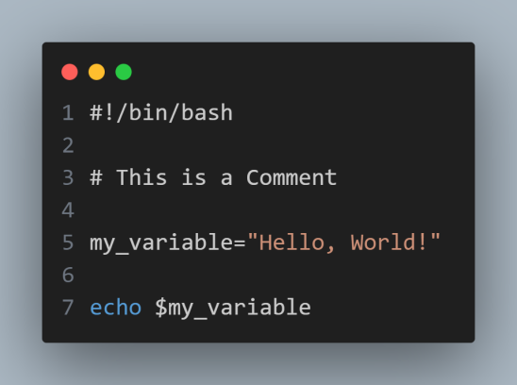

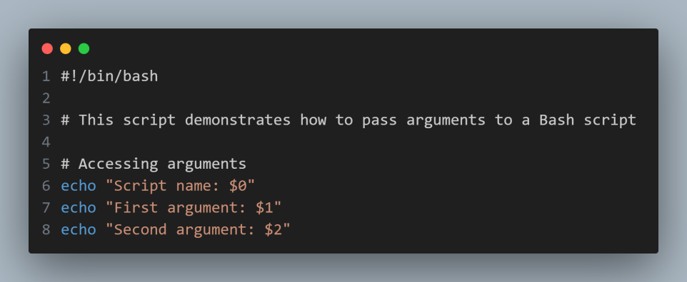**Pass Arguments to a Bash-Script**

* You can pass as many arguments as needed, and they will be accessible using $1, $2, $3, and so on, up to $9. Beyond $9, you need to use curly braces ${10}, ${11}, and so forth.
* If you need to access all the arguments as a single string, you can use the special variable $@ or $*.

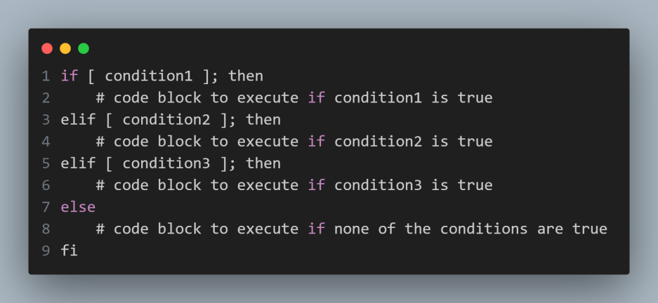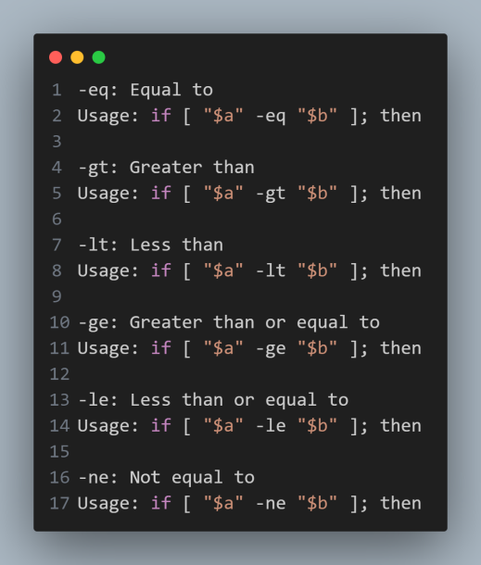**If Statement ( If then , If then else, If elif else)**

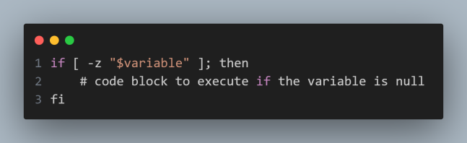

* Always wrap variables and expressions inside square brackets [ ] when using them in conditions.
* Use the appropriate comparison operators **(-eq, -gt, -lt, -ge, -le, -ne)** for numerical comparisons and **(==)** for string comparisons within square brackets.
* Always terminate each if, elif, else block with **(fi)** to signify the end of the block.

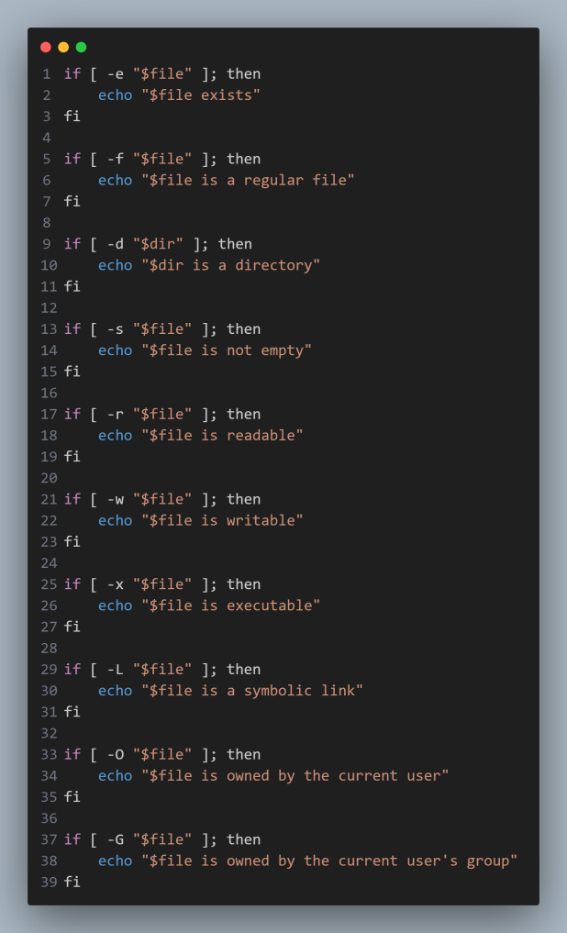

**File test operators**

-e: Checks if a file exists.

-f: Checks if a file exists and is a regular file

(not a directory or device file).

-d: Checks if a file exists and is a directory.

-s: Checks if a file exists and is not empty

(has a size greater than zero).

-r: Checks if a file exists and is readable.

-w: Checks if a file exists and is writable.

-x: Checks if a file exists and is executable.

-x: Checks if a file exists and is executable.

-x: Checks if a file exists and is executable.

-G: Checks if a file exists and is owned by

the current user's group.

**File Operations**

* Here are some commonly used commands for moving, copying, and deleting files in Unix/Linux environments, along with a few additional commands for file management

**mv (Move):**

* The mv command is used to move files or directories from one location to another.
* It can also be used to rename files

**cp (Copy):**

* The cp command is used to copy files or directories.
* To copy directories and their contents recursively, use the -r or -R option:

**rm (Remove):**

* The rm command is used to delete files or directories.

**mkdir :**

* The mkdir command is used to create directories.
* To create multiple directories at once, you can provide multiple directory names:

**rmdir (Remove Directory):**

* The rmdir command is used to delete empty directories.

**find:**

* The find command is used to search for files and directories within a directory hierarchy.

