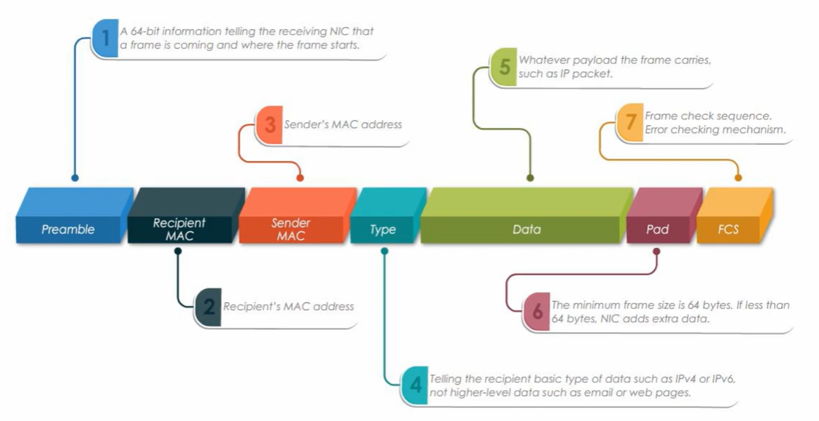

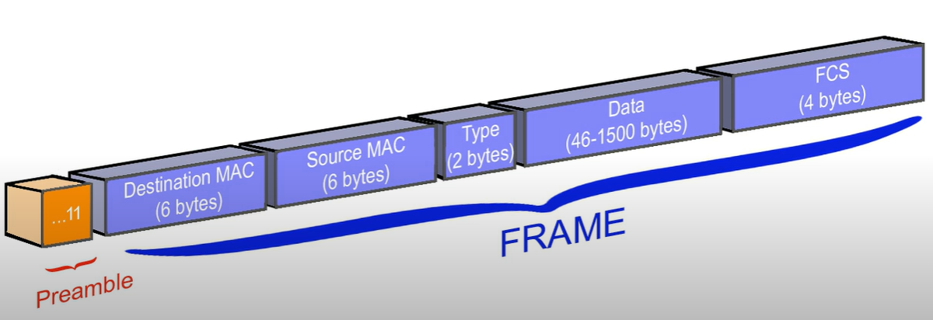

* **Ethernet Preamble (64 bits = 8 bytes)**
* The Ethernet preamble is a sequence of bits that precedes the actual data in an Ethernet frame.
* Its primary purpose is to signal the beginning of a frame and to allow the receiving device to synchronize its internal clock with the incoming data stream.

**The preamble consists of two parts:**

**● Preamble (7 bytes)**: A series of alternating 1s and 0s, ending with two consecutive 1s.

This helps the receiving device to synchronize its clock.

**● Start of Frame Delimiter (1 byte)**: A specific bit sequence (10101011) that indicates the end of

the preamble and the start of the actual data.

* **Ethernet Frame**

**● Destination MAC** :

These are six-byte addresses unique to each network interface card (NIC).

The destination address specifies where the frame is going

**● Source MAC :**

Hardware address of the source network adapter

the source address identifies the sender

**● Type or Length :**

A field that indicates either the protocol of the network layer (Ethernet II)

or the size of the data field (IEEE 802.3)

**● Data :**

The payload of the frame, which can be any network layer protocol data

The data must be at least 46 bytes , the NIC from the Sending Device will add padding (extra 0s)

**● Frame Check Sequence (FCS) :**

A cyclic redundancy check (CRC) that detects errors in the frame

**Advantages of automotive Ethernet**

1) High Speed

2) It can transfer large data

3) Single Twisted pair 2 wire cable, hence low weight.

4) Better Startup time

**Use Cases of automotive Ethernet**

1) Diagnostics

2) ECU Programming

3) Infotainment

4) ADAS/AD