# Proiect SGBD – Nedelcu Radu Gr. 232

CUPRINS

1. Scurtă prezentare a bazei de date
2. Diagrama Entitate-Relație
3. Diagrama Conceptuală
4. Implementarea bazei de date
5. Popularea tabelelor cu informații coerente
6. Afișarea datelor angajaților folosind un tablou îmbricat ce conține obiecte
7. Modificarea salariului angajaților folosind un cursor
8. Crearea unei funcții ce întoarce numărul de echipamente necesare unui antrenament
9. Crearea unei proceduri ce afișează mușchii lucrați de fiecare antrenament
10. Compound trigger ce limitează numărul maxim de participanți într-o clasă
11. Trigger la nivel de linie ce verifică respectarea limitelor salariale impuse de job
12. Trigger de tip LDD folosit pentru logging.
13. Definirea pachetului ce conține toate obiectele declarate anterior
14. Crearea unui pachet care facilitează managerierea membrilor

## Scurtă prezentare a bazei de date

Baza de date modelată este potrivită pentru o sală de sport ce oferă membrilor acces la antrenori privați și antrenamente în grup (Cum ar fi un centru World Class). Aceasta este împărțită în 3 părți ce se concentrează pe membri, angajați și exerciții.

## Diagrama Entitate-Relație

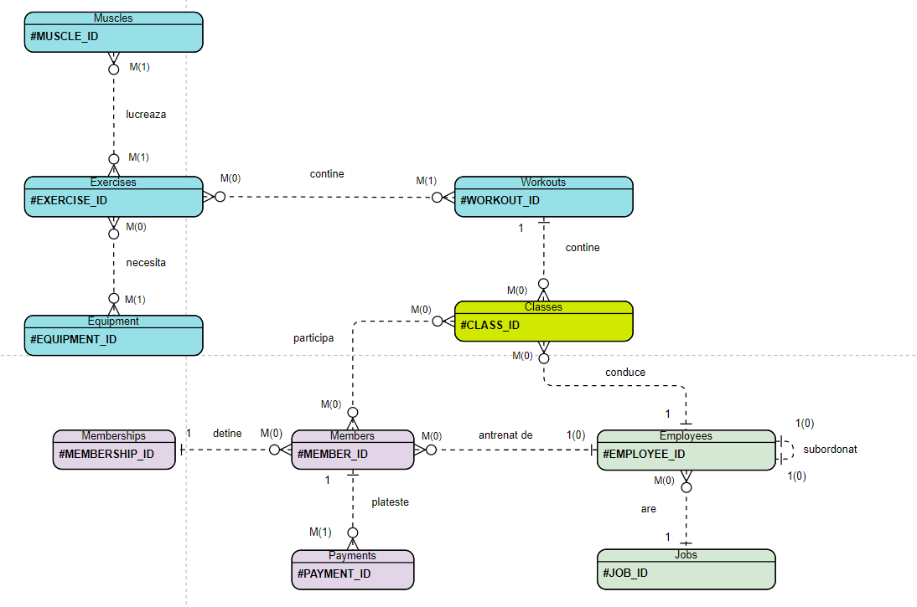

## Diagrama Conceptuală

## Implementarea Bazei De Date

### Codul SQL

CREATE TABLE jobs(

job_id VARCHAR(20) PRIMARY KEY,

job_title VARCHAR(30) NOT NULL,

min_salary INT NOT NULL,

max_salary INT NOT NULL,

UNIQUE(job_title),

CHECK(min_salary<=max_salary)

);

CREATE TABLE employees(

employee_id INT PRIMARY KEY,

first_name VARCHAR(25) NOT NULL,

last_name VARCHAR(25) NOT NULL,

email VARCHAR(25),

phone VARCHAR(20) NOT NULL,

hire_date DATE DEFAULT SYSDATE NOT NULL,

salary INT NOT NULL,

commission_pct NUMBER(2,2),

manager_id REFERENCES employees(employee_id) ON DELETE SET NULL, --FK

job_id VARCHAR(20) REFERENCES jobs(job_id) ON DELETE CASCADE, --FK

UNIQUE(first_name,last_name),

UNIQUE(phone),

UNIQUE(email)

);

CREATE TABLE memberships(

membership_id INT PRIMARY KEY,

name VARCHAR(25) NOT NULL,

price INT NOT NULL,

CHECK(price>0),

UNIQUE(name)

);

CREATE TABLE members(

member_id INT PRIMARY KEY,

first_name VARCHAR(25) NOT NULL,

last_name VARCHAR(25) NOT NULL,

email VARCHAR(25),

phone VARCHAR(20),

join_date DATE DEFAULT SYSDATE NOT NULL,

membership_id INT REFERENCES memberships(membership_id) ON DELETE SET NULL, -- FK

trainer_id INT REFERENCES employees(employee_id) ON DELETE SET NULL, -- FK

UNIQUE(first_name,last_name),

UNIQUE(phone),

UNIQUE(email)

);

CREATE TABLE payments(

payment_id INT PRIMARY KEY,

value INT NOT NULL,

payment_date DATE DEFAULT SYSDATE NOT NULL,

member_id INT REFERENCES members(member_id) ON DELETE CASCADE,

CHECK(value>0)

);

CREATE TABLE exercises(

exercise_id VARCHAR(30) PRIMARY KEY,

name VARCHAR(30) NOT NULL,

Description VARCHAR(300),

UNIQUE(name)

);

CREATE TABLE muscles(

muscle_id VARCHAR(30) PRIMARY KEY,

name VARCHAR(30) NOT NULL,

location VARCHAR(100)

);

CREATE TABLE equipment(

equipment_id INT PRIMARY KEY,

name VARCHAR(30) NOT NULL

);

CREATE TABLE musclesWorked(

exercise_id VARCHAR(30) REFERENCES exercises(exercise_id) ON DELETE CASCADE,

muscle_id VARCHAR(30) REFERENCES muscles(muscle_id) ON DELETE CASCADE,

CONSTRAINT musclesWorked_PK PRIMARY KEY (exercise_id, muscle_id)

);

CREATE TABLE requiredEquip(

equipment_id INT REFERENCES equipment(equipment_id) ON DELETE CASCADE,

exercise_id VARCHAR(30) REFERENCES exercises(exercise_id) ON DELETE CASCADE,

CONSTRAINT requiredEquip_PK PRIMARY KEY (equipment_id,exercise_id)

);

CREATE TABLE workouts(

workout_id INT PRIMARY KEY,

name VARCHAR(20) NOT NULL,

description VARCHAR(50),

UNIQUE(name)

);

CREATE TABLE workout_exercises(

exercise_id VARCHAR(30) REFERENCES exercises(exercise_id) ON DELETE CASCADE,

workout_id INT REFERENCES workouts(workout_id) ON DELETE CASCADE,

CONSTRAINT workout_exercises_PK PRIMARY KEY (exercise_id, workout_id)

);

CREATE TABLE classes(

class_id INT PRIMARY KEY,

name VARCHAR(30),

day_of_week VARCHAR(4),

start_time VARCHAR(5),

employee_id INT REFERENCES employees(employee_id) ON DELETE SET NULL,

workout_id INT REFERENCES workouts(workout_id) ON DELETE CASCADE

);

CREATE TABLE enrollments(

class_id INT REFERENCES classes(class_id) ON DELETE CASCADE,

member_id INT REFERENCES members(member_id) ON DELETE CASCADE,

CONSTRAINT enrollments_PK PRIMARY KEY (class_id, member_id)

);

### Imagine Rulare

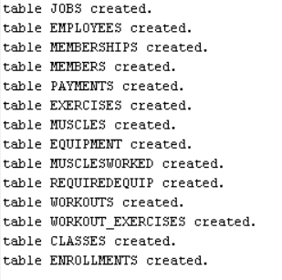

## Popularea tabelelor cu informații coerente

### Codul SQL

INSERT INTO equipment VALUES (1, 'Bench');

INSERT INTO equipment VALUES (2, 'Barbell');

INSERT INTO equipment VALUES (3, 'Squat Rack');

INSERT INTO equipment VALUES (4, 'Dumbbels');

INSERT INTO equipment VALUES (5, 'Leg Press Machine');

INSERT INTO equipment VALUES (6, 'Lat Pulldown Machine');

INSERT INTO equipment VALUES (7, 'Seated Row Machine');

INSERT INTO equipment VALUES (8, 'Shoulder Press Machine');

INSERT INTO equipment VALUES (9, 'Chest Press Machine');

INSERT INTO equipment VALUES (10, 'Lateral Shoulders Machine');

INSERT INTO equipment VALUES (11, 'Pulley System');

INSERT INTO muscles VALUES (1,'Pectorals','Chest');

INSERT INTO muscles VALUES (2,'Quadriceps', 'Most of the frontal leg');

INSERT INTO muscles VALUES (3, 'Biceps', 'Front arm');

INSERT INTO muscles VALUES (4, 'Triceps', 'Opposite of biceps');

INSERT INTO muscles VALUES (5, 'Lateral Shoulders',NULL);

INSERT INTO muscles values (6, 'Abs', 'Between the pubis and the fifth, sixth, and seventh ribs.');

INSERT INTO muscles VALUES (7, 'Hamstrings', 'Back of your legs, right under the glutes');

INSERT INTO muscles VALUES (8, 'Glutes', 'Dorsal area');

INSERT INTO muscles VALUES (9, 'Trapezius','Upper back');

INSERT INTO muscles VALUES (10, 'Spinal Erectors', 'Lower back');

INSERT INTO muscles VALUES (11, 'Latissimus dorsi', 'The large V-shaped muscles that connect your arms to your vertebral column');

INSERT INTO muscles VALUES (12, 'Posterior Shoulders', NULL);

INSERT INTO muscles VALUES (13, 'Anterior Shoulders', NULL);

INSERT INTO exercises VALUES ('LAT_PULLDOWN','Seated Lat Pulldown','While your arms are extended overhead, depress and retract your scapulae (pull shoulders back and down).');

INSERT INTO exercises VALUES ('TRI_PUSHDOWN', 'Triceps Pushdown', 'Pull the cable down until the bar touches your thighs and pause to squeeze your triceps at the bottom of the move.');

INSERT INTO exercises VALUES ('SKULL_CRSH', 'Triceps Skullcrushers', 'Hold the dumbbell with both hands above your chest, straight up, and with the dumbbell shaft in a vertical position.');

INSERT INTO exercises VALUES ('LAT_SH_RAISES','Lateral Shoulder Raises','Raise the weights to the sides and up to shoulder level, then lower them again');

INSERT INTO exercises VALUES ('CH_BAR_PRESS','Flat Barbell Chest Press', 'Grasp a barbell with an overhand grip just wider than shoulder-width apart.');

INSERT INTO exercises VALUES ('BIC_DB_CURL', 'Biceps Dumbell Curl', NULL);

INSERT INTO exercises VALUES ('BIC_BAR_CURL', 'Biceps Barbell Curl', 'Using an underhand grip, keep your chest up and your elbows tight to your sides, initiate the move by raising your hands slightly so you feel your biceps become engaged.');

INSERT INTO exercises VALUES ('LG_PRESS','Leg Press', 'Leg press using the leg press machine');

INSERT INTO exercises VALUES ('BAR_SQUAT','Barbell Squat', 'Trainees lowers their hips from a standing position and then stands back up.');

INSERT INTO exercises VALUES ('DEADLIFT','Deadlift','A loaded barbell or bar is lifted off the ground to the level of the hips, torso perpendicular to the floor, before being placed back on the ground.');

INSERT INTO exercises VALUES ('SH_DB_PRESS', 'Dumbbel Shoulder Press', 'Press the weights directly upwards until your arms are straight and the weights touch above your head.');

INSERT INTO exercises VALUES ('BAR_ROW','Bent Over Barbell Row', 'Lift the bar from the rack, bend forward at the hips, and keep the back straight with a slight bend in the knees.');

INSERT INTO musclesWorked VALUES ('LAT_PULLDOWN',11);

INSERT INTO musclesWorked VALUES ('LAT_PULLDOWN',5);

INSERT INTO musclesWorked VALUES ('TRI_PUSHDOWN',4);

INSERT INTO musclesWorked VALUES ('SKULL_CRSH',4);

INSERT INTO musclesWorked VALUES ('LAT_SH_RAISES',5);

INSERT INTO musclesWorked VALUES ('LAT_SH_RAISES',13);

INSERT INTO musclesWorked VALUES ('CH_BAR_PRESS',1);

INSERT INTO musclesWorked VALUES ('CH_BAR_PRESS',4);

INSERT INTO musclesWorked VALUES ('CH_BAR_PRESS',5);

INSERT INTO musclesWorked VALUES ('CH_BAR_PRESS',13);

INSERT INTO musclesWorked VALUES ('SH_DB_PRESS',5);

INSERT INTO musclesWorked VALUES ('SH_DB_PRESS',13);

INSERT INTO musclesWorked VALUES ('BAR_SQUAT',2);

INSERT INTO musclesWorked VALUES ('BAR_SQUAT',7);

INSERT INTO musclesWorked VALUES ('BAR_SQUAT',8);

INSERT INTO musclesWorked VALUES ('BAR_SQUAT',6);

INSERT INTO musclesWorked VALUES ('LG_PRESS',2);

INSERT INTO musclesWorked VALUES ('LG_PRESS',7);

INSERT INTO musclesWorked VALUES ('LG_PRESS',8);

INSERT INTO musclesWorked VALUES ('DEADLIFT',2);

INSERT INTO musclesWorked VALUES ('DEADLIFT',10);

INSERT INTO musclesWorked VALUES ('DEADLIFT',9);

INSERT INTO musclesWorked VALUES ('BIC_DB_CURL',3);

INSERT INTO musclesWorked VALUES ('BIC_BAR_CURL',3);

INSERT INTO musclesWorked VALUES ('BAR_ROW',11);

INSERT INTO requiredequip VALUES (6,'LAT_PULLDOWN');

INSERT INTO requiredequip VALUES (11,'TRI_PUSHDOWN');

INSERT INTO requiredequip VALUES (2,'SKULL_CRSH');

INSERT INTO requiredequip VALUES (1,'SKULL_CRSH');

INSERT INTO requiredequip VALUES (8,'LAT_SH_RAISES');

INSERT INTO requiredequip VALUES (1,'CH_BAR_PRESS');

INSERT INTO requiredequip VALUES (2,'CH_BAR_PRESS');

INSERT INTO requiredequip VALUES (4,'BIC_DB_CURL');

INSERT INTO requiredequip VALUES (2,'BIC_BAR_CURL');

INSERT INTO requiredequip VALUES (5,'LG_PRESS');

INSERT INTO requiredequip VALUES (3,'BAR_SQUAT');

INSERT INTO requiredequip VALUES (2,'BAR_SQUAT');

INSERT INTO requiredequip VALUES (2,'DEADLIFT');

INSERT INTO requiredequip VALUES (1,'SH_DB_PRESS');

INSERT INTO requiredequip VALUES (4,'SH_DB_PRESS');

INSERT INTO requiredequip VALUES (2,'BAR_ROW');

INSERT INTO workouts VALUES (1,'Push','A workout focused on pushing exercises');

INSERT INTO workouts VALUES (2,'Pull','A workout focused on pulling exercises');

INSERT INTO workouts VALUES (3,'Legs','Specially designed for massive legs');

INSERT INTO workouts VALUES (4,'Chest-Back-Triceps','Hit your whole upper body');

INSERT INTO workouts VALUES (5,'Shoulders-Biceps','Get boulder-like shoulders');

INSERT INTO workout_exercises VALUES ('CH_BAR_PRESS',1);

INSERT INTO workout_exercises VALUES ('SKULL_CRSH',1);

INSERT INTO workout_exercises VALUES ('SH_DB_PRESS',1);

INSERT INTO workout_exercises VALUES ('LAT_SH_RAISES',1);

INSERT INTO workout_exercises VALUES ('LAT_PULLDOWN',2);

INSERT INTO workout_exercises VALUES ('BIC_DB_CURL',2);

INSERT INTO workout_exercises VALUES ('BAR_ROW',2);

INSERT INTO workout_exercises VALUES ('BAR_SQUAT',3);

INSERT INTO workout_exercises VALUES ('LG_PRESS',3);

INSERT INTO workout_exercises VALUES ('DEADLIFT',3);

INSERT INTO memberships VALUES (1,'Bronze',150);

INSERT INTO memberships VALUES (2,'Silver',200);

INSERT INTO memberships VALUES (3,'Golden',230);

INSERT INTO jobs VALUES ('CLN_STF','Cleaning Staff',1400,2500);

INSERT INTO jobs VALUES ('P_TRN', 'Personal Trainer', 3000,9000);

INSERT INTO jobs VALUES ('SA_REP', 'Sales Representative', 1400,5000);

INSERT INTO jobs VALUES ('DESK','Front Desk Person',1400,3000);

INSERT INTO jobs VALUES ('ADM','Administration', 4000,8000);

INSERT INTO employees VALUES (1,'Dorothy','Haney','dorothy@gmail.com','973-722-4746','1-JUN-2010',7000,NULL,NULL,'ADM');

INSERT INTO employees VALUES (2,'Victor','Disney','victor23@gmail.com','563-449-0413','25-DEC-2012',1500,NULL,1,'CLN_STF');

INSERT INTO employees VALUES (3,'Lillian','Borton','lilly@gmail.com','518-454-9577','20-NOV-2011',7000,0.3,1,'P_TRN');

INSERT INTO employees VALUES (4,'Sally','Walden','sallynotsalty@yahoo.com','614-352-5238','20-JAN-2011',3500,NULL,3,'P_TRN');

CREATE SEQUENCE memberseq

START WITH 1

INCREMENT BY 1

NOCYCLE;

INSERT INTO members VALUES (memberseq.nextval, 'Lorraine','Wooldridge','LorWool@gmail.com','803-256-4224','22-NOV-2011',1,NULL);

INSERT INTO members VALUES (memberseq.nextval, 'Shery','Sousa','Shery@gmail.com','832-664-1475','25-NOV-2011',3,3);

INSERT INTO members VALUES (memberseq.nextval, 'Lisa','Barclay','lbarclay@gmail.com','214-277-8993','01-NOV-2011',1,4);

INSERT INTO members VALUES (memberseq.nextval, 'Mindy','Coleman','MinColeman@yahoo.com','860-520-2878','03-FEB-2012',2,NULL);

INSERT INTO classes VALUES (1,'Killer Leg Workout','MON','19:30',3,3);

INSERT INTO classes VALUES (2,'Beach Ready Body','FRI','18:30',3,4);

INSERT INTO classes VALUES (3,'Boulder Shoulders','SUN','12:30',4,5);

INSERT INTO classes VALUES (4,'Beginner Pull Workout','MON','19:30',4,3);

INSERT INTO classes VALUES (5,'Advanced Push Workout','TUE','15:15',3,1);

INSERT INTO enrollments VALUES (1,1);

INSERT INTO enrollments VALUES (2,1);

INSERT INTO enrollments VALUES (5,1);

INSERT INTO enrollments VALUES (3,2);

INSERT INTO enrollments VALUES (5,2);

INSERT INTO enrollments VALUES (4,2);

INSERT INTO enrollments VALUES (3,3);

INSERT INTO enrollments VALUES (5,3);

INSERT INTO enrollments VALUES (4,3);

INSERT INTO enrollments VALUES (1,4);

INSERT INTO enrollments VALUES (2,4);

CREATE SEQUENCE paymentseq

START WITH 1

INCREMENT BY 1

NOCYCLE;

INSERT INTO payments VALUES (paymentseq.nextval,150,'22-NOV-2011',1);

INSERT INTO payments VALUES (paymentseq.nextval,150,'22-DEC-2011',1);

INSERT INTO payments VALUES (paymentseq.nextval,150,'22-JAN-2012',1);

INSERT INTO payments VALUES (paymentseq.nextval,230,'25-NOV-2011',2);

INSERT INTO payments VALUES (paymentseq.nextval,150,'01-NOV-2011',3);

INSERT INTO payments VALUES (paymentseq.nextval,200,'03-FEB-2012',4);

### Imagine Rulare

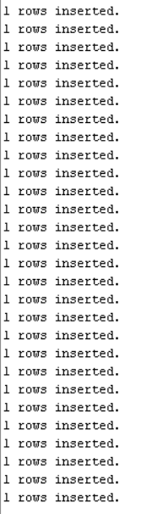

## Afișarea datelor angajaților folosind un tablou îmbricat ce conține obiecte

### Codul SQL

CREATE OR REPLACE TYPE employee_typ AS OBJECT (

employee_id INT,

first_name VARCHAR(25),

last_name VARCHAR(25),

email VARCHAR(25),

phone VARCHAR(20),

salary INT,

commission_pct NUMBER(2,2),

MAP MEMBER FUNCTION getId RETURN NUMBER, -- Pt comparari, nu e folosit, dar voiam sa vad cum merge

MEMBER FUNCTION getSalary RETURN NUMBER,

MEMBER PROCEDURE showData (SELF IN OUT NOCOPY employee_typ)

-- NOCOPY e asemanator cu & din C++, ii spune compilatorului sa nu mai faca inca o copie obiectului.

-- SELF e asemanator cu this din C++

);

/

CREATE OR REPLACE TYPE BODY employee_typ AS

MAP MEMBER FUNCTION getId RETURN NUMBER IS

BEGIN

RETURN employee_id;

END;

MEMBER FUNCTION getSalary RETURN NUMBER IS

BEGIN

RETURN salary*(1+commission_pct);

END;

MEMBER PROCEDURE showData (SELF IN OUT NOCOPY employee_typ) IS

BEGIN

DBMS_OUTPUT.PUT_LINE('---- Employee ID: '|| employee_id || ' Full Name: ' || first_name || ' '||last_name || ' ----');

DBMS_OUTPUT.PUT_LINE('Email: ' || email || ' Phone: ' || phone);

DBMS_OUTPUT.PUT_LINE('----------------------------------------------------------');

END;

END;

/

CREATE OR REPLACE PROCEDURE showEmployees IS

TYPE t_employee_typ IS TABLE OF employee_typ;

t_emp t_employee_typ;

BEGIN

SELECT employee_typ(employee_id, first_name, last_name, email, phone, salary, commission_pct)

BULK COLLECT INTO t_emp FROM employees;

FOR j IN t_emp.FIRST..t_emp.LAST LOOP

t_emp(j).showData();

END LOOP;

END showEmployees;

/

### Imagine Rulare

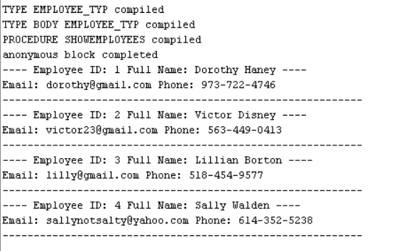

## Modificarea salariilor angajaților folosind un cursor

### Codul SQL

--7 Pt v_option = 1, se modifica salariul angajatilor cu salariul > threshold, altfel cu salariul < threshold.

CREATE OR REPLACE PROCEDURE modifySalary (v_option INTEGER, v_add INTEGER, v_sal INTEGER)

IS

TYPE empref IS REF CURSOR;

c_emp empref;

v_emp employees%ROWTYPE;

BEGIN

IF v_option = 1 THEN

OPEN c_emp FOR

'SELECT * FROM employees WHERE salary > :bind_var FOR UPDATE OF SALARY NOWAIT'

USING v_sal;

DBMS_OUTPUT.PUT_LINE('Adding ' || v_add || ' RON to employees whose monthly salary is BIGGER than '||v_sal || ' RON');

ELSIF v_option = 2 THEN

OPEN c_emp FOR

'SELECT * FROM employees WHERE salary < :bind_var FOR UPDATE OF SALARY WAIT 15'

USING v_sal;

DBMS_OUTPUT.PUT_LINE('Adding ' || v_add || ' RON to employees whose monthly salary is SMALLER than '||v_sal || ' RON');

ELSE

DBMS_OUTPUT.PUT_LINE('Invalid Option. Must be 1 for > or 2 for <');

END IF;

LOOP

FETCH c_emp INTO v_emp;

EXIT WHEN c_emp%NOTFOUND;

UPDATE employees

SET salary = salary+v_add

WHERE employee_id = v_emp.employee_id;

DBMS_OUTPUT.PUT_LINE('Updated ID: '||v_emp.employee_id|| ' Full Name: ' || v_emp.first_name || ' ' || v_emp.last_name || ' Salary: ' || v_emp.salary || ' -> ' || (v_emp.salary+v_add));

END LOOP;

DBMS_OUTPUT.PUT_LINE('Processed '||c_emp%ROWCOUNT || ' lines.');

CLOSE c_emp;

END modifySalary;

/

BEGIN

modifysalary(1,10,4000);

modifysalary(2,10,4000);

END;

/

### Imagine Rulare

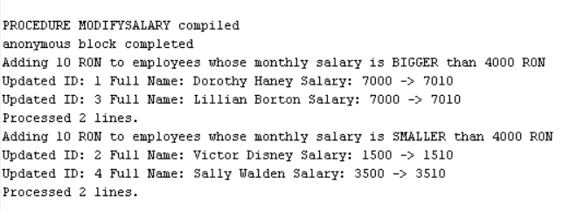

## Crearea unei funcții ce întoarce numărul de echipamente necesare unui antrenament

### Codul SQL

CREATE OR REPLACE FUNCTION necessaryEquipment(v_name workouts.name%TYPE)

RETURN NUMBER IS

v_count INTEGER;

BEGIN

SELECT COUNT(*)

INTO v_count

FROM workouts

WHERE workouts.name = v_name;

--Nu putem avea count > 1 din cauza constrangerii UNIQUE(name)

IF v_count = 0 THEN

raise NO_DATA_FOUND;

END IF;

SELECT COUNT(DISTINCT e.Name)

INTO v_count

FROM workouts wo, workout_exercises w, requiredequip r, equipment e, exercises ex

WHERE w.workout_id= wo.workout_id AND w.exercise_id = ex.exercise_id AND ex.exercise_id = r.exercise_id AND r.equipment_id=e.equipment_id AND UPPER(wo.name) = UPPER(v_name);

RETURN v_count;

EXCEPTION

WHEN NO_DATA_FOUND THEN

RAISE_APPLICATION_ERROR(-20000, 'There is no workout with this name');

END necessaryEquipment;

/

BEGIN

DBMS_OUTPUT.PUT_LINE(necessaryequipment('Pull'));

DBMS_OUTPUT.PUT_LINE(necessaryequipment('Pulls'));

END;

/

### Imagine Rulare

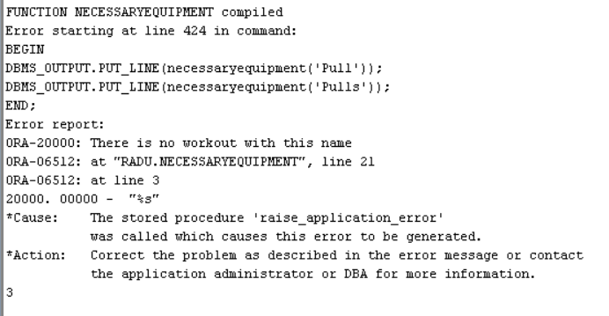

## Crearea unei proceduri ce afișează mușchii lucrați de fiecare antrenament

### Codul SQL

CREATE OR REPLACE PROCEDURE p_musclesWorked

IS

v_count INTEGER;

TYPE refcursor IS REF CURSOR;

CURSOR c_work IS

SELECT ws.name, CURSOR ( SELECT DISTINCT m.Name

FROM workouts wo, workout_exercises w, musclesWorked mw, muscles m, exercises ex

WHERE w.workout_id= wo.workout_id AND w.exercise_id = ex.exercise_id AND ex.exercise_id = mw.exercise_id AND mw.muscle_id=m.muscle_id AND wo.name =ws.name)

FROM workouts ws;

v_work_name workouts.name%TYPE;

v_cursor refcursor;

v_muscle_name muscles.name%TYPE;

BEGIN

OPEN c_work;

LOOP

FETCH c_work INTO v_work_name, v_cursor;

EXIT WHEN c_work%NOTFOUND;

DBMS_OUTPUT.PUT_LINE ('------ WORKOUT: '||v_work_name|| ' ------');

LOOP

FETCH v_cursor INTO v_muscle_name;

EXIT WHEN v_cursor%NOTFOUND;

DBMS_OUTPUT.PUT_LINE(v_cursor%ROWCOUNT || '. '||v_muscle_name);

END LOOP;

END LOOP;

CLOSE c_work;

END p_musclesWorked;

/

BEGIN

p_musclesWorked;

END;

/

### Imagine Rulare

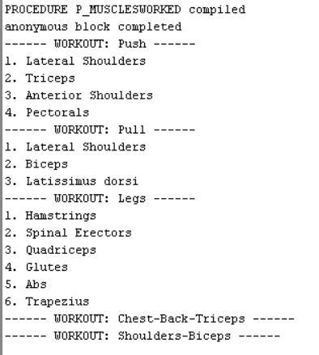

## Compound trigger ce limitează numărul maxim de participanți într-o clasă

### Codul SQL

CREATE OR REPLACE TRIGGER limit_members_in_class

FOR INSERT ON enrollments

COMPOUND TRIGGER

max_number constant number := 3;

TYPE t_class_count IS TABLE OF INTEGER INDEX BY BINARY_INTEGER;

class_count t_class_count;

TYPE t_class_IDs IS TABLE OF enrollments.class_id%TYPE;

c_class_IDs t_class_IDs;

TYPE t_counts IS TABLE OF INTEGER;

counts t_counts;

BEFORE STATEMENT IS

BEGIN

SELECT COUNT(*), class_id

BULK COLLECT INTO counts, c_class_IDs

FROM enrollments

GROUP BY class_id;

FOR i IN 1..c_class_IDs.COUNT() LOOP

class_count(c_class_IDs(i)) := counts(i);

END LOOP;

END BEFORE STATEMENT;

AFTER EACH ROW IS

BEGIN

IF class_count(:NEW.class_id) + 1 > max_number THEN

DBMS_OUTPUT.PUT_LINE('Too many members in Class ID: '||:NEW.class_id);

DBMS_OUTPUT.PUT_LINE('Maximum number of allowed members: '|| max_number);

RAISE_APPLICATION_ERROR(-20004, 'Too many members in the same class');

END IF;

END AFTER EACH ROW;

END limit_members_in_class;

/

INSERT INTO enrollments VALUES (5,4); -- Not Working, class 5 is already full

INSERT INTO enrollments VALUES (4,1); -- Working

### Imagine Rulare

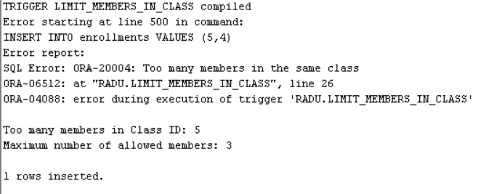

## Trigger la nivel de linie ce verifică dacă salariul respectă limitele impuse de job

### Codul SQL

CREATE OR REPLACE TRIGGER check_bounds

BEFORE INSERT OR UPDATE OF salary ON employees

FOR EACH ROW

DECLARE

v_min INTEGER;

v_max INTEGER;

BEGIN

SELECT min_salary, max_salary

INTO v_min, v_max

FROM employees e, jobs j

WHERE e.job_id=j.job_id AND j.job_id = :NEW.job_id;

IF (:NEW.salary<v_min) OR (:NEW.salary > v_max) THEN

raise_application_error(-20002, 'Salary is out of bounds for this job');

END IF;

END;

/

-- ADM are min 4000, max 8000

INSERT INTO employees VALUES (9,'Dorothy3','Haney3','dorothy33@gmail.com','973-722-47461','1-JUN-2010',10000,NULL,NULL,'ADM');

INSERT INTO employees VALUES (10,'Dorothy2','Haney2','dorothy32@gmail.com','973-722-47462','1-JUN-2010',5000,NULL,NULL,'ADM');

### Imagine Rulare

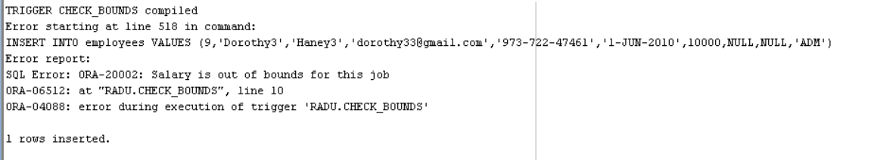

## Trigger de tip LDD folosit pentru logging

### Codul SQL

CREATE TABLE audit_log

( username VARCHAR2(30),

command VARCHAR2(100),

OBJECT_NAME VARCHAR2(50),

time TIMESTAMP,

ERROR VARCHAR2(100));

CREATE OR REPLACE TRIGGER audit_everything

AFTER DDL OR SERVERERROR ON SCHEMA

BEGIN

IF SYS.SYSEVENT = 'SERVERERROR' THEN

INSERT INTO audit_log VALUES (SYS.LOGIN_USER,'ERROR',SYS.DICTIONARY_OBJ_NAME,SYSDATE, DBMS_STANDARD.SERVER_ERROR(1)); --Top stack error

ELSE

INSERT INTO audit_log VALUES (SYS.LOGIN_USER,SYS.SYSEVENT,SYS.DICTIONARY_OBJ_NAME,SYSDATE, NULL);

END IF;

END audit_everything;

/

DROP TABLE testing;

CREATE TABLE testing(dummy INTEGER);

SELECT * FROM audit_log;

### Imagini Rulare

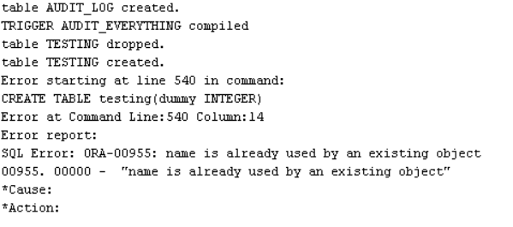 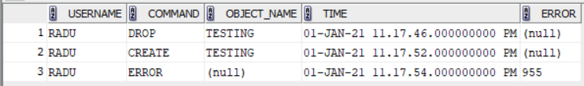

## Definirea pachetului ce conține toate obiectele declarate anterior

### Codul SQL

CREATE OR REPLACE PACKAGE p13 AS

PROCEDURE showEmployees;

PROCEDURE modifySalary (v_option INTEGER, v_add INTEGER, v_sal INTEGER);

FUNCTION necessaryEquipment(v_name workouts.name%TYPE) RETURN NUMBER;

PROCEDURE p_musclesWorked;

END p13;

/

CREATE OR REPLACE PACKAGE BODY p13 AS

PROCEDURE showEmployees IS

TYPE t_employee_typ IS TABLE OF employee_typ;

t_emp t_employee_typ;

BEGIN

SELECT employee_typ(employee_id, first_name, last_name, email, phone, salary, commission_pct)

BULK COLLECT INTO t_emp FROM employees;

FOR j IN t_emp.FIRST..t_emp.LAST LOOP

t_emp(j).showData();

END LOOP;

END showEmployees;

PROCEDURE modifySalary (v_option INTEGER, v_add INTEGER, v_sal INTEGER)

IS

TYPE empref IS REF CURSOR;

c_emp empref;

v_emp employees%ROWTYPE;

BEGIN

IF v_option = 1 THEN

OPEN c_emp FOR

'SELECT * FROM employees WHERE salary > :bind_var FOR UPDATE OF SALARY NOWAIT'

USING v_sal;

DBMS_OUTPUT.PUT_LINE('Adding ' || v_add || ' RON to employees whose monthly salary is BIGGER than '||v_sal || ' RON');

ELSIF v_option = 2 THEN

OPEN c_emp FOR

'SELECT * FROM employees WHERE salary < :bind_var FOR UPDATE OF SALARY WAIT 15'

USING v_sal;

DBMS_OUTPUT.PUT_LINE('Adding ' || v_add || ' RON to employees whose monthly salary is SMALLER than '||v_sal || ' RON');

ELSE

DBMS_OUTPUT.PUT_LINE('Invalid Option. Must be 1 for > or 2 for <');

END IF;

LOOP

FETCH c_emp INTO v_emp;

EXIT WHEN c_emp%NOTFOUND;

UPDATE employees

SET salary = salary+v_add

WHERE employee_id = v_emp.employee_id;

DBMS_OUTPUT.PUT_LINE('Updated ID: '||v_emp.employee_id|| ' Full Name: ' || v_emp.first_name || ' ' || v_emp.last_name || ' Salary: ' || v_emp.salary || ' -> ' || (v_emp.salary+v_add));

END LOOP;

DBMS_OUTPUT.PUT_LINE('Processed '||c_emp%ROWCOUNT || ' lines.');

CLOSE c_emp;

END modifySalary;

FUNCTION necessaryEquipment(v_name workouts.name%TYPE)

RETURN NUMBER IS

v_count INTEGER;

BEGIN

SELECT COUNT(*)

INTO v_count

FROM workouts

WHERE workouts.name = v_name;

--Nu putem avea count > 1 din cauza constrangerii UNIQUE(name)

IF v_count = 0 THEN

raise NO_DATA_FOUND;

END IF;

SELECT COUNT(DISTINCT e.Name)

INTO v_count

FROM workouts wo, workout_exercises w, requiredequip r, equipment e, exercises ex

WHERE w.workout_id= wo.workout_id AND w.exercise_id = ex.exercise_id AND ex.exercise_id = r.exercise_id AND r.equipment_id=e.equipment_id AND UPPER(wo.name) = UPPER(v_name);

RETURN v_count;

EXCEPTION

WHEN NO_DATA_FOUND THEN

RAISE_APPLICATION_ERROR(-20000, 'There is no workout with this name');

END necessaryEquipment;

PROCEDURE p_musclesWorked

IS

v_count INTEGER;

TYPE refcursor IS REF CURSOR;

CURSOR c_work IS

SELECT ws.name, CURSOR ( SELECT DISTINCT m.Name

FROM workouts wo, workout_exercises w, musclesWorked mw, muscles m, exercises ex

WHERE w.workout_id= wo.workout_id AND w.exercise_id = ex.exercise_id AND ex.exercise_id = mw.exercise_id AND mw.muscle_id=m.muscle_id AND wo.name =ws.name)

FROM workouts ws;

v_work_name workouts.name%TYPE;

v_cursor refcursor;

v_muscle_name muscles.name%TYPE;

BEGIN

OPEN c_work;

LOOP

FETCH c_work INTO v_work_name, v_cursor;

EXIT WHEN c_work%NOTFOUND;

DBMS_OUTPUT.PUT_LINE ('------ WORKOUT: '||v_work_name|| ' ------');

LOOP

FETCH v_cursor INTO v_muscle_name;

EXIT WHEN v_cursor%NOTFOUND;

DBMS_OUTPUT.PUT_LINE(v_cursor%ROWCOUNT || '. '||v_muscle_name);

END LOOP;

END LOOP;

CLOSE c_work;

END p_musclesWorked;

END p13;

/

### Imagine Rulare



## Crearea unui pachet ce facilitează managerierea membrilor

### Codul SQL

--14 Un pachet folosit la gestionarea membrilor

-- functie care primeste nume, prenume antrenor si returneaza ID --hidden

-- functie care primeste nume, prenume membru si returneaza ID --hidden

-- functie care primeste nume abonament si returneaza ID

-- functie care primeste o zi din saptamana, o ora de inceput si returneaza o lista de clase ( TYPE class_list) -- public

-- Nth most popular trainer -- public

-- procedura care modifica antrenorul unui membru -- public

-- proceduri pt upgrade/downgrade/change la abonamentul unui membru si adauga automat plata --public (se presupune ca ID-urile sunt ordonate crescator)

-- proceduri pt delete member (overloaded dupa id, nume+prenume) -- public

-- functie pt add member ce intoarce noul ID -- public

CREATE OR REPLACE PACKAGE member_manager AS

TYPE class_list IS TABLE OF classes%ROWTYPE;

FUNCTION getClasses (v_day VARCHAR2, v_hour VARCHAR2) RETURN class_list;

FUNCTION nthPopular (n NUMBER) RETURN employees.employee_id%TYPE;

PROCEDURE changeTrainer(v_first members.first_name%TYPE, v_last members.last_name%TYPE, v_first_e employees.first_name%TYPE, v_last_e employees.last_name%TYPE);

PROCEDURE upgradeMembership(v_first members.first_name%TYPE, v_last members.last_name%TYPE);

PROCEDURE downgradeMembership(v_first members.first_name%TYPE, v_last members.last_name%TYPE);

PROCEDURE deleteMember(v_first members.first_name%TYPE, v_last members.last_name%TYPE);

PROCEDURE deleteMember(v_id members.member_id%TYPE);

FUNCTION addMember(v_first members.first_name%TYPE, v_last members.last_name%TYPE,v_email members.email%TYPE,v_phone members.phone%TYPE,v_membership members.membership_id%TYPE,v_trainer members.trainer_id%TYPE)

RETURN members.member_id%TYPE;

PROCEDURE changeMembership(v_first members.first_name%TYPE, v_last members.last_name%TYPE, v_membership_name memberships.name%TYPE);

END member_manager;

/

CREATE OR REPLACE PACKAGE BODY member_manager AS

FUNCTION getMembershipId(v_membership memberships.name%TYPE) RETURN memberships.membership_id%TYPE

IS

v_id memberships.membership_id%TYPE;

BEGIN

SELECT membership_id INTO v_ID FROM memberships WHERE UPPER(name) = UPPER(v_membership);

RETURN v_ID;

EXCEPTION

WHEN NO_DATA_FOUND THEN

RAISE_APPLICATION_ERROR(-20000, 'There is no membership with this name');

-- nu pot avea TOO MANY ROWS din cauza constrangerii de UNIQUE(name)

END getMembershipId;

FUNCTION getEmployeeId (v_first employees.first_name%TYPE, v_last employees.last_name%TYPE)

RETURN employees.employee_id%TYPE IS

v_ID employees.employee_id%TYPE;

BEGIN

SELECT employee_id INTO v_ID FROM employees WHERE UPPER(first_name) = UPPER(v_first) AND UPPER(last_name) = UPPER(v_last);

RETURN v_ID;

EXCEPTION

WHEN NO_DATA_FOUND THEN

RAISE_APPLICATION_ERROR(-20000, 'There is no employee with this name');

-- nu pot avea TOO MANY ROWS din cauza constrangerii de UNIQUE(first_name,last_name)

END getEmployeeId;

FUNCTION getMemberId (v_first members.first_name%TYPE, v_last members.last_name%TYPE)

RETURN members.member_id%TYPE IS

v_ID members.member_id%TYPE;

BEGIN

SELECT member_id INTO v_ID FROM members WHERE UPPER(first_name) = UPPER(v_first) AND UPPER(last_name) = UPPER(v_last);

RETURN v_ID;

EXCEPTION

WHEN NO_DATA_FOUND THEN

RAISE_APPLICATION_ERROR(-20001, 'There is no member with this name');

-- nu pot avea TOO MANY ROWS din cauza constrangerii de UNIQUE(first_name,last_name)

END getMemberId;

FUNCTION getClasses (v_day VARCHAR2, v_hour VARCHAR2) RETURN class_list IS

t_classes class_list;

BEGIN

SELECT * BULK COLLECT INTO t_classes FROM classes WHERE UPPER(v_day) = day_of_week AND start_time>v_hour;

IF t_classes.COUNT = 0 THEN

RAISE NO_DATA_FOUND;

END IF;

RETURN t_classes;

EXCEPTION

WHEN NO_DATA_FOUND THEN

RAISE_APPLICATION_ERROR(-20002, 'There is no class in the requested day that starts after the given hour');

END getClasses;

FUNCTION nthPopular (n NUMBER) RETURN employees.employee_id%TYPE IS

v_id employees.employee_id%TYPE;

CURSOR desc_trainer IS

SELECT trainer_id FROM members WHERE trainer_id IS NOT NULL GROUP BY trainer_id ORDER BY COUNT(*) DESC;

BEGIN

OPEN desc_trainer;

FOR i IN 1..n LOOP

FETCH desc_trainer INTO v_id;

END LOOP;

IF desc_trainer%ROWCOUNT < n THEN

DBMS_OUTPUT.PUT_LINE('N is bigger than the number of trainers, returning id of the least popular trainer');

END IF;

CLOSE desc_trainer;

RETURN v_id;

END nthPopular;

PROCEDURE changeTrainer(v_first members.first_name%TYPE, v_last members.last_name%TYPE, v_first_e employees.first_name%TYPE, v_last_e employees.last_name%TYPE) IS

v_member_id members.member_id%TYPE := getmemberid(v_first,v_last);

v_trainer_id employees.employee_id%TYPE := getemployeeid(v_first_e,v_last_e);

v_old_trainer_id employees.employee_id%TYPE;

BEGIN

SELECT trainer_id INTO v_old_trainer_id FROM members WHERE member_id = v_member_id;

UPDATE members SET trainer_id = v_trainer_id WHERE member_id = v_member_id;

IF v_old_trainer_id IS NOT NULL THEN

DBMS_OUTPUT.PUT_LINE('Trainer changed sucessfully from '|| v_old_trainer_id || ' to ' || v_trainer_id || '!');

ELSE

DBMS_OUTPUT.PUT_LINE('Trainer ' || v_trainer_id || ' sucessfully assigned!');

END IF;

END changeTrainer;

PROCEDURE upgradeMembership(v_first members.first_name%TYPE, v_last members.last_name%TYPE) IS

v_member_id members.member_id%TYPE := getmemberid(v_first,v_last);

v_currentMembership members.membership_id%TYPE;

v_maxMembership members.membership_id%TYPE;

v_value payments.value%TYPE;

BEGIN

SELECT MAX(membership_id) INTO v_maxMembership FROM memberships;

SELECT membership_id INTO v_currentMembership FROM members WHERE member_id = v_member_id;

IF v_currentmembership < v_maxMembership THEN

UPDATE members SET membership_id = membership_id+1 WHERE member_id = v_member_id;

SELECT price INTO v_value FROM memberships WHERE membership_id = v_currentMembership+1;

INSERT INTO payments VALUES (paymentseq.nextval,v_value,SYSDATE,v_member_id);

DBMS_OUTPUT.PUT_LINE('Membership upgraded sucessfully!');

ELSE

RAISE_APPLICATION_ERROR(-20004,'Member already has the best available membership');

END IF;

END upgradeMembership;

PROCEDURE downgradeMembership(v_first members.first_name%TYPE, v_last members.last_name%TYPE) IS

v_member_id members.member_id%TYPE := getmemberid(v_first,v_last);

v_currentMembership members.membership_id%TYPE;

v_value payments.value%TYPE;

BEGIN

SELECT membership_id INTO v_currentMembership FROM members WHERE member_id = v_member_id;

IF v_currentMembership > 1 THEN

UPDATE members SET membership_id = membership_id-1 WHERE member_id = v_member_id;

SELECT price INTO v_value FROM memberships WHERE membership_id = v_currentMembership;

INSERT INTO payments VALUES (paymentseq.nextval,v_value,SYSDATE,v_member_id);

DBMS_OUTPUT.PUT_LINE('Membership downgraded sucessfully!');

ELSE

RAISE_APPLICATION_ERROR(-20005,'Member already has the lowest available membership');

END IF;

END downgradeMembership;

PROCEDURE deleteMember(v_first members.first_name%TYPE, v_last members.last_name%TYPE) IS

v_member_id members.member_id%TYPE := getmemberid(v_first,v_last);

BEGIN

DELETE FROM members WHERE member_id = v_member_id;

DBMS_OUTPUT.PUT_LINE('Member deleted sucessfully!');

END deleteMember;

PROCEDURE deleteMember(v_id members.member_id%TYPE) IS

BEGIN

DELETE FROM members WHERE member_id = v_id;

DBMS_OUTPUT.PUT_LINE('Member deleted by id sucessfully!');

END deleteMember;

FUNCTION addMember(v_first members.first_name%TYPE, v_last members.last_name%TYPE,v_email members.email%TYPE,v_phone members.phone%TYPE,v_membership members.membership_id%TYPE,v_trainer members.trainer_id%TYPE)

RETURN members.member_id%TYPE IS

v_newId members.member_id%TYPE := memberseq.nextval;

BEGIN

INSERT INTO members VALUES (v_newId,v_first,v_last,v_email,v_phone,SYSDATE,v_membership,v_trainer);

RETURN v_newId;

END addMember;

PROCEDURE changeMembership(v_first members.first_name%TYPE, v_last members.last_name%TYPE, v_membership_name memberships.name%TYPE) IS

v_membership_id memberships.membership_id%TYPE:= getMembershipId(v_membership_name);

v_member_id members.member_id%TYPE := getmemberid(v_first,v_last);

v_value payments.value%TYPE;

BEGIN

UPDATE members SET membership_id = v_membership_id WHERE member_id = v_member_id;

SELECT price INTO v_value FROM memberships WHERE membership_id = v_membership_id;

INSERT INTO payments VALUES (paymentseq.nextval,v_value,SYSDATE,v_member_id);

DBMS_OUTPUT.PUT_LINE('Membership changed sucessfully!');

END changeMembership;

END member_manager;

/

DECLARE

t_classes member_manager.class_list := member_manager.getClasses('MON','19:00');

v_id NUMBER;

BEGIN

FOR j in t_classes.FIRST..t_classes.LAST LOOP

DBMS_OUTPUT.PUT_LINE(t_classes(j).name);

END LOOP;

-- t_classes := member_manager.getClasses('MON','20:00'); -- Eroare deoarece nu exista nicio clasa care sa respecte conditiile

DBMS_OUTPUT.PUT_LINE(member_manager.nthPopular(2));

DBMS_OUTPUT.PUT_LINE(member_manager.nthPopular(5)); -- Afiseaza un warning si returneaza antrenorul cu cei mai putini clienti deoarece nu exista destui antrenori

member_manager.changeTrainer('Lorraine','Wooldridge','Lillian','Borton'); -- Daca nu exista antrenorul/membrul o sa dea eroare din cauza functiilor getMemberId si getEmployeeId

member_manager.downgradeMembership('Shery','Sousa'); -- Daca are deja minimul o sa dea eroare

member_manager.upgradeMembership('Mindy','Coleman'); -- Daca are deja maximul o sa dea eroare

member_manager.changeMembership('Mindy','Coleman','Bronze'); -- Daca nu exista abonamentul o sa dea eroare

member_manager.deleteMember('Shery','Sousa');

member_manager.deleteMember(1);

END;

/

### Imagine Rulare

