Prometheus and Grafana Installation using Helm chart

Command : helm repo add prometheus-community <https://prometheus-community.github.io/helm-charts>

Command2: helm search repo prometheus-community

Command3 : helm install omer(Any name of your choice) prometheus-community/kube-prometheus-stack

Command 4: kubectl get pods ( to list out the port)

Command 5: kubectl expose pod omer-grafana-69b855dc45-8mzlt(Name of the pod got created please replace it with your pod name for Grafana) --type=NodePort --target-port=3000 --port 3000

Command 5: kubectl expose pod alertmanager-omer-kube-prometheus-stack-alertmanager-0(Replace it with the podname for alertmanager) --type=NodePort --target-port=9093 --port 9093

Command 6: kubectl expose pod prometheus-omer-kube-prometheus-stack-prometheus-0(Replace it with the Prometheus stack pod name) --type=NodePort --target-port=9090 --port 9090

Command 7: kubectl expose pod omer-kube-prometheus-stack-operator-795569d679-krx5b(Replace it with your pod name for pormetheus stack) --type=NodePort --target-port=10250 --port 10250

Command 8: kubectl expose pod omer-kube-state-metrics-778b9f8f6b-bq8qk( Replace it with the podname for kube-state metric) --type=NodePort --target-port=8080 --port 8080

Command 9: sudo docker run -d --name=grafana -p 3000:3000 grafana/grafana ( Installing Grafana as container for our visualization)

How to access the Prometheus on the browser:

To access Prometheus over the browser first we need to get the nodeport for the same. Run the command kubectl get services to list all the services as the image below and check for the nodeport for the Prometheus as highlighted for the image below. Using the nodeport with the publicIP of the worker node we will be able to access the Prometheus.

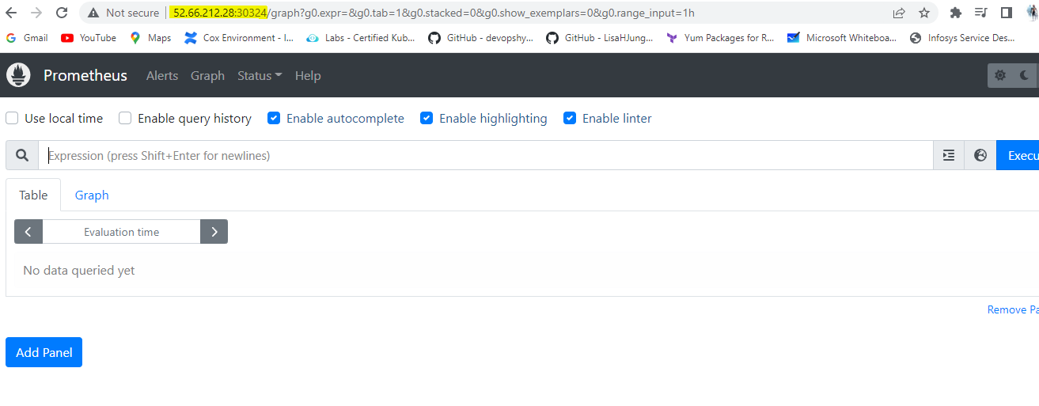

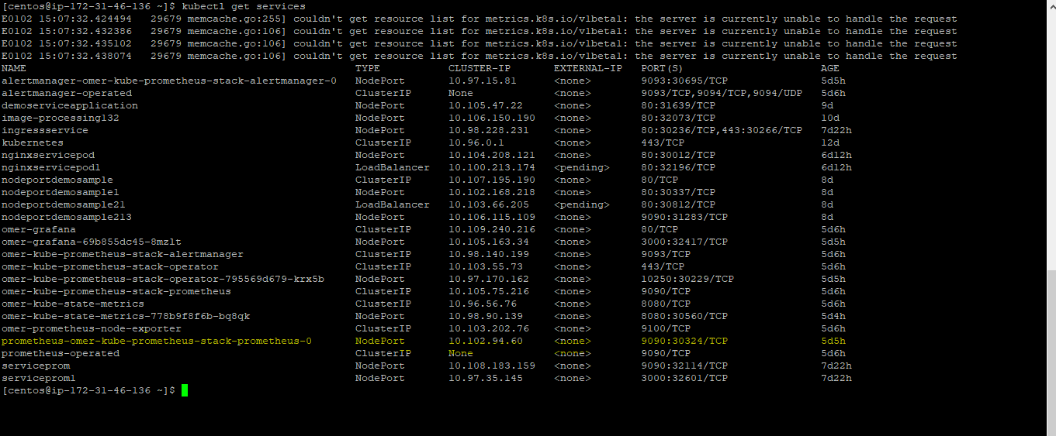

How to access granfana.

As we are running Grafana as a container run the below command to list out the container and use the port which we have use to bind to the Grafana container to access it over the browser. Please find the image below

Command: docker ps

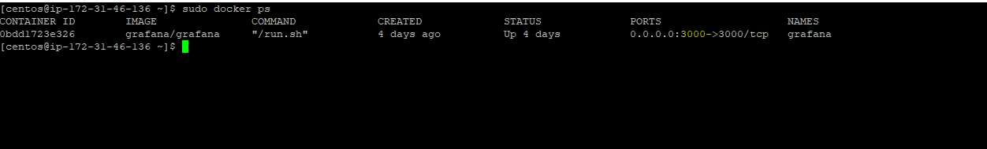

Note: default password for Grafana is username – admin, password – admin

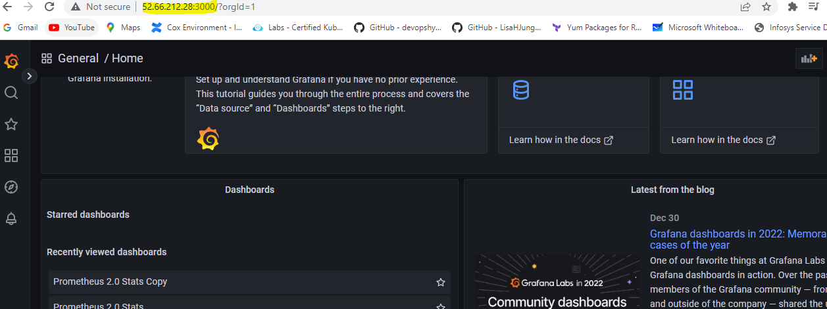

**To create a dashboard please follow the below instructions:**

**Upload the file I have shared separately in the google drive. Name of the file: KubernetesDashboard-1672289651285.**

**Go to the Grafana dashboard and follow the instructions as shared in the images below:**

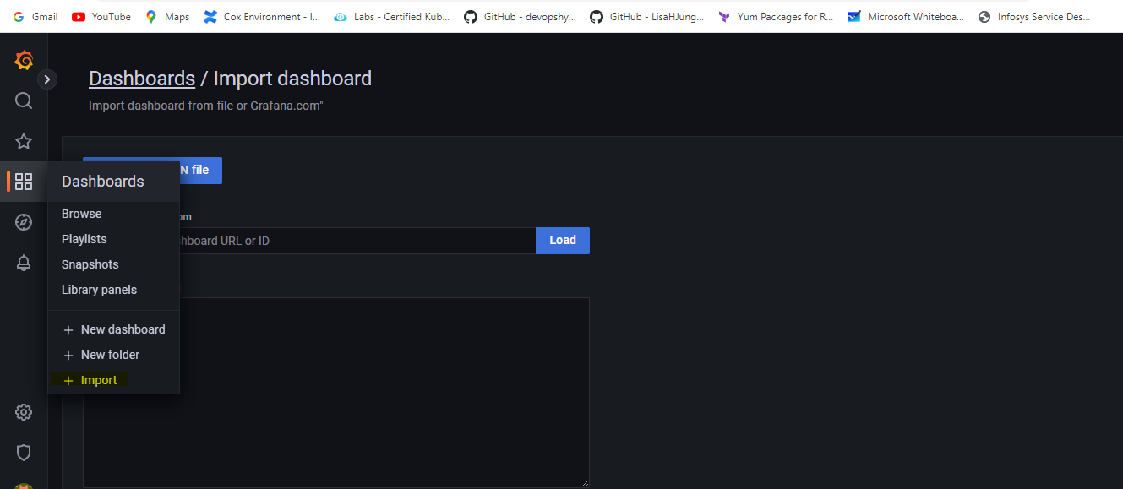

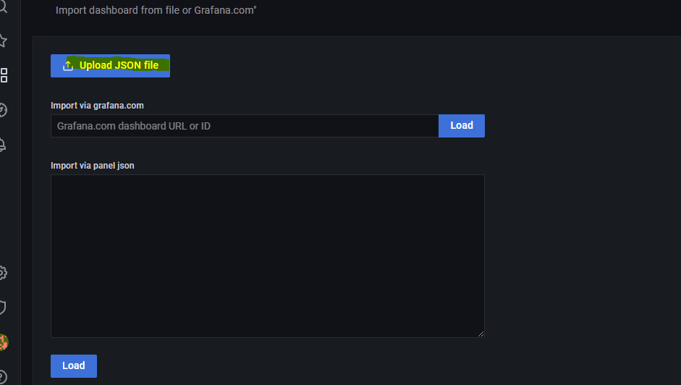

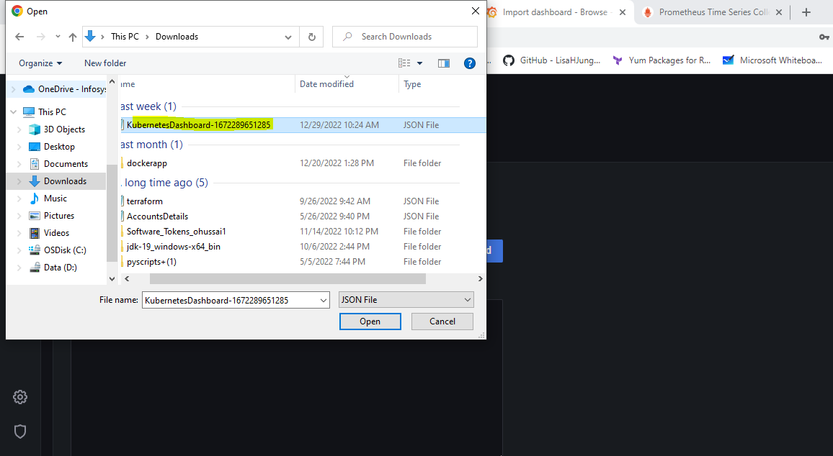

**And then click on import to import the dashboard**

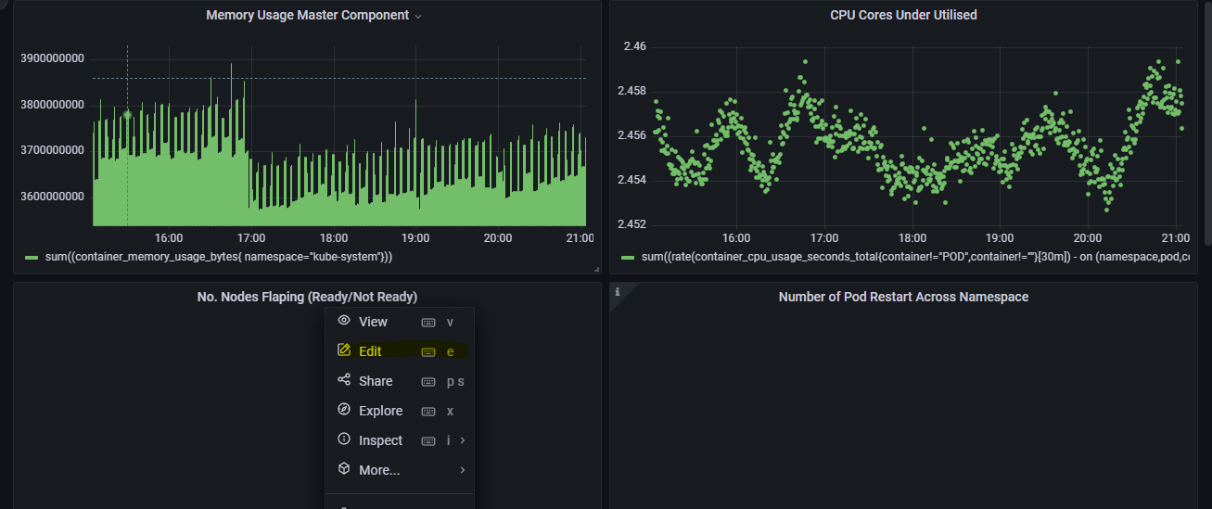

**Make sure select the right data source right click on the dashboard created and click on edit and cross check the data source as highlighted in the image below**

