**Setting up the infrastructure for DevOps**

AWS – EC2 Image: For Master Node

Centos Image on AWS t2.large 40 GB

/ProComputers CentOS-7.9-x86_64-Minimal-8GiB-HVM-20220707_053634-20255663-8070-4ad8-85c6-4d4f796c9265

**Note: You can use any other Image of centos but for to achieve uniformity in the class please do the above Image of centos only as other images I used for centos was having problem with Yum Package manager running in them.**

Please follow the instructions below to set up the master node that can be used for all our lab sessions:

Please click on Launch Instances as highlighted in the Image below to launch your instance:

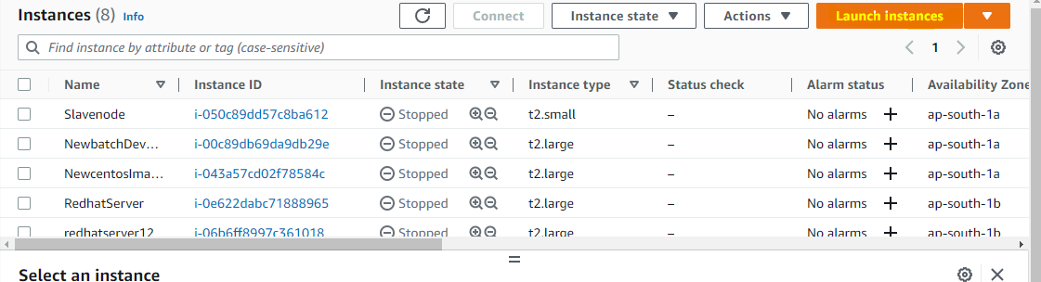

Once you click on launch instance it will open the below page as in the image . Please enter the details as below. As highlighted in below image enter your instance name it can any name of your choice.

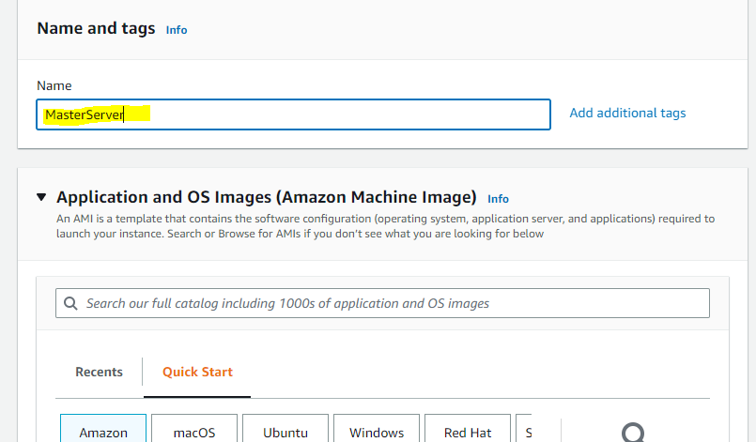

Scroll down you will see an option Browse AMIS click on the option as highlighted below

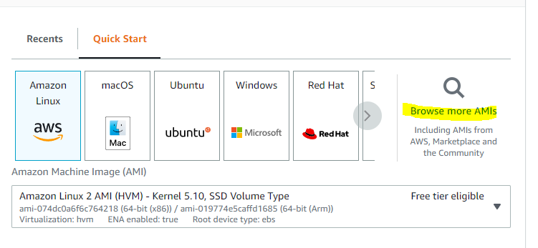

Search for the below Image in the search bar it will give you result like the image as below. Click on select to select that image as highlighted.

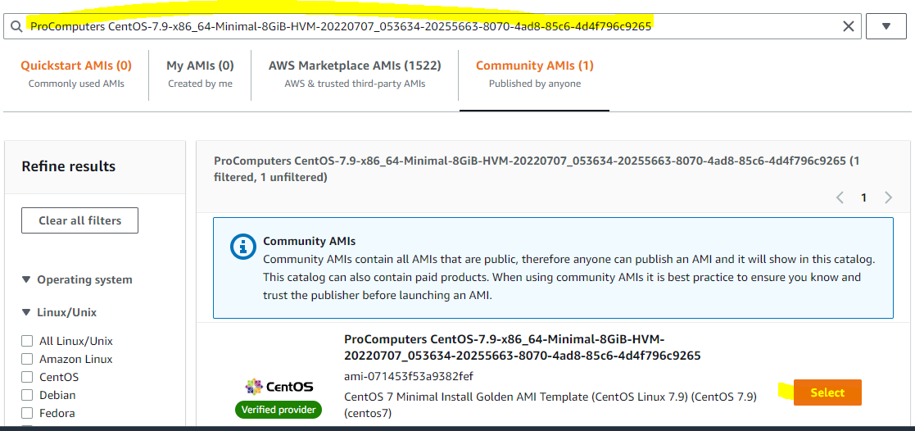

Once you click on select it will take you back to the main page. Under Instance type select the type according to Master and Slave node

Master Node: Select Instance type as t2. large

Slave Node: Select the instance type as t2. medium or small

Select the keypair if it was created before you will be able to see that Key pair from drop down menu. Or you must click on the option create new key pair chose accordingly as highlighted below.

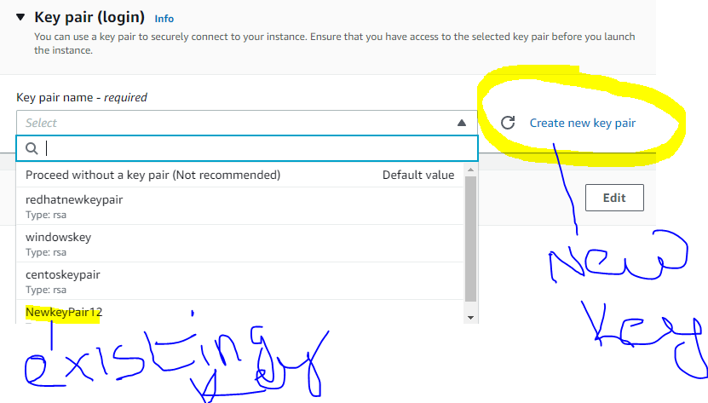

Under Network Settings select the firewall rule as highlighted below

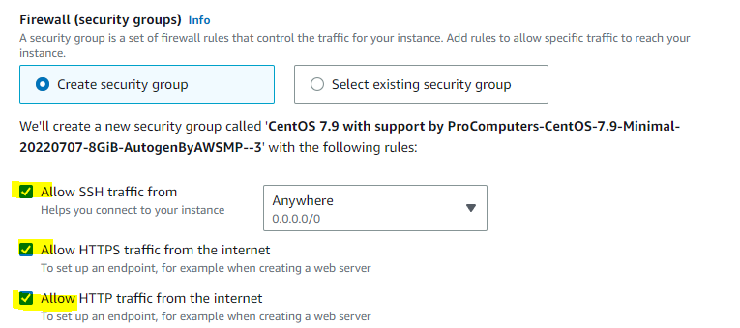

Under configure storage change the value as per master and slave node

For Master Node ; 40 GB

Slave node: 10 or 15 GB will be enough

Please find the image as highlighted

Master Node

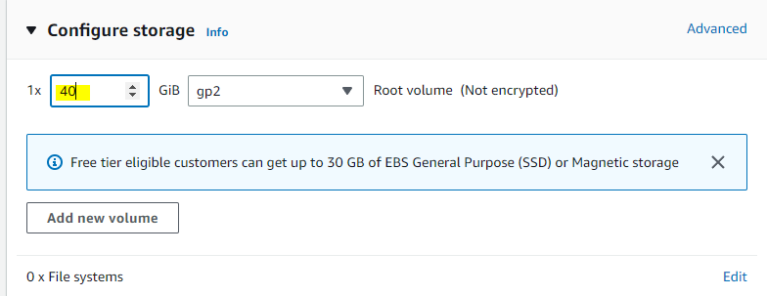

Slave Node:

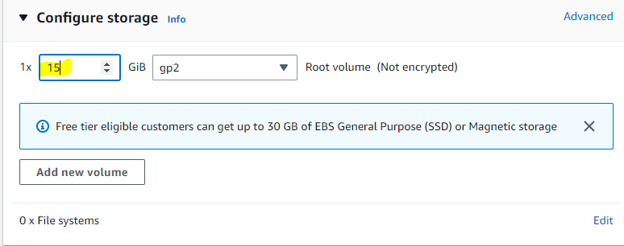

Click on Launch Instance to launch your instance as highlighted below

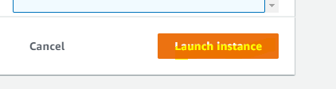

**Note: This Centos Image requires subscription enabled if the launch instance failed it will provide a URL on the same page. Please follow the URL to subscribe for this Image and once you subscribe click on retry it will be launch successfully.**

**Note: You either see an option continue to configuration or subscribe select accordingly**

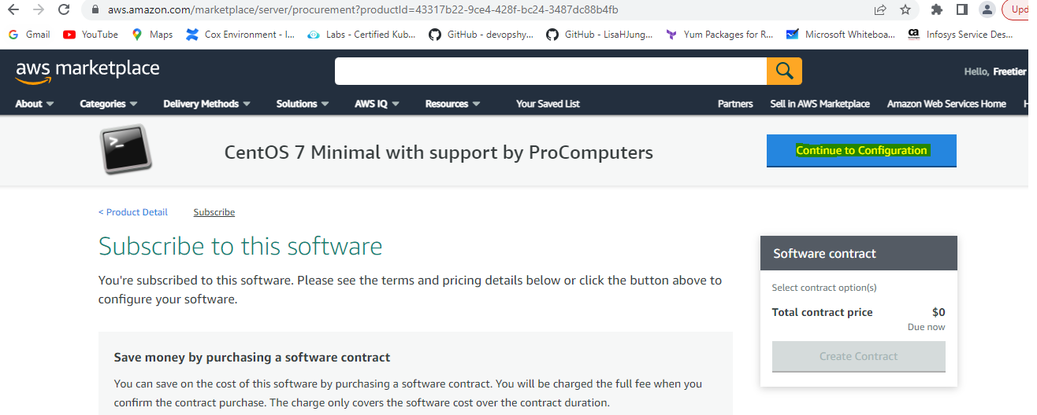

Once the Instance is launched on the Master node only for Jenkins Master node setup. Select the Master node and click on security tab as shown below:

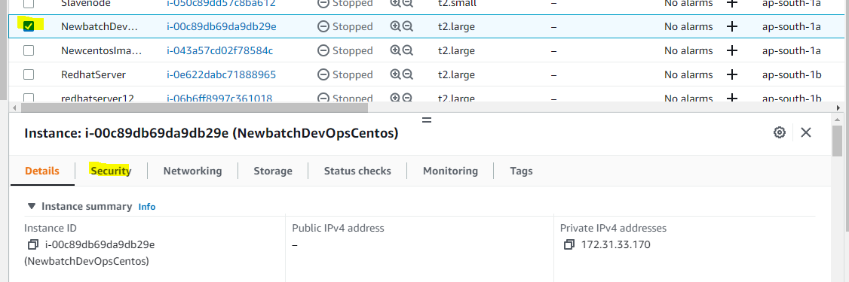

Click on the link as highlighted below

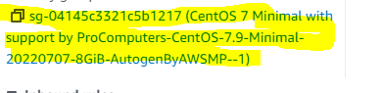

It will open the page as below click on the option Edit Inbound Rule as highlighted below:

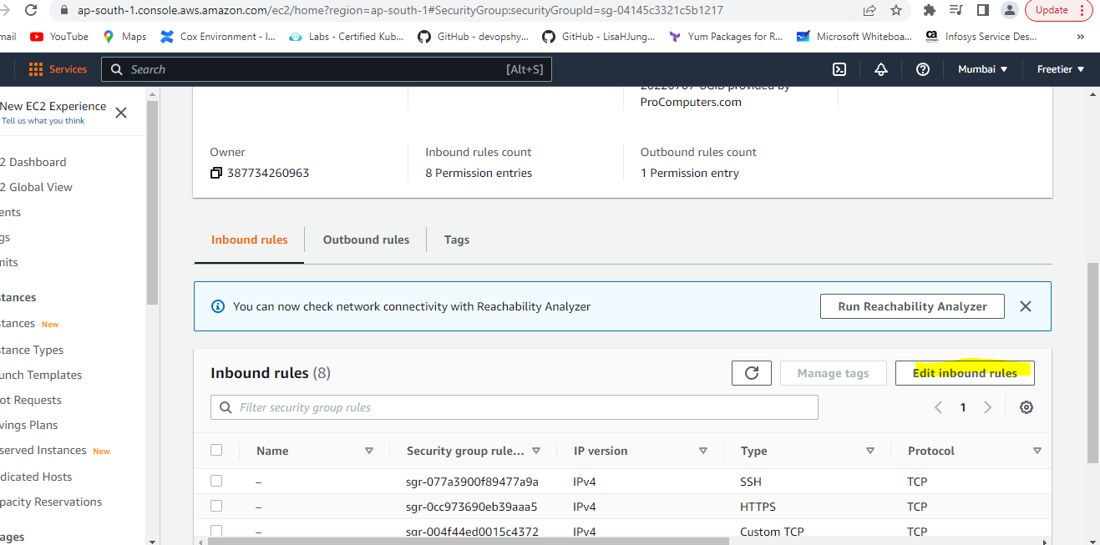

Click on Add rule to add new rule for Jenkins’s master node and the port 8080 as highlighted below and save the changes by click on save rules

