**Centos Image on AWS t2.large 40 GB**

**/ProComputers CentOS-7.9-x86_64-Minimal-8GiB-HVM-20220707_053634-20255663-8070-4ad8-85c6-4d4f796c9265**

Command to install git:

Syntax: yum install git

git --version

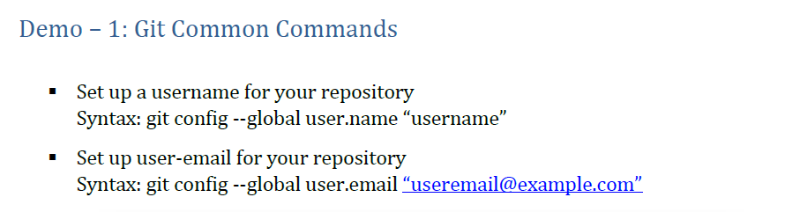

Example: git config – global user.name “Omer Hussain”

git config –global user.email [abbadi998@gmail.com](mailto:abbadi998@gmail.com)

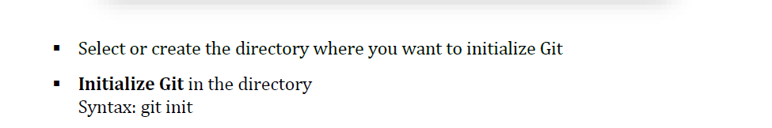

Example: mkdir demo

cd demo

git init

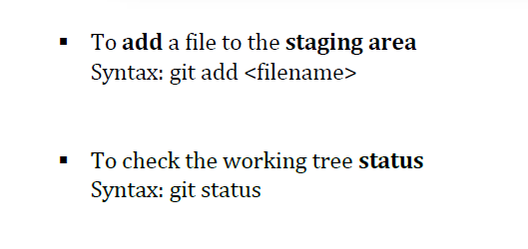

Example: touch demo.txt

git add demo.txt

git status

**To Commit the stage files to your local repository:**

**Syntax: git commit**

**Example: git commit -m “ this is my new commit” demo.txt**

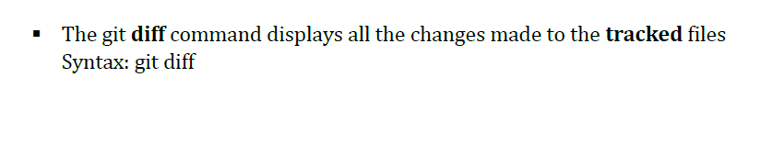

**Example: vi demo.txt**

**Add some line (press ctrl c , shift :wq!)**

**git diff**

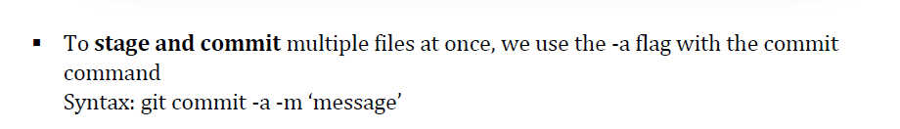

**Example: touch demo2.txt**

**git commit -a -m “new File added”**

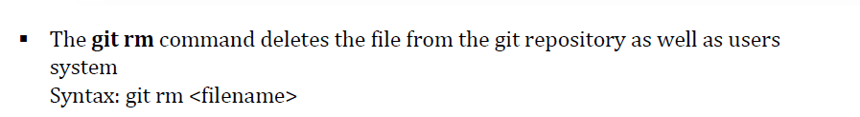

**Example git rm demo.txt**

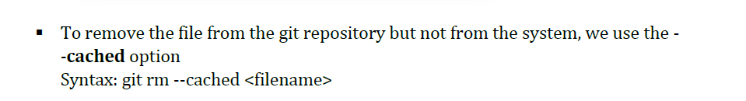

**Example git rm –cached demo1.txt**

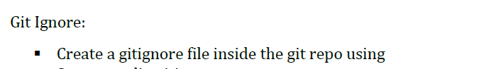

**Example: vi .gitignore**

**\*.txt (ctrl+c , shift :wq!)**

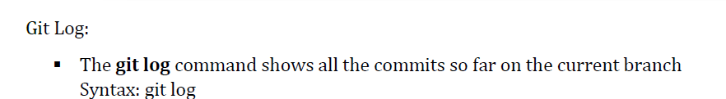

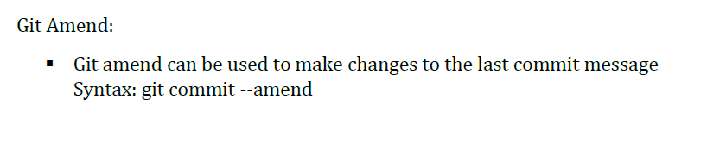

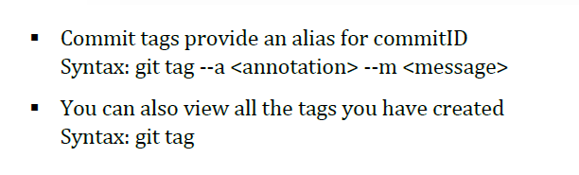

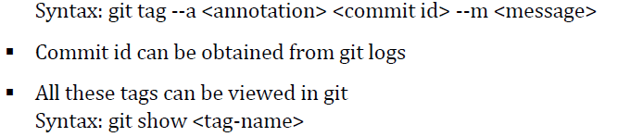

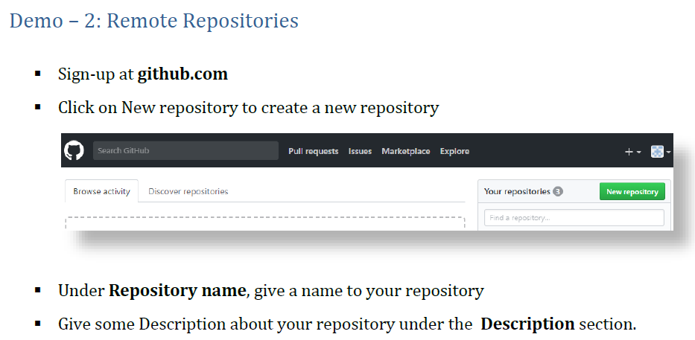

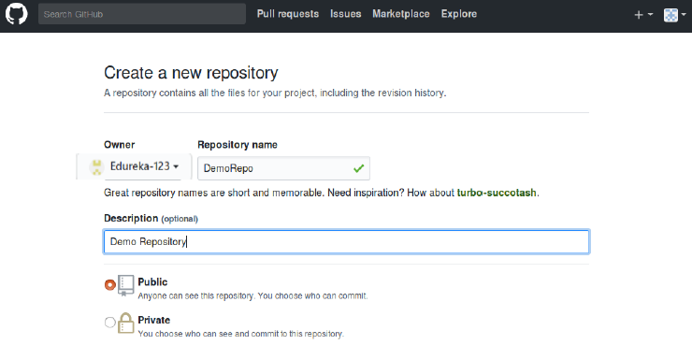

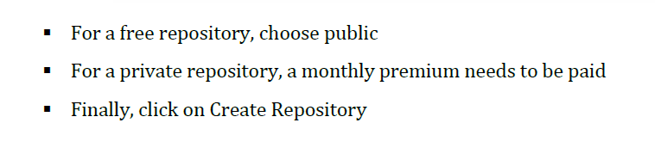

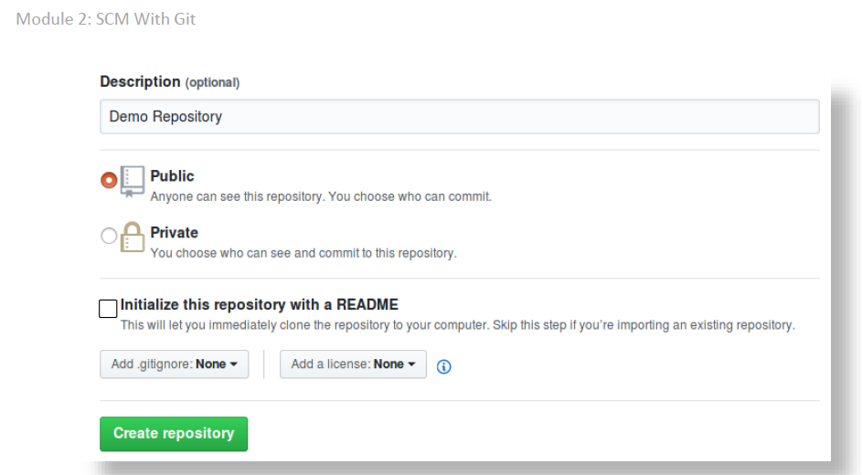



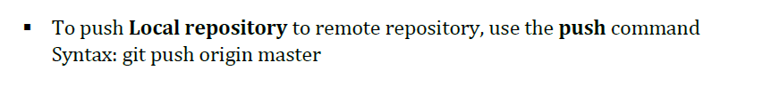

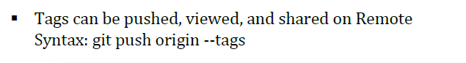

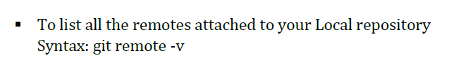

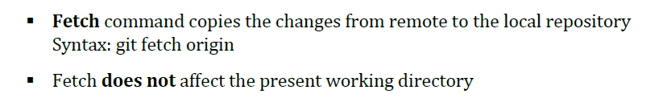

**Pull copies changes from remote to local repository**

**It then merges the changes with the present working directory**

**Syntax: git pull origin**

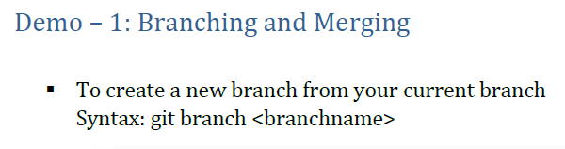

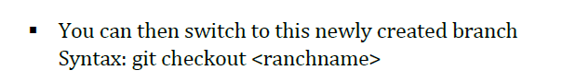

**Typo: git checkout branchname**

**Creating and switching to a new branch can be done by using -b flag**

**Syntax: git checkout -b branchname**

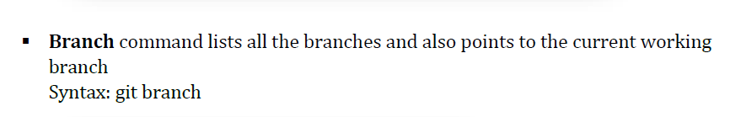

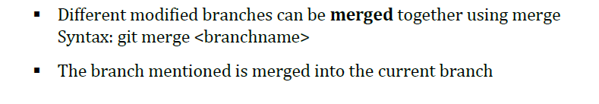

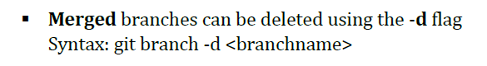

**Umerged: branches can be deleted usind -D flag**

**Syntax: git branch -D branchname**

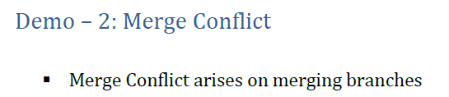

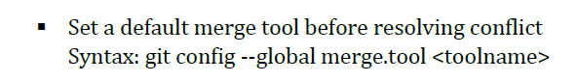

**Merge-tool automatically detects the conflicts and displays them**

**Syntax: git mergetool**

**commit the resolve changes**

**merge the branch again**

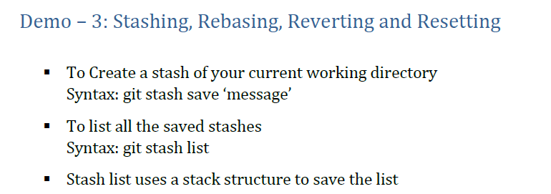

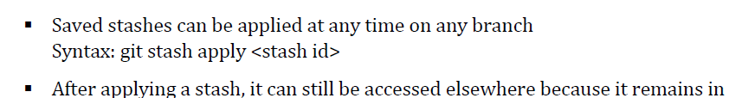 **Stash**

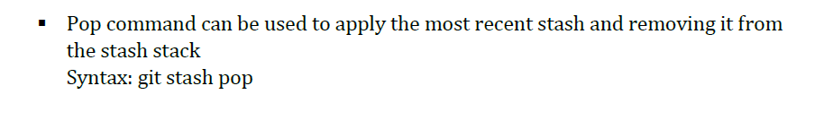

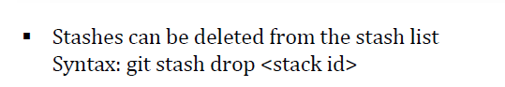

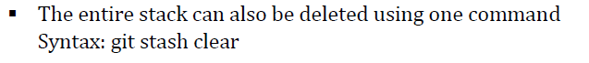

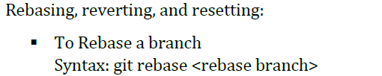

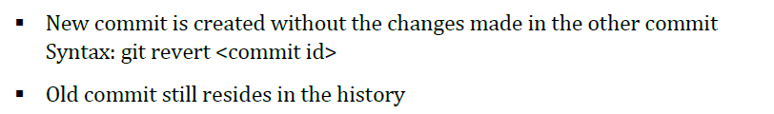

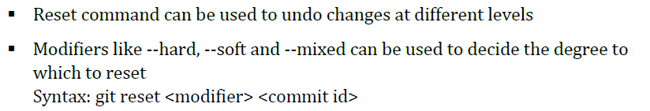

**Jenkins Installation:**

**sudo yum -y install java-11-openjdk**

**curl --silent --location http://pkg.jenkins-ci.org/redhat-stable/jenkins.repo | sudo tee /etc/yum.repos.d/jenkins.repo**

**sudo rpm --import https://jenkins-ci.org/redhat/jenkins-ci.org.key**

**sudo yum install jenkins**

**sudo systemctl start jenkins**

**sudo systemctl status jenkins**

**sudo cat /var/lib/jenkins/secrets/initialAdminPassword**

**Access Jenkins via browser :** [**http://publicIP:8080**](http://publicIP:8080)

**How to create a sample job in Jenkins**

**To create new project/Item/Job**

**Click on new Item as showing below**

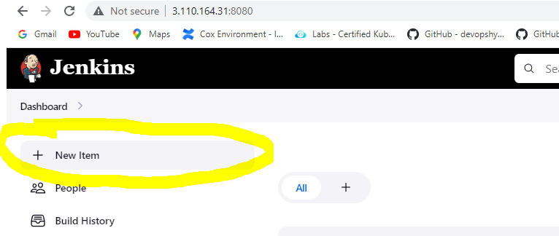

**Enter the job name as Newjob and select Freestyle project as shown in the below figure and click ok**

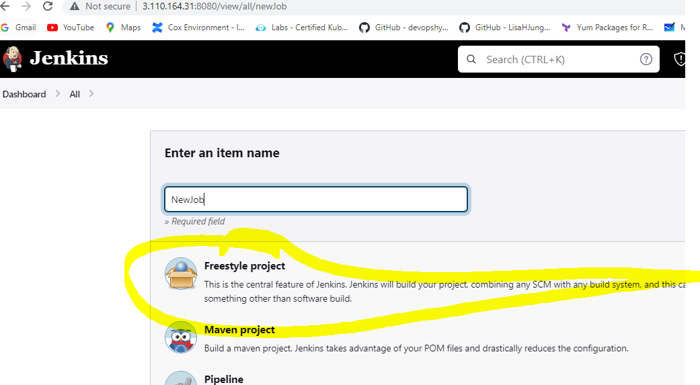

**Enter the description**

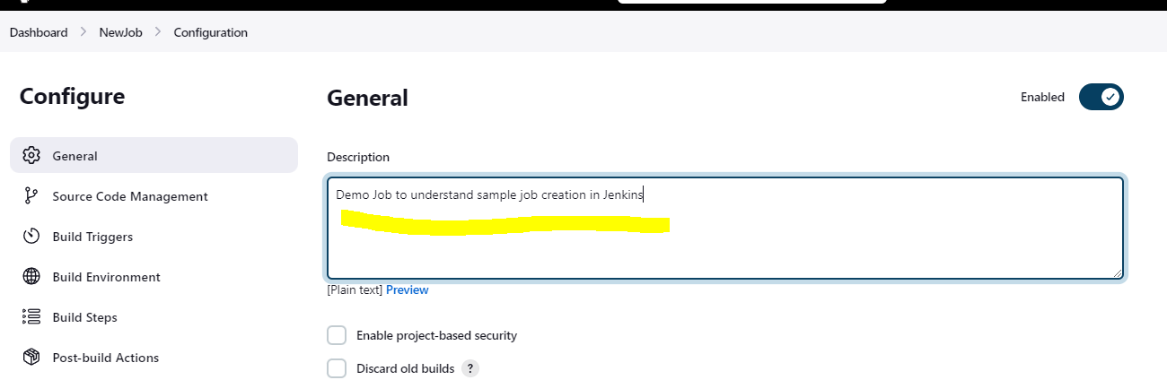

**Click on BuildStep and click on add built step and select Execute shell as shown in the figure below**

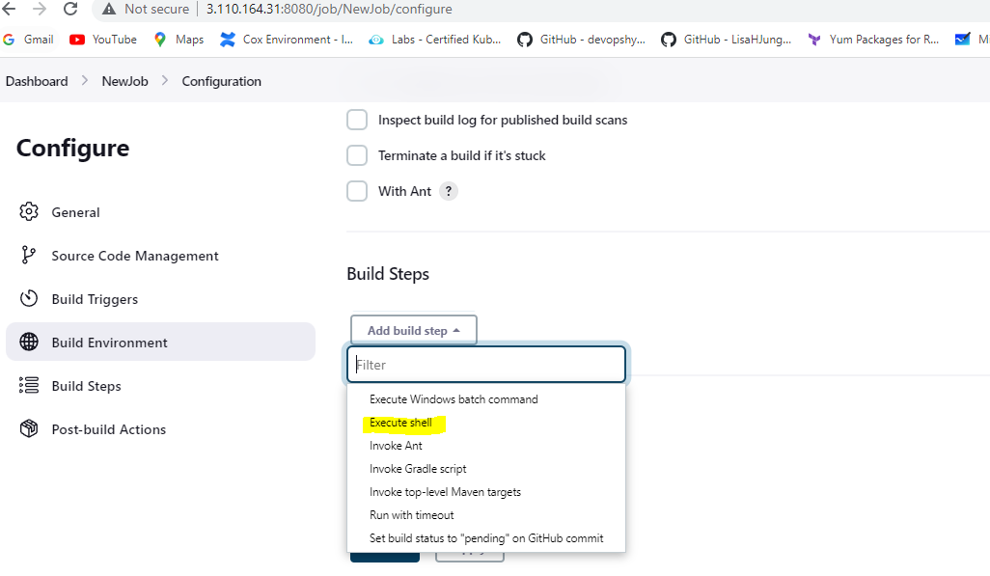

**Enter any linux command as below we are echoing the statement and click apply**

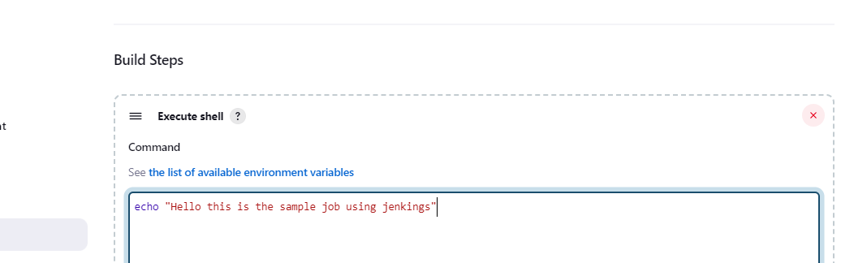

**Go to dashboard to see all the jobs created and you will be able to see the job which we created just now as shown in the figure. The Column S will show the status if the job is executed or not. The blue color signifies that the job is not executed, and green signal signifies the job is executed. The column W will let you know if the job failed any time. You would see cloud symbol if the job failed and sun symbol if the job is successful. Other Columns are self-explanatory as NAME, Last success, Last failure and Last duration of the job**

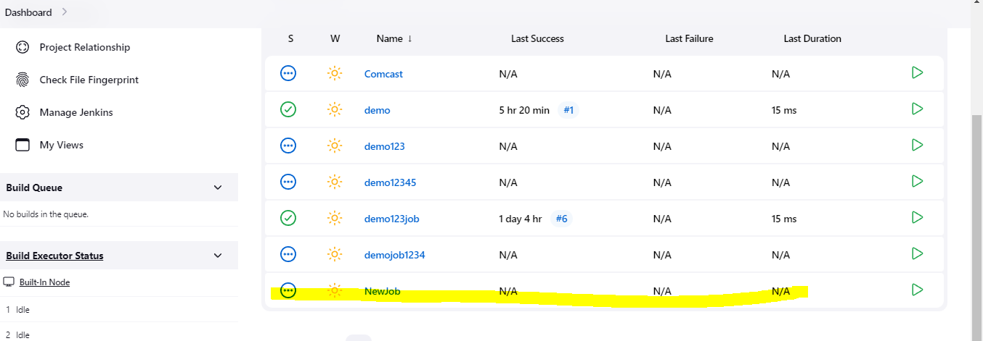

**Either Click on the green button as highlighted and shown below to run the job**

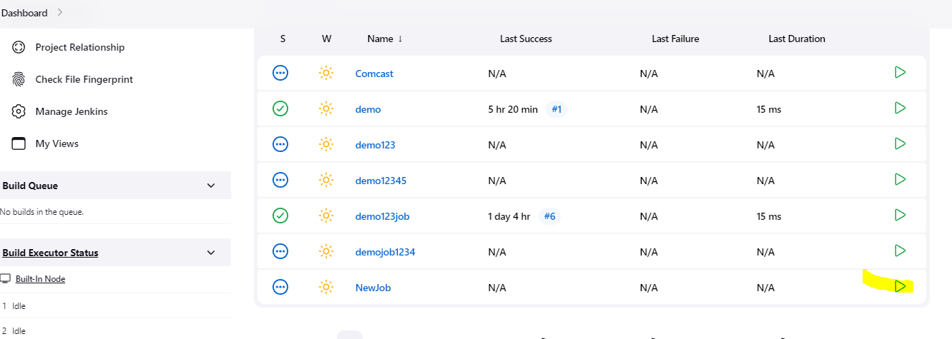

**Or click on the Name of the job and it will land u on this page and click on build now as highlighted in the image below:**

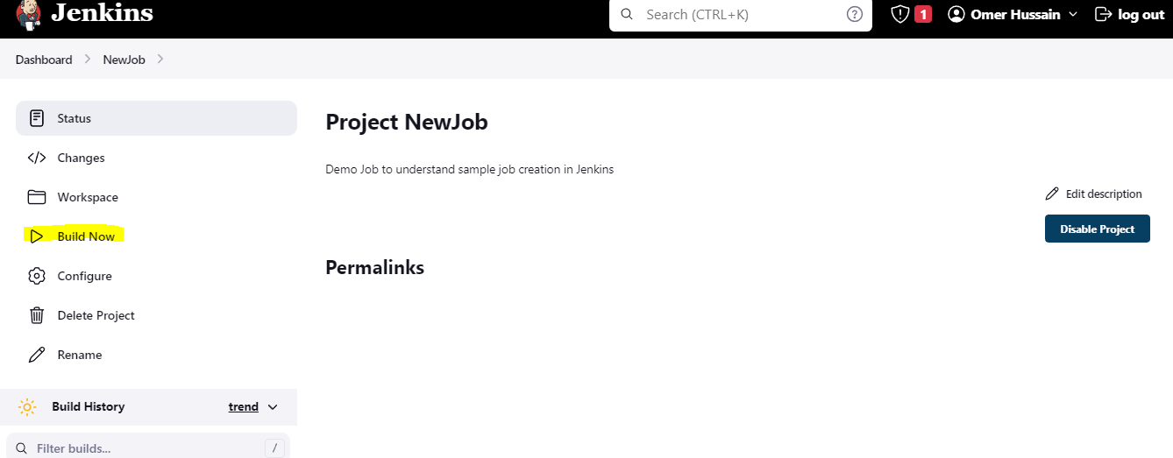

**Once the job is build you will see the job under Build history as highlighted in the image below. Click on the job number and it will take to the next page and then click on the console to see the output as highlighted in the second Image.**

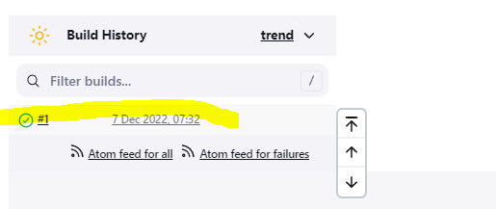

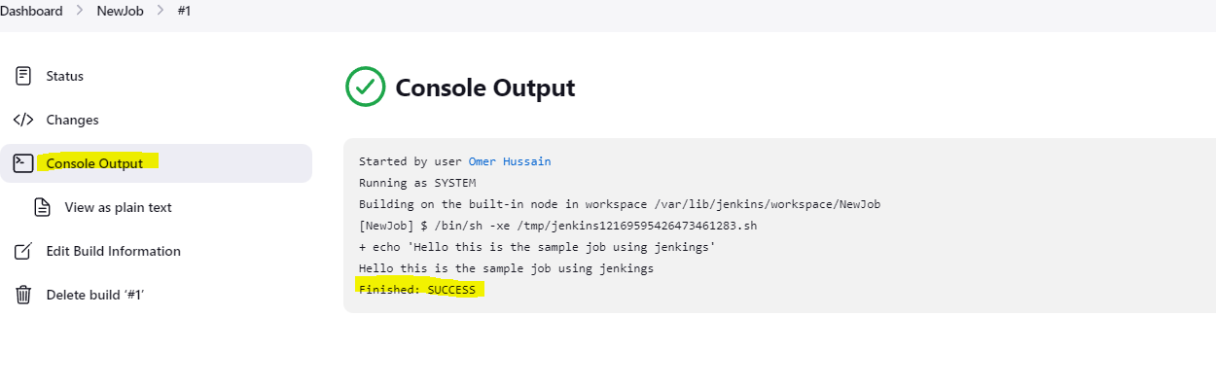

**To delete the build click on the Delete build option as highlighted in the image below:**

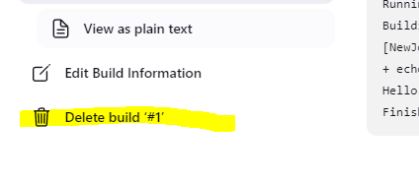

**Click yes it will delete the build for you as shown in the image**

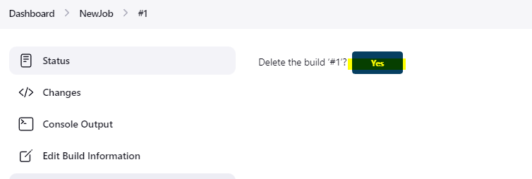

**To delete the Job/Project/Item go to the name of the project after clicking on the project name it will land to the Image as shown in the picture below and click on delete project to delete the project by selecting delete project option**

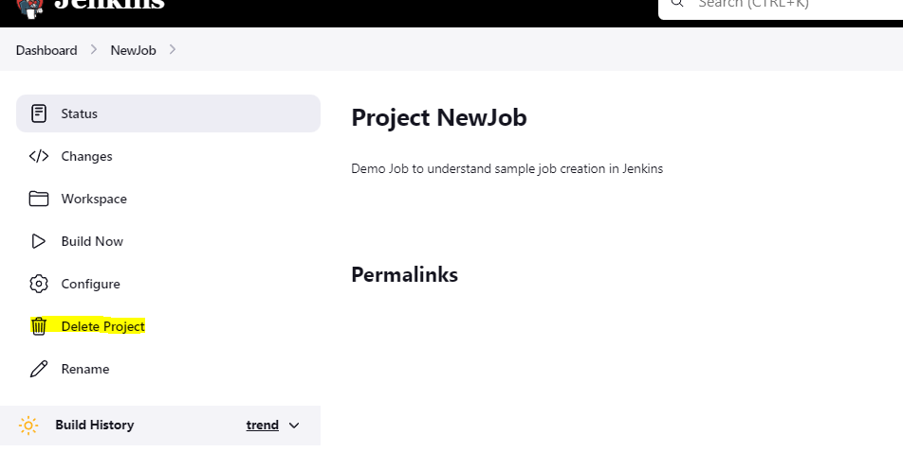

**To install any plugin click on Manage Jenkins options and then click on manage plugin as shown in the image below:**

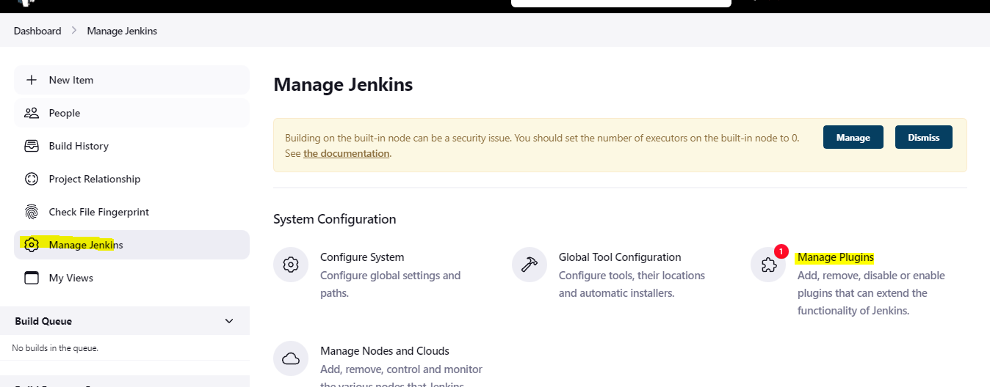

**Select Available plugin search for plugin you want to install select the checkbox beside the plugin name and install without restart and the plugin will get installed on jenkins**

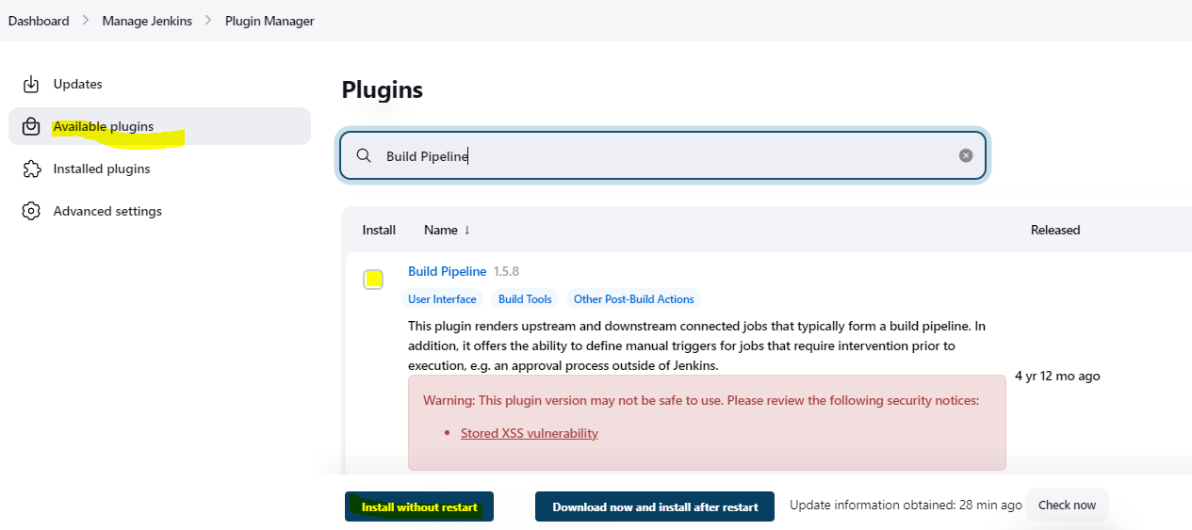

**To setup Email notification on Jenkins**

**Click on Manage Jenkins and then click on configure system as shown in the image**

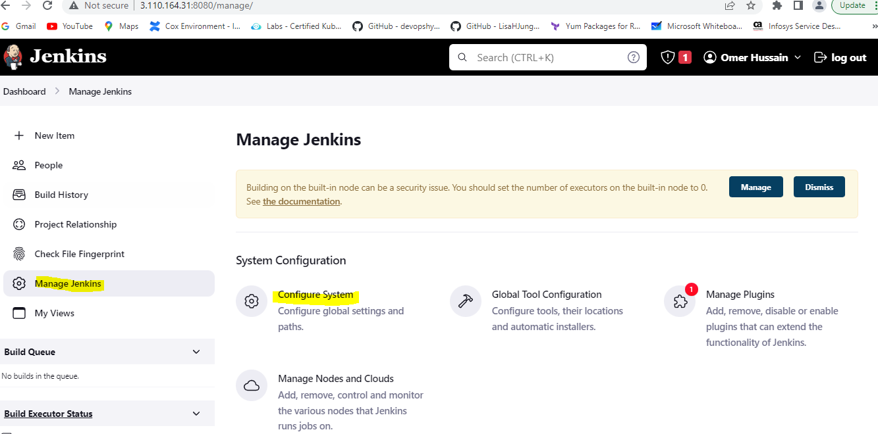

**Scroll down until you see Email notification:**

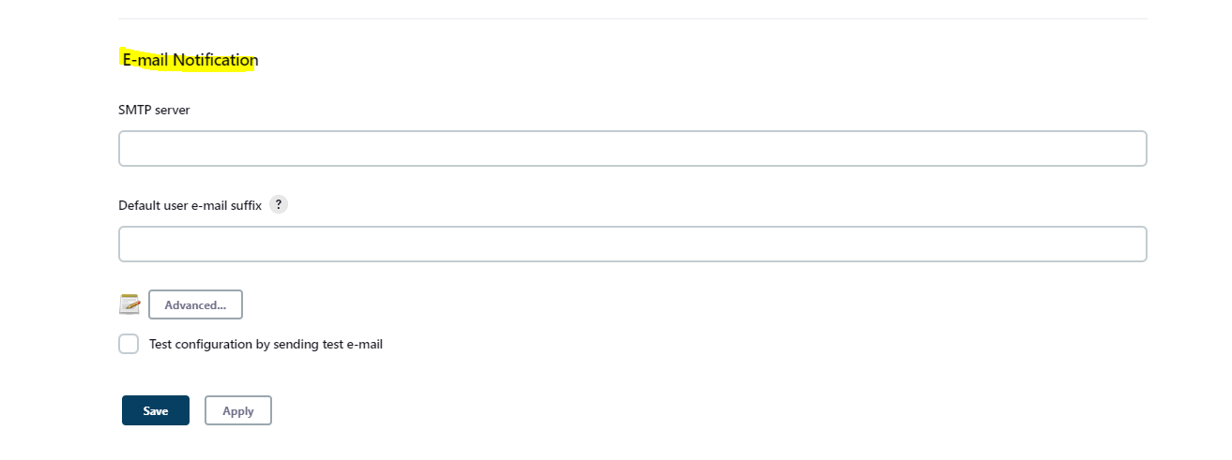

**To set up gmail as ur email service update the details as below click on advance to see all the options and select the smtp authentication to enter the gmail and the Application password (Generate it as mentioned below)**

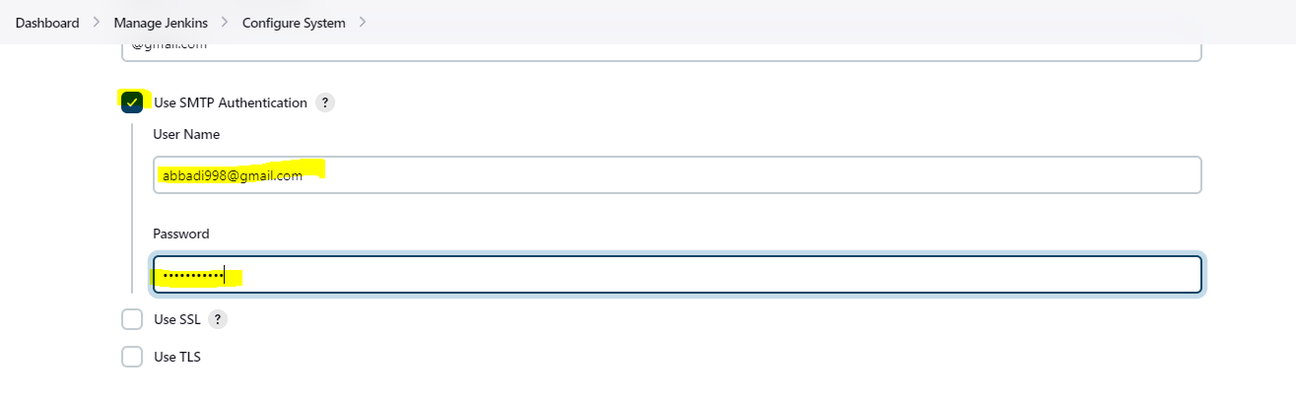

**Check the checkbox beside test configuration by sending test e-mail option to check if we are able to receive email and enter your personal gmail**

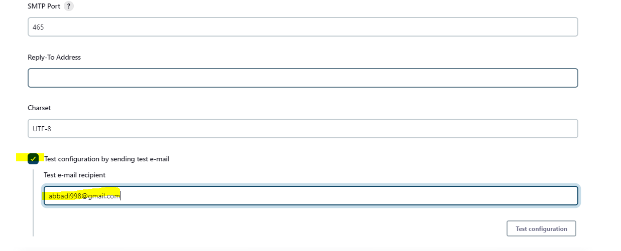

**Note: By default gmail will block any app accessing the email if you want it work have to make changes as below**

1. **Obtain application specific password**
   * sing-in to gmail account >> navigate to settings >> privacy and security settings
   * setup two step verification settings (because without two step verification we cannot generate application specific password)
   * after setting up two step verification setting in gmail account navigate back to security and privacy settings
   * click on application specific password >> give the name of the application in the drop down as Jenkins (google by default does not have any specific application password setting for Jenkins) >> this will generate password note down the password generated