HARAMAYA UNIVERSITY
Department of Computer Science
Industrial Practice (Internship) Program
INDUSTRIAL PRACTICE REPORT
Software Development
Design and Development of a Dynamic University Website and Content Management System (OBU-CMS)
Host Organization
Oda Bultum University - Information and Communication Technology (ICT) Executive Office
Prepared by
NEDI USMAN
ID No.: [STUDENT ID]
Academic Advisor: Mr. Kibru G.
Host Supervisor: [HOST SUPERVISOR NAME], ICT Director, Oda Bultum University
Internship Period: [START DATE] - [END DATE]
Submitted in partial fulfillment of the requirements of the Industrial Practice Program
October 2026

DECLARATION AND APPROVAL
I, NEDI USMAN, declare that this Industrial Practice Report is my own work. It describes the software development project that I carried out at the Information and Communication Technology (ICT) Executive Office of Oda Bultum University as part of the Industrial Practice Program of the Department of Computer Science, Haramaya University. All sources of information used in the report have been acknowledged in the References section.
This report has been submitted for examination with the approval of the following persons.

Role | Name | Signature | Date
Student | NEDI USMAN
Academic Advisor | Mr. Kibru G.
Host Supervisor (ICT Director) | [HOST SUPERVISOR NAME]
Department Head / Internship Coordinator | [NAME]

ACKNOWLEDGEMENT
First and foremost, I thank Almighty Allah for giving me the health, patience, and strength to complete this internship and to finish the project described in this report.
I am sincerely grateful to my academic advisor, Mr. Kibru G., of Haramaya University for his guidance, constructive feedback, and encouragement from the proposal stage to the final report.
I express my deep appreciation to Oda Bultum University for hosting me, and especially to the ICT Director and the staff of the ICT Executive Office. They gave me a workstation, access to the information I needed, and the freedom to design and build a real system for the university. I also thank the Senior Web and Content Officer and the Communications and Public Relations representatives, who explained how the university publishes information and what problems they face with the existing website.
I thank the Department of Computer Science of Haramaya University and all my instructors, whose courses in databases, software engineering, web development, and information security gave me the foundation I used every day during this project.
Finally, I thank my family and friends for their continuous moral support throughout my studies and during the internship period.
NEDI USMAN

LIST OF ABBREVIATIONS
Abbreviation | Meaning
API | Application Programming Interface
CMS | Content Management System
CRUD | Create, Read, Update, Delete
CSRF | Cross-Site Request Forgery
CSS | Cascading Style Sheets
DB | Database
ERD | Entity-Relationship Diagram
FK / PK | Foreign Key / Primary Key
HTML | HyperText Markup Language
HTTP(S) | HyperText Transfer Protocol (Secure)
ICT | Information and Communication Technology
IDE | Integrated Development Environment
JSON | JavaScript Object Notation
JWT | JSON Web Token
OBU | Oda Bultum University
OBU-CMS | Oda Bultum University Website and Content Management System
RBAC | Role-Based Access Control
REST | Representational State Transfer
RLS | Row Level Security (PostgreSQL)
SEO | Search Engine Optimization
SQL | Structured Query Language
SSE | Server-Sent Events
SSR | Server-Side Rendering
UAT | User Acceptance Testing
UI / UX | User Interface / User Experience
UML | Unified Modeling Language
URL | Uniform Resource Locator
UUID | Universally Unique Identifier

TABLE OF CONTENTS
Acknowledgement i
List of Abbreviations ii
Table of Contents iii
List of Figures and Tables iv
Organization of the Document vi
CHAPTER 1: INTRODUCTION 1
1.1. Background of the Organization 1
1.2. Structure of the Organization 1
1.3. Team / Department Overview 2
1.4. Project Context 3
1.5. Objectives 4
CHAPTER 2: SOFTWARE DEVELOPMENT PLAN 5
2.1. Project Schedule 5
2.2. Resources 6
2.3. Risk Management 7
2.4. Development Methodology 7
2.5. Quality Assurance 8
2.6. Required Documents 8
CHAPTER 3: SYSTEM REQUIREMENTS 9
3.1. Existing System Analysis 9
3.2. Proposed System 11
CHAPTER 4: SYSTEM ANALYSIS AND DESIGN 13
4.1. System Models 13
4.2. User Interface Design 21
4.3. Software Architecture 26
4.4. Security and Access Control 32
CHAPTER 5: IMPLEMENTATION 35
5.1. Development Process 35
5.2. Challenges and Solutions 37
5.3. Testing 38
CHAPTER 6: INTERNSHIP REFLECTION AND CONCLUSION 40
6.1. Learning Outcomes 40
6.2. Challenges Faced 40
6.3. Recommendations 41
6.4. Conclusion 41
APPENDICES 43
Appendix A: Code Snippets 43
Appendix B: System Data at the Time of the Final Screenshots (8 October 2026) 44
Appendix C: Route Overview 45
Appendix D: Administrator Quick Guide 45
Appendix E: Test Script (`test_final_curls.sh`, excerpt) 46
REFERENCES 47

LIST OF FIGURES
Figure | Title
Figure 1.1 | Organizational structure of Oda Bultum University and the position of the ICT Executive Office
Figure 2.1 | Project schedule (Gantt chart)
Figure 3.1 | Existing OBU website: administration mega-menu
Figure 3.2 | Existing OBU website: footer and contact section
Figure 3.3 | Existing OBU website: President's message page
Figure 3.4 | Existing OBU website: login / lost-password page
Figure 4.1 | Use case diagram of OBU-CMS
Figure 4.2 | Class diagram of the main application modules
Figure 4.3 | Sequence diagram: administrator login and route protection
Figure 4.4 | Sequence diagram: create and publish a news article
Figure 4.5 | Sequence diagram: visitor reads a published news article
Figure 4.6 | Activity diagram: content publishing workflow
Figure 4.7 | Navigation flow of the public website
Figure 4.8 | Navigation flow of the Admin CMS
Figure 4.9 | New public website: home page and hero slider
Figure 4.10 | New public website: President's message section
Figure 4.11 | New public website: newsletter block and footer
Figure 4.12 | Admin CMS: login page
Figure 4.13 | Admin CMS: dashboard
Figure 4.14 | Admin CMS: homepage management
Figure 4.15 | Admin CMS: create user form
Figure 4.16 | Three-tier software architecture
Figure 4.17 | Deployment diagram
Figure 4.18 | Entity-relationship diagram (1): security, settings, and web content
Figure 4.19 | Entity-relationship diagram (2): academics, administration, research, and services

LIST OF TABLES
Table | Title
Table 1.1 | People involved in the project
Table 1.2 | Specific objectives and measurable outcomes
Table 2.1 | Project phases, approximate timeline, and deliverables
Table 2.2 | Software tools and technologies
Table 2.3 | Risk analysis and mitigation
Table 2.4 | Required project documents
Table 3.1 | Limitations of the existing website
Table 3.2 | Functional requirements - public website
Table 3.3 | Functional requirements - Admin CMS
Table 3.4 | Non-functional requirements
Table 4.1 | Main actors and use cases
Table 4.2 | Use case description: publish a news article
Table 4.3 | Subsystems of OBU-CMS
Table 4.4 | Database tables by module
Table 4.5 | Row Level Security policies in the migration files
Table 4.6 | Security controls and where they are enforced
Table 5.1 | Project folder structure
Table 5.2 | Migration history
Table 5.3 | Challenges and solutions
Table 5.4 | Test cases and evidence
Table 6.1 | Skills gained
Table 6.2 | Real-world problems solved by the project
Table B.1 | Dashboard figures
Table D.1 | Common administrator tasks

ORGANIZATION OF THE DOCUMENT
This report follows the Industrial Practice Report Guideline (Software Development) of the Department of Computer Science. It is organized as follows.
- Preliminary sections: front page, cover page with declaration, acknowledgement, list of abbreviations, table of contents, list of figures and tables, and this overview.
- Chapter 1 - Introduction: the host organization, its structure, the team, the project context, and the objectives.
- Chapter 2 - Software Development Plan: schedule, resources, risk management, methodology, quality assurance, and required documents.
- Chapter 3 - System Requirements: analysis of the existing website and the functional and non-functional requirements of the proposed system.
- Chapter 4 - System Analysis and Design: use case, class, sequence, and activity diagrams, database design, user interface design, software architecture, and security.
- Chapter 5 - Implementation: the development process, challenges and solutions, and testing.
- Chapter 6 - Internship Reflection and Conclusion: learning outcomes, challenges, and recommendations.
- Appendices and References: code snippets, system data, and the sources used (IEEE style).

CHAPTER 1: INTRODUCTION
This chapter introduces the host organization, Oda Bultum University (OBU), explains how the university is organized, describes the department and team in which the internship was carried out, and presents the context and objectives of the project that was developed.

1.1. Background of the Organization
Oda Bultum University is a public higher education institution in Ethiopia. It is located in Chiro town in the West Hararghe Zone of the Oromia Regional State, in the eastern part of the country. The university describes itself as one of the fourth-generation universities of Ethiopia, and its emblem carries the year 2015 as its founding year. Its official motto, as stated by the President in the university's welcome message, is "Productive Mind for Development".
The university was established to widen access to higher education in Eastern Ethiopia. It offers undergraduate programs through its colleges, institutes, and departments, and it carries out research and community service activities as part of its mission. Like other public universities, it must communicate continuously with students, applicants, staff, partners, and the public: admission and registration notices, exam and calendar announcements, job vacancies, research news, events, and services.
The university's public website (obu.edu.et) is the main channel for this communication. As the number of programs, offices, and announcements grew, the website became harder to maintain and to use. The ICT Executive Office, which manages the university's information systems, therefore hosted this internship project: the design and development of a new dynamic website with a built-in Content Management System, called OBU-CMS.

1.2. Structure of the Organization
The administrative structure of OBU, as shown in the Administration menu of the university's existing website, is headed by the University President. Three main branches report to the President:
- President Offices: a group of executive offices and directorates directly attached to the President. They are the Information and Communication Technology (ICT) Executive Office, the Internal Audit Office, the Strategic Planning, Monitoring and Evaluation Executive Office, the Women, Children and Youth Affairs Directorate, the Legal Service Directorate, the Public and International Relations Directorate, the Construction Project Office, and the University Protection and Security Service Directorate.
- Administrative and Development Vice President: responsible for administrative, financial, and development support services of the university.
- Academic, Research, Technology Transfer and Community Service Vice President: responsible for academic programs, the colleges and departments, the Registrar, research, technology transfer, and community service.
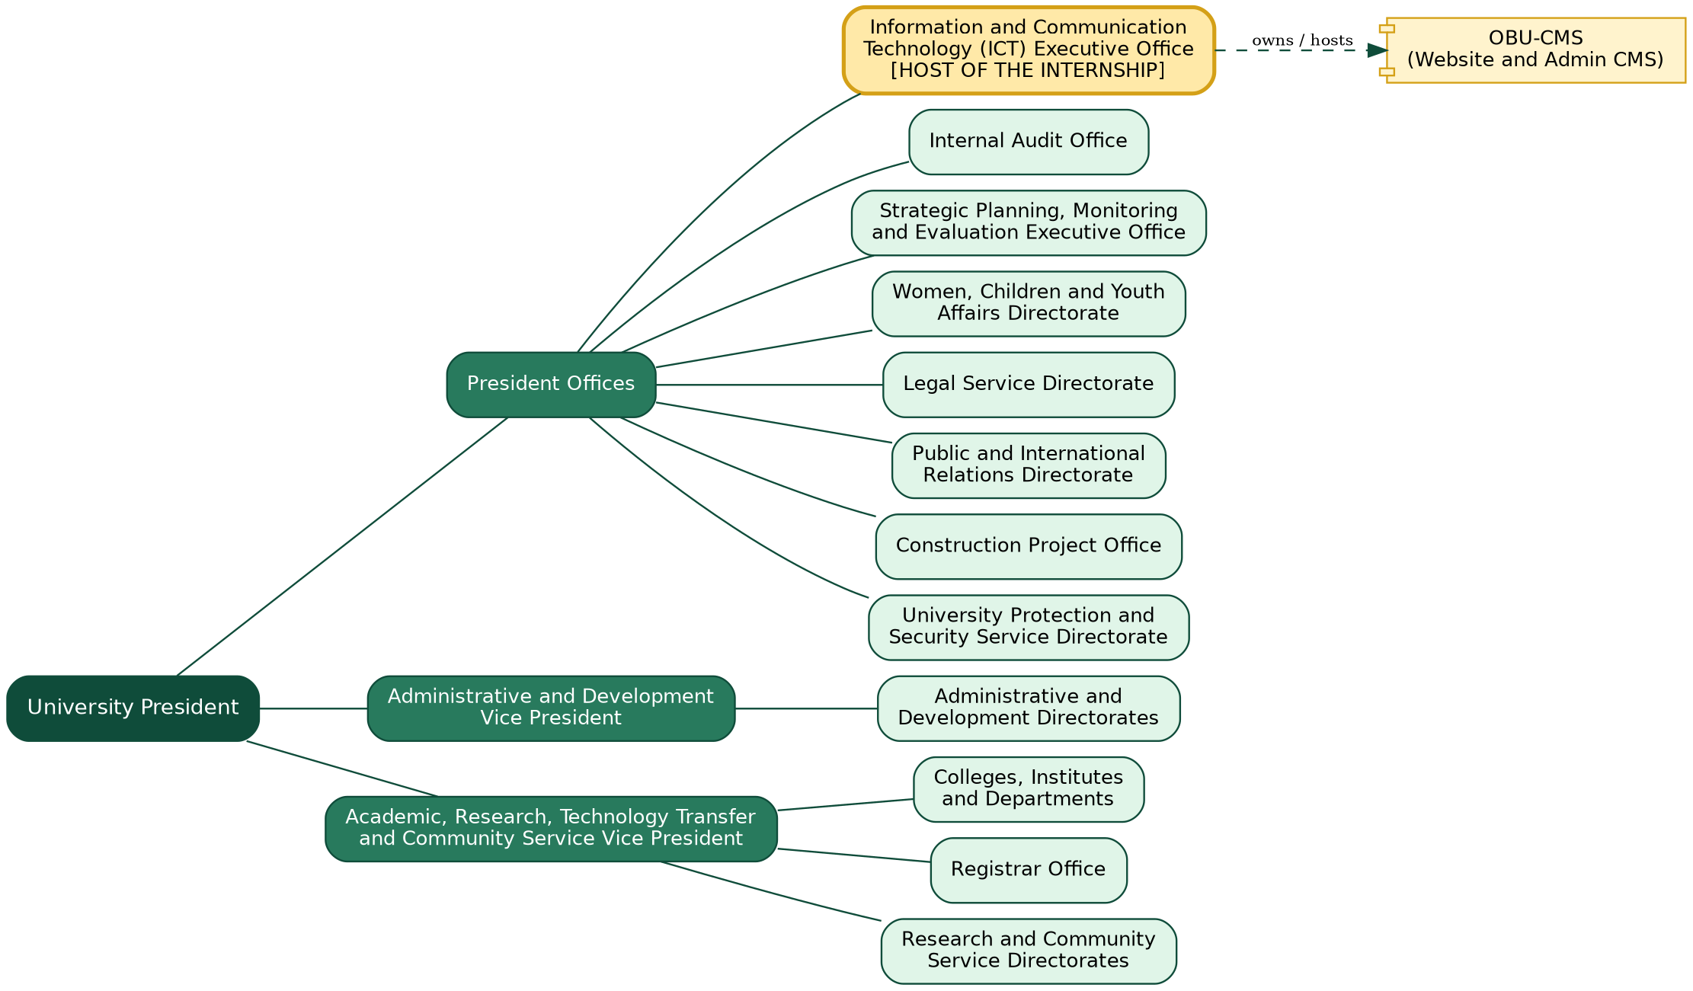
Figure 1.1: Organizational structure of Oda Bultum University and the position of the ICT Executive Office
Relevance to the project. The structure directly shaped the system. The ICT Executive Office is the technical owner of the website. The Academic Vice Presidency supplies most of the public content (programs, departments, Registrar notices, research projects, community engagement), and the Public and International Relations Directorate supplies news and events. For this reason OBU-CMS has separate content modules for each of these areas, a Registrar section, and an administration section for offices and leadership, and it separates ordinary content administrators from the Super Admin who manages users and roles.

1.3. Team / Department Overview
The internship was carried out in the ICT Executive Office, which is responsible for the university's network, servers, and software systems. The intern worked as the single full-stack developer of the project. Other people contributed as follows.
Table 1.1: People involved in the project
Person / Office | Contribution to the project
Intern (NEDI USMAN) | Requirements analysis, database design, architecture, front-end and Admin CMS development, testing, and documentation.
ICT Director (host supervisor) | Approved the project scope, gave access to the environment, and reviewed progress and demonstrations.
Senior Web and Content Officer | Explained the existing website and content workflow; provided content and reviewed the new Admin CMS as a future user.
Communications / Public Relations representative | Described how news, events, and announcements should be organized and displayed.
Academic advisor (Mr. Kibru G.) | Academic supervision, review of progress, and guidance on the report.
Workflow and collaboration. The intern worked in short iterations. Each iteration produced a working part of the system, which was demonstrated to the ICT Director and the content staff to collect feedback before the next iteration. Requirements were clarified through discussions with the content staff, and the progress was reported to the academic advisor.

1.4. Project Context

1.4.1. Purpose
The purpose of the project is to give Oda Bultum University a modern, dynamic, mobile-friendly website whose content is managed by authorized university staff through a secure Admin CMS, without editing source code. The system publishes news, events, announcements, academic programs, leadership profiles, administrative offices, research projects, services, vacancies, galleries, and Registrar information.

1.4.2. Problem Statement
A review of the existing website (obu.edu.et) and discussions with ICT and content staff showed the following problems:
- Content depends on technical staff. Publishing or correcting information requires help from the ICT staff, which delays time-sensitive notices such as registration and exam announcements.
- No structured content types. News, events, announcements, vacancies, and programs are not separate, searchable content types with their own addresses (URLs), dates, statuses, and images.
- No central media management. Images and documents are not stored in a library with metadata, so they cannot be reused or controlled.
- No separation of roles and no audit trail. It is not possible to say who published or changed what, and to limit users to the parts they are responsible for.
- Outdated and inconsistent presentation. Some pages are hard to read, the navigation is a deep mega-menu, and fixed text such as the footer copyright year (2023) is not updated automatically.
- Weak mobile experience and search visibility because pages do not use consistent titles, descriptions, and responsive layouts.
The university therefore needed one central system that lets different offices publish accurate content quickly and safely.

1.4.3. Scope
In scope - public website: home page (hero slides, statistics, welcome and President's message, featured content); news; events; announcements; academic units, colleges, departments, and programs; leadership; administrative offices; research projects, facilities, and community engagement; services; career vacancies; galleries; Registrar information, announcements, and documents; contact form; general pages and privacy policy.
In scope - Admin CMS: secure login; dashboard with statistics and recent activity; create, read, update, and delete (CRUD) for all content modules; media library; page, navigation, and homepage-section management; user and role management; activity logs; site and system settings; personal account page.
Out of scope: student portal (grades, course registration), online payments, mobile applications, and e-learning integration. These are listed as future work.

1.5. Objectives

1.5.1. General Objective
To design, develop, and test a secure and responsive web-based dynamic website and Content Management System for Oda Bultum University, so that authorized staff can publish and manage university information independently and the public can access accurate information on any device.

1.5.2. Specific Objectives
Table 1.2: Specific objectives and measurable outcomes
No. | Specific objective | Measurable outcome
1 | Replace the existing website with a database-driven website. | All planned public modules available through route files, with slug-based addresses for content detail pages (for example /news/$slug).
2 | Build an Admin CMS for non-technical staff. | Admin area at /admin with 35 route files covering the main content modules, protected by login.
3 | Design a relational database for all university content. | 27 PostgreSQL tables with foreign keys and migrations for later changes.
4 | Protect data with authentication and database-level access rules. | Supabase Auth login; Row Level Security policies so the public reads only published or active records.
5 | Provide a central media library. | Images and documents uploaded once (type and 10 MB size checks) and reused through media foreign keys.
6 | Provide role-based administration. | Roles and permissions tables; System menu limited to Super Admin.
7 | Record administrator actions. | Create, update, delete, and upload actions written to activity_logs.
8 | Deliver documentation. | README, specification documents, migration files, and this report.

CHAPTER 2: SOFTWARE DEVELOPMENT PLAN
This chapter describes how the project was planned: the schedule and deliverables, the resources used, the risks and how they were handled, the development methodology, the quality assurance approach, and the documents produced.

2.1. Project Schedule
The project was divided into eight phases. The calendar periods below are approximate. They are based on the project's working files: the screenshots of the old website (June and August 2026), the database migration files (25 August to 22 September 2026), and the final screenshots of the new system (8 October 2026). The internship period is [START DATE] to [END DATE].
Table 2.1: Project phases, approximate timeline, and deliverables
Phase | Main activities | Approx. period | Deliverable
1. Requirements and analysis | Study of the existing website, discussions with ICT and content staff, list of modules and users | June 2026 | Requirements list, screenshots of the old website
2. System design | Database design, user roles, page structure, navigation, UI layout | June - July 2026 | Specification documents (specs/university-admin-media: requirements, design, tasks)
3. Prototype | Public pages and Admin CMS interface built with sample data to confirm the screens with users | July - August 2026 | Working interface prototype
4. Database and security | Supabase project, PostgreSQL schema, Row Level Security, storage bucket for media | Late August 2026 | Migration files dated 25 August 2026
5. CMS modules | Admin pages and data hooks for all modules, slugs, media upload, activity logging, user profiles | End of August - mid September 2026 | Admin modules; migrations dated 31 Aug and 3 Sep 2026
6. Navigation and homepage | Dynamic navigation, footer links, homepage sections, site settings | September 2026 | Migration dated 22 September 2026
7. Testing and fixing | Functional checks of public and admin pages, security review of access rules, bug fixing | September - October 2026 | Test scripts and verified screens (Chapter 5)
8. Documentation and handover | README, report, final screenshots | October 2026 | This report; final screenshots dated 8 October 2026
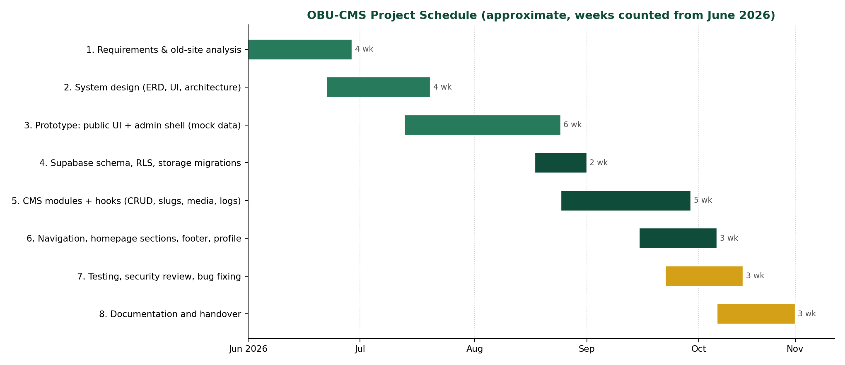
Figure 2.1: Project schedule (Gantt chart; approximate weeks counted from June 2026)

2.2. Resources

2.2.1. Software Tools
Table 2.2: Software tools and technologies
Tool / technology | Version (from package.json) | Purpose in the project
TanStack Start (React framework) | 1.168 | Full-stack framework: server-side rendering, routing, server functions, middleware
React | 19.2 | User interface components
TanStack Router | 1.170 | File-based routing with dynamic parameters such as $slug
TanStack Query | 5.101 | Data fetching, caching, and refresh in the Admin CMS
TypeScript | 5.8 | Typed code across the whole project
Tailwind CSS | 4.2 | Responsive, utility-based styling
Radix UI, Lucide, Sonner | various | Accessible components, icons, and notifications (toasts)
React Hook Form | 7.71 | Form handling in selected forms
Supabase (supabase-js) | 2.112 | Authentication, PostgreSQL access, file storage
PostgreSQL / node-postgres (pg) | pg 8.23 | Database and server-side SQL access
Vite | 8.1 | Development server and build tool
ESLint and Prettier | 9.32 / 3.7 | Code checking and formatting (npm run lint, npm run format)
Git, VS Code, browser developer tools | - | Version control, editing, debugging
curl scripts | - | Quick checks of public pages (test_curls.sh, test_final_curls.sh)

2.2.2. Hardware, Infrastructure, and Workspace
- Development computer: a personal laptop running Kali Linux with the Firefox browser.
- Cloud services: a Supabase project that provides the PostgreSQL database, authentication, and file storage.
- Workspace: a workstation in the ICT Executive Office of the university with power and campus network and internet access.
- Team roles: listed in Table 1.1. The development work was done by the intern alone.

2.3. Risk Management
Table 2.3: Risk analysis and mitigation
Risk | Prob. | Impact | Mitigation and contingency
Scope growth: new modules requested by offices during development | High | High | Modules were prioritized: news, events, programs, leadership first; extra modules later. New requests were added to a backlog.
Database structure changing while pages already depend on it (schema drift) | High | Medium | All changes written as migration files in supabase/migrations; typed table definitions in database.types.ts updated after each change.
Wrongly configured access rules exposing admin-only data | Medium | Critical | Row Level Security enabled; public policies limited to published / active rows; script check_rls.ts and query_policies.js used to inspect the real policies.
Weak or shared test credentials left in the project | Medium | High | Development-only admin script marked as such; recommendation to remove it and rotate the password before production (Chapter 6).
Supabase service unavailable during development | Low | High | Environment variables allow switching project; media and data can be exported.
Content migration errors from the old website | Medium | High | Content entered through the Admin CMS and verified page by page against the old site.
Time pressure from the number of modules | Medium | Medium | Reusable patterns (one hook per module, shared admin components) to speed up new modules.
Data loss from accidental deletion by an administrator | Low | High | Delete actions confirmed in the interface and recorded in the activity log; regular database export recommended.

2.4. Development Methodology
The project followed an Agile, Scrum-inspired iterative and incremental approach adapted to a single developer. Work was divided into short iterations; at the end of each iteration a working increment was shown to the ICT staff and content staff, and their feedback decided the next tasks.
The approach was chosen for four reasons. First, the requirements were not complete at the start: each office had different content needs that became clear only when the screens were shown. Second, the system divides naturally into independent modules (news, events, academics, research, media, users), each of which could be built and shown separately. Third, regular demonstrations gave early warnings about wrong or missing features. Fourth, delivering a working system after every iteration reduced the risk of reaching the deadline with nothing usable. A strict Waterfall model was rejected because it would have fixed the requirements before the users had seen anything.
A lightweight specification was still written before coding (requirements, design, and a task list in specs/university-admin-media), and the database changes were written as ordered migration files, so the iterative work stayed controlled.

2.5. Quality Assurance
- Code quality: the code is written in TypeScript with ESLint and Prettier configured (eslint.config.js, npm run lint, npm run format). Each module follows the same structure (a data hook, a list page, and a form page), which made self-review easier.
- Testing protocol: public pages are checked with curl scripts against the running development server; access rules are checked by inspecting the policies in the database and by trying public requests; each Admin CMS module is checked manually through create, edit, publish, and delete. Details and evidence are in Chapter 5.
- Database quality: foreign keys connect related tables, unique constraints protect slugs, and every schema change is a migration file.
- Documentation standards: README for setup, specification documents for requirements and design, comments in the SQL migrations, and this report.

2.6. Required Documents
Table 2.4: Required project documents
Document | Content | Where it is
README | Project purpose, technology stack, folder structure, setup and run instructions | README.md
Specification documents | Requirements, design, and task list of the admin and media modules | specs/university-admin-media/
Database design | Tables, relationships, and migrations | Chapter 4 and supabase/migrations/
System design document | Use case, class, sequence, activity, architecture, and deployment diagrams | Chapter 4
Administrator guide | Admin CMS screens and the steps for common tasks | Appendix D
Test documentation | Test cases, scripts, and results | Chapter 5 and the test_*.sh scripts
Industrial practice report | This report | Submitted to the department

CHAPTER 3: SYSTEM REQUIREMENTS
This chapter analyzes the existing university website and defines the functional and non-functional requirements of the proposed system, OBU-CMS.

3.1. Existing System Analysis

3.1.1. Overview
Before the project, the university's public presence was the website at obu.edu.et. It has a green header with a contact bar, a main menu (Home, About Us, Academics, Administration, Registrar, Research, Services, Vacancy), an image slider, a welcome section, a Google map, and a footer with contact information. The Administration menu is a three-level drop-down that lists the President offices and the two Vice Presidencies (Figure 3.1). The site also has a login and lost-password page (Figure 3.4).
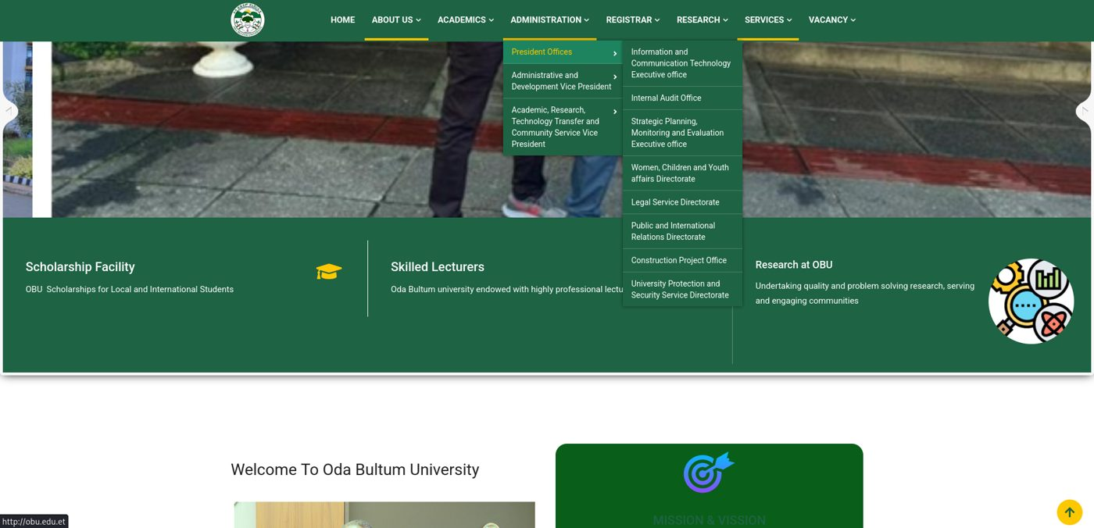
Figure 3.1: Existing OBU website - the Administration mega-menu over the home page
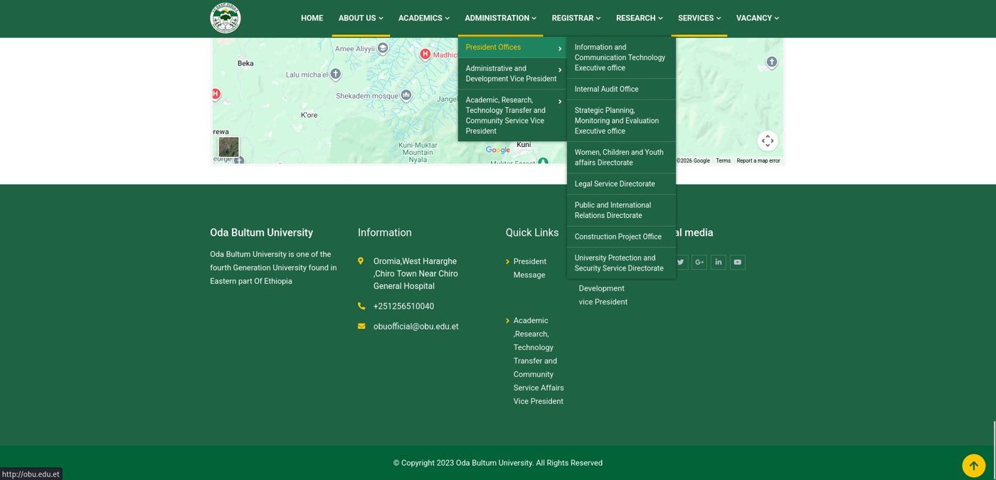
Figure 3.2: Existing OBU website - footer and contact section (copyright text fixed to 2023)
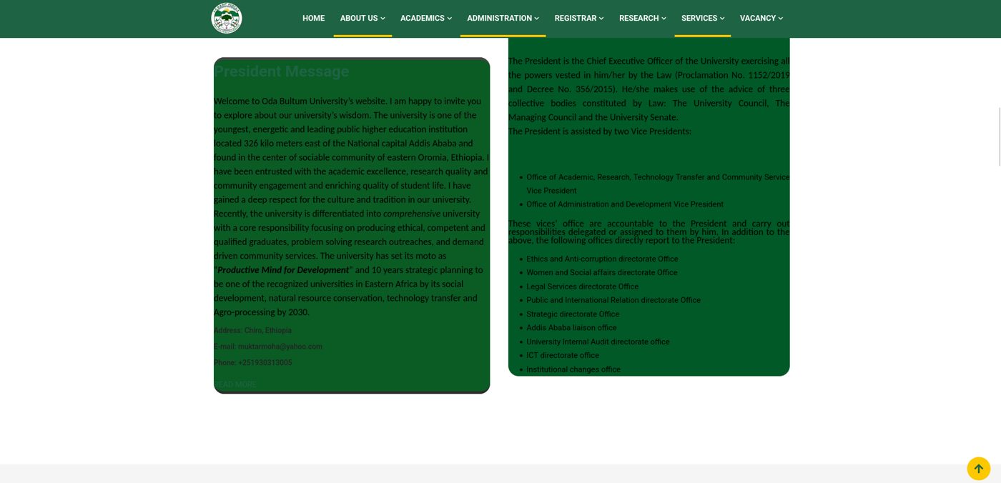
Figure 3.3: Existing OBU website - the President's message page with low-contrast, overflowing text blocks
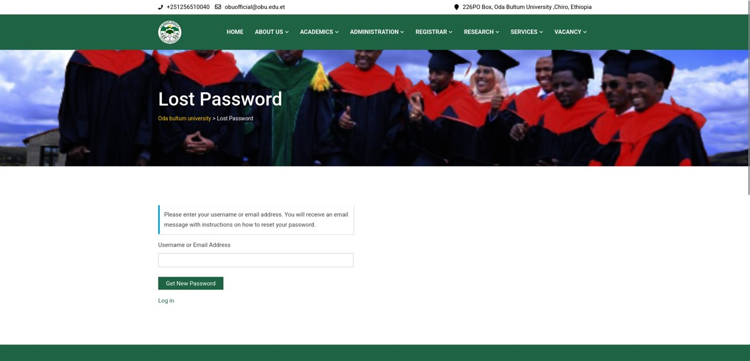
Figure 3.4: Existing OBU website - login / lost-password page

3.1.2. Limitations of the Existing System
Table 3.1: Limitations of the existing website
No. | Limitation | Evidence / effect
1 | Content changes depend on ICT staff | Reported by ICT and content staff; time-sensitive notices (registration, exams) are delayed.
2 | Deep navigation | The Administration menu has three levels and eight sub-items on the President Offices alone (Figure 3.1); hard to use on small screens.
3 | Outdated, fixed text | The footer shows a fixed copyright year (2023) and fixed contact lines (Figure 3.2).
4 | Poor readability on some pages | The President's message page shows text in green boxes with weak contrast and overflowing content (Figure 3.3).
5 | No structured content types | News, events, announcements, vacancies, and programs do not have their own managed records with status, date, image, and a clean address.
6 | No central media library | Images and documents cannot be reused or searched with their descriptions.
7 | No role separation and no audit trail | Staff cannot be limited to their own modules, and changes are not recorded.
8 | Weak search visibility and mobile behavior | Pages do not use consistent titles and descriptions and are not designed mobile-first.

3.2. Proposed System
The proposed system, OBU-CMS, is a single web application with two parts: a public website for visitors and an Admin CMS for authorized staff. Both read and write the same PostgreSQL database hosted on Supabase.

3.2.1. Functional Requirements
Table 3.2: Functional requirements - public website
ID | Requirement (the system shall ...)
FR-01 | display a dynamic home page with hero slides, welcome and President's message, statistics, and featured content from the database.
FR-02 | list published news with search and category filter and show each article on its own address /news/$slug.
FR-03 | list events and show an event detail page with date, time, location, organizer, and registration link.
FR-04 | list announcements (including Registrar announcements) and hide expired ones.
FR-05 | show colleges, departments, and programs in a hierarchy: college, department, program.
FR-06 | show leadership profiles and administrative offices with contact information.
FR-07 | show research projects, research facilities, and community engagement activities.
FR-08 | show university services and open career vacancies with deadline, requirements, and attachment.
FR-09 | show photo galleries and Registrar documents.
FR-10 | provide a contact form that stores the message with a status in the database.
FR-11 | show general pages and the privacy policy managed from the CMS.
FR-12 | build the header menu and footer links from the navigation table.
Table 3.3: Functional requirements - Admin CMS
ID | Requirement (the system shall ...)
FR-13 | provide an email and password login for administrators and redirect anonymous users from every /admin page to the login page.
FR-14 | show a dashboard with counts of pages, news, vacancies, announcements, events, research projects, and media, with quick actions, pending actions, and recent activity.
FR-15 | provide create, view, edit, and delete screens for the content modules (the admin screens for research facilities, community engagement, and the research gallery are linked in the sidebar but are still to be built).
FR-16 | let administrators set a status (draft or published; active or inactive) that controls what is visible to the public.
FR-17 | generate a unique slug from the title and add a number when the slug already exists.
FR-18 | provide a media library with upload, preview, and delete, and let any module attach a media item.
FR-19 | manage pages, homepage sections, hero slides, navigation items, and site settings (name, logo, contacts, social links).
FR-20 | let a Super Admin create users, assign roles, activate or deactivate accounts, and view roles and permissions.
FR-21 | record create, update, delete, and upload actions in an activity log that a Super Admin can read.
FR-22 | let each administrator edit their own profile (name, phone, profile image).
FR-23 | show contact messages sent from the public form.

3.2.2. Non-Functional Requirements
Table 3.4: Non-functional requirements
Category | Requirement | How it is met
Usability | Consistent screens and clear feedback so non-technical staff can work without training in code. | Same list-and-form pattern for every module; toast messages after every save or error; sidebar groups by topic.
Reliability | Data must stay consistent; failures must not show raw errors to visitors. | Foreign keys and unique constraints; error middleware returns a friendly error page; database hosted by Supabase.
Performance | Public pages should load quickly on ordinary connections (target: about 2 seconds). | Server-side rendering of route data; compressed images (10 MB upload limit); lists loaded with one query plus joins. The target was observed informally and was not measured with a tool.
Security | Only authorized staff can change data; the public can read only published content. | Supabase Auth, route guard, Row Level Security, storage policies, CSRF middleware, upload validation (see Section 4.4).
Responsiveness | Pages must work on phones, tablets, and desktops. | Tailwind CSS responsive classes; separate mobile sidebar behavior in the Admin CMS.
Maintainability | Easy to extend with new modules. | TypeScript types for every table; one data hook per module; migrations for each schema change.
Legal / privacy | Collect only the data needed and publish a privacy policy. | Contact form collects name, email, subject, and message (phone optional); /privacy-policy page.

CHAPTER 4: SYSTEM ANALYSIS AND DESIGN
This chapter presents the analysis and design of OBU-CMS. It contains the system models (use case, class, sequence, and activity diagrams), the user interface design, the software architecture with the database design, and the security design. All diagrams were drawn from the real project: its route files, data hooks, migration files, and database types.

4.1. System Models

4.1.1. Use Case Diagram
The system has three kinds of users. The Public Visitor needs no login and can only read published information and send a contact message. The Content Admin is any authenticated staff member who manages content modules. The Super Admin is a Content Admin who also manages users, roles, activity logs, and system settings; in the application this is the role named "Super Admin".
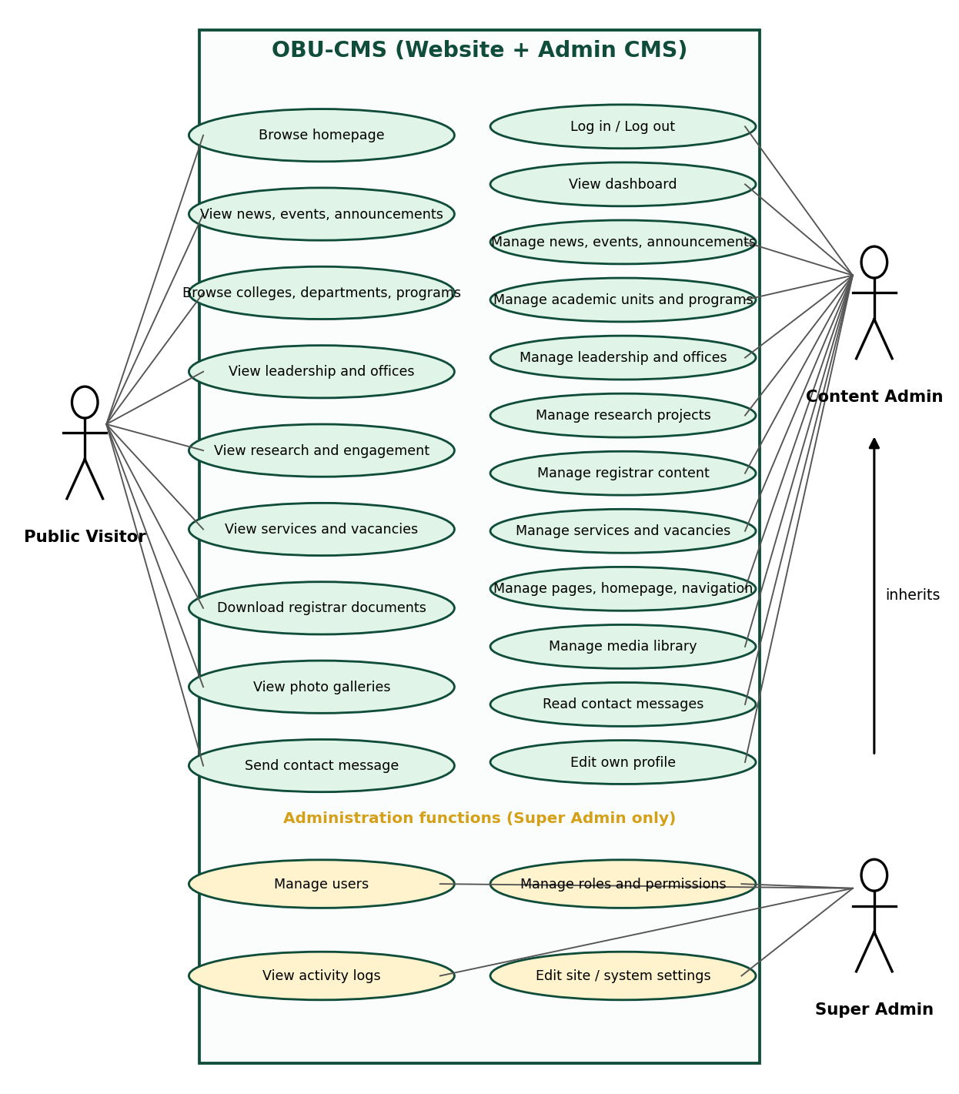
Figure 4.1: Use case diagram of OBU-CMS
Table 4.1: Main actors and use cases
Actor | Main use cases | Pre-condition
Public Visitor | Browse home page; read news, events, announcements; browse colleges, departments, programs; view leadership, offices, research, services, vacancies; download Registrar documents; view galleries; send a contact message | None
Content Admin | Log in and out; view dashboard; manage news, events, announcements, academic units and programs, leadership, offices, research, Registrar content, services, vacancies, pages, homepage, navigation, and media; read contact messages; edit own profile | Valid account in Supabase Auth and in the users table
Super Admin | All Content Admin use cases plus manage users, manage roles and permissions, view activity logs, edit site and system settings | User role is "Super Admin"

4.1.2. Use Case Description: Publish a News Article
Table 4.2: Use case description
Item | Description
Use case | UC-07 Publish a news article
Actor | Content Admin
Pre-conditions | The administrator is logged in and opens Content > News > Add.
Main flow | 1. Enter title, category, short description, and content. 2. Optionally choose a cover image (uploaded to the media library). 3. Choose status Published. 4. Click Save. 5. The system makes the slug unique, stores the article with the author's name, writes an activity log entry, refreshes the list, and shows a success message.
Alternative flows | A1. Required field missing: the form shows an error and nothing is saved. A2. Image type or size not allowed: the upload is rejected with a message. A3. Session expired: the user is redirected to the login page. A4. Status Draft: the article is saved but stays hidden from the public.
Post-conditions | Published article visible at /news/{slug} and listed on the news page; action recorded in activity_logs.

4.1.3. Class Diagram
OBU-CMS is written in TypeScript and React, so the "classes" are modules, context providers, hooks, and typed table rows. Figure 4.2 shows the main ones and their relations: the AuthProvider holds the current user and uses the Supabase client; every data hook uses the client and reads the current user for the author name and activity log; the admin layout and sidebar use the context; public routes read through the client with the anonymous key.

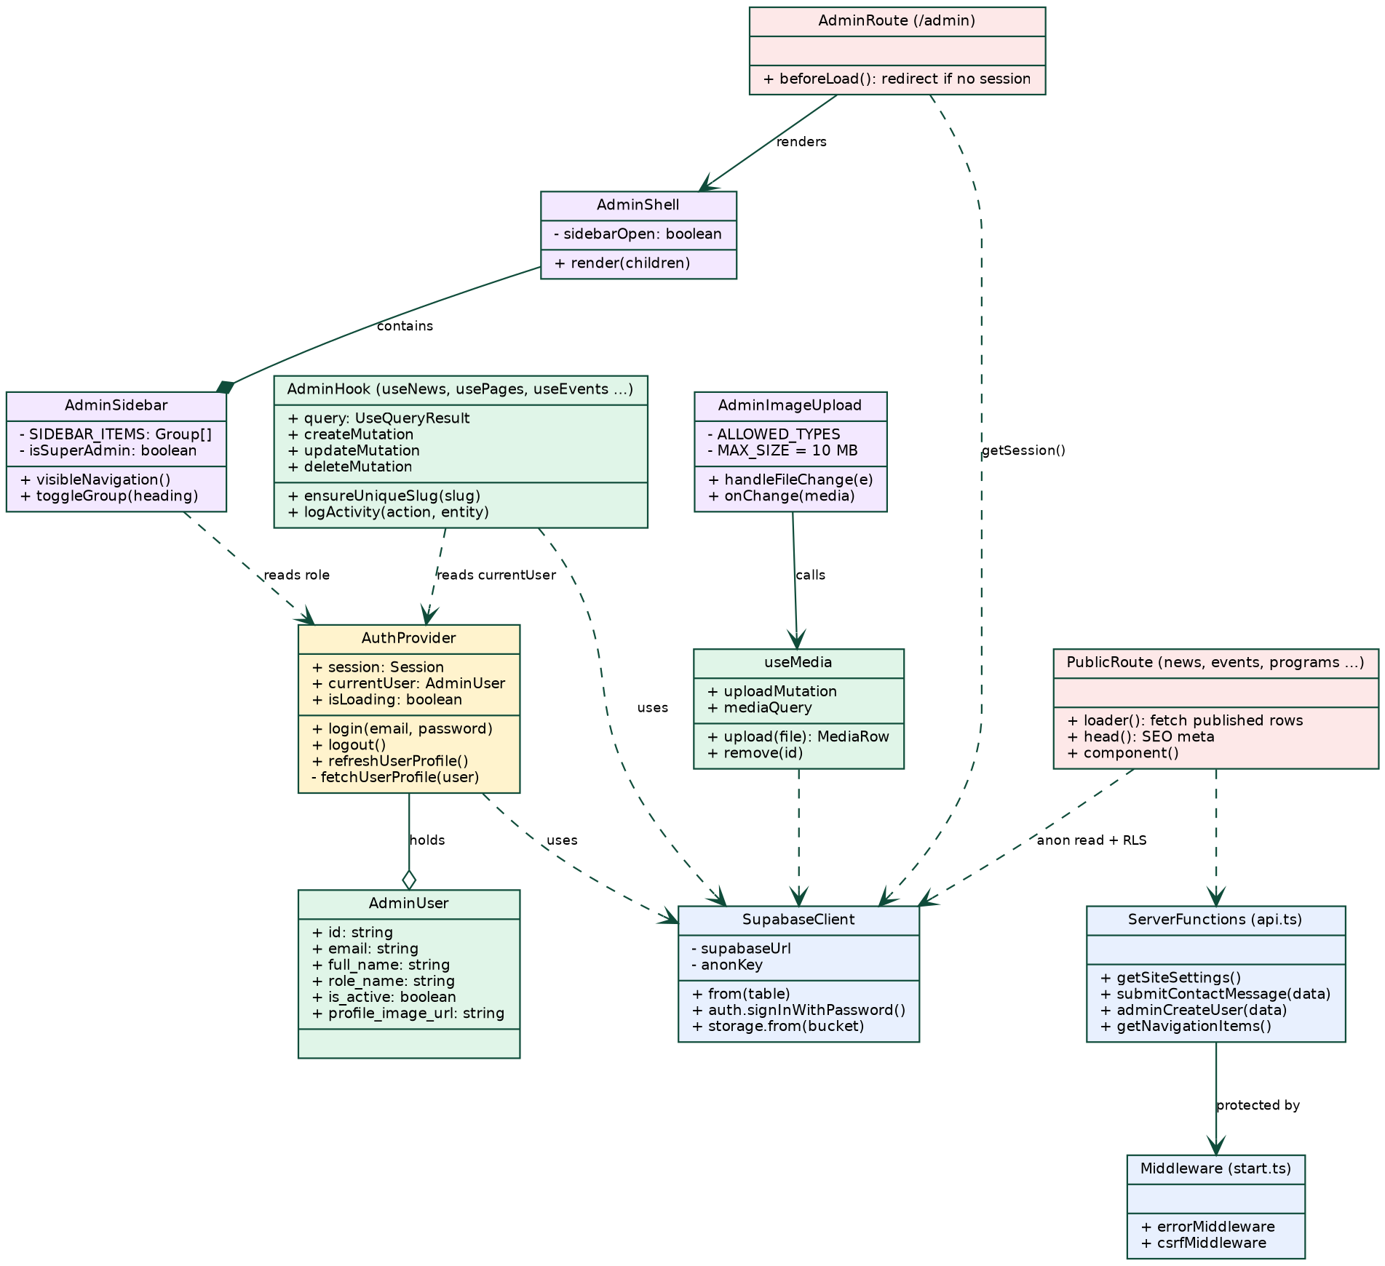
Figure 4.2: Class diagram of the main application modules

4.1.4. Sequence Diagrams
Three sequence diagrams describe the most important interactions: administrator login with route protection (Figure 4.3), creating and publishing a news article (Figure 4.4), and a visitor reading an article (Figure 4.5).
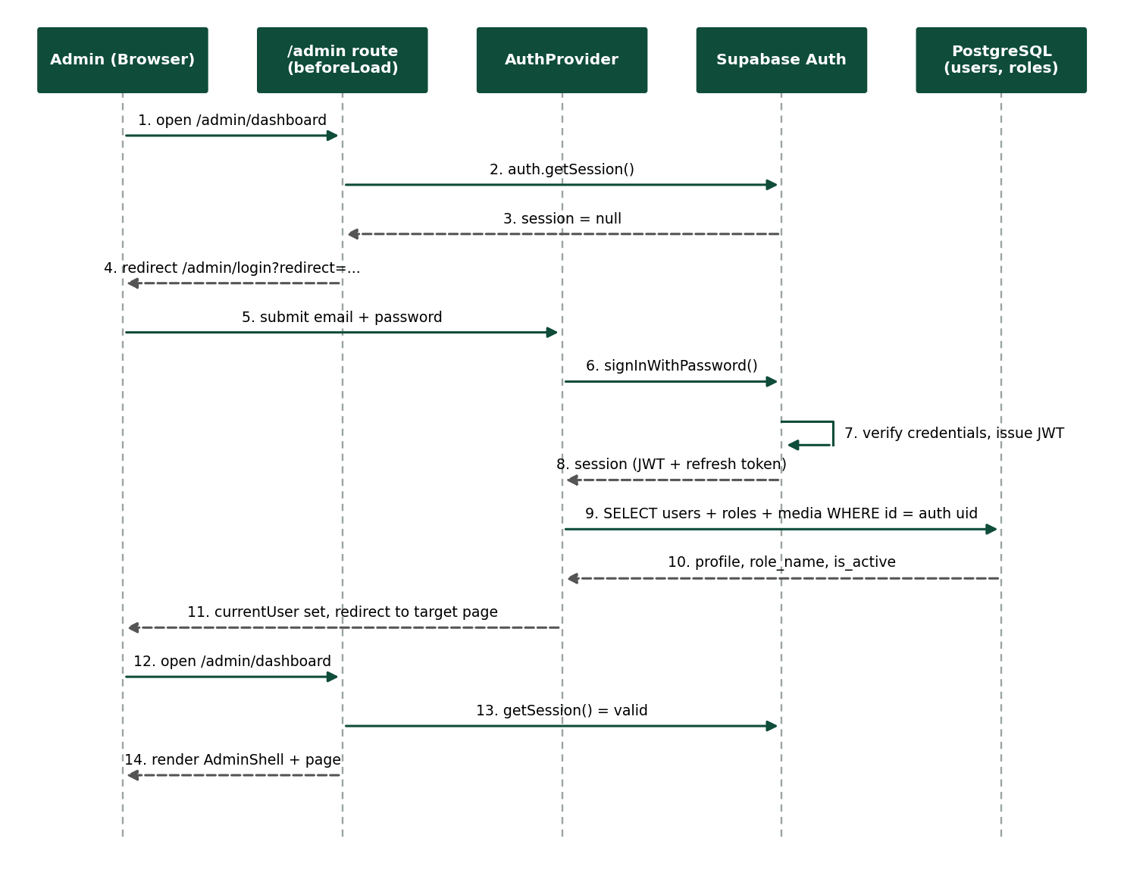
Figure 4.3: Sequence diagram - administrator login and route protection
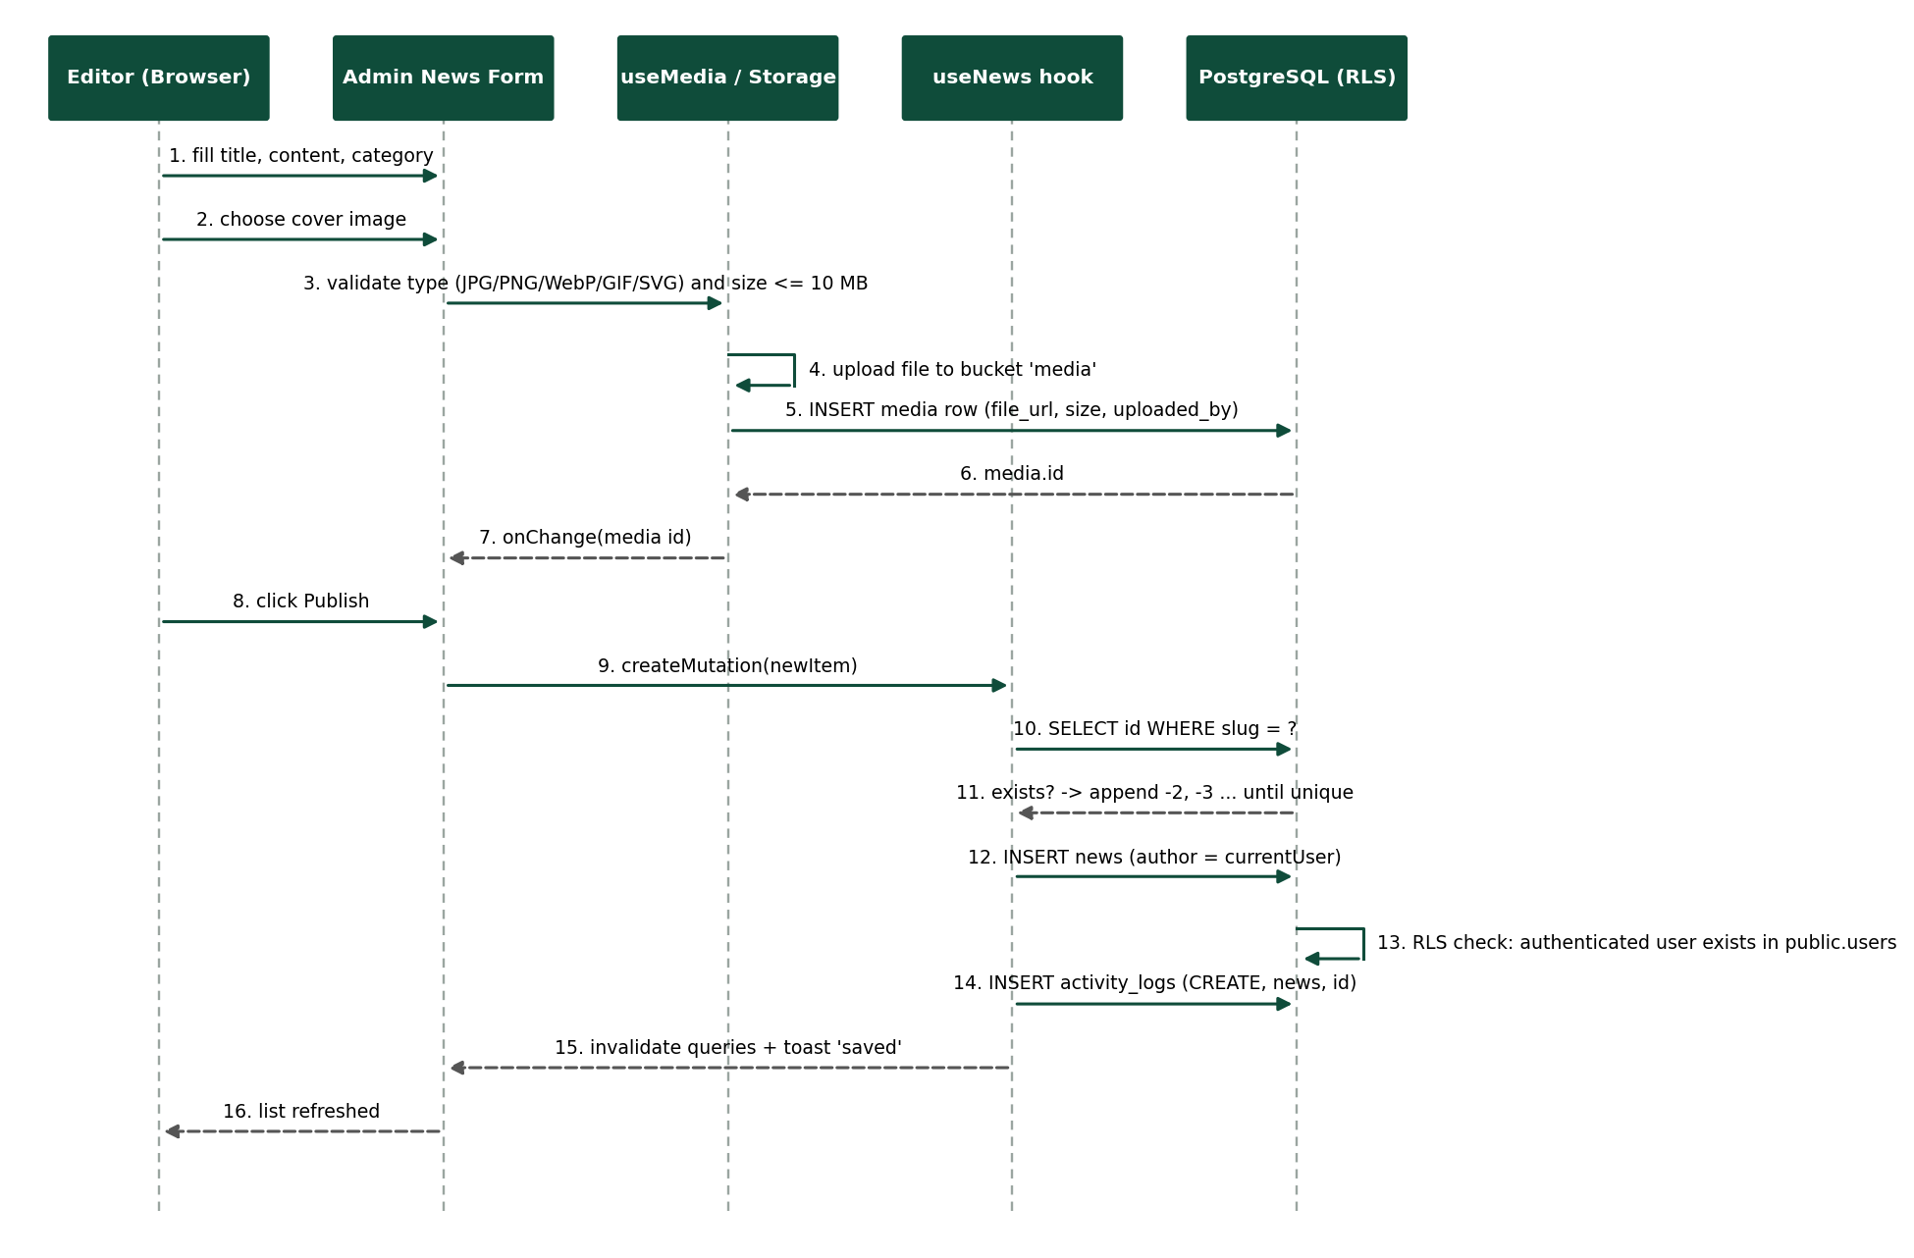
Figure 4.4: Sequence diagram - create and publish a news article with image upload
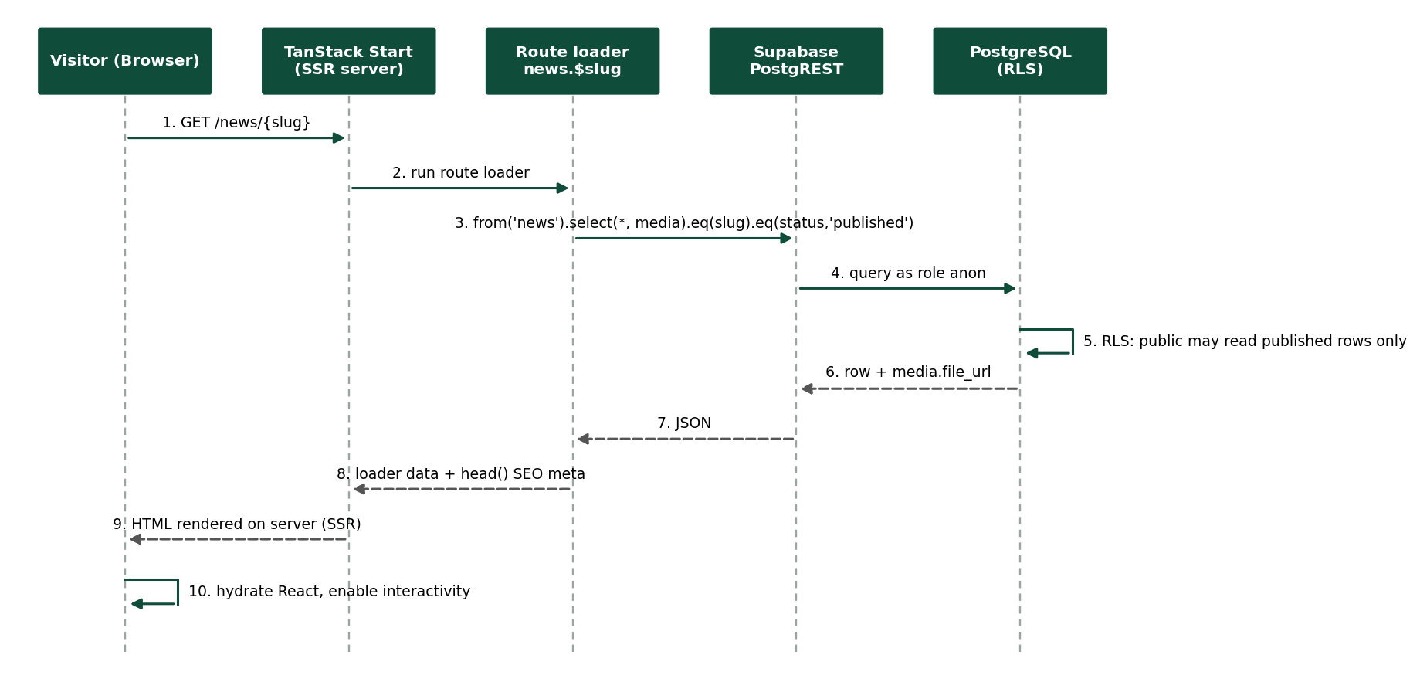
Figure 4.5: Sequence diagram - a visitor reads a published news article

4.1.5. Activity Diagram
Figure 4.6 shows the content publishing workflow common to all modules: session check, form validation, optional media upload, slug uniqueness check, saving with the Row Level Security check, activity logging, and the effect of the status on public visibility.
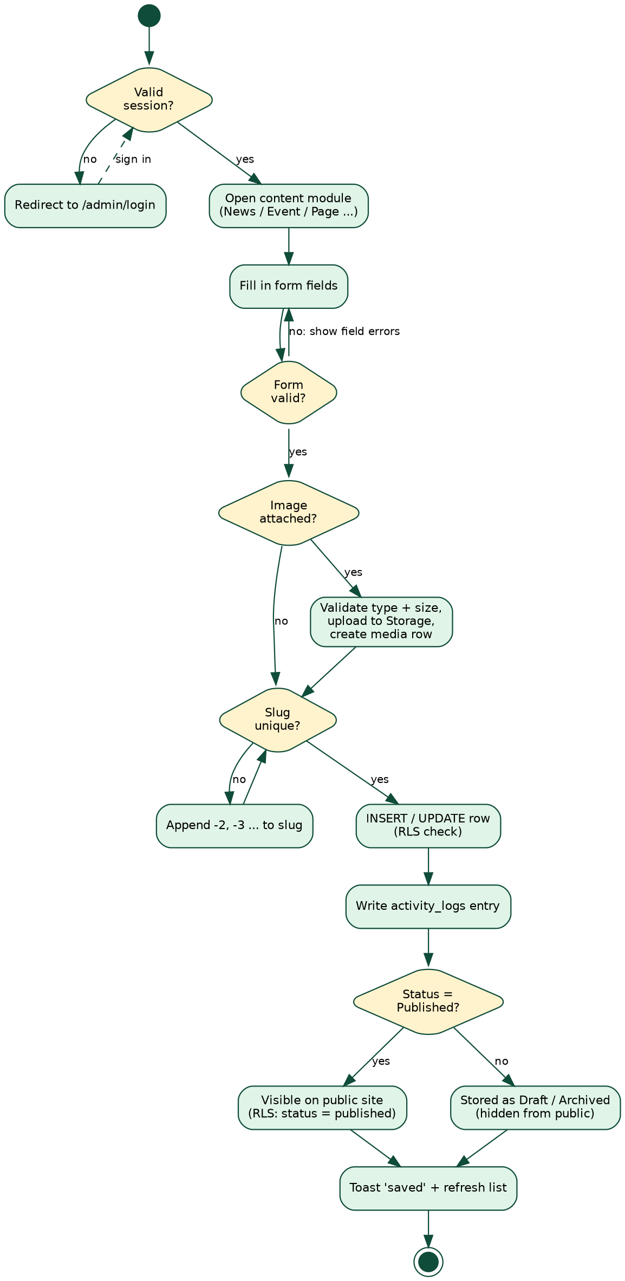
Figure 4.6: Activity diagram - content publishing workflow

4.2. User Interface Design

4.2.1. Design Principles
- University identity: deep green and gold colors from the university emblem, the bilingual name (Afaan Oromo, Amharic, English) in the header, and serif headings for a formal look.
- Consistency: all Admin CMS modules use the same layout: page header, list table with status badges, and a create/edit form with Save and Cancel.
- Responsive design: Tailwind CSS breakpoints; the Admin sidebar collapses into a drawer on small screens.
- Feedback: toast notifications for success and errors; loading and empty states.
- Accessibility: accessible dialog, select, tab, and menu components from Radix UI; descriptive page titles and meta descriptions for each public route.

4.2.2. Navigation Flow
Figure 4.7 shows how a visitor moves through the public site from the home page and Figure 4.8 shows the structure of the Admin CMS after login. The same grouped menu (Academics, Leadership and Administration, Registrar, Research, Services, Content / Communication, Career) is used in the public header.
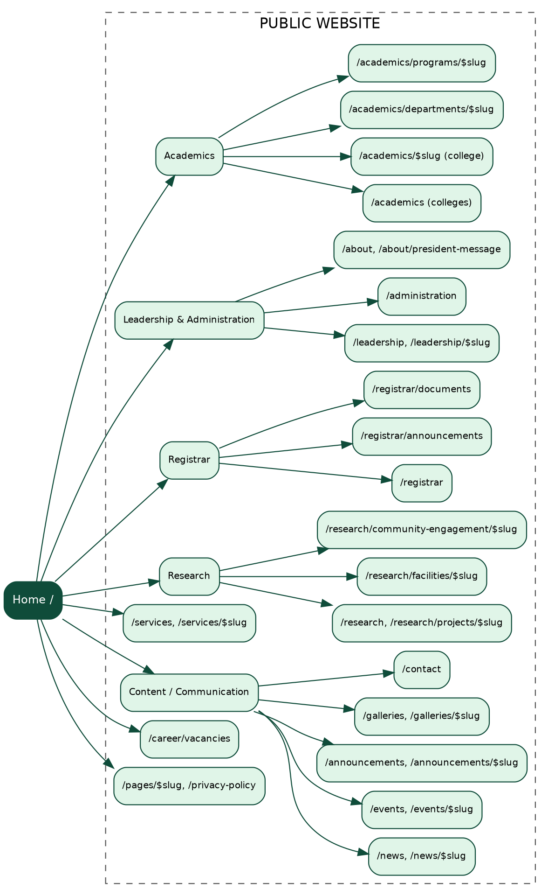
Figure 4.7: Navigation flow of the public website
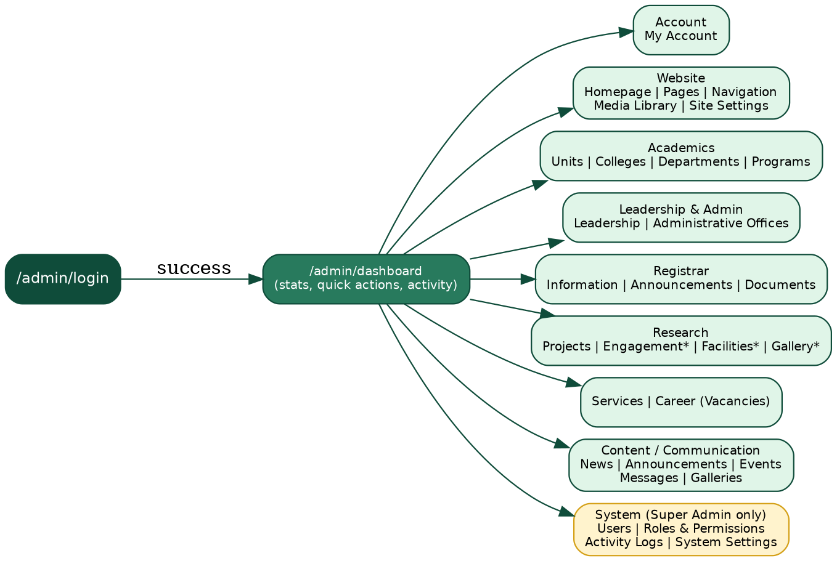
Figure 4.8: Navigation flow of the Admin CMS (* = menu entry present, page still to be built)

4.2.3. Screens of the New System
The following screenshots, taken from the running system, show the main screens. The public site shows the hero slider, the President's message section, and the footer with links grouped as Essentials, About Us, Resources, and Quick Links. The Admin CMS shows the login page, the dashboard, the homepage manager, and the form for creating a user.
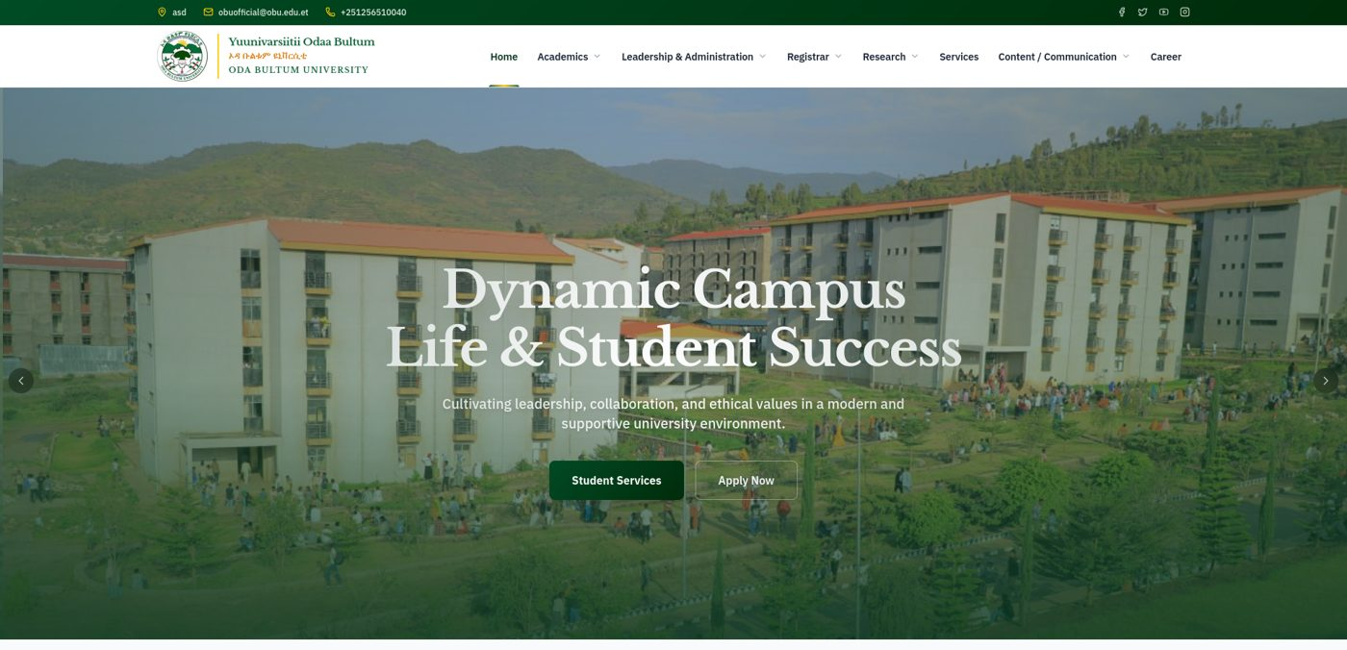
Figure 4.9: New public website - home page with hero slider and main menu
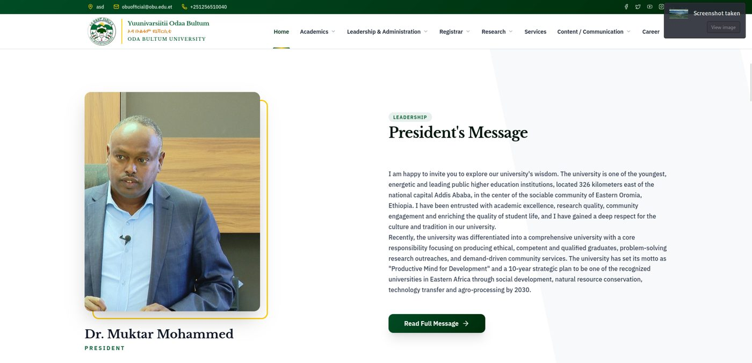
Figure 4.10: New public website - President's message section
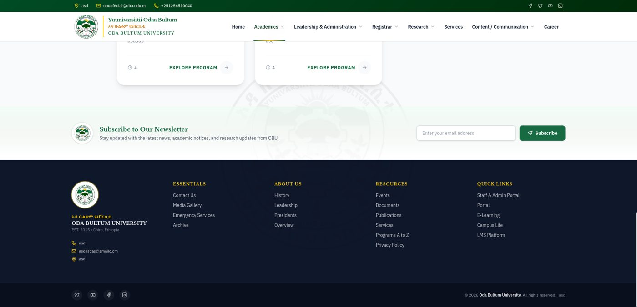
Figure 4.11: New public website - newsletter block and footer
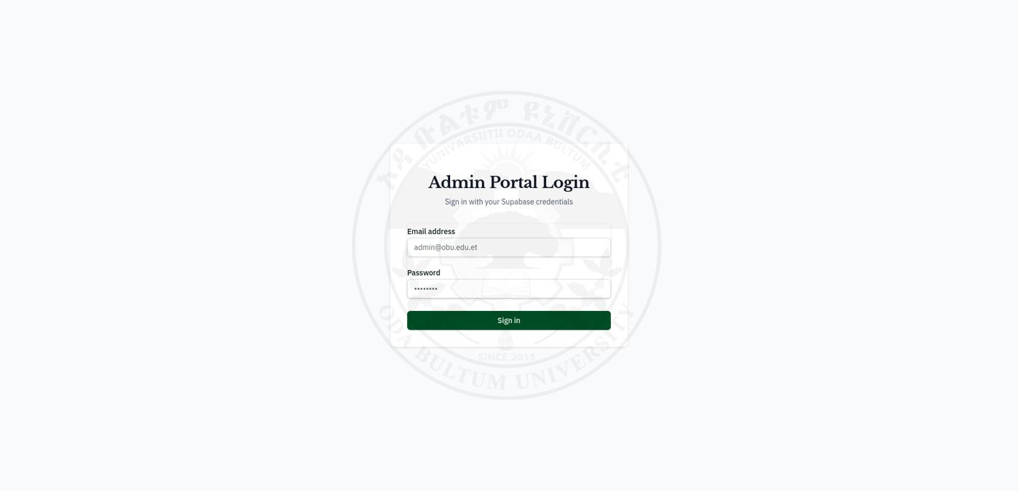
Figure 4.12: Admin CMS - login page (Admin Portal Login)
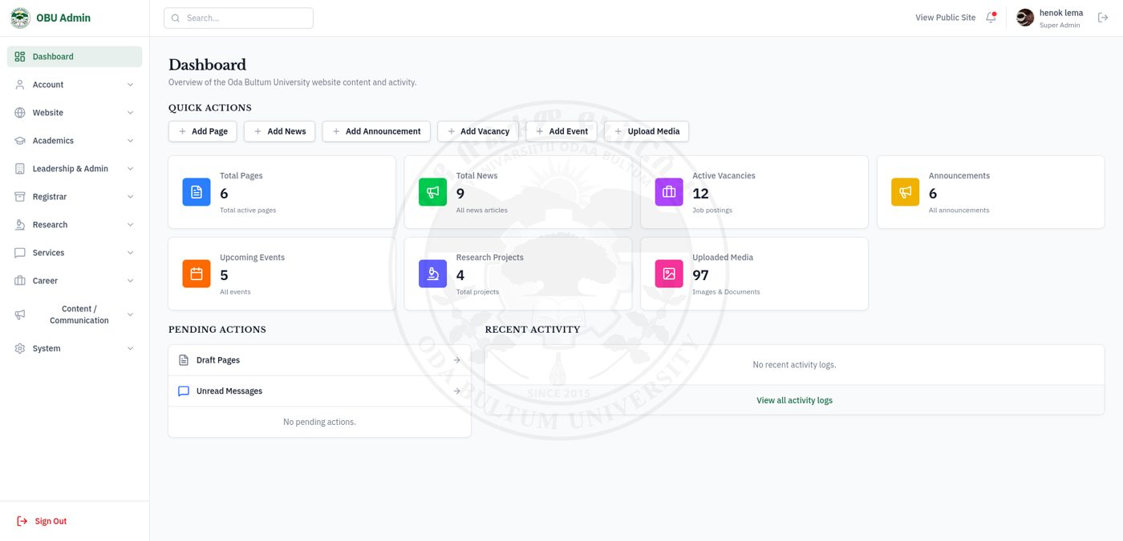
Figure 4.13: Admin CMS - dashboard with statistics, quick actions, and pending actions
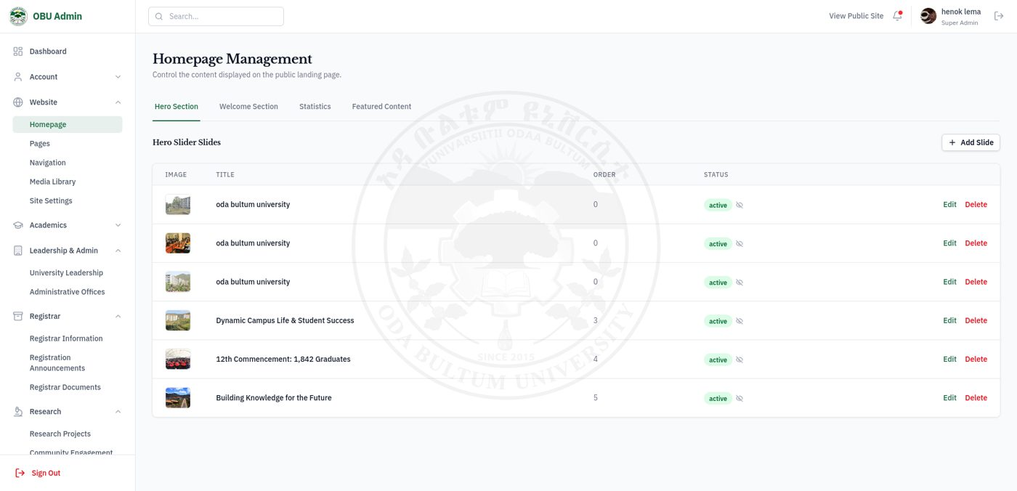
Figure 4.14: Admin CMS - homepage management (hero slides, welcome, statistics, featured content)
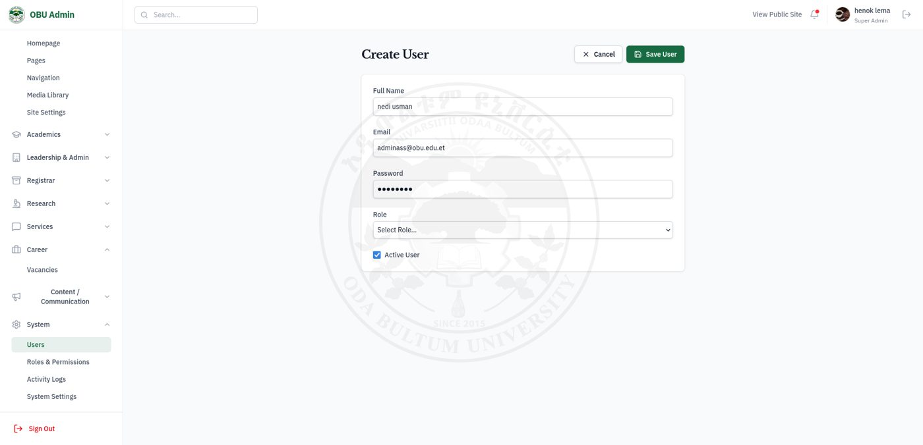
Figure 4.15: Admin CMS - create user form (full name, email, password, role, active)

4.3. Software Architecture

4.3.1. Subsystem Decomposition
Table 4.3: Subsystems of OBU-CMS
Subsystem | Responsibility | Main location
Public website | Pages for visitors: home, news, events, academics, research, registrar, services, vacancies, galleries, contact | src/routes/*.tsx (38 public files), src/frontend/components
Admin CMS | Protected area /admin: dashboard, content modules, media, users, roles, logs, settings | src/routes/admin.*.tsx (35 files), src/frontend/admin
Authentication and session | Login, logout, current user profile and role | src/frontend/contexts/AuthContext.tsx, route guard in src/routes/admin.tsx
Data access | Typed queries and mutations for each module with cache refresh and activity logging | src/frontend/admin/hooks/use*.ts (22 hooks), route loaders
Server functions | Server-side operations: site settings, navigation, contact messages, user creation, some listings | src/backend/api.ts, src/backend/lib/supabase-server.ts, src/start.ts (middleware)
Media management | Upload, validation, storage, and reuse of images and documents | AdminImageUpload.tsx, useMedia.ts, Supabase Storage bucket media
Database and policies | 27 tables, relations, slug function, access rules | supabase/migrations, src/frontend/lib/database.types.ts

4.3.2. Three-Tier Architecture
OBU-CMS follows a three-tier architecture (Figure 4.16). The presentation tier is the React user interface in the browser, rendered first on the server for speed and search engines. The application tier is the TanStack Start server: it matches routes, runs route loaders, hosts server functions with CSRF and error middleware, and keeps the client data cache up to date. The data tier is the Supabase cloud project with authentication, PostgreSQL with Row Level Security, file storage, and the automatic REST interface (PostgREST).
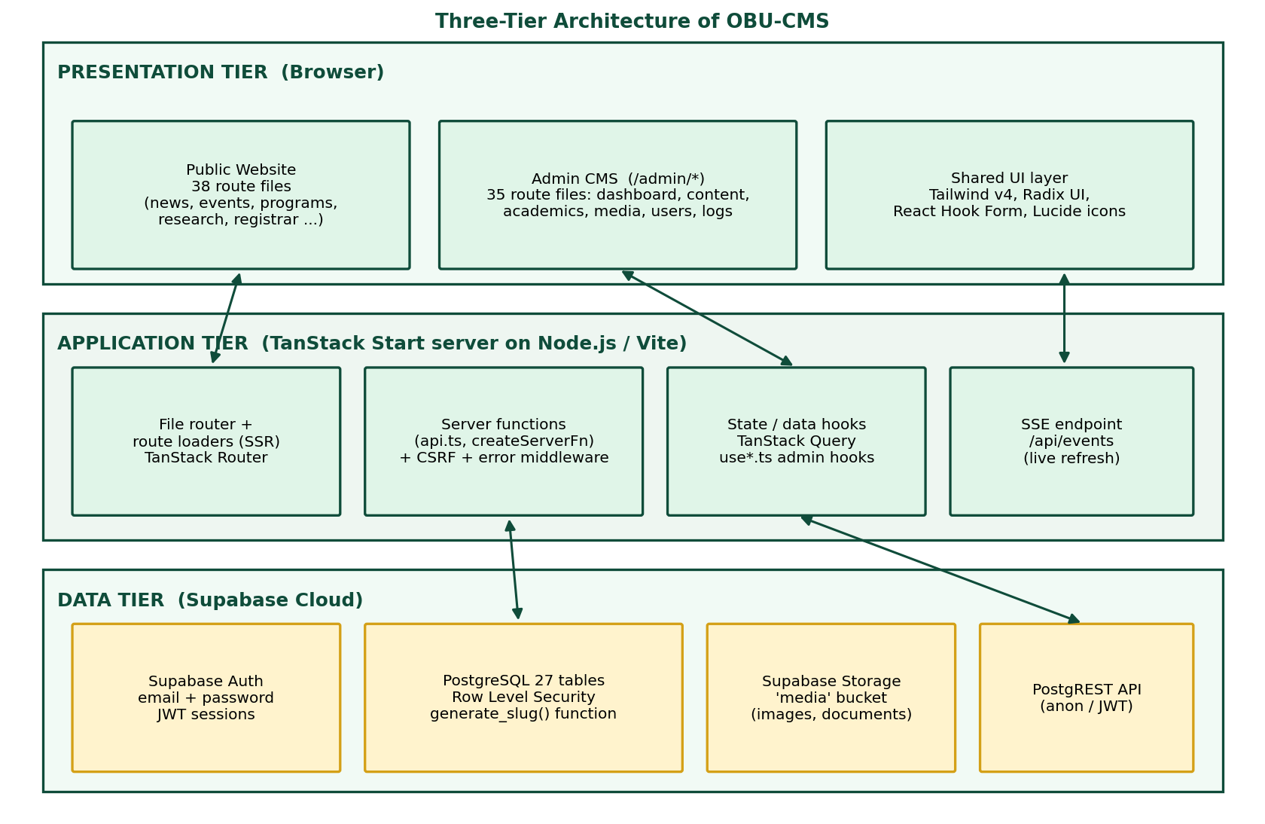
Figure 4.16: Three-tier software architecture of OBU-CMS

4.3.3. Deployment Diagram
Figure 4.17 shows the deployment. Users reach the application over HTTPS. The application is built with Vite into a Node.js server entry (server.ts). Browsers also talk directly to Supabase with the public (anonymous) key or the signed-in user's token; the access rules in the database decide what each request may read or write. Secrets such as the service key and the database connection string stay in the server's environment file. During development and in the screenshots of this report the application ran on the development server (port 5173) connected to the Supabase project; the deployment on the university's server is the target topology.
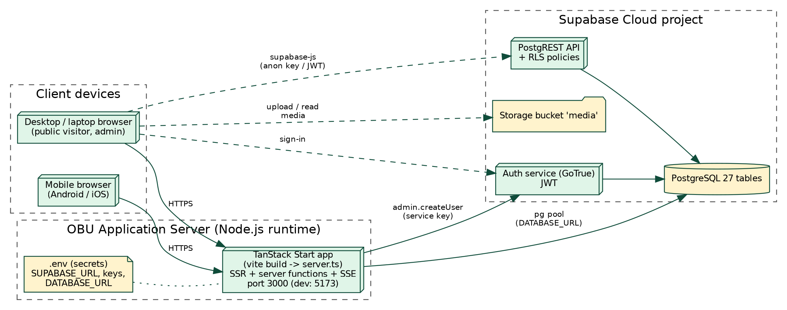
Figure 4.17: Deployment diagram of OBU-CMS

4.3.4. Data Management and Database Design
Two data paths. Most pages read and write through the Supabase client (supabase-js) from route loaders and data hooks. Public visitors use the anonymous key and are limited by Row Level Security; administrators use their login token. A smaller set of server functions in src/backend/api.ts uses a direct PostgreSQL connection (pg) for settings, navigation, contact messages, and creation of users (which needs the service key). This split is explained in Chapter 5.
Database design. The database has 27 tables. Figures 4.18 and 4.19 show them and their foreign keys, and Table 4.4 lists their purpose. The main design decisions are:
- Central `media` table. Every image or document is stored once in media; content tables reference it through columns such as main_image_id, featured_image_id, attachment_id, and profile_image_id.
- UUID primary keys and created_at / updated_at timestamps in the content tables.
- Status columns (draft / published, active / inactive) so that the public site can be restricted to visible records.
- Slugs with unique constraints for entities that have detail pages (galleries, leadership, services, academic units, programs, administrative offices, announcements, events, research projects, news, pages).
- Hierarchies with a self reference: academic_units.parent_id (college to department), pages.parent_id, and navigation_items.parent_id; programs.academic_unit_id links a program to its unit.
- Role model: users.role_id references roles; role_permissions joins roles and permissions (many-to-many).
- Audit: activity_logs references users and stores action, entity type, entity id, and description.
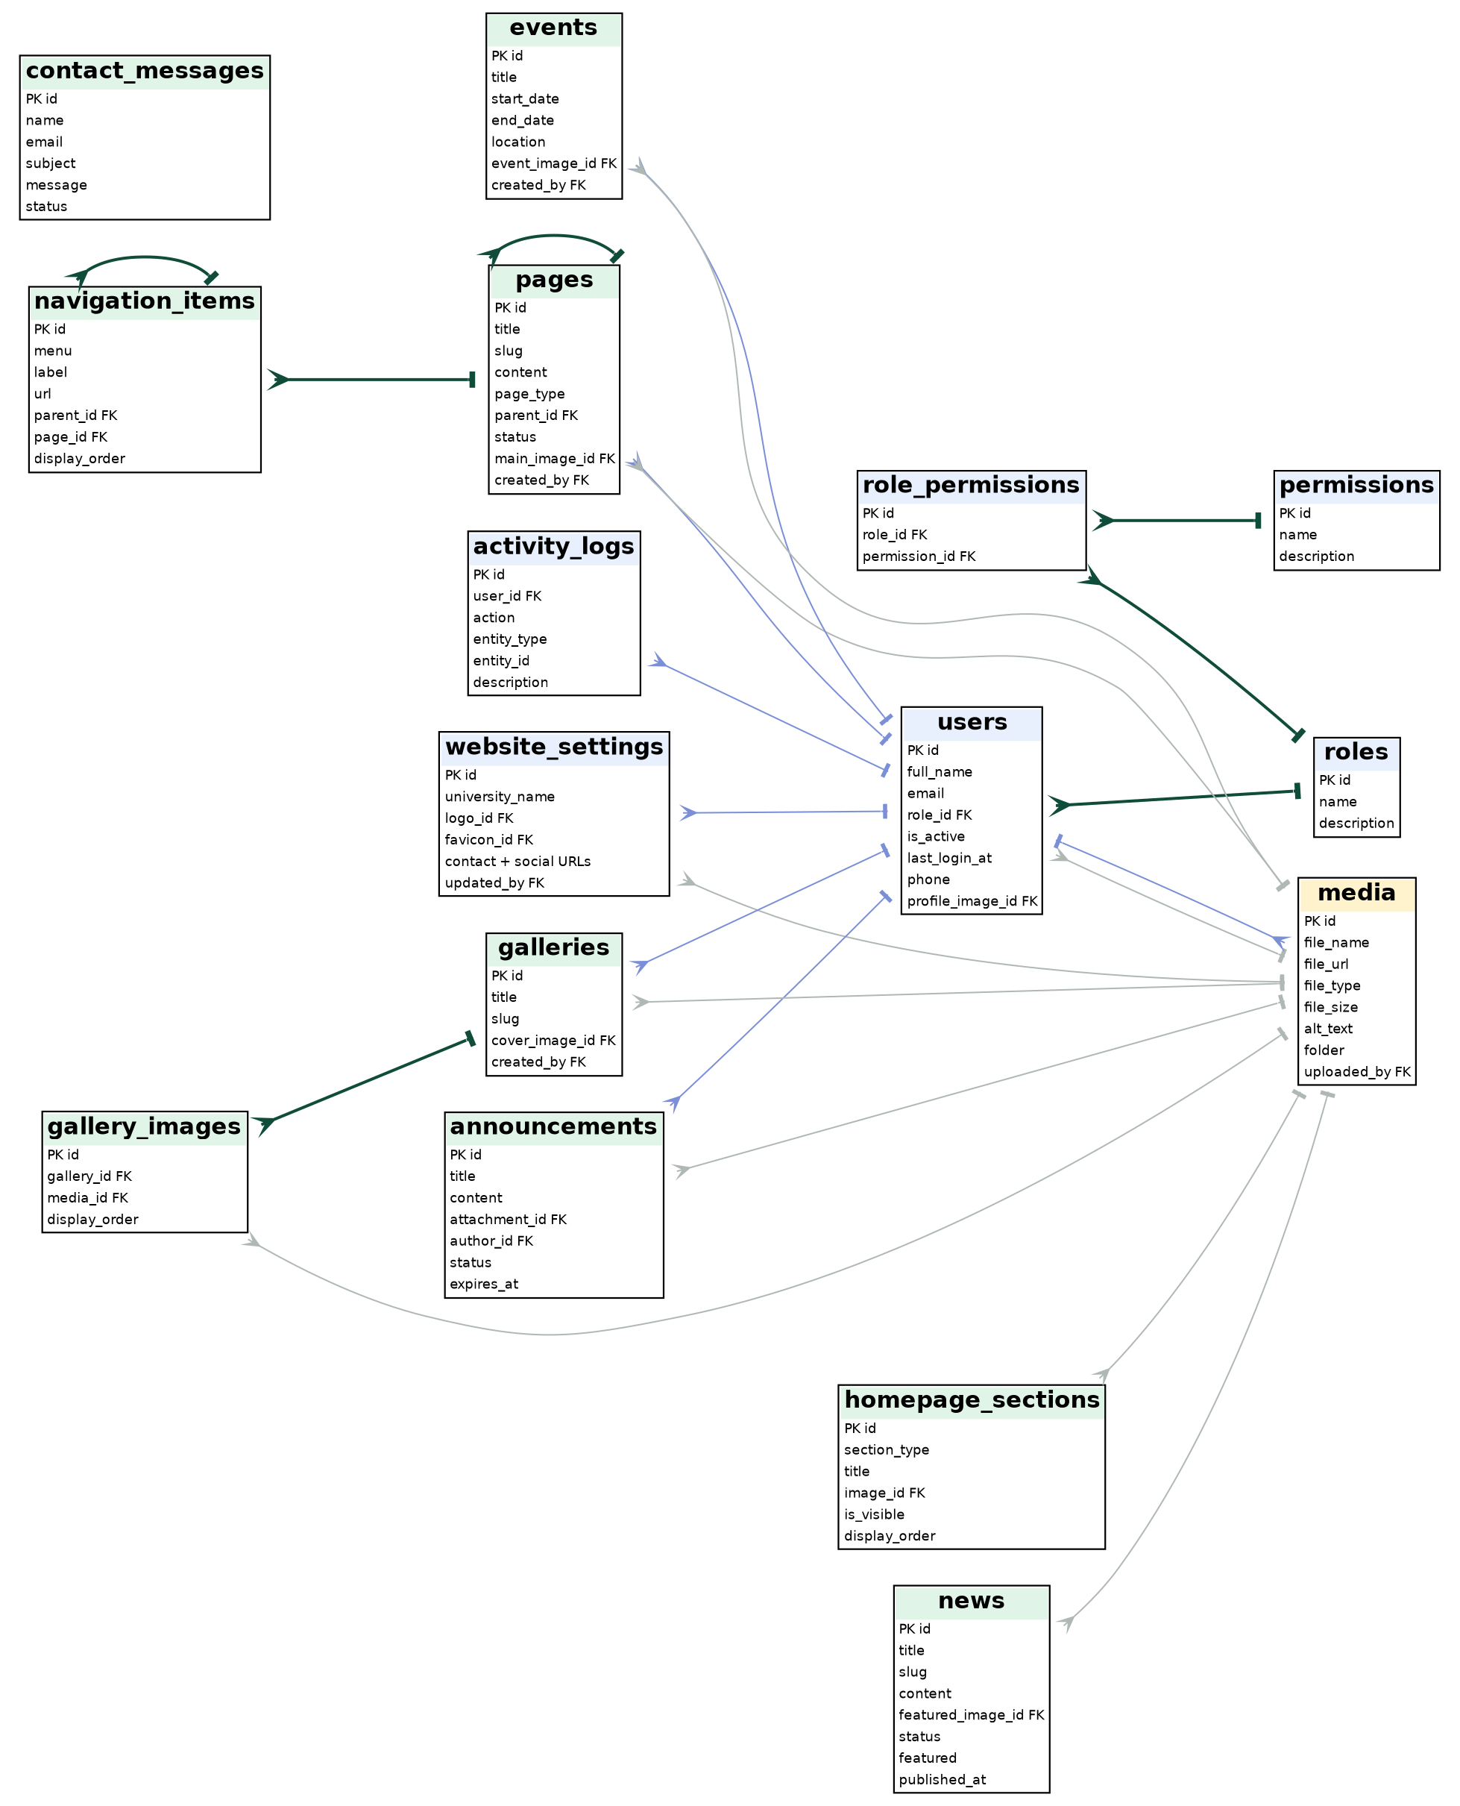
Figure 4.18: Entity-relationship diagram (1) - security, settings, and web content
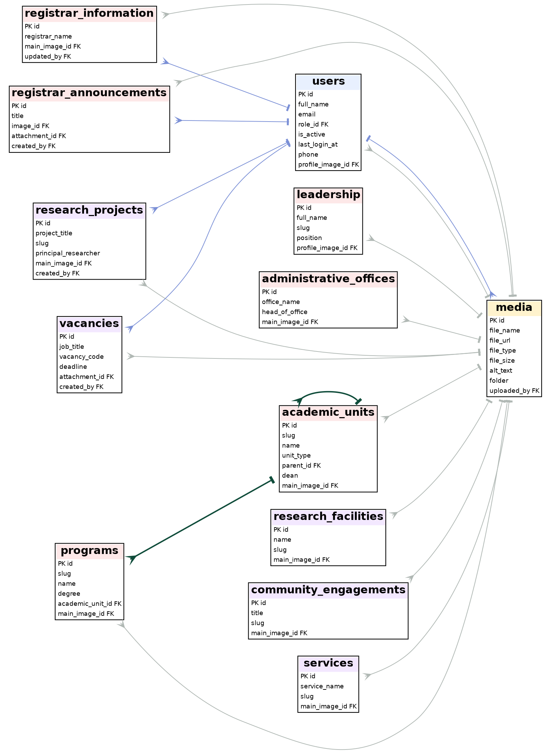
Figure 4.19: Entity-relationship diagram (2) - academics, administration, research, and services
In the diagrams, the crow's foot marks the "many" side. Dark green lines are relations between content tables; thin grey lines are references to media; blue lines are references to users. Some columns are omitted for readability.
Table 4.4: Database tables by module (27 tables)
Module | Tables | Purpose
Security and audit | users, roles, permissions, role_permissions, activity_logs | Staff accounts, roles with permissions, and the audit trail.
Site and web content | website_settings, pages, navigation_items, homepage_sections, media, contact_messages | Site identity and contacts, general pages, menus, home page blocks, uploaded files, messages from visitors.
Communication | news, announcements, events, galleries, gallery_images | News, notices, events, and photo galleries.
Academics | academic_units, programs | Colleges and departments (hierarchy) and degree programs.
Administration and Registrar | leadership, administrative_offices, registrar_information, registrar_announcements | University leaders, offices, and the Registrar's information and notices.
Research and services | research_projects, research_facilities, community_engagements, services, vacancies | Research, community engagement, services, and job vacancies.

4.4. Security and Access Control

4.4.1. Authentication
Administrators sign in on /admin/login with an email and a password. The sign-in is handled by Supabase Auth (signInWithPassword), which checks the password against a salted hash that it stores itself and returns a signed JSON Web Token (JWT) session with a refresh token. The application never stores or handles password hashes: when a user is created, the server function adminCreateUser creates the account in Supabase Auth with the service key and then inserts a profile row in users with the same id; the password_hash column of that table holds only the marker text SUPABASE_AUTH_DELEGATED. After login, AuthProvider loads the profile, the role name, and the profile image.
Every /admin route runs a beforeLoad check: if there is no valid session, the user is redirected to /admin/login with the original address saved as a redirect target.

4.4.2. Authorization
- Database level: Row Level Security is enabled on the tables created by the migrations. Public policies allow only SELECT of published or active rows. Write policies are granted to the authenticated role and require that the caller's id exists in public.users (Table 4.5).
- Storage level: the media bucket is publicly readable, while upload, update, and delete require an authenticated user listed in users.
- Application level: the sidebar hides the whole System group (Users, Roles and Permissions, Activity Logs, System Settings) unless the user's role is "Super Admin". The roles screen lists roles with their permission assignments.
Table 4.5: Row Level Security policies written in the migration files
Object | Policy | Rule
pages | Public read active pages | SELECT where status = 'published'
pages | Admin write pages | ALL for authenticated users that exist in users
academic_units | Public read active units / Admin write units | SELECT where status = 'active'; ALL for authenticated users in users
programs | Public read active programs / Admin write programs | SELECT where status = 'active'; ALL for authenticated users in users
users | Users can update their own profile | RLS enabled; each user may update only their own row
storage.objects (bucket media) | Public media read / Admin media upload, update, delete | SELECT for everyone; INSERT, UPDATE, DELETE for authenticated users in users
The policies for the other content tables (news, events, announcements, and so on) were configured in the Supabase project and are inspected with the helper scripts check_rls.ts and query_policies.js. Recording them in migration files is a recommended improvement so that the database can be rebuilt exactly.

4.4.3. Encryption and Data Protection
- In transit: the Supabase endpoints use HTTPS; the deployed website is intended to be served over HTTPS.
- Passwords: hashed and salted by Supabase Auth; never stored in plain text by the application.
- Secrets: the service-role key, database URL, and project URL are read from environment variables (src/backend/.env), not written into the client code. The public anonymous (publishable) key is the only key used in the browser.
- Cross-site request forgery: createCsrfMiddleware in src/start.ts is applied to all server functions.
- Error handling: an error middleware and a fallback page in server.ts return a friendly error page instead of stack traces.

4.4.4. Input Validation and Upload Control
- Uploaded files are limited to JPG, PNG, WebP, GIF, and SVG images and to 10 MB by AdminImageUpload; unsupported files are rejected with a message.
- Server-side SQL uses parameterized queries ($1, $2, ...), which prevents SQL injection; the Supabase client builds parameterized requests as well.
- React escapes text by default, which reduces the risk of cross-site scripting; the contact form checks that required fields are filled in.
Table 4.6: Security controls and where they are enforced
Control | Where enforced | Layer
Login and session | Supabase Auth; /admin route guard | Authentication
Read only published or active rows | RLS policies | Database
Writes only by registered users | RLS policies; storage policies | Database
System menu for Super Admin | Sidebar role check | Application
Cross-site request protection | CSRF middleware | Server
Upload type and size limits | AdminImageUpload | Application
Audit trail | activity_logs written by data hooks | Application

CHAPTER 5: IMPLEMENTATION
This chapter describes how the system was built: the tools and project structure, how a module is implemented, the main technical challenges and solutions, and the testing that was carried out.

5.1. Development Process

5.1.1. Tools and Environment
The system was written in TypeScript with React 19 and the TanStack Start framework (file-based routing, server-side rendering, and server functions), styled with Tailwind CSS v4, and connected to Supabase (PostgreSQL, Auth, Storage). Vite is the development server and build tool. The code was edited in VS Code on a Linux laptop, checked with ESLint and formatted with Prettier, and tracked with Git. The project is started with npm install and npm run dev after the Supabase environment variables are set; npm run build creates the production build.

5.1.2. Project Structure
Table 5.1: Project folder structure
Folder / file | Purpose
src/routes/ | 76 entries: 38 public page files, 35 admin page files, the __root.tsx layout, the api/events.ts endpoint, and a README. File names define the address, for example news.$slug.tsx is /news/{slug}.
src/frontend/components/ | Public interface components: Navbar, Footer, PageHero, cards, carousel, breadcrumbs.
src/frontend/admin/ | Admin layout (AdminShell), components (sidebar, topbar, page header, badge, image upload) and 22 data hooks (useNews, usePages, useMedia, useUsers, ...).
src/frontend/contexts/ | AuthContext with login, logout, and the current user.
src/frontend/lib/ | Supabase client, generated and extended database types, error page and error capture.
src/backend/ | api.ts (server functions), database/db.ts (PostgreSQL pool), lib/supabase-server.ts (service-key client), events.ts (event channel), server.ts (server entry).
src/start.ts | Global middleware: error handling and CSRF protection.
supabase/migrations/ | Ordered SQL files that change the database (Table 5.2).
specs/university-admin-media/ | Requirements, design, and task documents.
document/ | Screenshots of the old and new websites and report material.
Root scripts (check_rls.ts, inspect_*.ts, test_*.sh, seed-admin.ts) | Helper scripts to inspect the database and policies, check pages with curl, and create a development admin.

5.1.3. How a Module Is Implemented
Every Admin CMS module follows the same pattern, which made the work repeatable:
- Table and migration: create or extend the table in a migration file and update the typed definitions.
- Data hook: write use<Module>.ts with a query (list with joined media), and create, update, and delete mutations that also write to activity_logs and show a toast.
- Admin screens: a list page with search and status badges, and a form page with AdminImageUpload for images.
- Public page: a route with a loader that reads only published or active rows, a head() function for the page title and description, and a slug-based detail route.
- Policies and sidebar entry: add the Row Level Security policy and the menu item.
For example, the news hook lists articles ordered by publication date with the cover image joined from media, makes the slug unique by adding a number, sets the author from the signed-in user, and records "Created news article" in the activity log (Appendix A.3).

5.1.4. Database Migration History
Table 5.2: Migration history
Migration file | Change
20260825_phase2a_schema.sql | Slug columns for galleries, leadership, services, academic units, programs, and offices; the generate_slug() function; back-filling of existing rows; unique constraints.
20260825_phase2b_rls.sql | Row Level Security and policies for pages, academic_units, and programs.
20260825_media_bucket.sql | Public media storage bucket and its four storage policies.
20260825_website_title.sql | Website title field in the site settings.
20260831110000_add_research_projects_slug.sql | Slug and unique index for research projects.
20260903000000_add_announcements_main_image_id.sql | Cover image column for announcements.
20260903010000_add_slug_to_announcements_and_events.sql | Slugs and unique constraints for announcements and events.
20260903020000_add_profile_fields_to_users.sql | Phone and profile image for users; policy so users can update their own profile.
20260922000000_footer_navigation_seed.sql | Footer navigation items stored in navigation_items.

5.2. Challenges and Solutions
Table 5.3: Challenges and solutions
No. | Challenge | Solution
1 | From prototype to real database. The first version of the Admin CMS kept data in the browser and a local store with sample data, which is not shared between users and not secure. | Each module was moved to a typed hook that reads and writes Supabase. The old store and sample data were kept only until each module was converted. The remaining legacy functions are listed as technical debt (Section 5.2.1).
2 | Two ways of reaching the database. Server functions with a direct PostgreSQL connection bypass Row Level Security, while the Supabase client respects it. | Row Level Security became the main protection: public pages and admin hooks use the Supabase client. Direct-connection server functions were kept for settings, navigation, contact messages, and user creation, and CSRF middleware was added.
3 | Clean, unique, permanent addresses (slugs) for many content types, including existing records. | A generate_slug() SQL function, a back-fill that adds the first 8 characters of the id to duplicates, unique constraints, and a check in the hooks that appends -2, -3, ... for new records.
4 | Many content types need images. Storing a text URL in each table caused duplicates and no control. | One media table and a storage bucket; the AdminImageUpload component uploads the file, checks type and size, creates the media row, and returns its id to the parent form.
5 | Database types drifting from the real schema after each migration, causing TypeScript errors. | database.openapi.types.ts is generated from the schema; database.types.ts extends it with columns added by later migrations so the code stays fully typed.
6 | Creating administrators. The browser cannot create Supabase Auth users, and the app needs a matching profile row. | A server function adminCreateUser uses the service key to create the Auth user and then inserts the users row with the same id.
7 | College - department - program hierarchy. Academic data is hierarchical and needs clean pages for each level. | academic_units with unit_type and parent_id; programs.academic_unit_id; routes /academics/$slug, /academics/departments/$slug, and /academics/programs/$slug; verified with test_final_curls.sh.
8 | Hidden server errors. The server framework turned some errors into a plain JSON 500 response. | server.ts detects that response and returns a branded HTML error page; start.ts adds error middleware; errors are logged.
9 | Keeping the admin lists fresh. Several administrators may edit at the same time. | TanStack Query invalidates cached lists after each mutation, and a server-sent events endpoint (/api/events) with a reconnecting client hook can trigger a refresh.

5.2.1. Technical Debt and Known Limitations
A review of the finished code found the following points. They do not stop the system from working, but they should be handled before a production launch. They are also the basis of the recommendations in Chapter 6.
- Legacy server functions without a session check. api.ts still contains early-prototype functions (adminUpsert*, adminDeleteRows, adminLoadCollection) that work on an older set of tables and do not verify the caller. They should be removed or protected by a session and role check.
- Admin write policies are not role-specific. The database policies allow any signed-in user listed in users to write; the Super Admin restriction is applied in the interface. Role-aware policies (using role_permissions) are the next step.
- Development credentials in the repository. seed-admin.ts and a specification file contain a development admin email and password. They must be removed and the password changed before deployment.
- Validation library not used. zod is installed but the inputs are mostly validated by the forms and the database; schema validation of server function inputs should be added.
- No automated unit tests yet. Checks are done by scripts and manually (Section 5.3).
- Slug function supports only Latin letters and digits. Titles written only in Amharic or Afaan Oromo script (Ge'ez) would fall back to the generic word "item"; transliteration or a manual slug should be supported.
- Three admin pages missing. The sidebar links Research > Community Engagement, Research Facilities, and Research Gallery have no page yet (their public pages and database tables exist); they must be built or hidden.
- Newsletter box is a placeholder. The subscribe form in the footer only shows a confirmation and does not store the email.
- Placeholder data in site settings. The test value "asd" is visible in the header and footer address in the screenshots and must be replaced with the real address.

5.3. Testing

5.3.1. Testing Approach
The project does not yet have an automated test framework, so testing combined static checks, scripted checks, and manual functional testing:
- Static checks (unit level): the TypeScript compiler with typed table definitions catches wrong column names and data shapes at build time; ESLint checks code quality.
- Integration tests: test_curls.sh and test_final_curls.sh request the running site and search the returned HTML for records that were created in the Admin CMS (a college, a department, and a program, and the text of an updated college). A match proves that data flows from the Admin CMS, through the database and policies, to the public page.
- Security checks: check_rls.ts lists which tables have Row Level Security enabled, and query_policies.js prints the policies of a table from the database catalog.
- System tests: manual end-to-end walkthroughs of login, content creation, publication, and viewing, supported by the screenshots in Chapter 4.

5.3.2. Test Cases
Table 5.4: Test cases and evidence
ID | Test case | Expected result | Status / evidence
TC-01 | Open the home page | Hero slider, menu, and sections load from the database | Passed - Figure 4.9
TC-02 | Create a test college, department, and program in the Admin CMS; open the public pages | Each record appears on its page and the program page shows its department and college | Script test_final_curls.sh (prints the match or "Not found")
TC-03 | Rename the test college and reload the public page | The public page shows the new name | Script test_final_curls.sh
TC-04 | Open /admin/dashboard without logging in | Redirect to /admin/login | Manual - record result
TC-05 | Log in with a valid account | Dashboard opens with counts and the user's name and role | Passed - Figure 4.13
TC-06 | Log in with a wrong password | Error message; no session | Manual - record result
TC-07 | Create a news article with a cover image | Article listed in the admin and on /news; log entry created | Manual - record result
TC-08 | Create two articles with the same title | Second slug gets the suffix -2 | Manual - record result
TC-09 | Save an article as Draft | Not visible on the public site | Manual - record result
TC-10 | Upload a PDF as a cover image, and a file larger than 10 MB | Both rejected with a message | Manual - record result
TC-11 | Send the contact form | Message stored; visible in Admin > Contact Messages | Manual - record result
TC-12 | Request draft rows with the public key | No rows returned (Row Level Security) | Manual / policy inspection
TC-13 | Try to insert a page with the public key | Request denied by policy | Manual / policy inspection
TC-14 | Log in as a non-Super Admin | System menu hidden | Manual - record result
TC-15 | Super Admin creates a user and that user logs in | User can sign in with the assigned role | Form shown - Figure 4.15; login result: record
TC-16 | Open the public site at 375 px width | Layout adapts; menu usable | Manual - record result
TC-17 | Delete a record | Confirmation shown; record removed; log entry created | Manual - record result

5.3.3. Results
The screenshots show that the public site renders data from the database and that the Admin CMS dashboard loads live counts (6 pages, 9 news articles, 12 active vacancies, 6 announcements, 5 events, 4 research projects, and 97 media files). The integration scripts check the full college-department-program chain on the public site. The remaining cases are listed so that every result can be recorded in the same table when the final acceptance test is performed with the ICT staff; the results of those runs should be entered in the "Status / evidence" column.

5.3.4. Summary of Findings
The testing and code review confirmed that the main flow works: an administrator logs in, manages content and media, and visitors immediately see published content. They also produced the list of limitations in Section 5.2.1, which is an important result of the project because it gives the ICT Executive Office a clear, prioritized list of work before production use.

CHAPTER 6: INTERNSHIP REFLECTION AND CONCLUSION

6.1. Learning Outcomes

6.1.1. Practical Skills
Table 6.1: Skills gained
Area | What I learned and did
Full-stack TypeScript | Built a complete application in TypeScript from database types to React components, using file-based routing and server-side rendering.
Database design | Designed a 27-table PostgreSQL schema with relations, hierarchies, slugs, and ordered migrations.
Security | Used Supabase Auth, Row Level Security, storage policies, CSRF middleware, and upload validation, and reviewed the code for weaknesses.
CMS design | Designed reusable patterns for CRUD modules, media reuse, status workflow, and an audit log.
Responsive UI | Built a responsive public site and admin interface with Tailwind CSS and Radix UI.
Tooling | Used Vite, ESLint, Prettier, Git, curl scripts, and SQL inspection scripts.
Documentation | Wrote requirements, design documents, migrations, and this report with diagrams.

6.1.2. Theoretical Knowledge Applied
- Database systems: normalization, primary and foreign keys, many-to-many relations (role_permissions), and self-referencing hierarchies.
- Software engineering: requirements analysis, UML modeling (use case, class, sequence, activity), iterative development, and risk management.
- Web development: HTTP, server-side rendering versus client-side rendering, REST, and sessions with tokens.
- Information security: least privilege, defense in depth, authentication versus authorization, and common web attacks (SQL injection, XSS, CSRF).

6.1.3. Personal Growth
Working on a real system for my own university taught me to talk with non-technical users, to turn vague requests into clear requirements, to manage my time, and to take responsibility for quality. Reviewing my own code for security weaknesses and writing them down honestly in this report was an important professional lesson.

6.2. Challenges Faced
- Workplace adaptability: learning how the ICT office works, how decisions and approvals are made, and how to schedule demonstrations around the staff's duties.
- Technical issues: the change from a prototype with sample data to a real database while keeping the interface working, and the two data paths (Supabase client and direct database connection).
- Scope management: the university has many offices with different content needs, so I had to prioritize modules and postpone some requests.
- Working alone: being the only developer meant I was also the tester and the documenter; automated tests would have reduced this load.

6.3. Recommendations

6.3.1. For the Organization (OBU ICT Executive Office)
- Before production launch, remove or protect the legacy server functions, delete the development credentials, and change all passwords.
- Build the three missing Research admin pages (community engagement, facilities, gallery) or hide their menu links.
- Add role-aware database policies so that permissions in role_permissions are enforced by the database and not only by the interface.
- Record all Row Level Security policies in migration files and keep the Supabase project reproducible.
- Introduce an approval step (draft, review, published) for sensitive content such as announcements and Registrar notices.
- Schedule regular database and media backups stored on university infrastructure.
- Train content officers from each office and publish a short content style guide (image sizes, titles, categories).
- Replace placeholder settings, make the newsletter form functional or remove it, and add Afaan Oromo and Amharic content support (multi-language pages and non-Latin slugs).
- Plan the next phase: student portal features, search, and analytics.

6.3.2. For Future Internship Programs
- Ask students to agree with the host organization on the schedule, deliverables, and a named supervisor in the first week.
- Hold a mid-internship review among the student, the advisor, and the host supervisor.
- Teach database design, migrations, and web security earlier in the curriculum, because they are central in real projects.
- Keep an archive of internship project documentation and code so later students can build on earlier work.

6.4. Conclusion
The internship produced a working website and Content Management System for Oda Bultum University: 38 public route files, 35 admin route files, a 27-table database with security policies, a media library, role-based administration, and an audit log. It replaces a content process that depended on technical staff with one that lets each office publish its own information. The review in this report also lists the remaining work before production use. The table below summarizes the real problems that the project addresses.
Table 6.2: Real-world problems solved by the project
Real problem at the university | Solution in OBU-CMS | Benefit
Only technical staff could update the website | Admin CMS with forms for every content type | Offices publish urgent notices themselves
Registrar and academic information hard to find | Registrar section and college, department, program pages with clean addresses | Applicants and students find information faster
No control over who changes what | Login, roles, Row Level Security, activity log | Security and accountability
Images and documents scattered and unmanaged | Central media library | Reuse and consistent presentation
Outdated, fixed texts and menus | Settings, navigation, and homepage sections stored in the database | Information stays current without code changes
Hard to use on phones | Responsive layout with Tailwind CSS | Better access for students on mobile devices

APPENDICES

Appendix A: Code Snippets
The following excerpts are taken from the project source code (shortened where noted).

A.1. Route guard for the Admin CMS (src/routes/admin.tsx)
export const Route = createFileRoute("/admin")({
beforeLoad: async ({ location }) => {
if (location.pathname === "/admin/login") return;
const { data: { session } } = await supabase.auth.getSession();
if (!session) {
throw redirect({ to: "/admin/login", search: { redirect: location.href } });
}
},
component: AdminLayout,
});

A.2. Login function (src/frontend/contexts/AuthContext.tsx)
const login = async (email: string, password: string) => {
setIsLoading(true);
const { error } = await supabase.auth.signInWithPassword({ email, password });
setIsLoading(false);
if (error) return { success: false, error: error.message };
return { success: true };
};

A.3. Unique slug and activity log in the news hook (useNews.ts, shortened)
let finalSlug = newItem.slug || "";
let isUnique = false; let counter = 1; const originalSlug = finalSlug;
while (!isUnique) {
const { data: existing } = await supabase.from("news").select("id").eq("slug", finalSlug);
if (!existing || existing.length === 0) isUnique = true;
else { counter++; finalSlug = `${originalSlug}-${counter}`; }
}
const { data } = await supabase.from("news")
.insert([{ ...newItem, slug: finalSlug, author: currentUser?.full_name || currentUser?.email }])
.select().single();
await supabase.from("activity_logs").insert([{
user_id: currentUser.id, action: "CREATE", entity_type: "news",
entity_id: data.id, description: `Created news article: ${data.title}` }]);

A.4. Row Level Security policies (20260825_phase2b_rls.sql)
ALTER TABLE public.programs ENABLE ROW LEVEL SECURITY;

CREATE POLICY "Public read active programs" ON public.programs
FOR SELECT USING (status = 'active');

CREATE POLICY "Admin write programs" ON public.programs
FOR ALL TO authenticated
USING (EXISTS (SELECT 1 FROM public.users WHERE id = auth.uid()));

A.5. Slug function (20260825_phase2a_schema.sql)
CREATE OR REPLACE FUNCTION public.generate_slug(base_text TEXT)
RETURNS TEXT AS $$
DECLARE base_slug TEXT;
BEGIN
base_slug := lower(regexp_replace(base_text, '[^a-zA-Z0-9]+', '-', 'g'));
base_slug := trim(both '-' from base_slug);
IF base_slug IS NULL OR base_slug = '' THEN base_slug := 'item'; END IF;
RETURN base_slug;
END;
$$ LANGUAGE plpgsql;

A.6. CSRF and error middleware (src/start.ts, shortened)
const csrfMiddleware = createCsrfMiddleware({
filter: (ctx) => ctx.handlerType === "serverFn",
});
export const startInstance = createStart(() => ({
requestMiddleware: [errorMiddleware, csrfMiddleware],
}));

A.7. Upload validation (AdminImageUpload.tsx)
const ALLOWED_TYPES = ["image/jpeg","image/png","image/webp","image/gif","image/svg+xml"];
const MAX_SIZE_BYTES = 10 * 1024 * 1024; // 10MB

A.8. Creating an administrator (api.ts - adminCreateUser, shortened)
const { data: authData, error } = await supabaseServer.auth.admin.createUser({
email: data.email, password: data.password, email_confirm: true });
if (error) return { ok: false, error: error.message };
await db.query(
`INSERT INTO users (id, email, full_name, role_id, is_active, password_hash)
VALUES ($1, $2, $3, $4, $5, $6)`,
[authData.user.id, data.email, data.full_name, data.role_id, data.is_active,
"SUPABASE_AUTH_DELEGATED"]);

Appendix B: System Data at the Time of the Final Screenshots (8 October 2026)
Table B.1: Dashboard figures
Item | Count shown on the dashboard
Active pages | 6
News articles | 9
Active vacancies | 12
Announcements | 6
Upcoming events | 5
Research projects | 4
Uploaded media (images and documents) | 97

Appendix C: Route Overview
Public routes (38 files): / ; /about, /about/president-message ; /academics, /academics/$slug, /academics/departments, /academics/departments/$slug, /academics/programs, /academics/programs/$slug ; /administration, /administration/$slug ; /announcements, /announcements/$slug ; /career/vacancies, /careers ; /contact ; /events, /events/$slug ; /galleries, /galleries/$slug ; /leadership, /leadership/$slug ; /news, /news/$slug ; /pages/$slug ; /privacy-policy ; /registrar, /registrar/announcements, /registrar/documents ; /research, /research/projects, /research/projects/$slug, /research/facilities, /research/facilities/$slug, /research/community-engagement, /research/community-engagement/$slug ; /services, /services/$slug.
Admin routes (35 files): /admin/login, /admin/dashboard, /admin/account (the sidebar also links /admin/research/engagement, /admin/research/facilities, and /admin/research/gallery, which are not yet built) ; Website: homepage, pages, navigation, media, settings ; Academics: units, faculties, departments, programs ; leadership, administration ; Registrar: information, announcements, documents ; Research: projects, centers ; admissions ; services ; career/vacancies ; Content: news, announcements, events, messages, galleries ; System (Super Admin): users, roles, activity-logs, settings.

Appendix D: Administrator Quick Guide
Table D.1: Common administrator tasks
Task | Steps
Log in | Open /admin/login, enter email and password, click Sign in. The dashboard opens.
Publish news | Content / Communication > News > Add. Enter title, category, short description, and content. Choose a cover image. Set status Published and Save.
Upload media | Website > Media Library > Upload (or use the image field inside any form). Allowed: JPG, PNG, WebP, GIF, SVG up to 10 MB.
Change the home page | Website > Homepage. Use the tabs Hero Section, Welcome Section, Statistics, and Featured Content.
Edit the menu | Website > Navigation. Add or reorder items and set the parent item for sub-menus.
Create a user (Super Admin) | System > Users > Add. Enter full name, email, password, choose a role, keep Active checked, and Save.
Check who changed what (Super Admin) | System > Activity Logs.
Hide content | Set the status to Draft (or Inactive) and save; the item disappears from the public site.

Appendix E: Test Script (`test_final_curls.sh`, excerpt)
echo "--- College ---"
curl -s http://localhost:5173/academics/test-college-of-technology \
| tr -d '\000' | grep -a -o "TEST Department of Computer Science" | head -n 1 || echo "Not found"

echo "--- Program ---"
curl -s http://localhost:5173/academics/programs/test-bachelor-of-computer-science \
| tr -d '\000' | grep -a -o "TEST College of Technology" | head -n 1 || echo "Not found"

REFERENCES
[1] Haramaya University, Department of Computer Science, "Industrial Practice Report Guideline (Software Development)," internal document.
[2] Oda Bultum University, "Official website." [Online]. Available: https://obu.edu.et (accessed Oct. 2026).
[3] TanStack, "TanStack Start, Router, and Query documentation." [Online]. Available: https://tanstack.com (accessed Oct. 2026).
[4] Supabase, "Supabase documentation: Auth, Database, Row Level Security, and Storage." [Online]. Available: https://supabase.com/docs (accessed Oct. 2026).
[5] The PostgreSQL Global Development Group, "PostgreSQL documentation: Row Security Policies." [Online]. Available: https://www.postgresql.org/docs/current/ddl-rowsecurity.html (accessed Oct. 2026).
[6] Meta Platforms, Inc., "React documentation." [Online]. Available: https://react.dev (accessed Oct. 2026).
[7] Tailwind Labs, "Tailwind CSS documentation." [Online]. Available: https://tailwindcss.com/docs (accessed Oct. 2026).
[8] OWASP Foundation, "OWASP Top Ten." [Online]. Available: https://owasp.org/www-project-top-ten/ (accessed Oct. 2026).
[9] I. Sommerville, Software Engineering, 10th ed. Harlow, U.K.: Pearson, 2016.
[10] R. Elmasri and S. B. Navathe, Fundamentals of Database Systems, 7th ed. Hoboken, NJ, USA: Pearson, 2016.
[11] K. Schwaber and J. Sutherland, "The Scrum Guide," Nov. 2020. [Online]. Available: https://scrumguides.org

