1) Find the colord.conf file from the linux_task directory.



Result:



2) Inside the colord.conf file, find all lines containing the word "false".



Result:

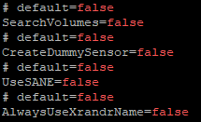

3) Copy the file to the tmp folder.



Result:



4) Assign the following access rights to the copied file:

• owner - read, execute, write

• group - reading execution

• the rest – reading



Result:



List the possible options for assigning these rights.

* u=rwx, g=rx, o=r
* 754

5) Check the availability of the resource (127.0.0.1) with command ping by redirecting the output to the tmp/ping.log file. Number of echo steps = 10.



Result:

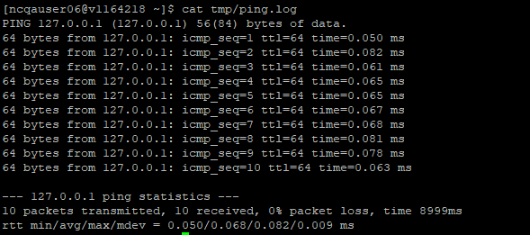

6) Add a reference to the ping command to the end of the ping.log file.



Result:

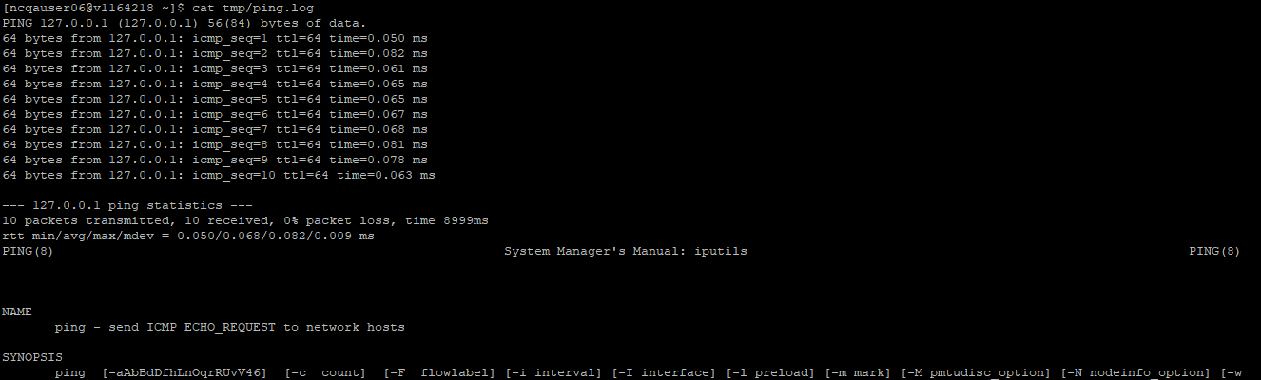

7) Count the number of lines in the ping.log file using the cat and wc utilities.



Result:



8) Create an empty file named sample.h in the tmp directory.



Result:



9) Using the tar utility, combine the three created files (sample.h, ping.log, colord.conf) into an archive. Next, use the bzip utility to compress the archive that was created by the tar utility.



Result:



10) Display the contents of the tmp directory, including hidden files, using the "long listing format" output.

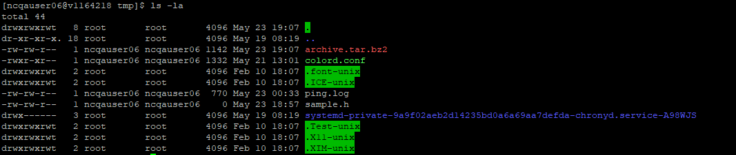

**11)** Вывести информацию только о процессе **init**.



12) Display information about which process is using the most CPU time at the current moment.



Result:

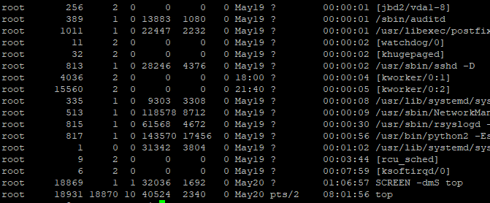

13) Display information about which process is using the most memory at the current moment.



Result:

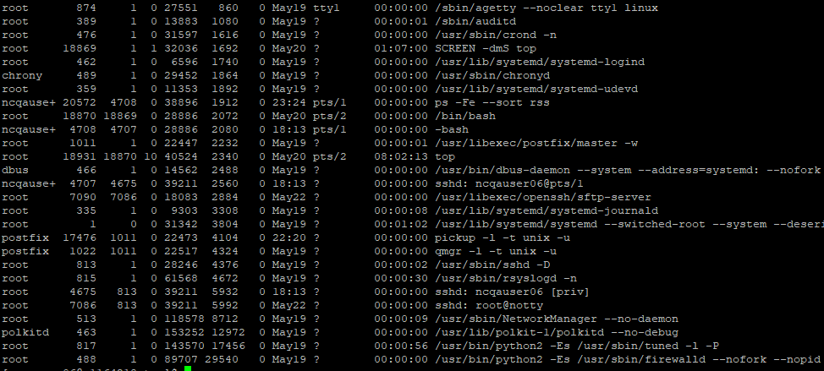

14) Find all files larger than 1Mb.

