1. Create a “Test” Environment and a URL variable for this Environment, it must be used instead of the server address in all requests

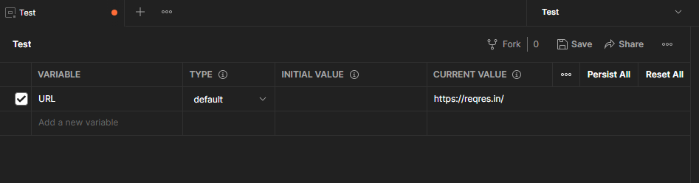

2. First request - Display ALL users

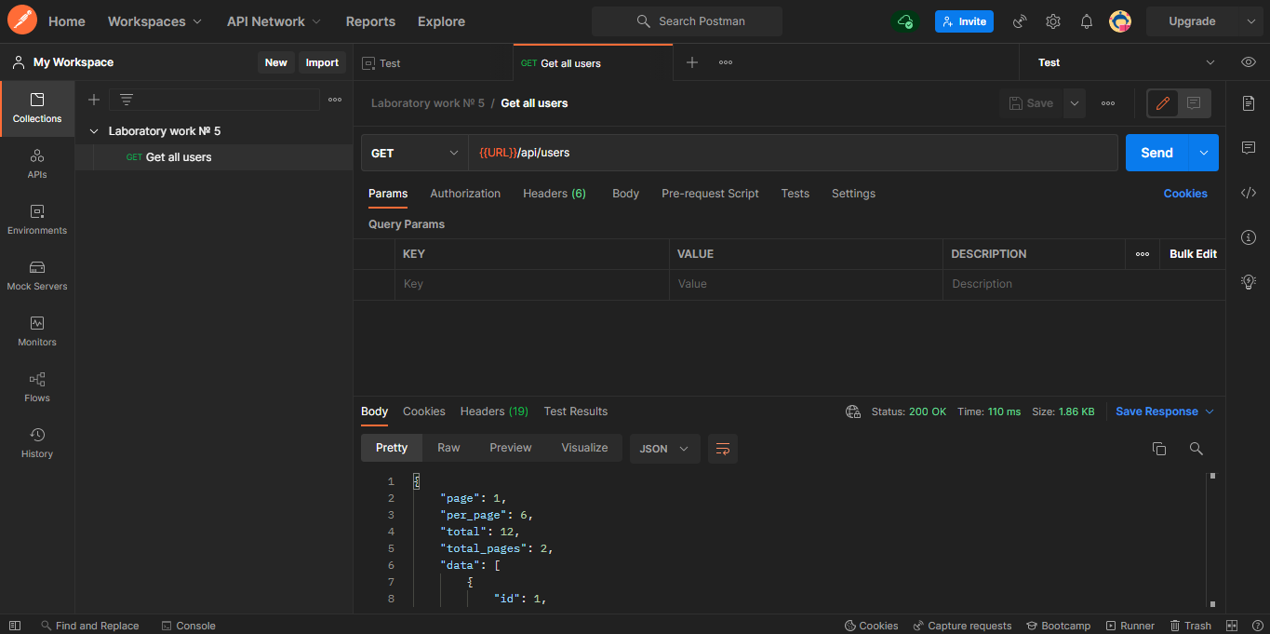

3. Second request - Create a new user by entering your Name and any position

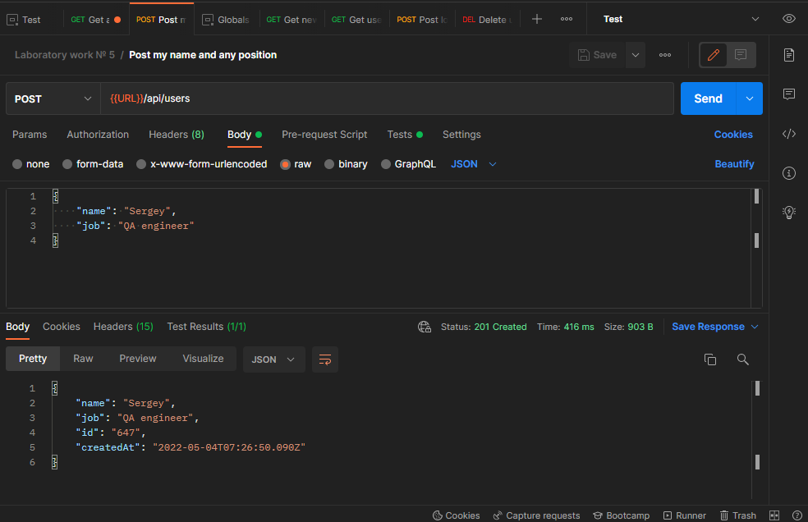

4. Third request - Display information on the newly created user [an error will be returned in response]

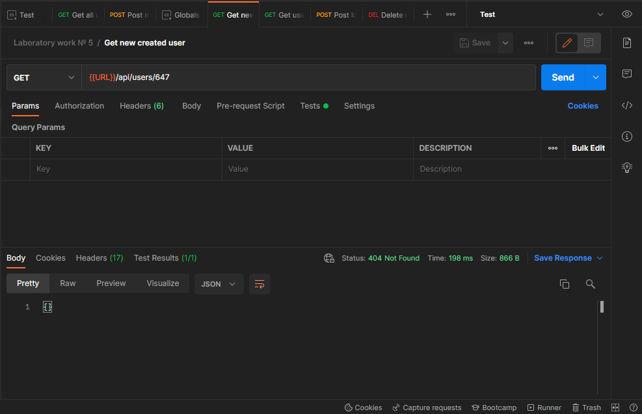

5. The fourth request - Display information on the old user [id in the range from 1 to 10]

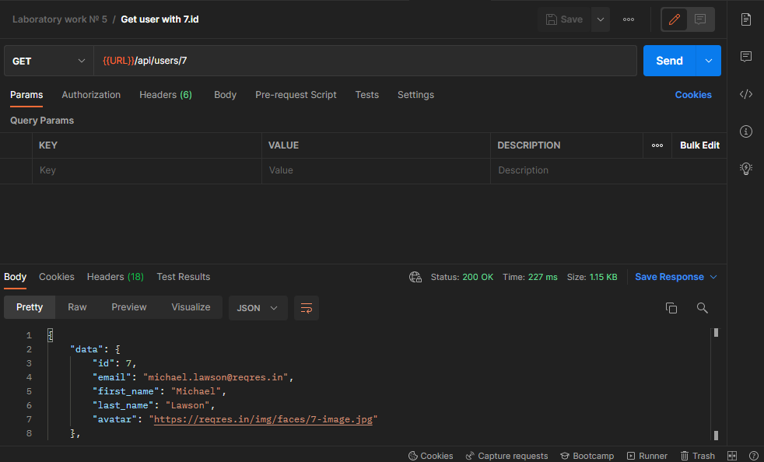

6. Fifth request - Perform the login operation with the user's e-mail from task 5 and any password. Create a global variable 'access_token' and fill it in from the response to this request (field 'token')

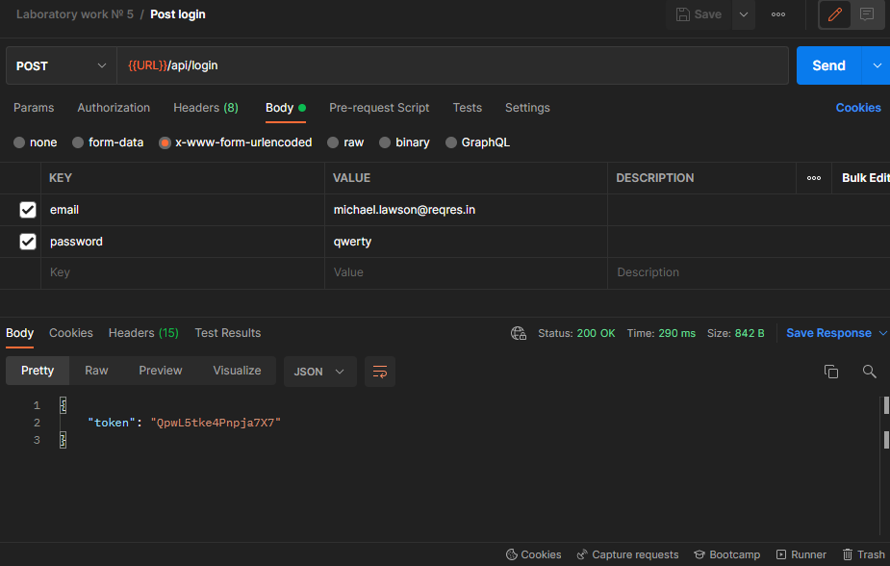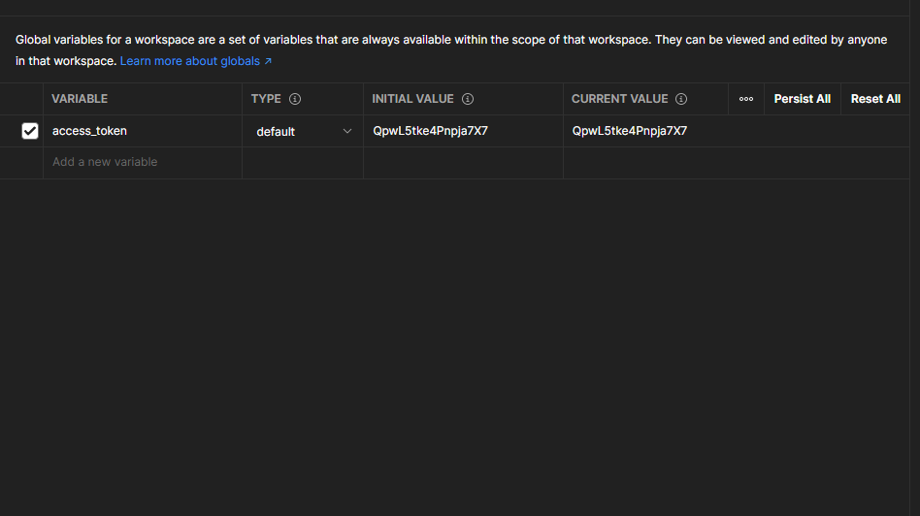

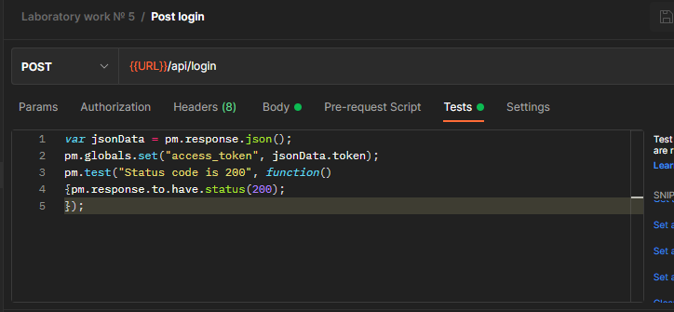

7. Sixth request - Update any information on the user from task 5, on the Authorization tab add the authorization type - Bearer Token and pass the global variable 'access_token' saved in step 6

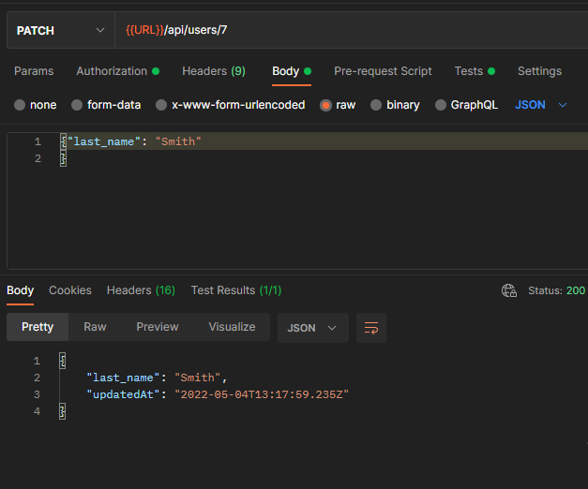

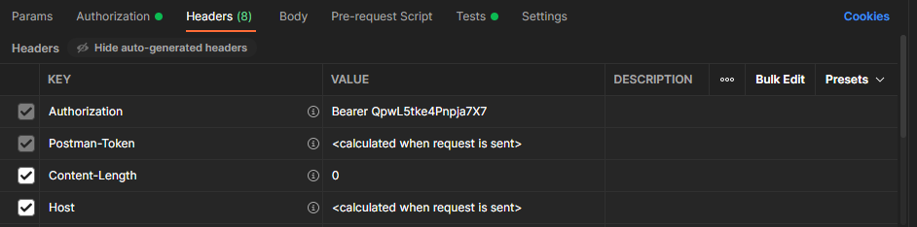

8. Seventh request - Delete the user from the 5th task, on the Authorization tab add the type of authorization - Bearer Token and pass the global variable 'access_token' saved in step 6

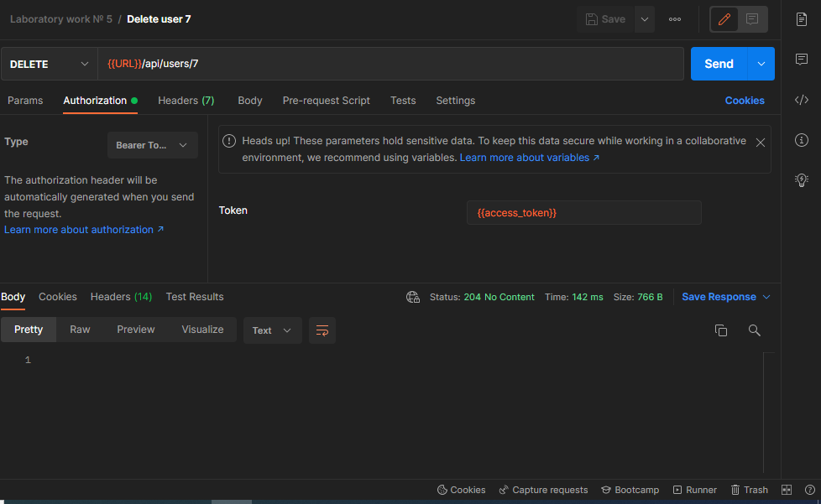

9. For all requests above, add a check for the HTTP code returned in the response

