# Web and Mobile Technologies B9IS124

# Lecturer Ehtisham Yasin

# CA1 Develop a responsive web application, optimised for mobile, tablets and desktop devices

# Group (2 members)

Student Name and Number: Sharon Farrell 10581193

Description:

Layout

Fonts

We looked at several fonts which have been designed specifically for use with sports and fitness websites including Proxima Nova, Avenir, Grot 10, Uniform, Brandon, Grotesque and Mollen. [typ.ie] We choose Uniform font.

Colour scheme

When we researched fitness websites and designed we noticed a lot of fitness and sports website used static dark colours, we decided to use a gradient colour scheme for the header and footer of the site and a mix of these colours through out the body of the page. We used [colorspace.com](http://colorspace.com) to generate the gradient. the mix of colours we used are purple, royal blue and tiffany blue. the gradient code is “background-image: linear-gradient(to right top, #361b85, #311e88, #2b218a, #23238d, #1a268f, #10379c, #0547a8, #0056b3, #0074c4, #008ec6, #00a5bf, #0abab5);”

The hex base colours are #361B85, #042992, #0ABAB5.

Layout of the website

Using Adobe XD we designed the first initial style. This design will be tweaked as we go through our design phase and layout of the website.

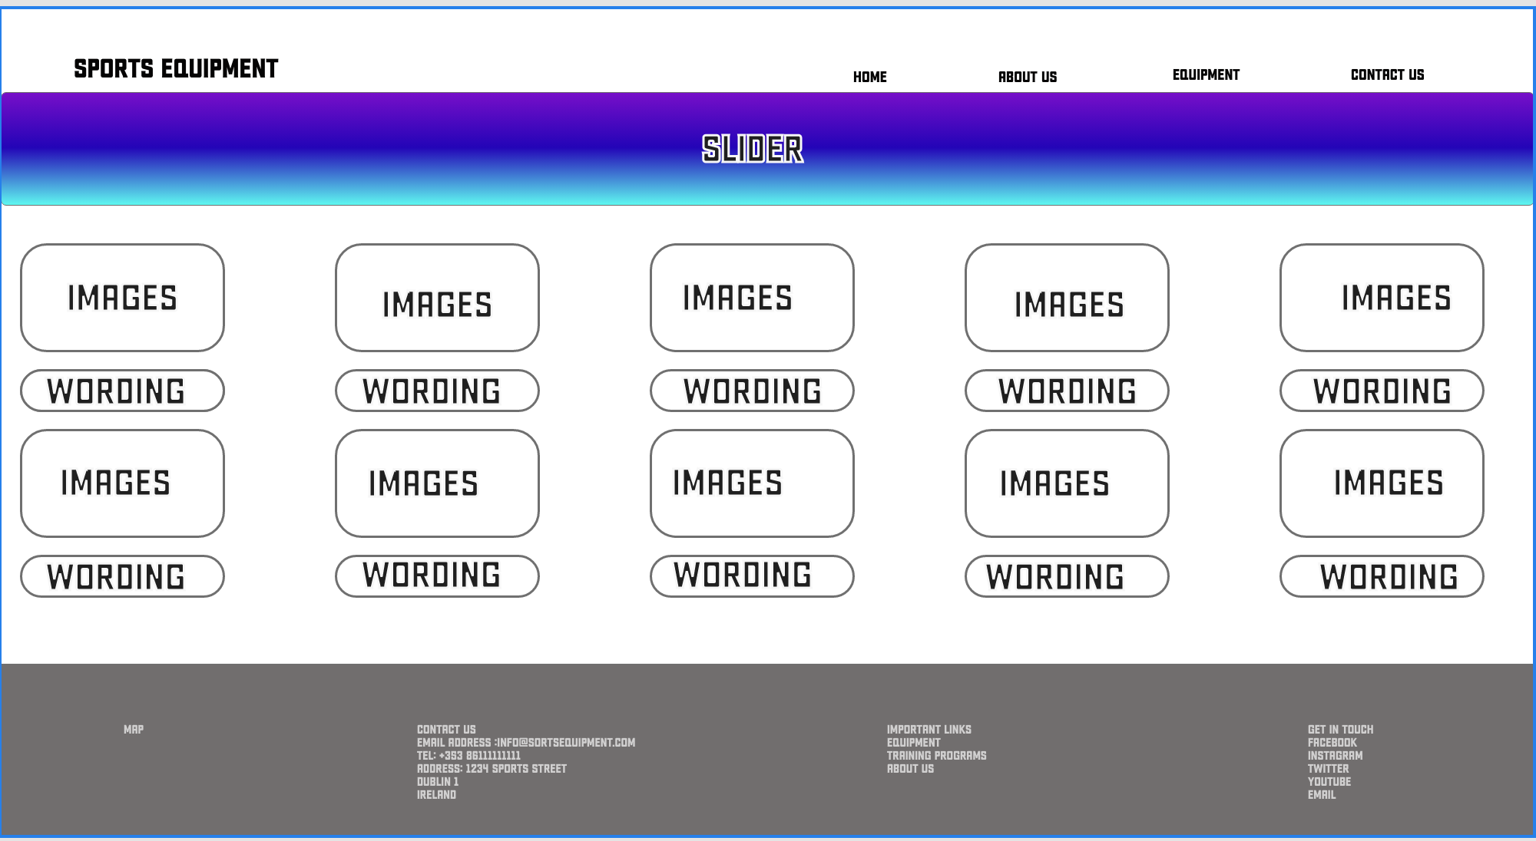

Reference

* <https://typ.io/tags/fitness>
* <https://mycolor.space>