**Project1a Report**

Pham Hai Dang – 20194736

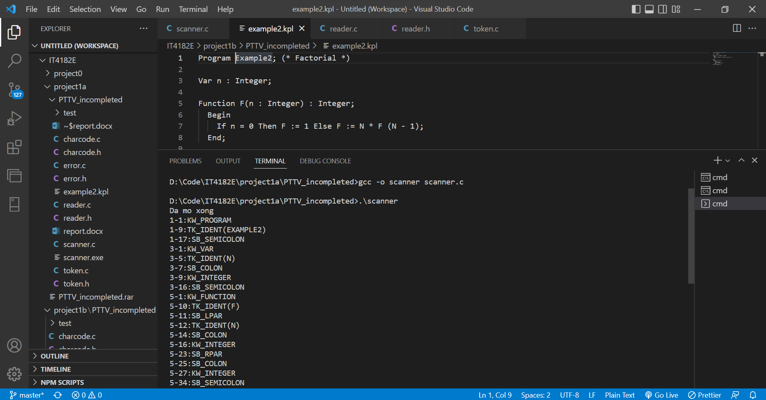

Result of running project1 with example2.kpl

Result with end of comment error

Result with error identification too long

Result with error invalid const char

Result with invalid symbol