**Project1b Report**

Pham Hai Dang – 20194736

Replace the lexical rules of the KPL language with the following rules:

Identifiers: A valid identifier can have letters (both uppercase and lowercase letters), digits, the dollar sign ($) and the underscore (_)

1.The first letter of an identifier should be either a letter or an underscore.

2.You cannot use keywords as identifiers.

3.Length of an identì?er is not over than 15.

4.Identifiers are case-sensitive

Keywords: All keywords must be written in uppercase

Comments: Multi-line Comments : between /* and */

Special Symbols: Relop: not equal to <>

Character/String constants: Use an addition character \ for 2 constants single quote and backslash, that is ‘\’’ for a single quote and ‘\\’for backslash.

Program result with underscore and dollar in identifier

I add two more characters as CHAR_DOLA and CHAR_UNDERSCORE, if we scan an underscore, program will call readIdentKeyword function.

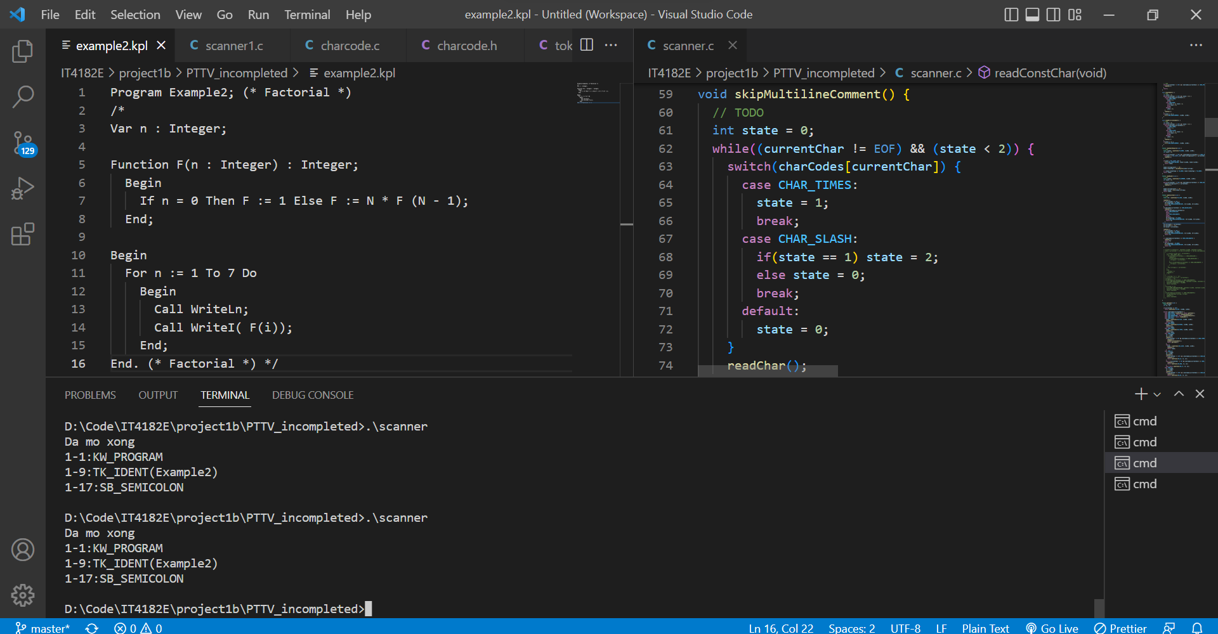

Program result with multiline comment

I create a skipMultilineComment function as in image. When we scan slash letter, then we check next letter, if get time character, we call above function.

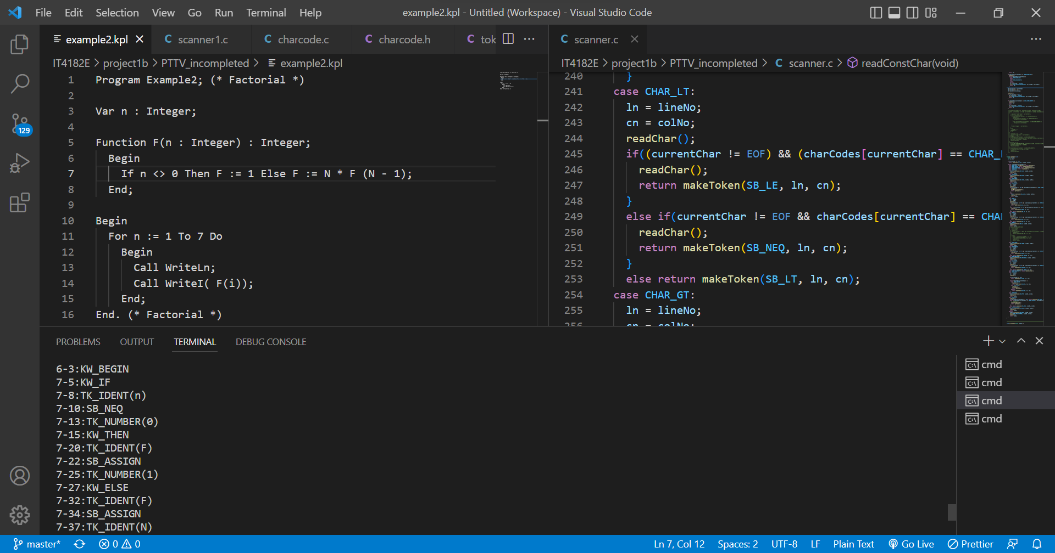

Program result with new unequal <>

I modify the case less than as above and remove exclaimation character.

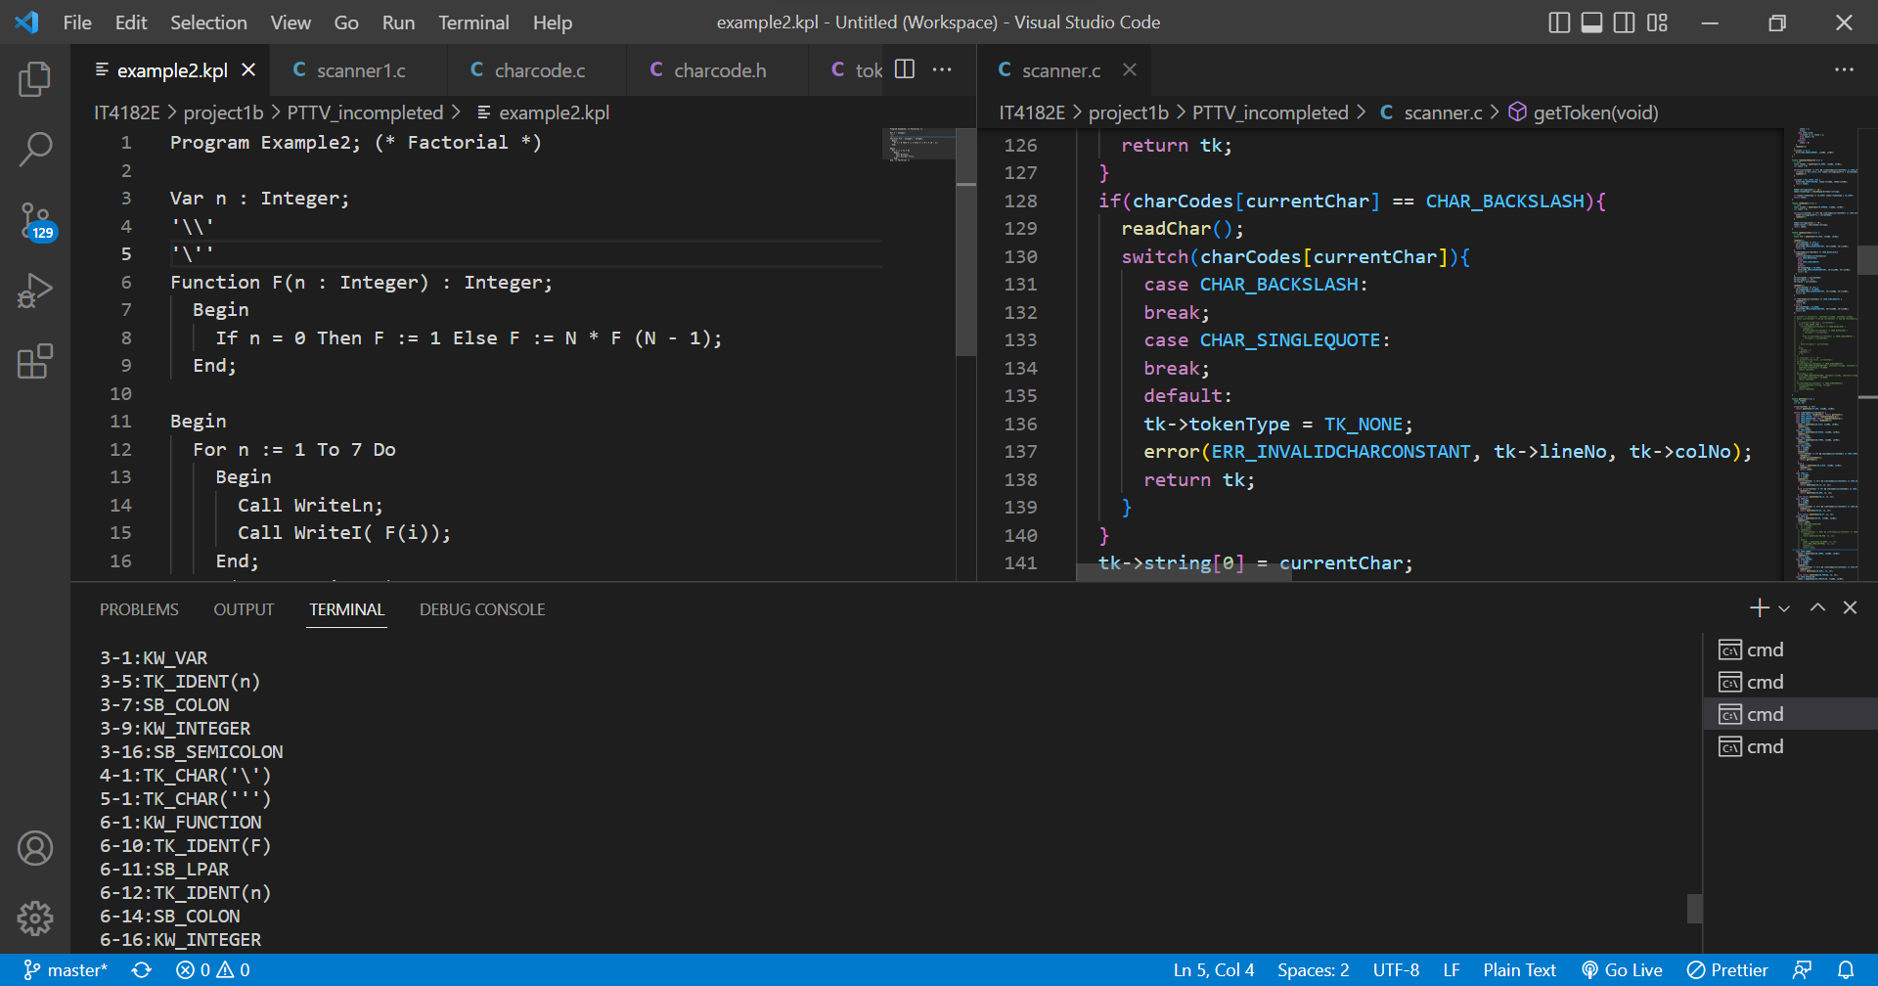

Program result with including backslash and singlequote in const character

I modify the readConstChar as in image.