**Project2a**

**Phạm Hải Đăng 20194736**

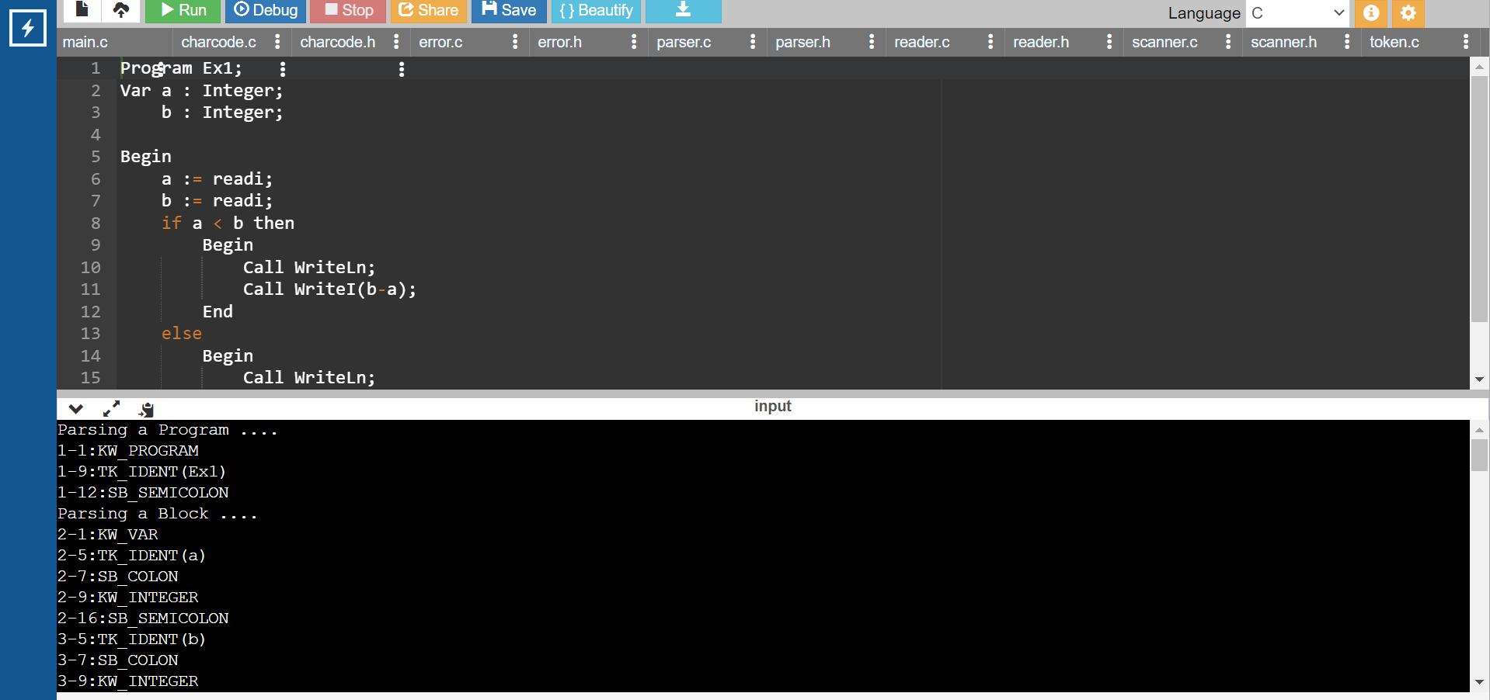

Result with file ex1.txt

Result with file example2.kpl