**Project2b**

**Phạm Hải Đăng 20194736**

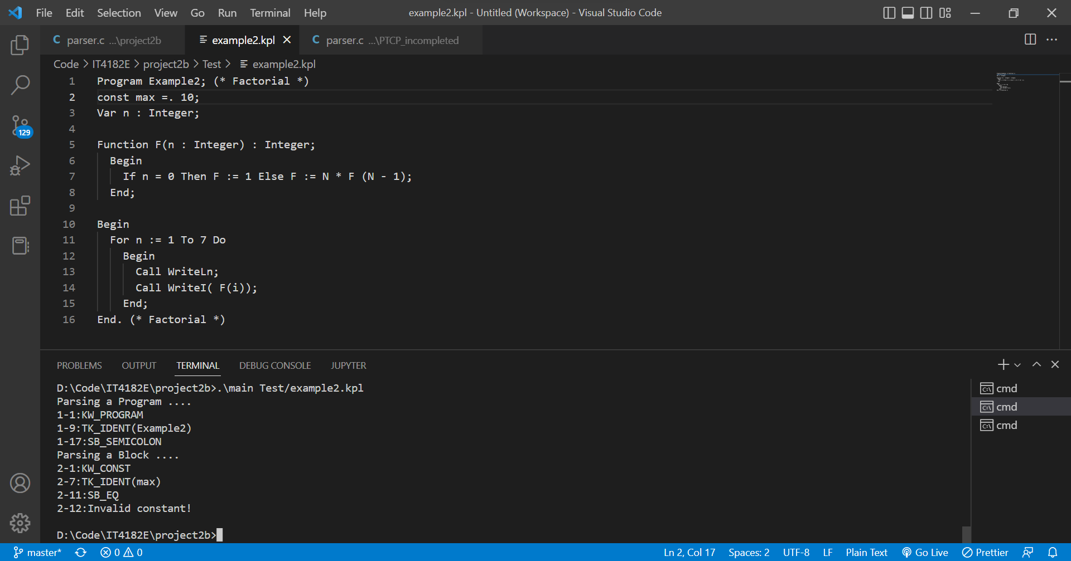

Example2 with error invalid constant

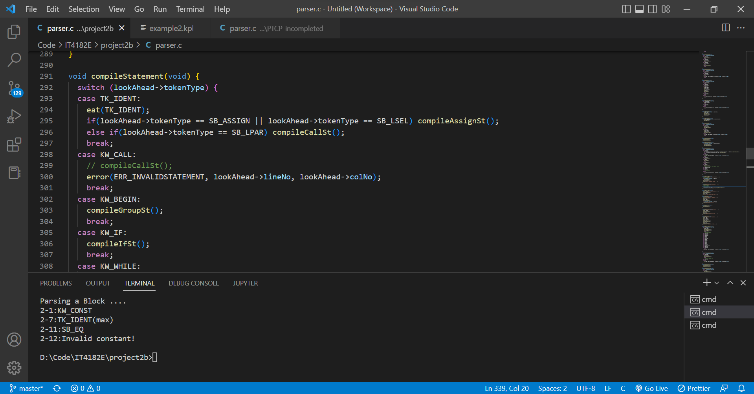

I modify compileStatement function: if meet keyword CALL, we notify error INVALIDSTATEMENT. Now in caseTK_IDENT, we have two cases as compileAssignSt and compileCallSt.

For each case I check the next token after TK_IDENT: if it is SB_ASSIGN or SB_LSEL, we compile assignment statement, if it is SB_LPAR, we compile call statement.