Project3c Report

Pham Hai Dang – 20194736

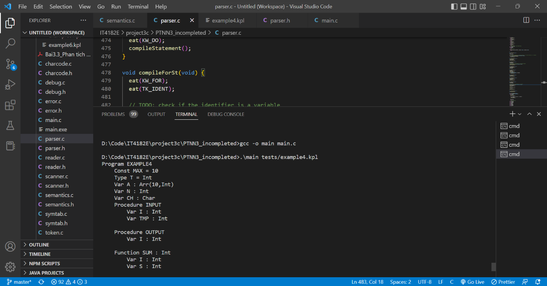

Result of running with example4.kpl

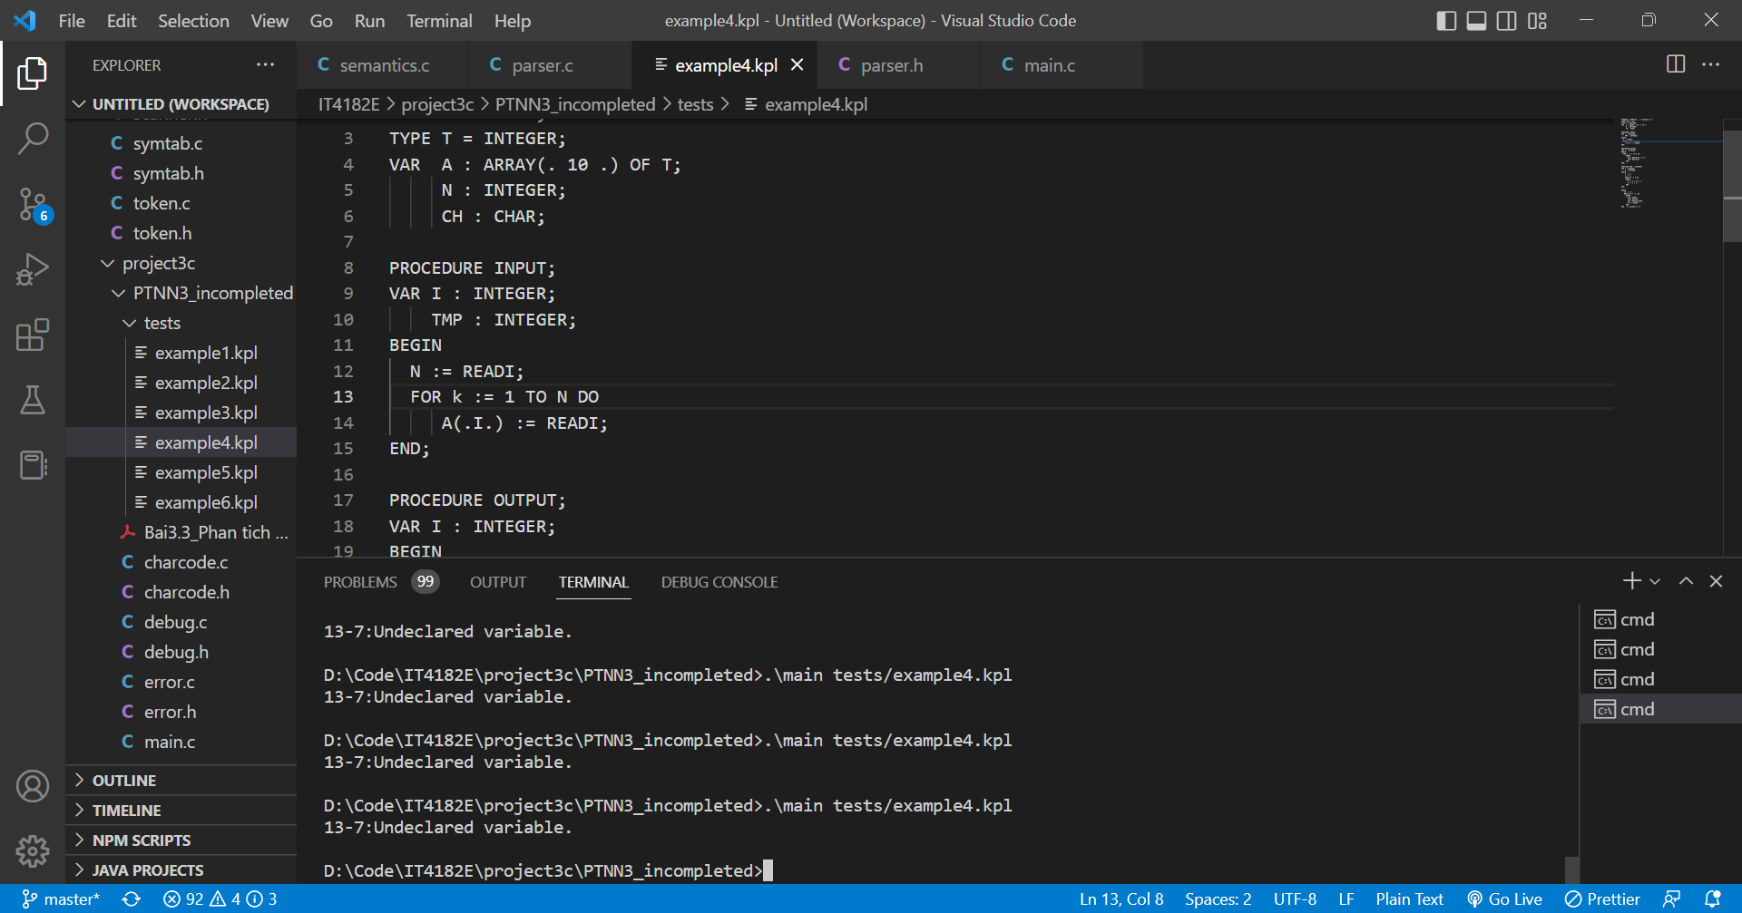

Modify exampl4.kpl to get Undeclared variable: In for loop, we use another identifier that is not declared before (I use k instead of I)