**Compiler lab report**

Phạm Hải Đăng – 20194736

Result of running example2.kpl

Result of running modified example2.kpl

This error happens when we assign the type of variable n is integer, but assign its value as a character (n = ‘a’)

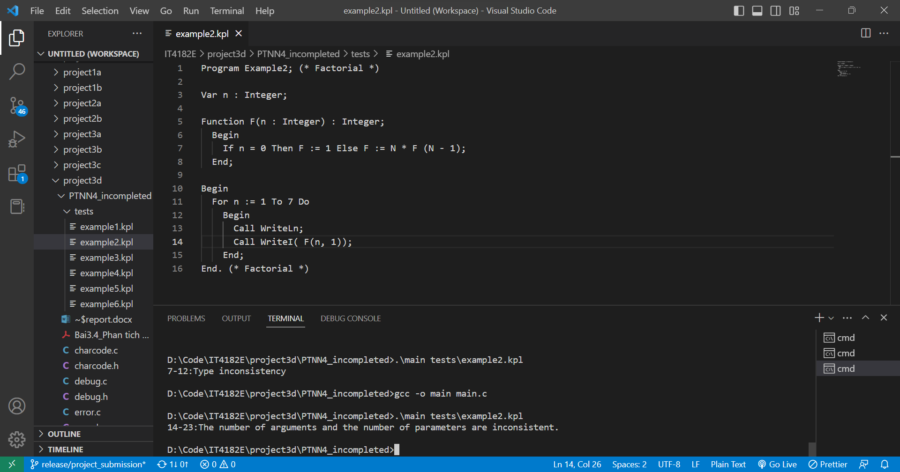

Result of running modified example2.kpl

This error happens when we use less or more number of arguments in a function than we has declared before