**Báo cáo thực hành tuần 11: Thiết kế mạch Mux 2-1, Mux 2-1(2 bits), Mux 4-1**

**1 Mux 2 to 1**

<https://www.multisim.com/content/DANakasEZzGLVmeU2HYzvi/week11-mux2to1/>

Mux 2 to 1 using AND, OR, NOT gates to pass one of two inputs through to the output. In this figure, if S3 is 0, the output signal is as same as S1 input. If S3 is 1, the output signal is as same as S2.

<https://www.tinkercad.com/things/kJu07DckYMh-week11-mux2to1>

**Mux 2 to 1 using 2 bits**

<https://www.multisim.com/content/LLVn5sSX2Th8WVVNsFEjBY/week11-mux2to12bit/>

In this circuit, we combine 2 Mux 2 to 1 to make above circuit and get 2 outputs. Each output signal is as same as in the Mux 2 to 1 using 1 bit.

<https://www.tinkercad.com/things/1mLEjfKmWRS-week11-mux2to12bits>

**Mux 4 to 1**

<https://www.multisim.com/content/C2YYVXpgrh4ZDHWKWucJmC/week11-mux4to1/>

In this circuit, we combine 3 Mux 2 to 1 to get 1 output signal. The output signal is as follow:

|  |  |  |
| --- | --- | --- |
| S0 | S1 | Output |
| 0 | 0 | X |
| 1 | 0 | Y |
| 0 | 1 | W |
| 1 | 1 | Z |

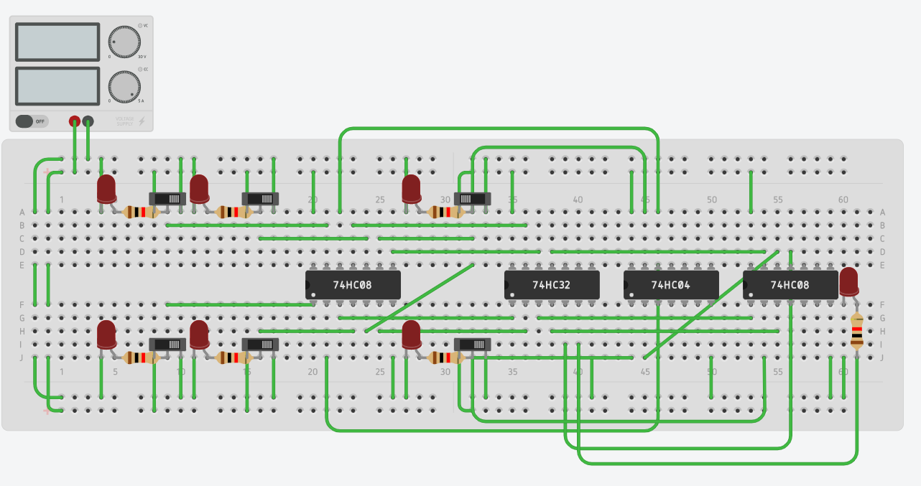

<https://www.tinkercad.com/things/kMerPaNHLHQ-week11-mux4to1>