Lab report 5

**Lab1:**

Result:

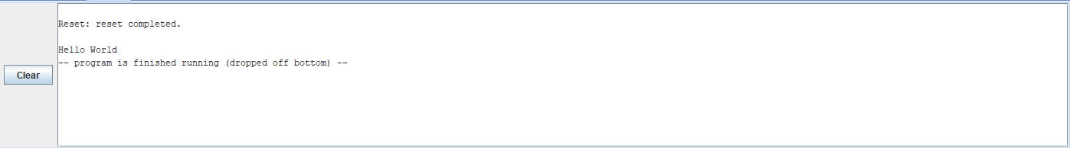

Data memory section:



**Lab2:**

$s0 = 24

$s1 = 56

$s2 = $s1 + $s0 = 80



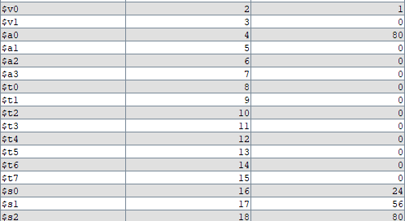

**Lab3:**

Address of x: 0x10010000

Addess of y: 0x100103e8

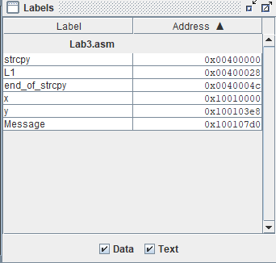

Value of y:

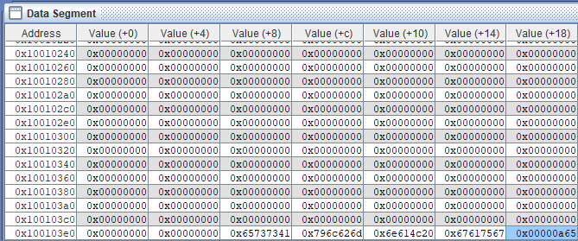

Value of x:

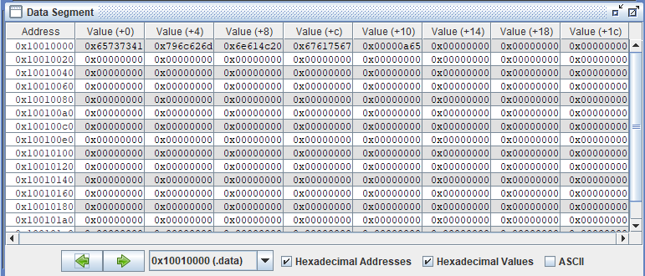

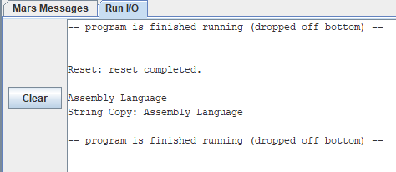

**Lab4:**

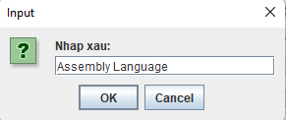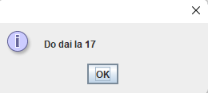

**Lab5:**

