**Debug Report**

**Pham Hai Dang - 20194736**

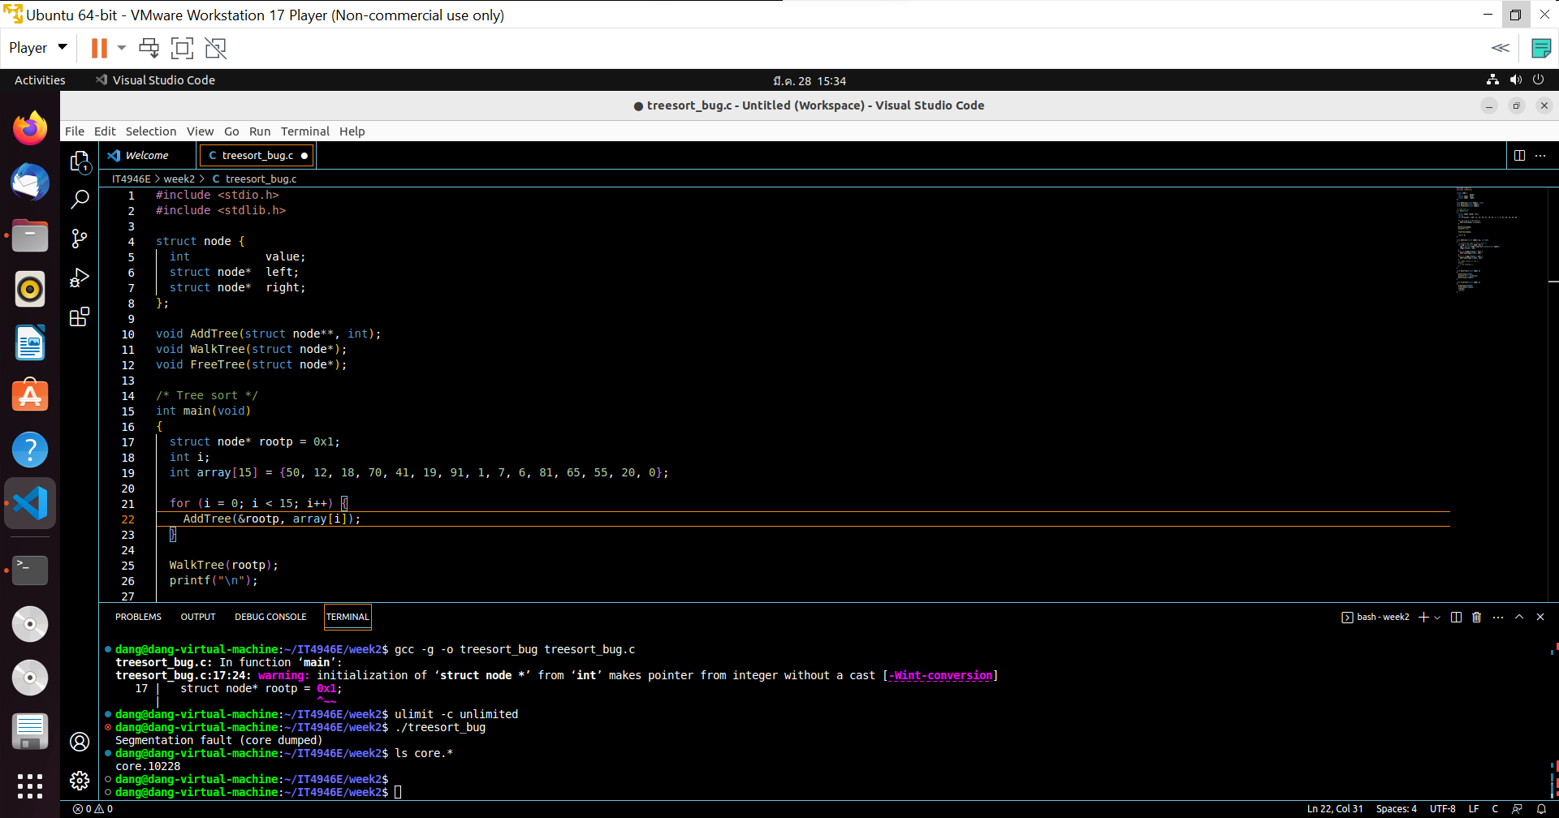

Generate core dump when running program

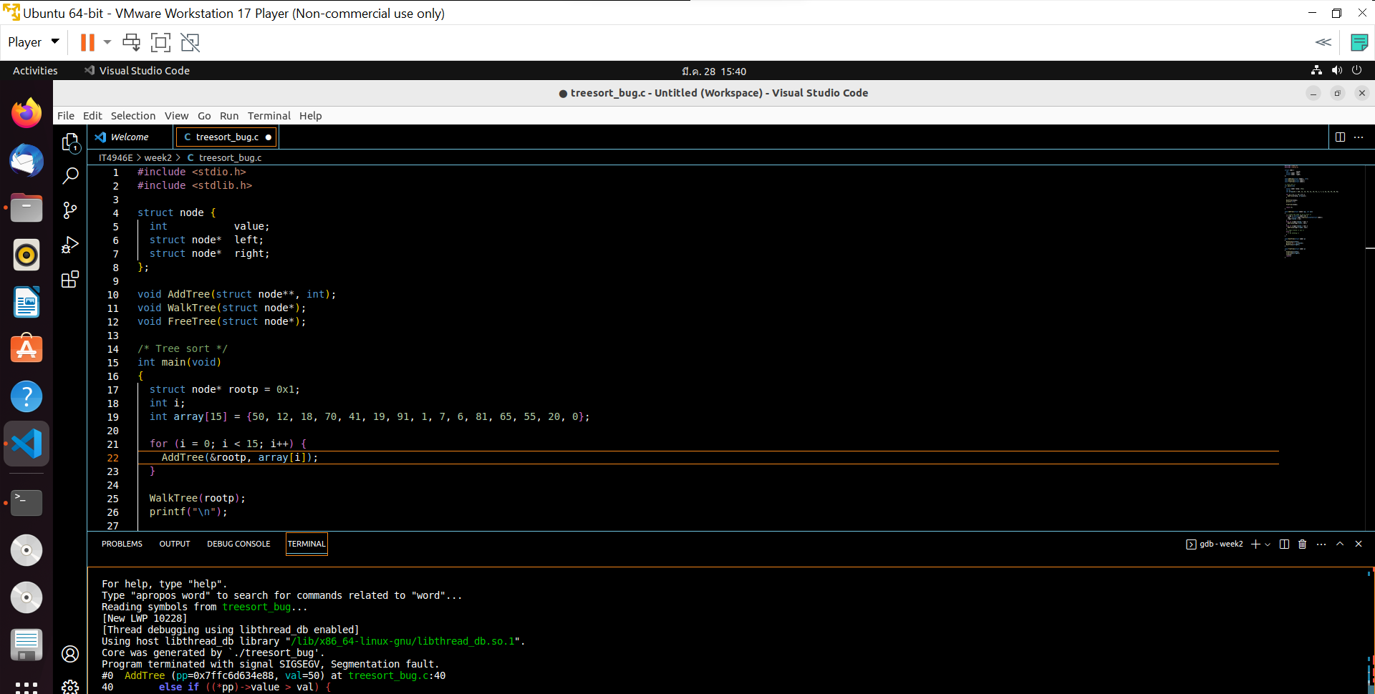

Debug with above core dump

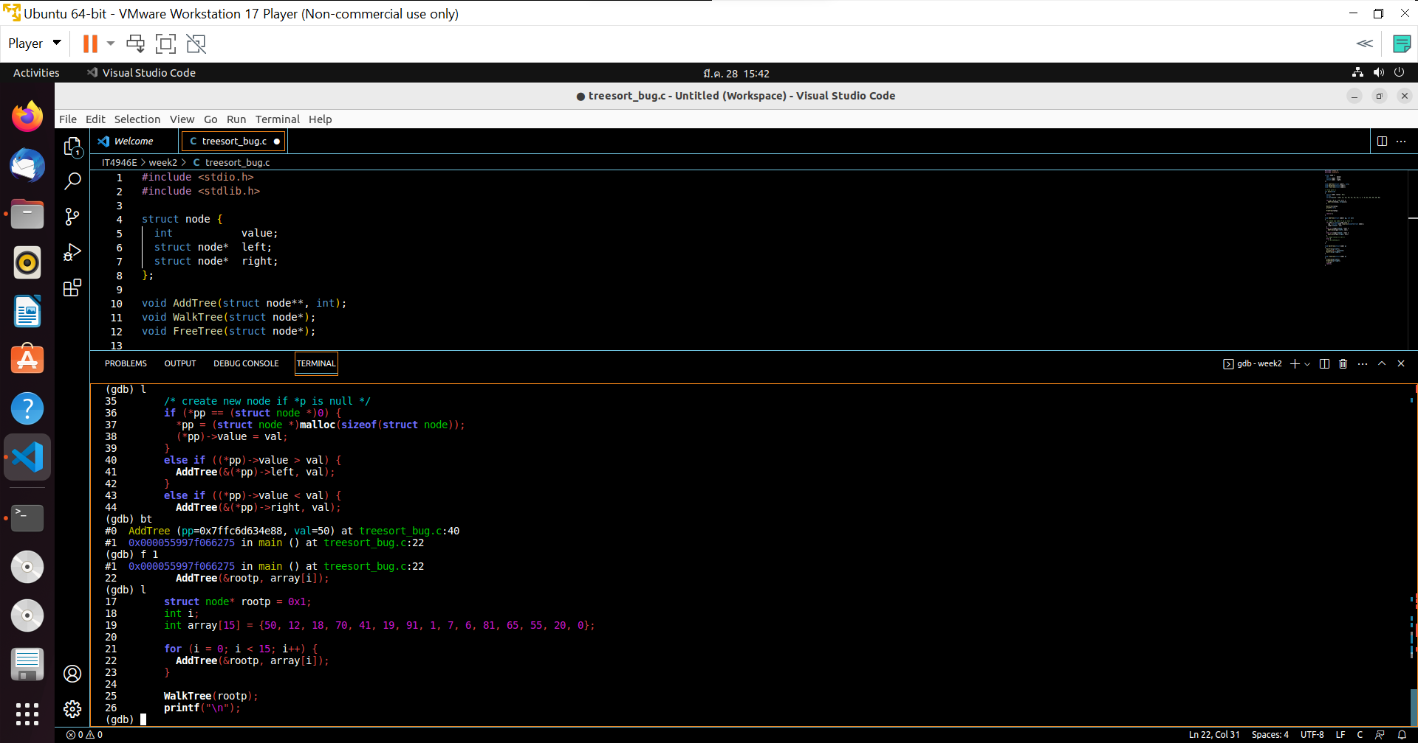

The error occurs by AddTree() -> move to to AddTree() -> list function AddTree()

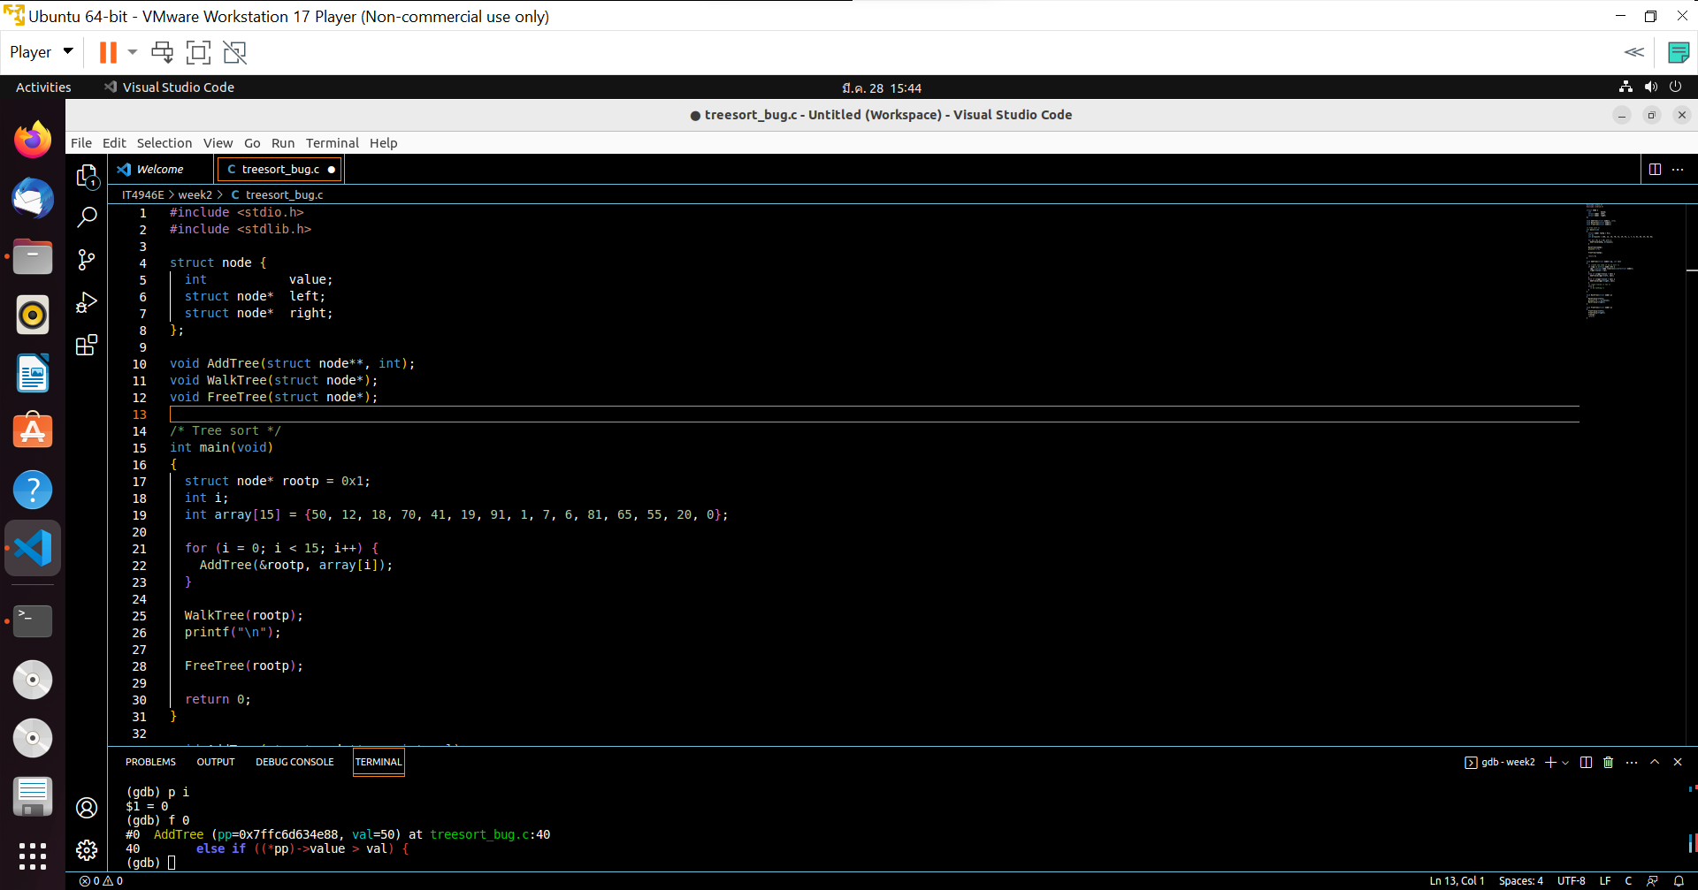

Command ‘p i’ use to calculate number of loop = 0 -> fail in first call -> move to next frame

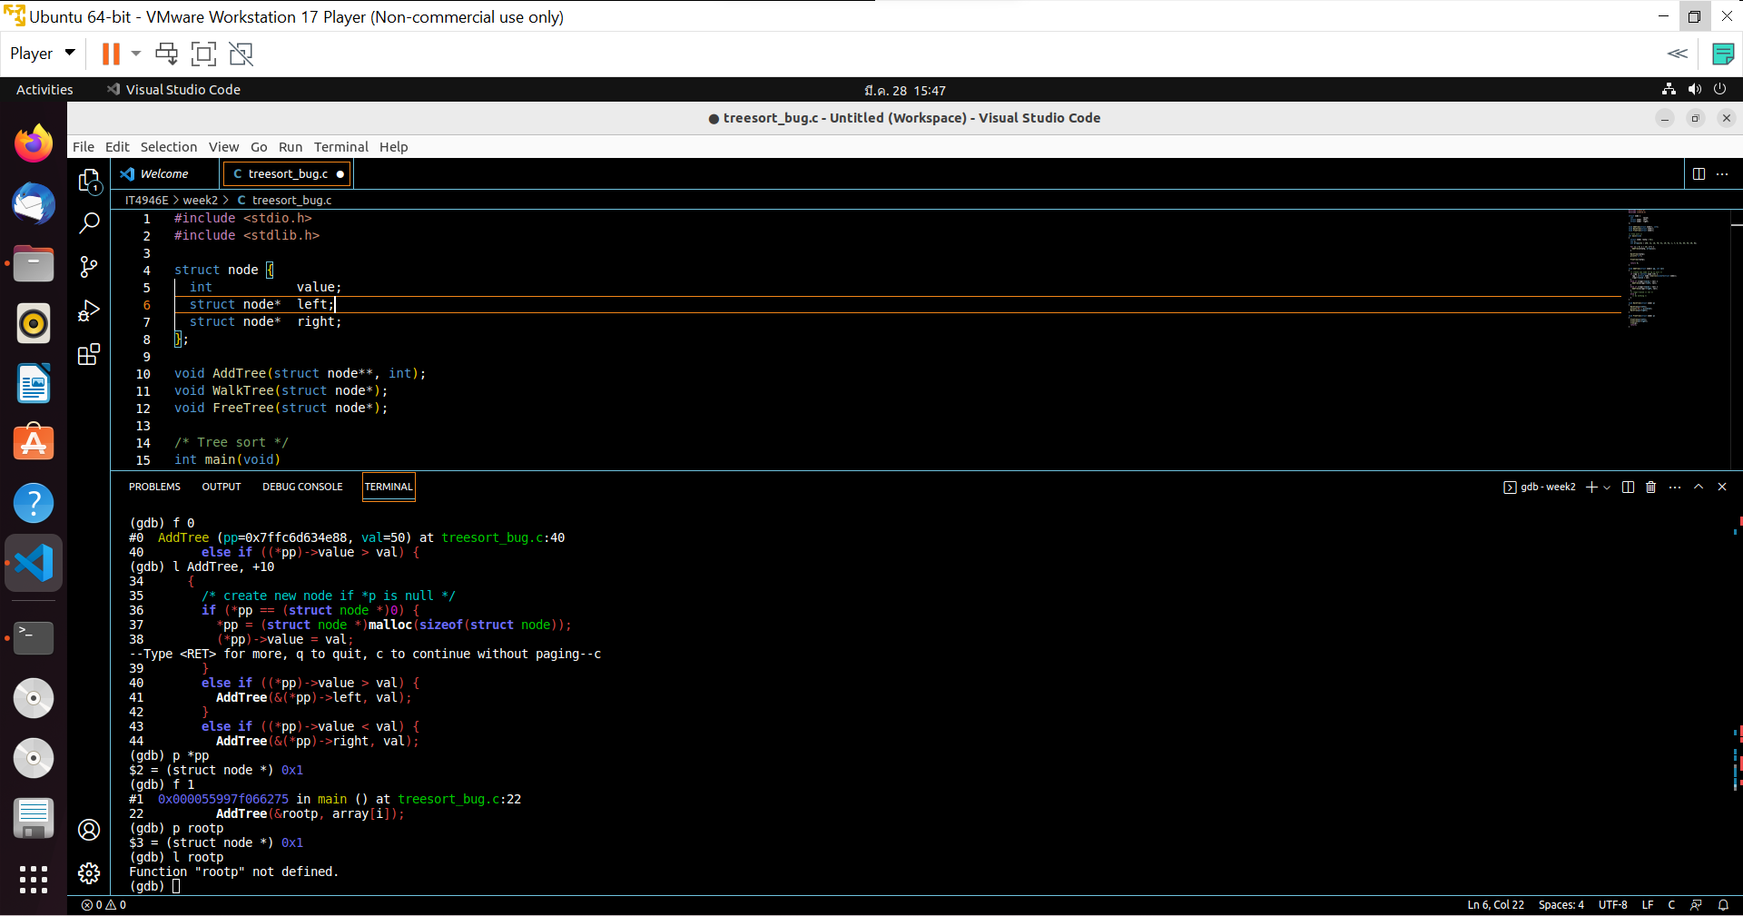

Bug is that value of pp is not 0 -> need to change rootp to NULL

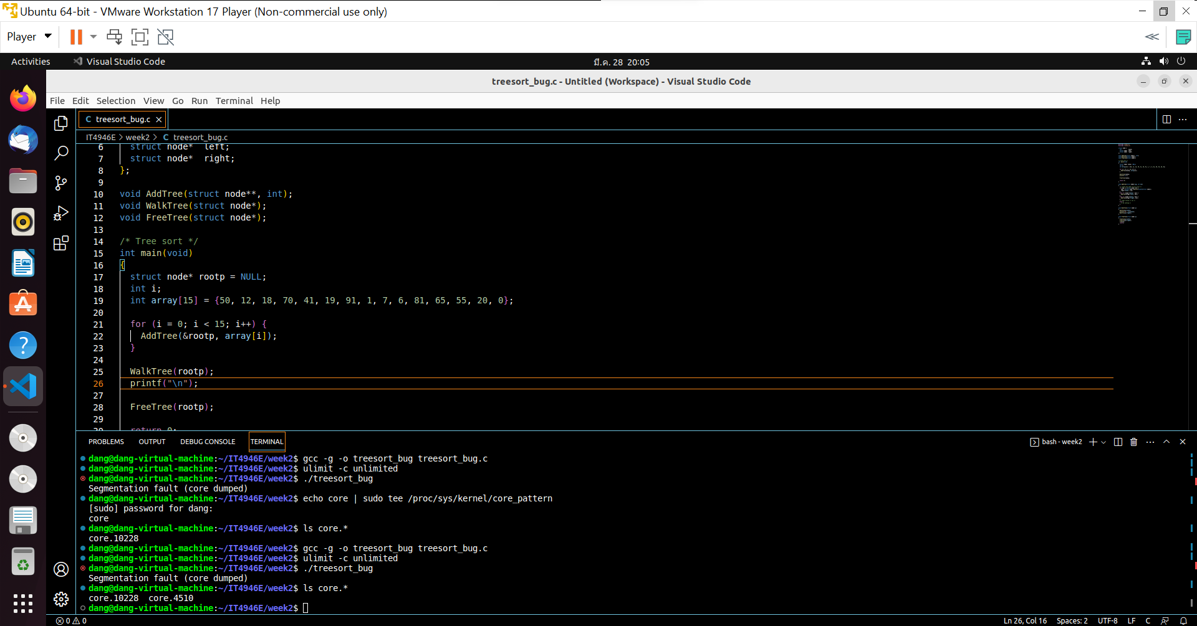

After fix above bug, we run again to generate new core dump: core.4510

We run that core dump, then use command ‘bt’

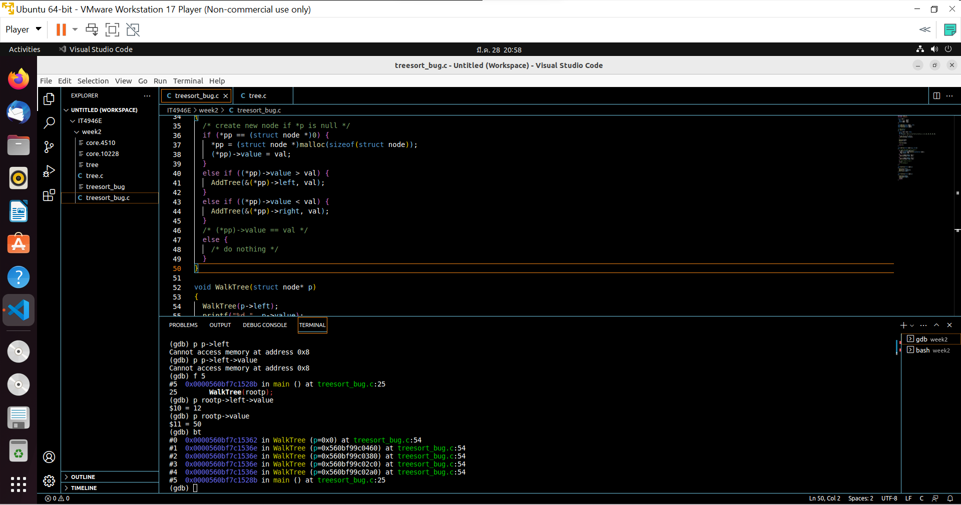

Next bug is in walkTree()

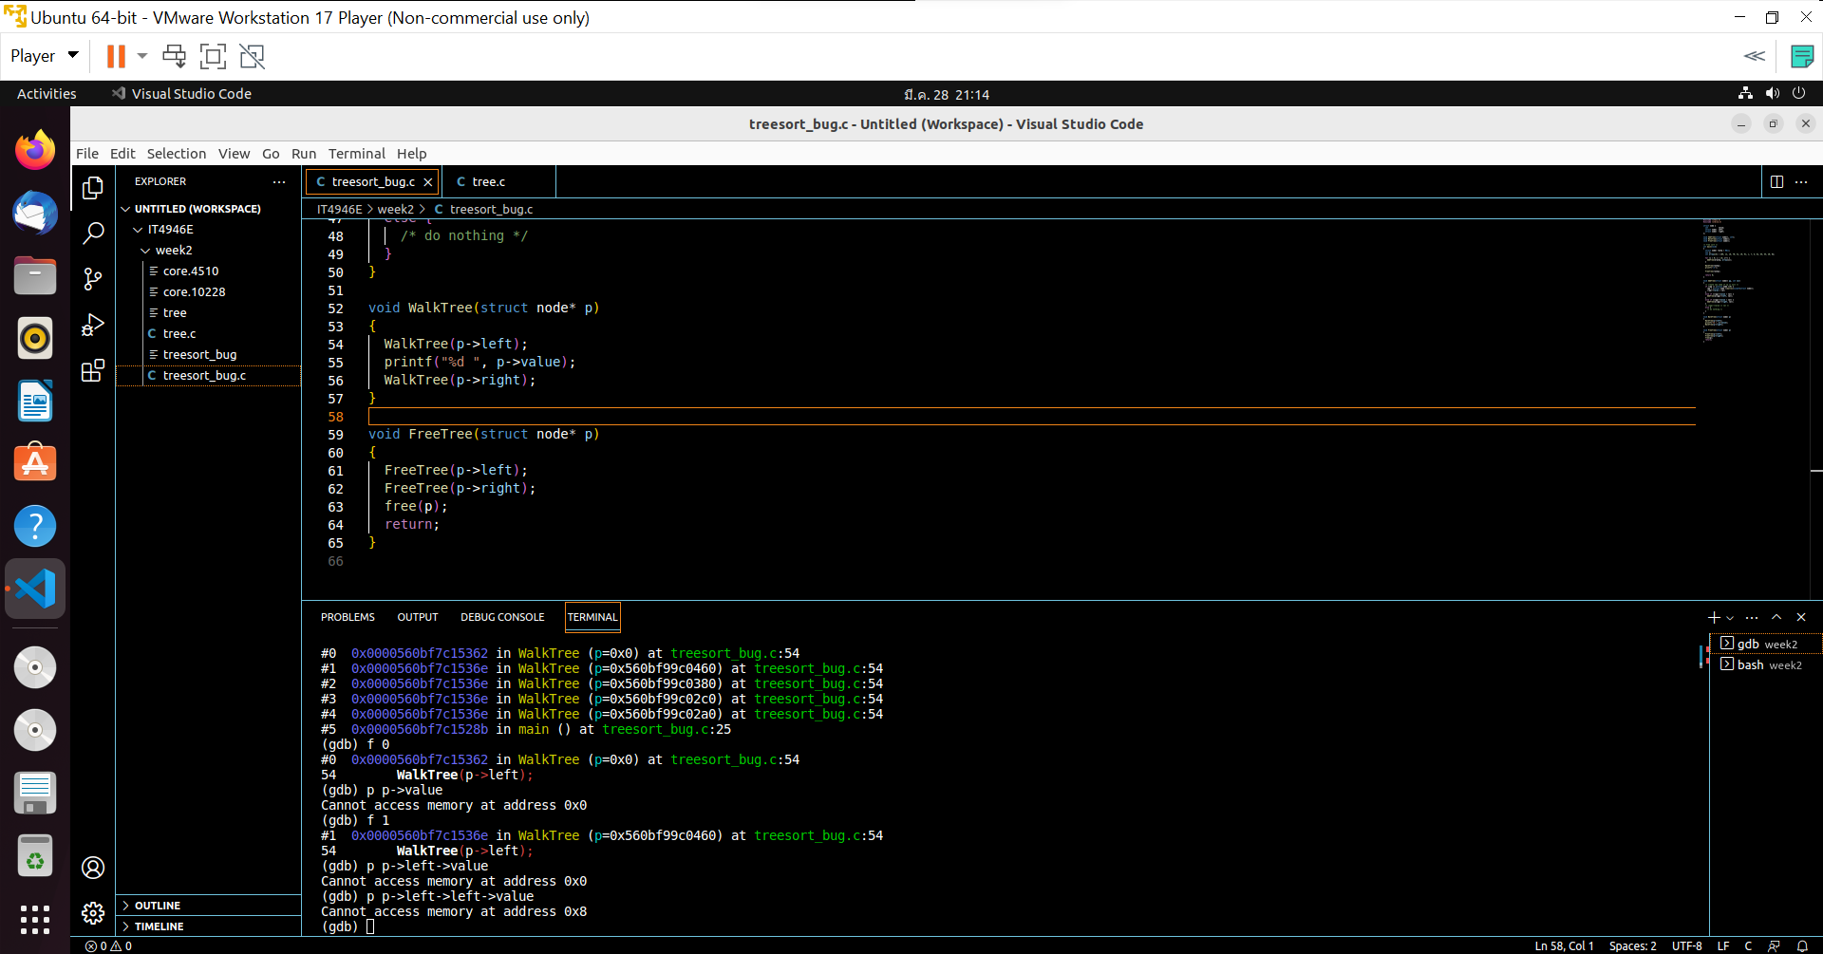

We need check each node with NULL to fix above bug

The improved version here

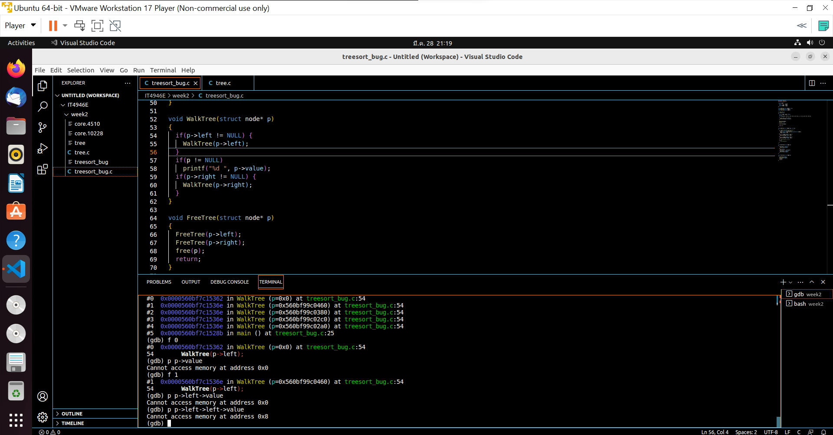

Similar to walkTree(), we check NULL for each node in function freeTree()

Final code and result here

