**Lab Report**

**Pham Hai Dang - 2019436**

**7.2**

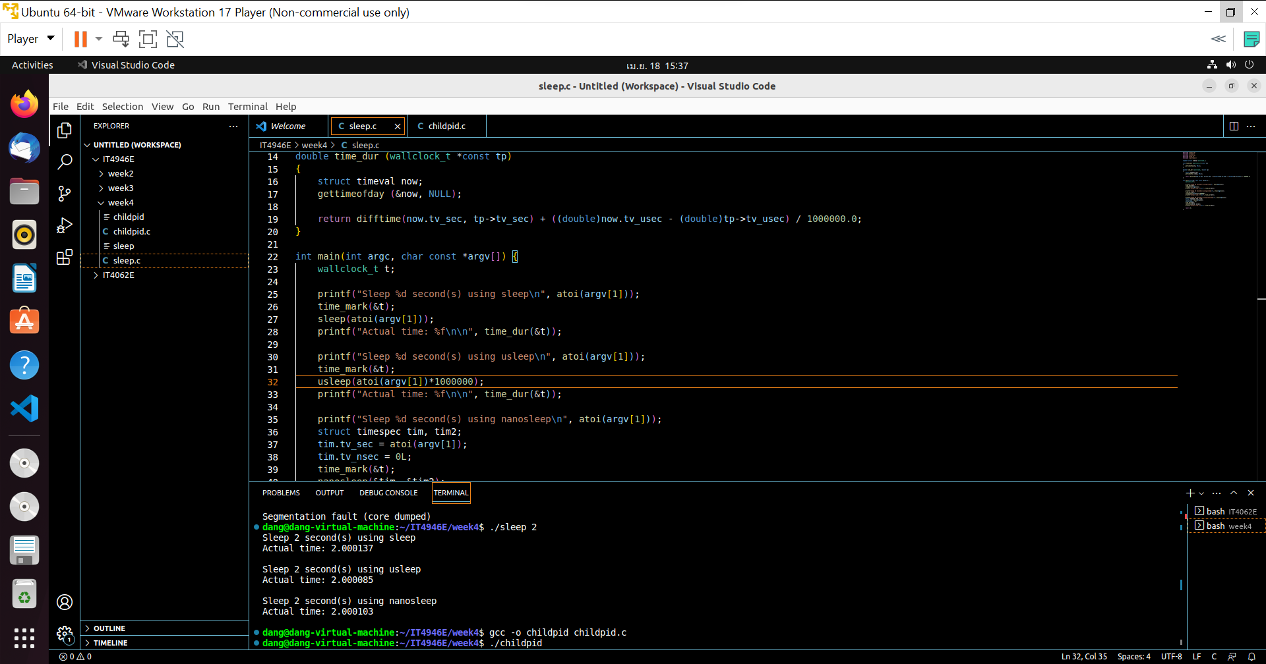

There are different in result of three sleep function because system is busy with other tasks

**7.3**

Shell execution

program uses the system() function to execute the command "ls -l" in a shell. The system() function takes a string argument that specifies the command to execute in the shell. In this case, "ls -l" will list the files in the current directory in a long format.

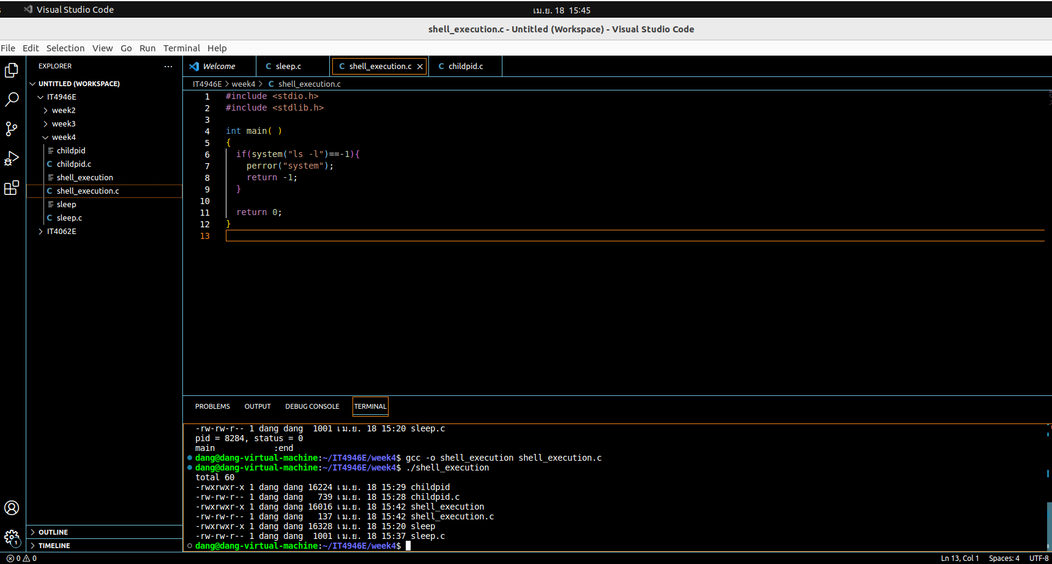

Popen stream

this program executes the "netstat" command, reads its output from a pipe, and prints the output to the console

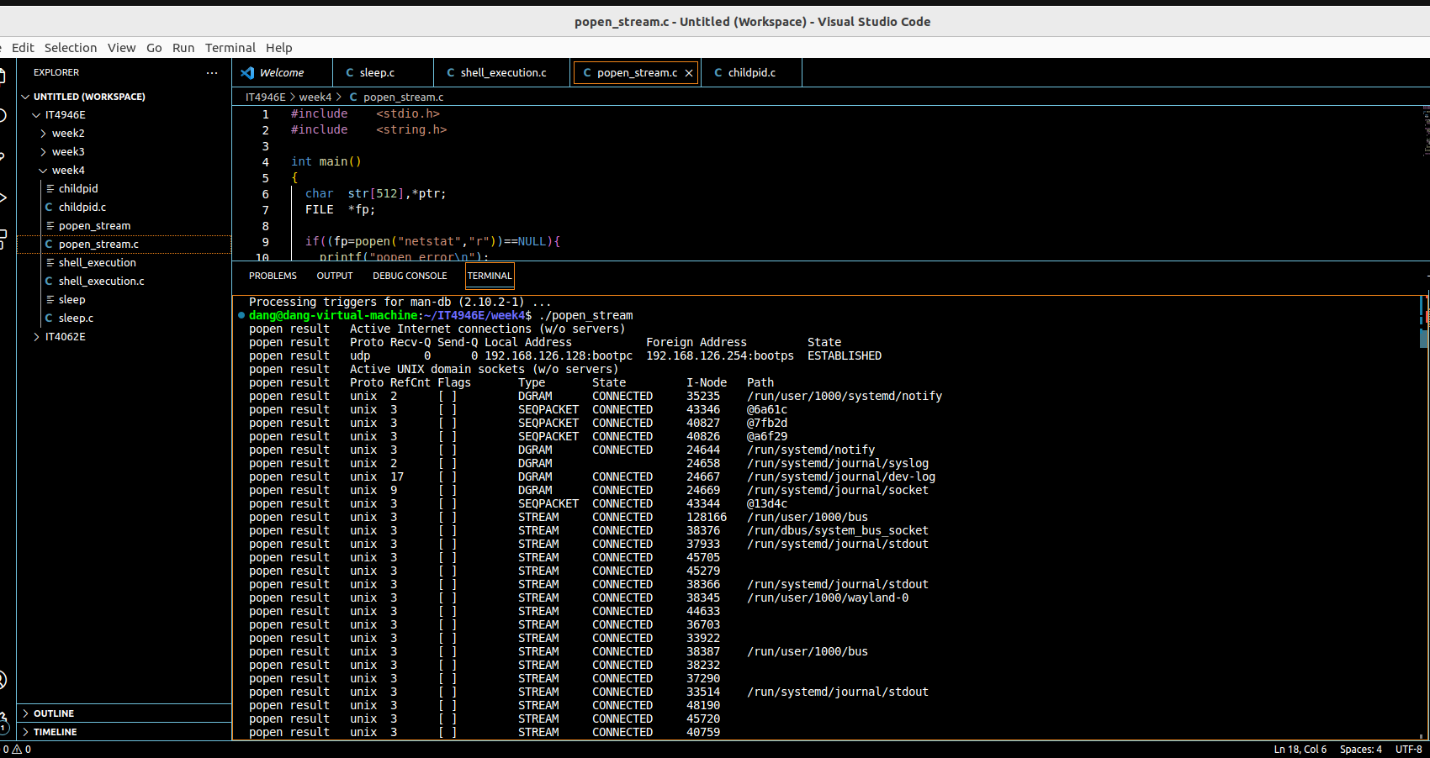

**7.4**

The program forks a child process and uses the execvp function to replace the child process with the ls command, which lists the contents of the current directory. The parent process waits for the child process to exit and then prints its exit status.

This section of the code forks a child process and enters an infinite loop in which the child process prints a message once per second. The parent process prints the PID of the child process and instructs the user to end the child process by sending a kill command from the console. The parent process waits for the child process to exit and then prints its exit status.

In this section of the code, the program forks a child process that sleeps for three seconds and then exits. The parent process immediately exits without waiting for the child process to finish. This section demonstrates what happens to the child process if the parent process does not wait for it to exit.

In this section of the code, the program generates and ends two child processes using a for loop. Each child process prints a message, sleeps for two seconds, and then exits. The parent process waits for both child processes to exit and prints their exit statuses.

