**Report**

**Phạm Hải Đăng - 20194736**

**7.5**

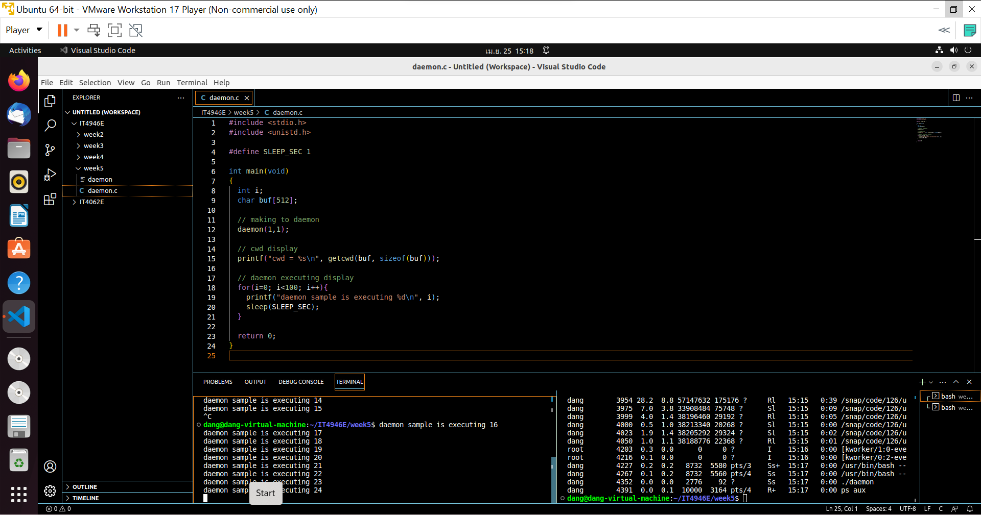

We cannot kill daemon commonly

To kill daemon, we use command kill [pid] as in figure

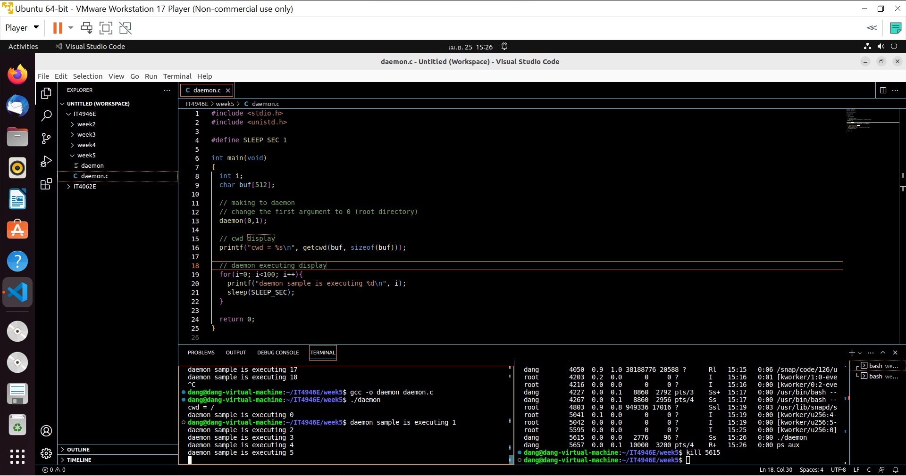

The first argument define the current working directory, I change to 0 and cwd now is the root directory

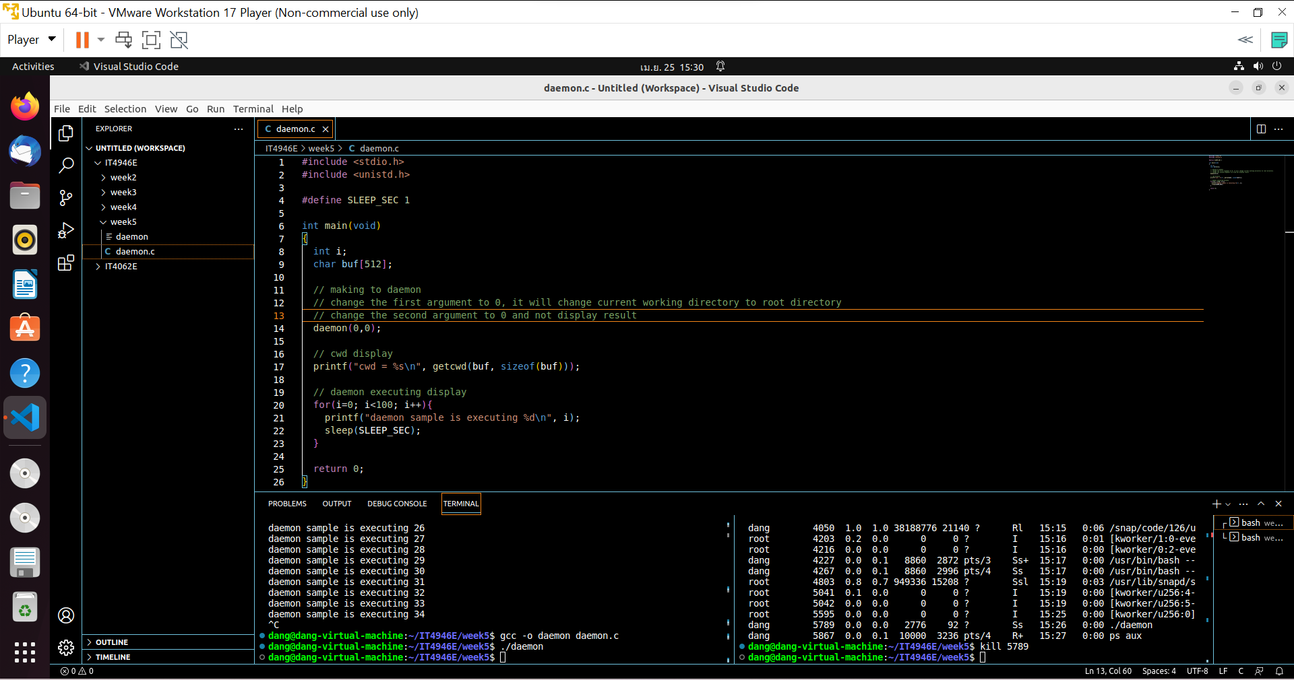

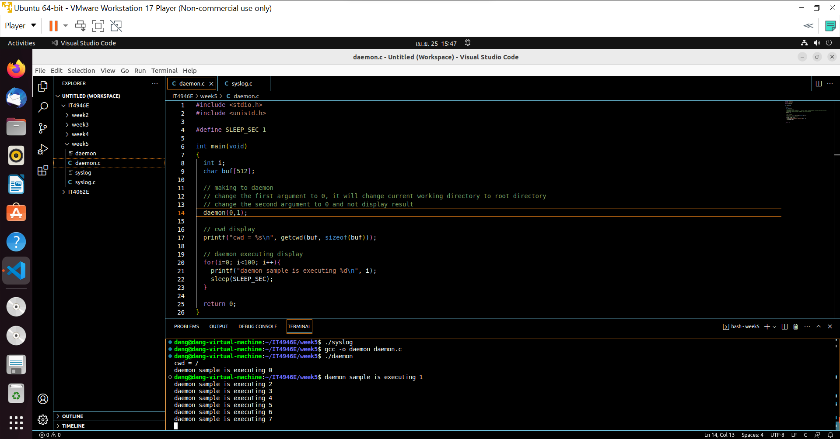

The second directory redirect the standard output, and I set to 0 to present a standard error (and will not display)

I set to 1 and it present a standard output as in figure

**7.6**

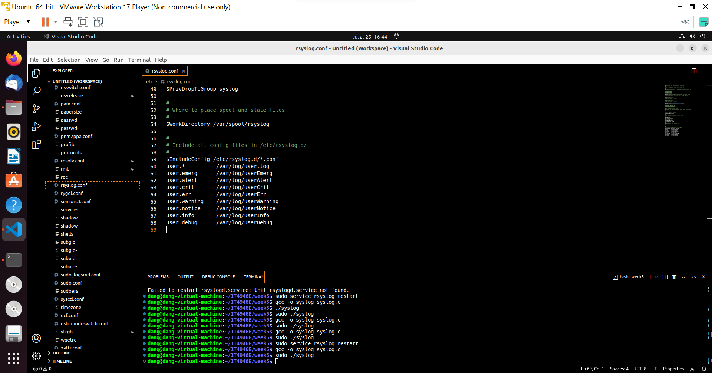

I add these line to file rsyslog.conf

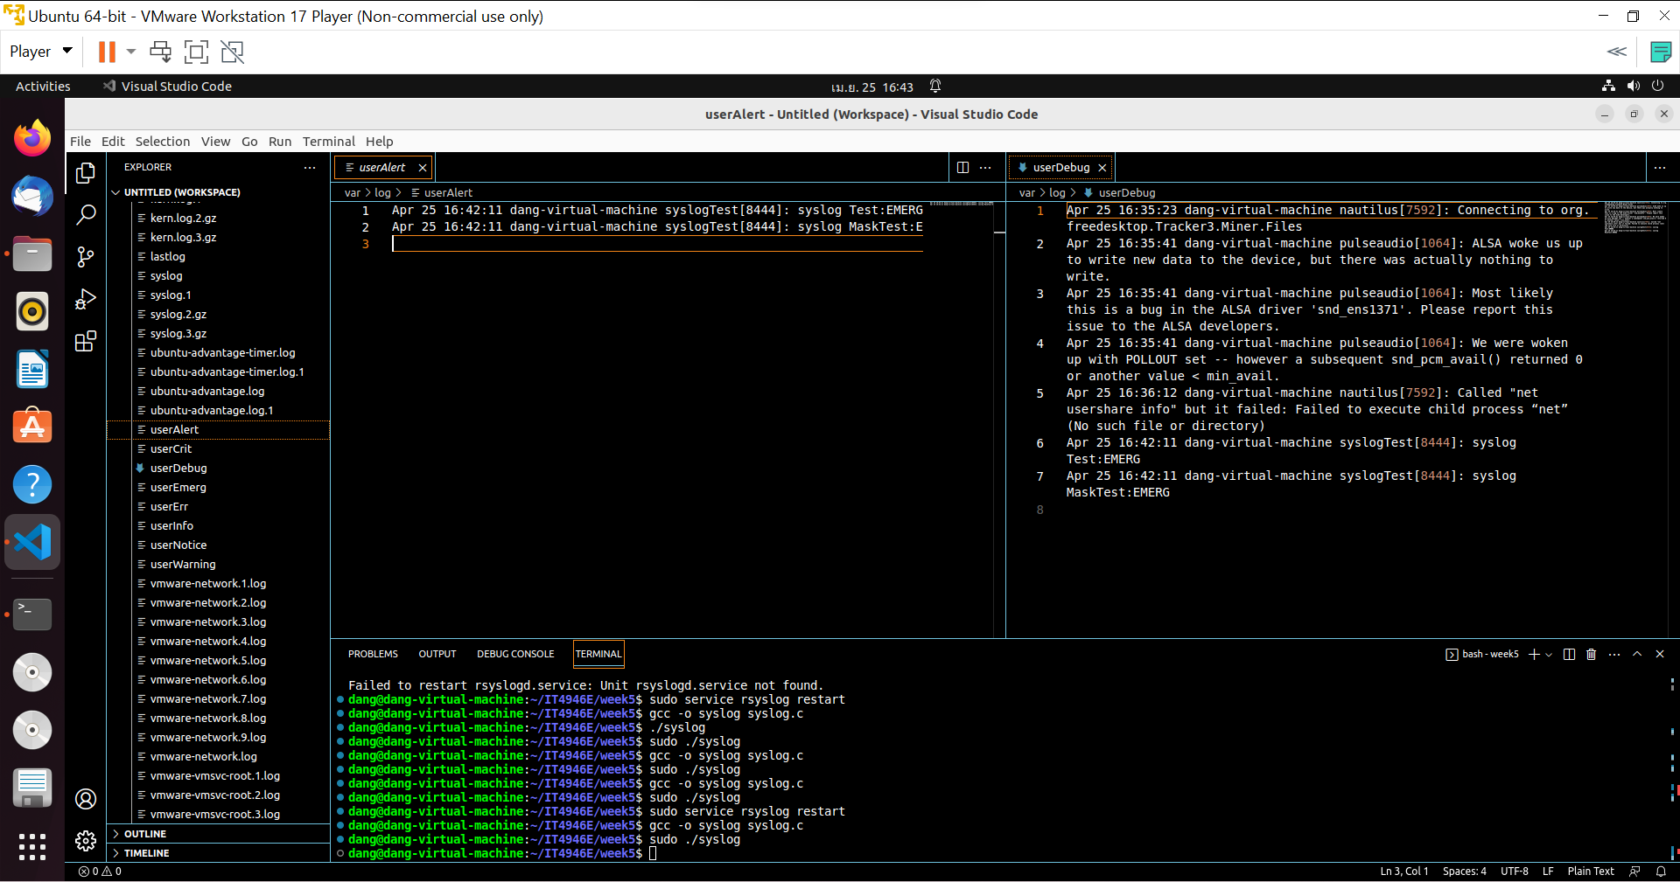

Each type is logged to coresponding file in var/log

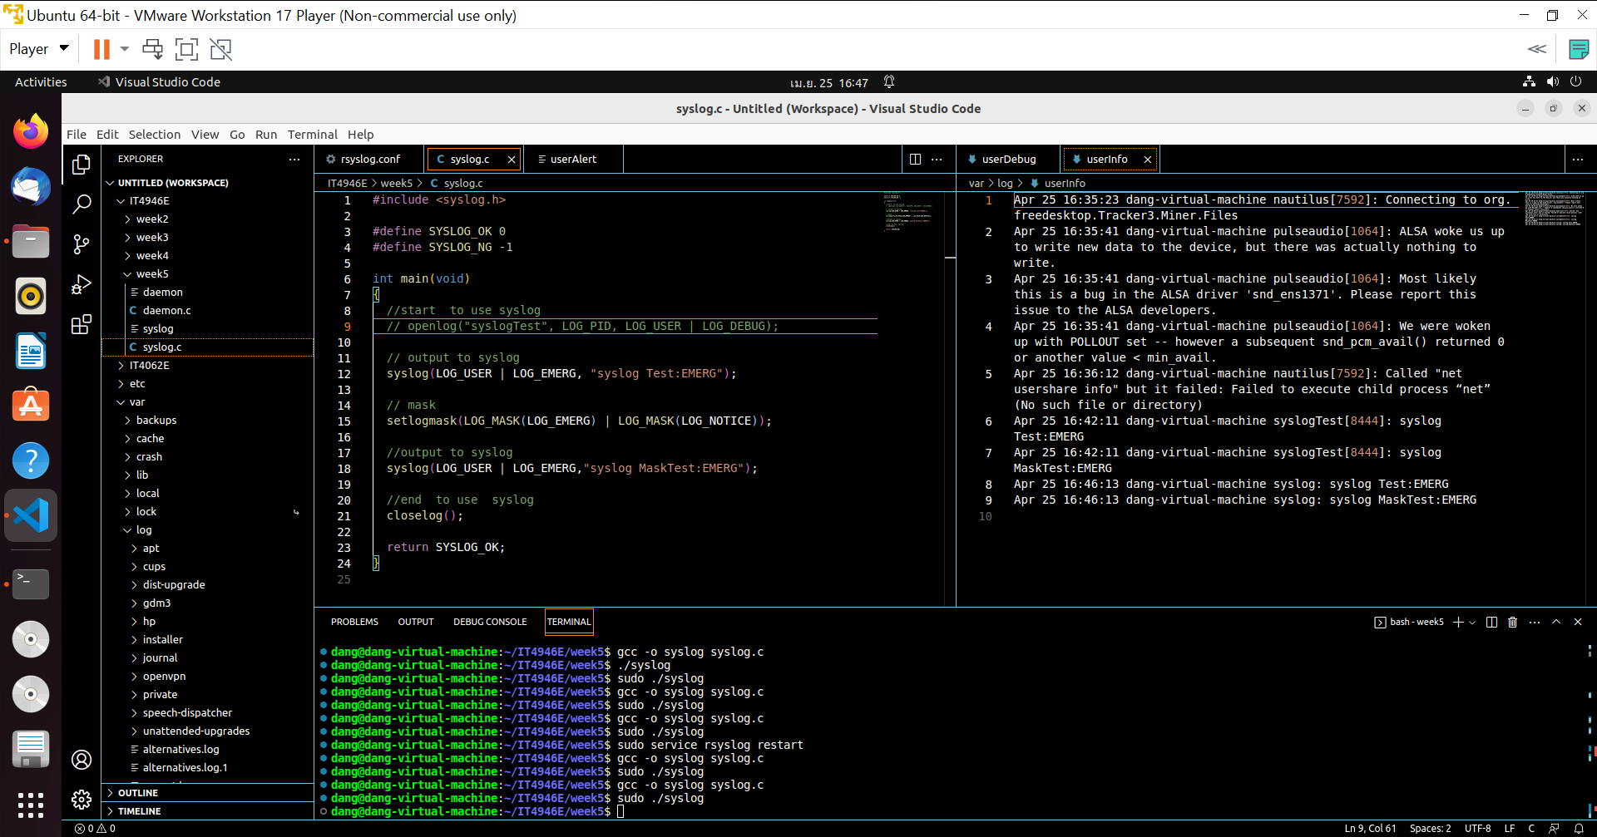

Without openLog, Emerge is logged to every file