**Report**

**Phạm Hải Đăng – 20194736**

**8.3**

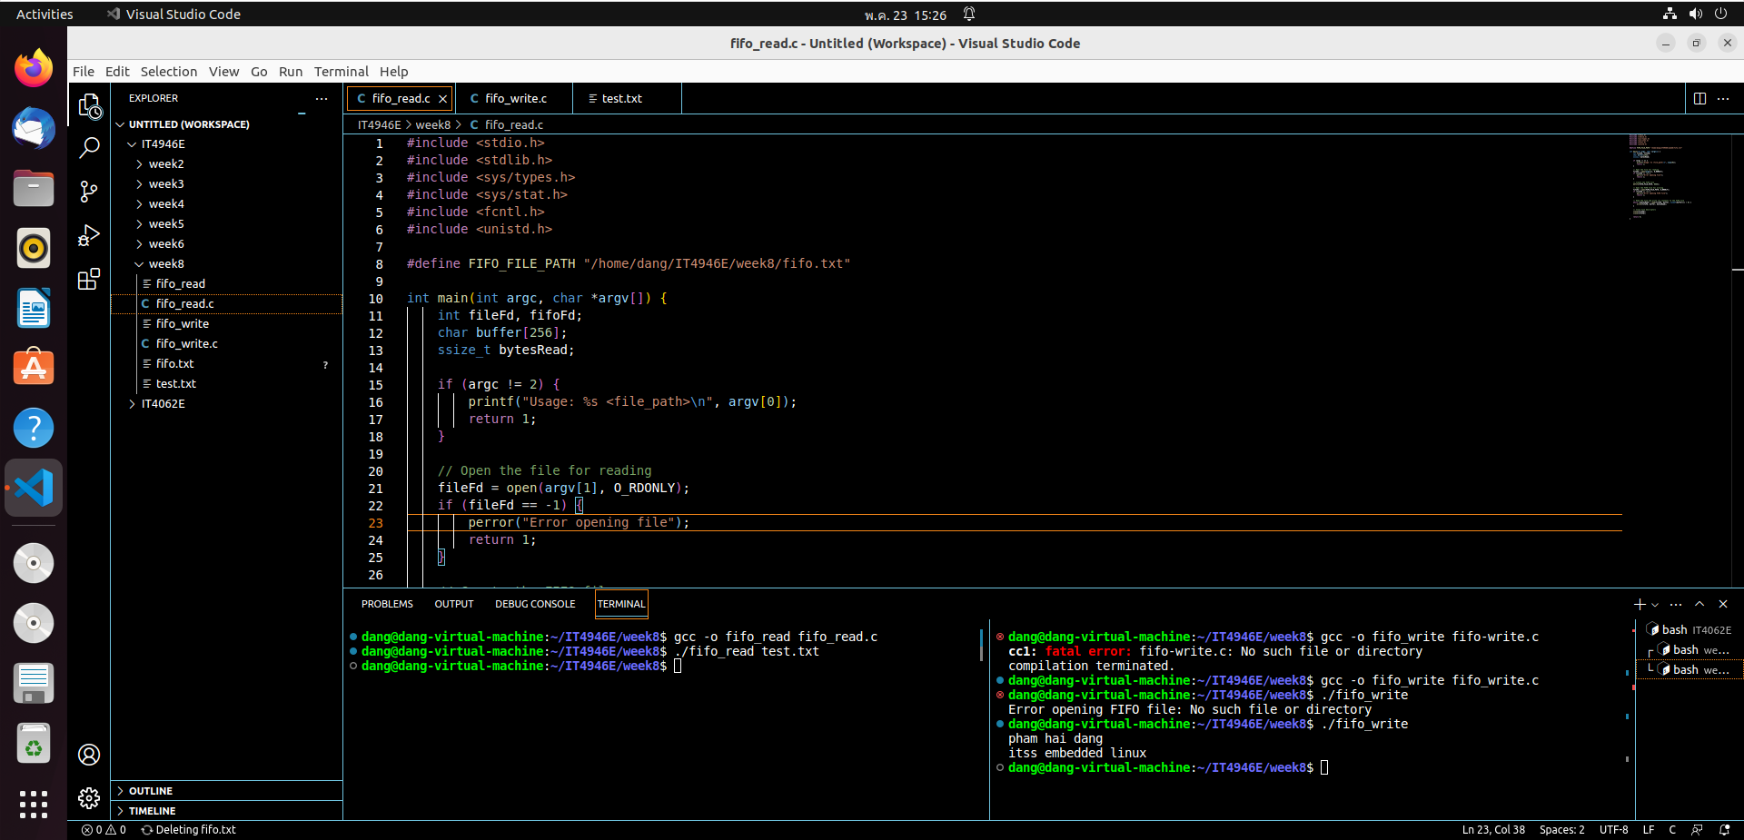

Fifo_read program read data file to FIFO and fifo_write program write display that data

**8.4**

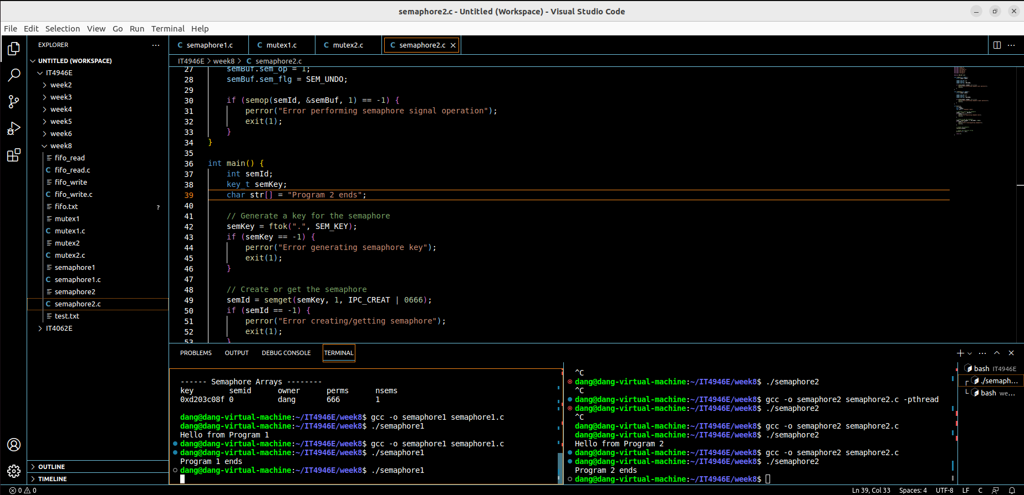

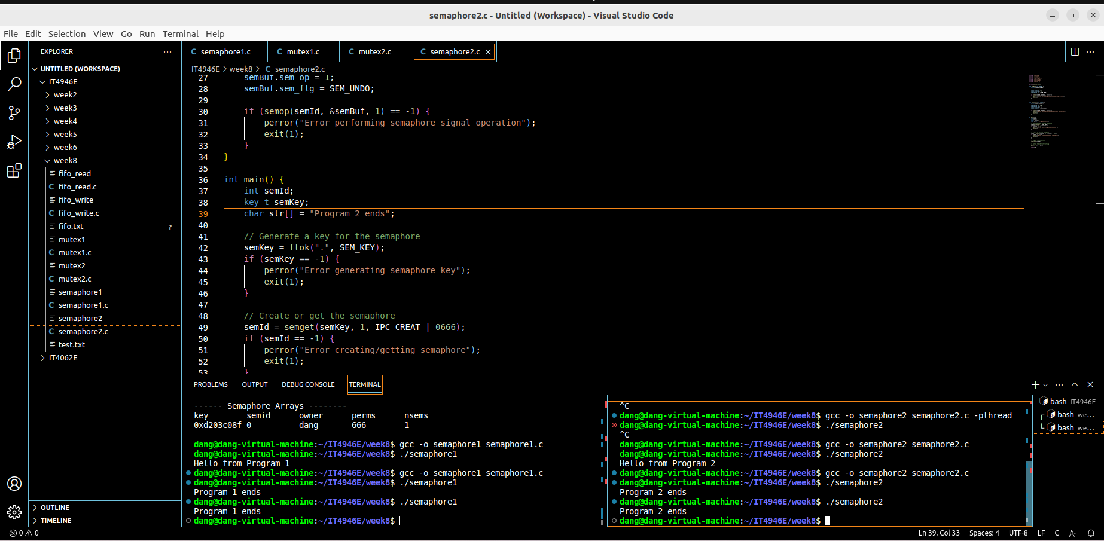

Program 1 and 2 change semaphore value

**8.5**

Program 1 lock the mutex and wait Enter to unlock, program 2 also wait for unlock

Press Enter and both 2 program run continue