NeedProgrammingJob407

1. Create a new, professional, job search only gmail account
   1. <https://accounts.google.com/signup>
2. Open file explorer
   1. Navigate to c:/
   2. Create new folder
   3. Rename to DevProjects
3. Download NodeJS (includes NPM)
   1. <www.nodejs.org>
   2. Select the button that ends in LTS (long term support build)
   3. Open the .exe file after it downloads
   4. Keep the default destination folder (important)
   5. Select the box to auto install necessary tools  
      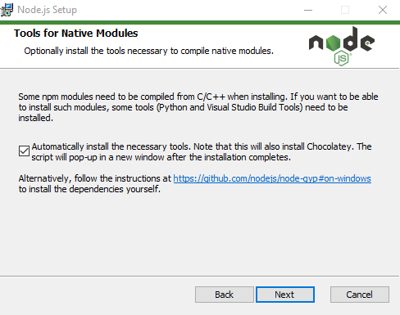
   6. Install
   7. A black popup will come up
   8. Keep hitting enter a few times to go through the screens
   9. The blue Windows PowerShell will popup and do the downloads
   10. Let it run in the background and move on
4. Download Git + Git Bash
   1. <https://gitforwindows.org/>
   2. Open the .exe file after it downloads
   3. Keep default location
   4. Keep default components
   5. Change default editor used by git to use Visual Studio Code  
      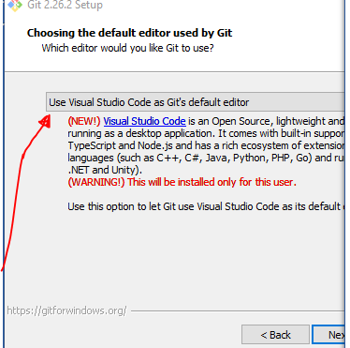
   6. Keep rest as defaults
   7. Install
   8. Unselect view release notes
   9. Select Launch Git Bash checkbox -> next
   10. Type the following into the console then hit enter
       1. cd:/DevProjects >> ~/.bashrc
   11. Close the window
5. Sign up for GitHub
   1. <https://github.com/join>
   2. Complete setup button
   3. Open your new gmail account and click the GitHub verification email
6. Download GitHub Desktop
   1. <https://desktop.github.com/>
   2. Select download button
   3. Open the GitHubDesktopSetup.exe file after it downloads
   4. Create a New Repository on your hard drive  
      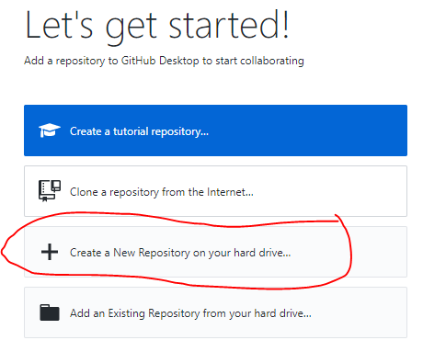
   5. Name - Portfolio
   6. Description – My portfolio of projects
   7. Local path - C:\DevProjects
   8. Git ignore – VisualStudio
   9. License – None
   10. After creating the repo, select File in the top left -> Options
       1. Accounts tab -> Sign in to your GitHub.com account
       2. Integrations tab -> Visual Studio Code
7. Download Visual Studio Code(VSC)
   1. <https://code.visualstudio.com/>
   2. Select the download button
   3. Open the .exe file after it downloads
   4. Accept the agreement
   5. Keep default install location (this is import)
   6. Make sure Add to PATH is selected  
      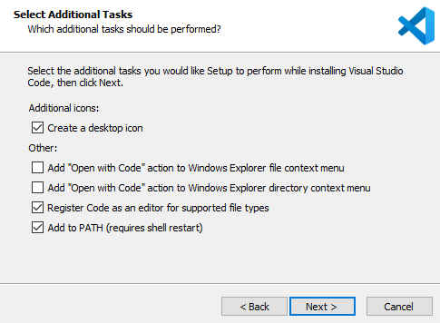
   7. Install
   8. Launch visual studio code
   9. File -> Open Folder -> c:/DevProjects
8. Install VSC extensions
   1. Select extensions icon in the left tab  
      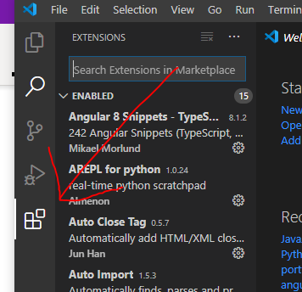
   2. Search Live Server and click green install button
   3. Search Prettier Now and click green install button
9. Set Default VSC Shell
   1. Visual Studio Code -> File -> Preferences -> Settings -> Search "termimal" -> Terminal: Explorer Kind -> External -> Scroll down -> Terminal › External: Windows Exe -> Point file path to the Git exe file
   2. Visual Studio Code -> Terminal -> New Terminal -> Select drop down -> Set default shell -> Git Bash
10. Create portfolio
    1. VSC -> Explorer Tab  
       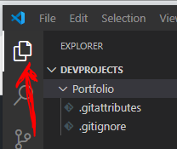
    2. If you don’t see DEVPROJECTS you need to do File -> Open Folder -> DevProjects
    3. Right click Portfolio -> New File -> styles.css -> enter
    4. Copy my file here <https://raw.githubusercontent.com/NeedProgrammingJob407/Portfolio/master/styles.css>
    5. Paste it in
    6. Ctrl + S keyboard shortcut to save
    7. Right click Portfolio -> New File -> index.html -> enter
    8. Copy my template file here <https://raw.githubusercontent.com/NeedProgrammingJob407/Portfolio/master/index.html>
    9. Paste it in
    10. Save
    11. Alt + L, or right click ->Open with live server, or select icon in bottom right  
        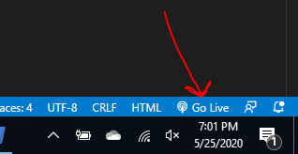
    12. The portfolio template should open in your browser
    13. None of the links will work. No images/gifs will load.
        1. This is because I changed all the references in the index.html file to “PLACEHOLDER”.
    14. You can edit the index.html page later
11. Store project on GitHub.com
    1. Make sure you saved all your changes in Visual Studio Code
    2. Open GitHub for Desktop
    3. Make sure Portfolio is selected as the current repository
       1. You should see your two files, the index.html and styles.css
    4. Make sure current branch is master
       1. In the future, after you learn about git, you can create a “dev” branch that you make changes on and then merge those changes into the “master” branch.
    5. Add a commit message in the bottom left  
       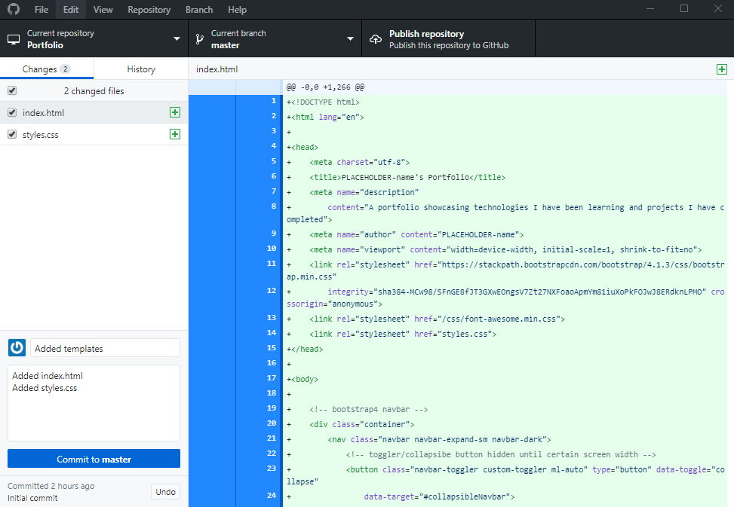
    6. Commit to master
    7. Publish repository
    8. Unselect keep this code private
    9. Publish repository
12. Host your portfolio project
    1. [www.github.com](http://www.github.com)
    2. Select your icon in the top right -> Your repositories
    3. Select portfolio
    4. Settings tab  
       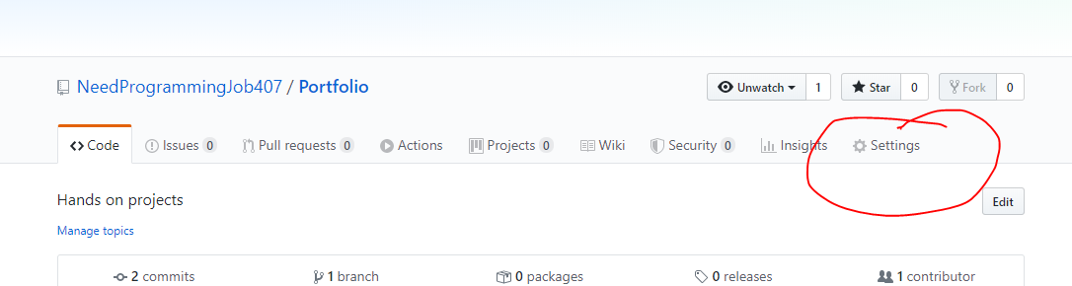
    5. Scroll down to GitHub Pages
    6. Change Source None to Master Branch
    7. Scroll back down to GitHub pages
       1. Copy the link where is says “your site is ready to be published at…..”
          1. Should be YourGitHubUserName.github.io/Portfolio/
       2. Open the link to make sure it’s working
13. Update your portfolio with changes
    1. Open VSC
    2. Open your index.html
    3. Scroll to the very bottom and add a new line of blank space
    4. Save
    5. Open GitHub for Desktop
    6. It should show your new change
    7. Add a commit message and description
    8. Commit to master
    9. Push origin
    10. It will take GitHub ~15 minutes to reflect your new changes

Make sure you have a live server running while you make changes to get instant feedback.

As a first challenge I would try to get the navbar icon links to your linkedInd displaying and working. Also add your resume into your Portfolio project folder in PDF form and update the link in the template.

To change the styling you can either google what Bootstrap class name to add in your index.html file or you can make changes in the styles.css file.

After your done playing around you need to get some projects up. Your goal is to get up THREE basic sites in a weekend. Search for a project tutorial and code along with it. You need content on your site, it doesn’t have to be great or original yet.

After your three basic sites are up you can choose your path. I added a WebGL game, YouTube tutorials, Blender projects, ReactJS site.

Example YouTube Tutorial Search  
<https://www.youtube.com/results?search_query=html+restaurant+project+tutorial>

Learning to Program Tips  
<https://reddit.com/r/learnprogramming>

Portfolio Inspiration  
<https://zero-to-mastery.github.io/ZtM-Job-Board/>

PLEASE DO NOT SHARE THIS WITH ANYONE IT HAS MY PERSONAL INFO ATTACHED