Ifeng
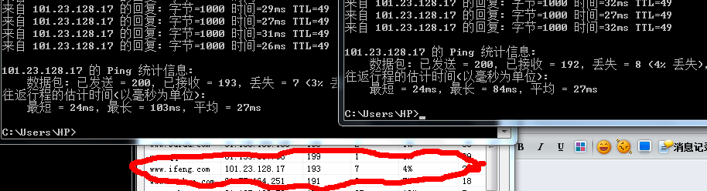
Taobao

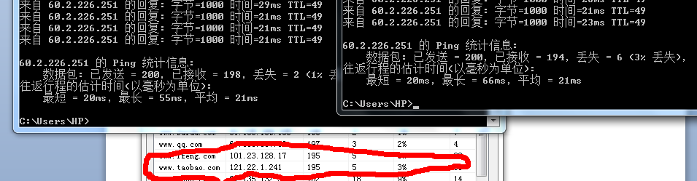

Sohu

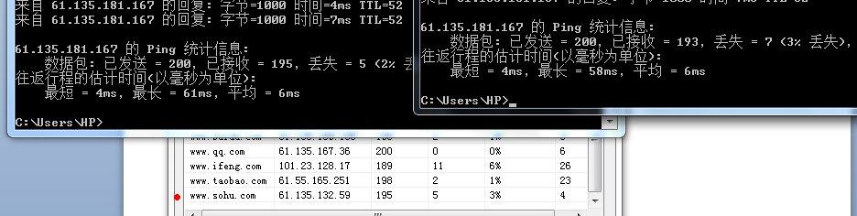

Sina

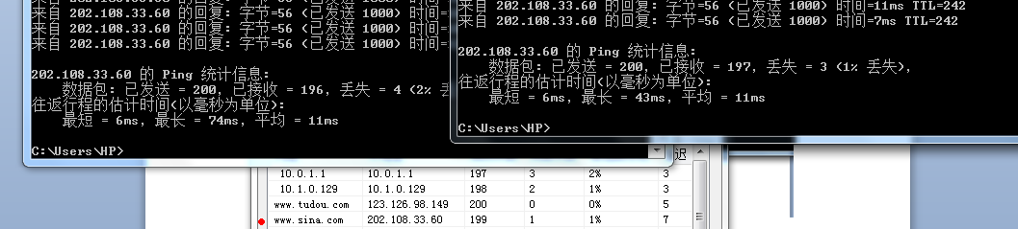

Youku

