

This is displayed. You press “Play” or the botón and had an ad you can skip after 5 sec. Then goes to the loading sceen showed below.



Doesn’t have transition effect or the fade to black is too quick. It displays the following.

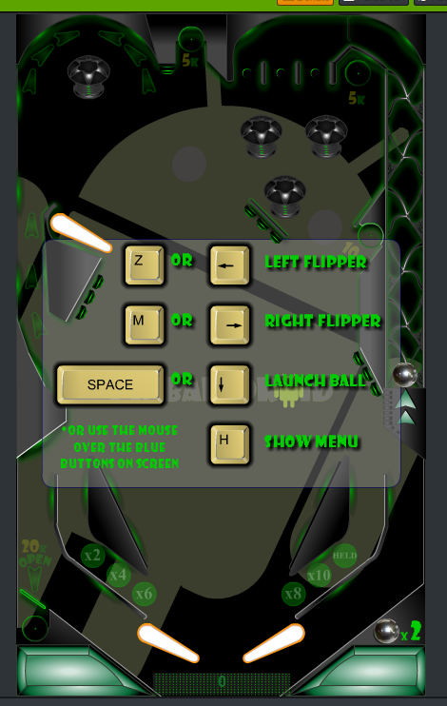

You press SPACE to move forward.

The square goes down VERY quickly and bounces twice/three times ar the bottom of the screen.

Ypu can start playing now. If you end 3 rounds, you start over. The first round has x2 balls, from then on, once you are done you have x3 balls.

If you press H this is displaye. No effects to change scene.

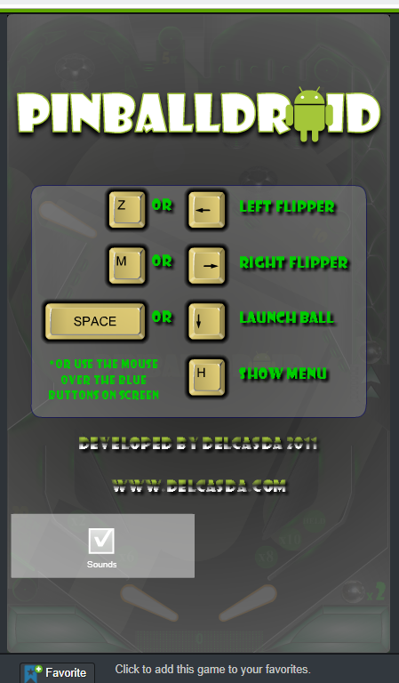

If you have three green lights at the top (which you can move with the flippers -displace them clicking each Flipper to the left) you hav a bonus x2 which has an image on the screen

FALTA SPRITE D’AQUEST BONUS X2