Exploratory Data Analysis (EDA) Guide

Ask Meaningful Questions About the Dataset

  - What is the purpose of this dataset?
  - What problem are we trying to solve?
  - What does each row and column represent?
  - Are there missing values or duplicates?
  - Are there outliers or unusual patterns?

Explore the Data Structure
import pandas as pd
df = pd.read_csv("Study_Hour.csv")
print(df.head()) print(df.shape) print(df.columns) print(df.dtypes) print(df.info())

Check Missing Values
print(df.isnull().sum())

Check Duplicate Records
print(df.duplicated().sum())

Summary Statistics
print(df.describe())

Histogram Visualization
import matplotlib.pyplot as plt
df.hist(figsize=(10,6)) plt.show()

Correlation Matrix
import seaborn as sns
corr = df.corr(numeric_only=True) sns.heatmap(corr, annot=True, cmap='coolwarm')

plt.show()

Detect Outliers Using Boxplot
df.boxplot(figsize=(10,5)) plt.show()

Scatter Plot Analysis
plt.scatter(df['Hours'], df['Marks'])
plt.xlabel("Study Hours") plt.ylabel("Marks") plt.title("Study Hours vs Marks")
plt.show()

Hypothesis Testing Example
correlation = df['Hours'].corr(df['Marks']) print("Correlation:", correlation)

Common Data Issues

  - Missing values
  - Duplicate rows
  - Outliers
  - Incorrect data types
  - Skewed distributions
  - Imbalanced classes

Graphs
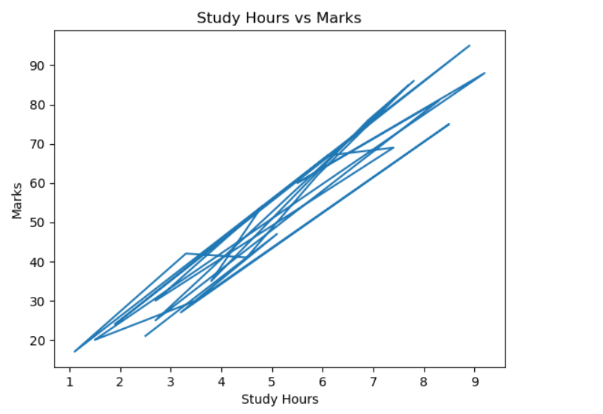
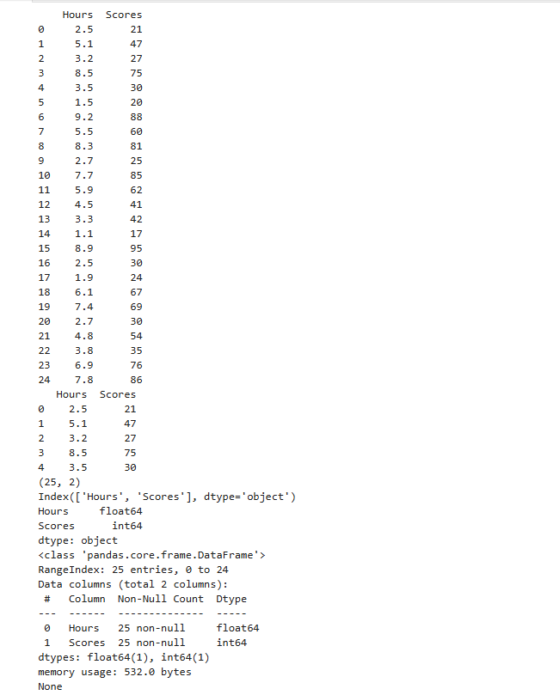

EDA Goals Summary

Goal | Purpose
Understand Data | Know structure and relationships
Detect Issues | Find missing values and outliers
Find Patterns | Identify trends and correlations
Prepare for ML | Clean and transform data

