Hello, I'm Sarmathi k, I am an experienced joiner with well-developed skills and experience in front-end developer with a knack for creating Enthrallment and visually appealing web experiences. Am keen and very willing to learn and develop new skills. I have strong ethic and am very motivated towards what i do when my off day. I enjoy working with others and am always happy to help. I possess knowledge in various testing methodologies of ChatGpt and a deep understanding of AI and ML concept. Additionally, my excellent networking and team- working skills enable me to collaborate effectively with other developers, designers, to achieve project goals. Furthermore, I am good at English and German. I am a hardworking, honest individual. I am outgoing and tactful, and able to listen effectively when solving problems.

HTML

CSS

Java Script

React Js

Digital Marketing

Figma

Canva

Agile methodology

github

ChatGpt

Generative AI

25

/06/2022 – CURRENT Chennai, India

**FRONT-END DEVELOPER**

PEPPER PROGRAMMING AB

**DIGITAL SKILLS**

**WORK EXPERIENCE**

1. Providing maintenance support for customer Web Pages which are in live environment.
2. As a skilled Full Stack Developer with experience in UI, tools like HTML, CSS & JAVASCRIPT and UX, tools like Figma, Canvas, Adobe Express, Framer and GitHub. I have created my own blog by using

WordPress. I am confident that I can make a significant contribution with our team. Regarding AI Engineer, I possess knowledge in various testing methodologies of ChatGpt and a deep understanding of AI and ML concept.

**Sarmathi K**

**Date of birth:**

19/06/1999

**Nationality:**

Indian

**Gender:**

Female

**Phone number:**

Mobile)

(+91) 9500397028 (

**Email address:**

sarmathi1906@gmail.com

**Website:**

https://ppchennai.vercel.app/Sarmathi/MY_BLOG/blog.htm

[l](https://ppchennai.vercel.app/Sarmathi/MY_BLOG/blog.html)

**Twitter:**

https://twitter.com/Sarmathik83997?t=4Li7TU0JXPnV4x_QM5vZ2w&s=0

[8](https://twitter.com/Sarmathik83997?t=4Li7TU0JXPnV4x_QM5vZ2w&s=08)

**Whatsapp Messenger:**

https://whatsapp.com/dl/

**Address:**

6

/318, Periyar nagar,, Manavadi, Karur., 639005, Karur, India (Home)

**ABOUT ME**

1. I am proficient in Agile Scrum methodology, which enables me to develop high-quality applications while ensuring that they meet project timelines and requirements. Additionally, my excellent networking and team- working skills enable me to collaborate effectively with other developers, designers, to achieve project goals.

07/01/2022 – 25/10/2022 Karur

**GRADUATE APPRENTICE TRAINEE** POWER GRID CORPORATION OF INDIA PVT LTD.

* Worked in an intern position for Power Grid maintenance and new service provisioning cases.
* I am done more field works and takeover shutdown and testing tools.

# EDUCATION AND TRAINING

08/07/2016 – 17/05/2020 Tiruchencode, India

**BACHELOR OF ENGINEERING** Vivekanandha College of Engineering for Women

**Website** <https://vivekanandha.ac.in/>

# LANGUAGE SKILLS

Mother tongue(s): **TAMIL**

Other language(s):

|  |  |  |  |  |  |
| --- | --- | --- | --- | --- | --- |
| **UNDERSTANDING** | | | **SPEAKING** | | **WRITING** |
|  | Listening Reading | Spoken production | | Spoken  interaction |  |
| **ENGLISH** | C1 C1 | B2 | | C1 | B2 |
| **GERMAN** | A2 A2 | A2 | | A2 | A2 |
| *Levels: A1 and A2: Basic user; B1 and B2: Independent user; C1 and C2: Proficient user*  **ADDITIONAL INFORMATION** | | | |  |  |

# HOBBIES AND INTERESTS

**Reading books-**When I started to read books, I thoroughly came out from the live world. Because I am too deep to focus when I am reading books. Reading habits to change my inner thoughts of inferiority complex and happened to my mind in refresh and shown happiness of my face.

**Painting-**When I am bored I start to paint myself off to our house wall. I am not painting professionally but I am a professional painter in myself.

# PROJECTS

10/07/2023 – 13/07/2023

**My Blog** I created my own portfolio including myself, projects and blogs. You want to know me just touch the link.

KARUR, 21/07/2023

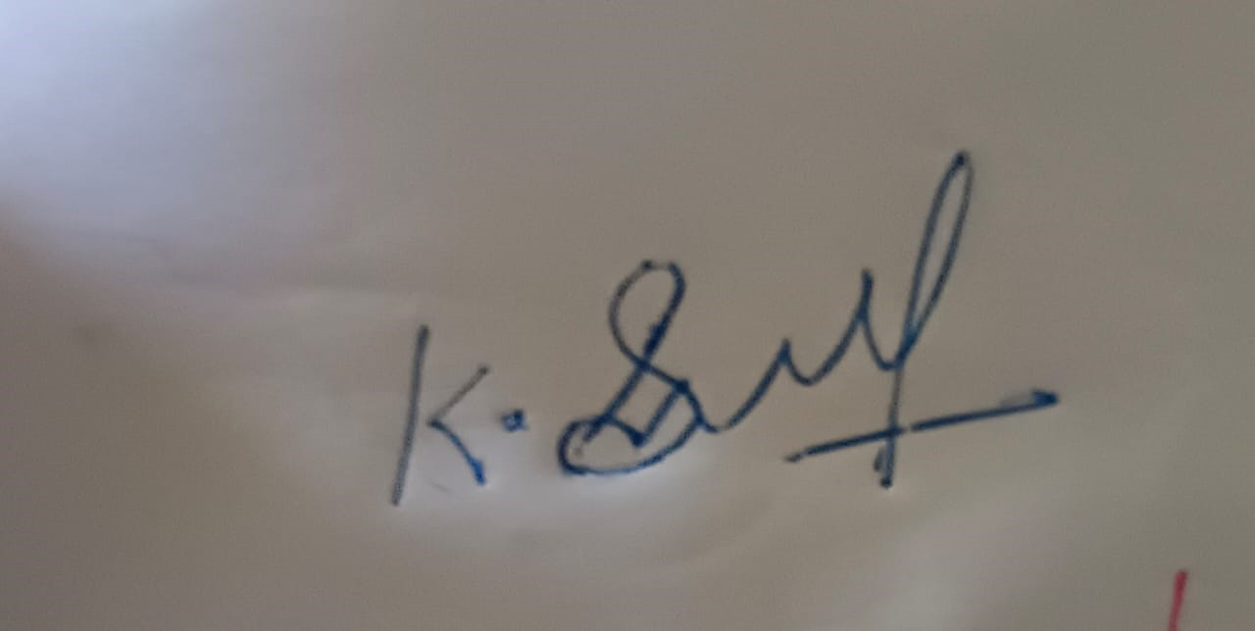

Sarmathi K