**Machine-learning-Challenge**

Planets

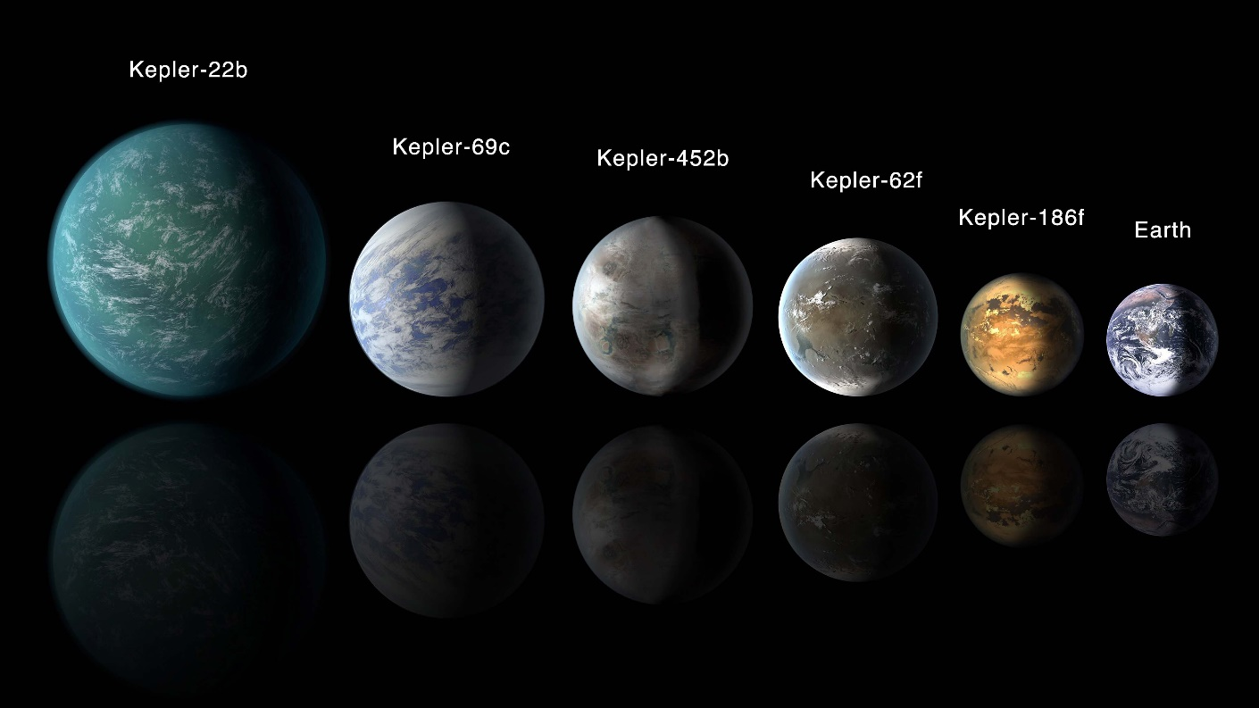

Over a period of nine years in deep space, the NASA Kepler space telescope has been out on a planet-hunting mission to discover hidden planets outside of our solar system.

To help process this data, I created machine learning models capable of classifying candidate exoplanets from the raw dataset.

Procedure:

1. Preprocessing)

2. Tune-Model-Parameters

3. Compared two or more models to Evaluate-Model-Performance

SVC Model:

1.Extracted the exoplanet_data.csv and did a clean up to get the required fields.

2.Selected the features columns to be used as the X data and ‘koi-disposition’ as the labels column.

3.Split the data to train and test set.

3.Scaled the X data means to normalize the data within a particular range using theMinMaxscaler.

4.Linear SVC classifier model was used to get the below score.

Training Data Score: 0.8371161548731643

Testing Data Score: 0.8564073226544623

5.Parameter hypertuning was done using Gridsearchcv and got the below accuracy,which shows a better accuracy rate compared to the one before hypertuning.

Test Acc: 0.894

Random forest Classifier:

1.The entire data columns were used as the features except for ‘koi disposition’ which was used as the y data.

2. It gave a Test accuracy of 0.8963545389563974

3.Random forest was also used to get the feature importance and it showed

0.10421437579727973, 'koi_fpflag_co'),

(0.09378707558496266, 'koi_fpflag_nt'),

(0.07169929952525715, 'koi_fpflag_ss')

The above three features could be used to get better accuracy.

Sequential modeling and Neural:

1.Sequential modelling and neural was also used to get the below score

55/55 - 0s - loss: 0.2594 - accuracy: 0.9090 Loss: 0.2594063878059387, Accuracy: 0.9090389013290405

2.further deep learning with two hidden layers were used,but the accuracy rate was 55/55 - 0s - loss: 0.4453 - accuracy: 0.8970 Deep Neural Network - Loss: 0.44529274106025696, Accuracy: 0.8970251679420471

There wasn’t much difference by usung another layer,