

CONTENT
Sl.No. | Date | Experiment Title | Page No
1. |  | Take any real time problem and do the following experiments.
a) |  | Write down the problem statement for a suggested system of relevance. Develop Flow-Charts to understand basic problem-solving technique.
b) |  | Do requirement analysis and develop Software Requirement Specification Sheet (SRS) for suggested system.
c) |  | Using COCOMO model estimate effort.
d) |  | Perform Estimation of effort using FP Estimation for chosen system.
e) |  | Analyze the Risk related to the project and prepare RMMM plan.
f) |  | Develop Time-line chart and project table using PERT or CPM project scheduling methods.
g) |  | Draw E-R diagrams, DFD, CFD and structured charts for the project.
h) |  | Design of Test cases based on requirements and design.
2. |  | Using UML/JAVA, design Abstract Factory design pattern.
3. |  | Using UML/JAVA, design Builder design pattern.
4. |  | Using UML/JAVA, design Façade design pattern.
5. |  | Using UML/JAVA, design Bridge design pattern.
6. |  | Using UML/JAVA, design Decorator design pattern.

Experiment – 1 : Take any real time problem and do the following experiments.
SPY CAMERA DETECTION
With the increasing prevalence of surveillance technology, there is a growing need to protect privacy and ensure security in private and public spaces. This project aims to develop a software solution for detecting hidden spy cameras in various environments. Leveraging principles of software engineering and design patterns, the project will deliver a robust, scalable, and efficient system for spy camera detection.

Experiment – 1.a: Write down the problem statement for a suggested system of relevance. Develop Flow-Charts to understand basic problem solving technique.
Problem Statement
The prevalence of covert surveillance devices, such as spy cameras, poses a significant threat to privacy. This project aims to develop a software solution for detecting and alerting users of potential spy cameras in their vicinity. The solution will leverage image processing and machine learning techniques to identify hidden cameras, providing an additional layer of security for individuals in sensitive environments.
SYSTEM REQUIREMENTS
Camera Detection:
- Detect hidden cameras using infrared (IR) & radio frequency (RF) scanning
User Interface:
- Provide a user-friendly interface for initiating scans and displaying results.
- Allow users to view detected cameras' locations on a map or floor plan.
Data Management:
- Store scan history and detected camera data.
- Provide options for exporting scan reports (PDF, CSV).
System Settings:
- Allow configuration of scan sensitivity and detection methods.
- Manage user accounts and authentication for access control
Connectivity:
- Support for Wi-Fi or Bluetooth connectivity to external scanning devices.

FLOW-CHART
START

Initialize System

DATA -ACQUISITION

PRE- PROCESSING

FEATURE EXTRACTION

DETECTION ALGORITHM

POST-PROCESSING

ALERT SYSTEM

LOG RESULTS

END

This flow chart follows intermediate task management model adds additional steps for more structured task management including categorization, time estimation, delegation and periodic review.

Experiment – 1.b: Do requirement analysis and develop Software Requirement Specification Sheet (SRS) for suggested system.
Introduction:
PURPOSE
The purpose of this document is to provide a comprehensive Software Requirements Specification (SRS) for the Spy Camera Detection Project. This document outlines the functional and non-functional requirements of the system, aiming to serve as a guide for the development, testing, and validation of the project.
SCOPE
The Spy Camera Detection Project aims to develop a software application capable of detecting hidden spy cameras within a given environment. This system will utilize various detection techniques, including infrared light detection, network scanning, and image recognition to identify potential spy cameras. The application will be designed to run on multiple platforms, including Windows, macOS, and Linux.
Requirements:
Functional Requirements:
When developing a spy camera detection project, it's important to outline both functional and non-functional requirements to ensure the system meets all necessary specifications and performance criteria.
Functional Requirements
- Camera Detection
  - Detect and identify various types of spy cameras (wired, wireless, mini, pinhole, etc.).
  - Provide real-time alerts when a spy camera is detected.
- Range of Detection
  - Specify the effective range for detecting cameras (e.g., up to 30 feet).
- Multiple Detection Modes
  - RF signal detection for wireless cameras.
  - Lens reflection detection using infrared or laser technology.
  - Visual inspection using high-resolution cameras and AI algorithms.
- User Interface
  - User-friendly mobile and/or desktop application for system control and monitoring.
  - Display of detected camera locations on a map or floor plan.
  - Manual scan option for targeted detection in specific areas.

- Data Logging
  - Log detection events with timestamps and location data.
  - Provide access to historical data for analysis and reporting.
- Alerts and Notifications
  - Immediate alerts via push notifications, SMS, or email when a camera is detected.
  - Audible and/or visual alerts on the detection device.
- Power Management
  - Battery status monitoring and low battery alerts.
  - Options for power-saving modes.
- Self-Test and Calibration
  - Automated self-test routines to ensure the system is functioning correctly.
  - Manual calibration options for improved accuracy.
- Integration with Other Systems
  - Compatibility with existing security systems and IoT devices.
  - API for third-party software integration.
.
Non-Functional Requirements:
Performance
- Detection accuracy: Must achieve at least 95% accuracy in detecting spy cameras.
- Latency: Detection and alert latency should be under 5 seconds.
Reliability
- System uptime: Should ensure 99.9% uptime.
- Mean Time Between Failures (MTBF): Should be greater than 1 year.
Scalability
- Ability to scale up to detect cameras in large buildings or multiple locations.
- Support for multiple detection devices connected to a single monitoring system.
Security
- Data encryption: All stored and transmitted data must be encrypted.
- User authentication: Multi-factor authentication for accessing the system.
Usability
- Intuitive user interface with minimal learning curve.
- Multilingual support for global use.
Portability
- Detection devices should be lightweight and easy to transport.
- Mobile app compatibility with both iOS and Android platforms.
Compliance
- Compliance with privacy laws and regulations in target markets.
- Adherence to relevant industry standards (e.g., FCC for RF devices).
System Features:
Multi-Mode Detection:
- RF Signal Detection: Identifies wireless spy cameras by detecting radio frequency signals.
- Lens Reflection Detection: Uses infrared or laser technology to detect the reflection from camera lenses.
- Thermal Detection: Detects heat signatures from active cameras.
- Magnetic Field Detection: Identifies magnetic fields generated by electronic devices
Real-Time Detection
- Instant Alerts: Provides immediate alerts when a spy camera is detected.
- Continuous Monitoring: Offers 24/7 monitoring capabilities for constant surveillance.
Range and Sensitivity Settings
  - Adjustable detection range (e.g., short, medium, long).
  - Sensitivity controls to fine-tune detection based on the environment.
External Interface
Dashboard
  - Centralized dashboard for monitoring and controlling all detection activities.
  - Visual representation of detected devices, including their locations on a map or floor plan.
Mobile Application
  - Compatible with iOS and Android devices.
  - Allows remote control and monitoring of detection devices.
  - Push notifications for alerts and updates.
Desktop Application/Web Interface
Video Stream:
  - The project accesses the device’s camera feed using web technologies.
  - It captures live video from the camera.
- Object Detection:
  - The project employs the COCO-SSD (Common Objects in Context - Single Shot MultiBox Detector) model.
  - Specifically, it focuses on identifying objects resembling cell phones or mobile phones within the video stream.
- Real-time Monitoring:
  - The system continuously monitors the video feed.
  - When it detects a potential spy camera (object resembling a phone), it alerts the user.
- User Interface:
  - Users interact with the system through a web interface.
  - The interface displays the live camera feed and detection results.
Technical Details
Hardware and Software Requirements
- Hardware:
  - A computer or mobile device with a camera.
- Software:
  - A modern web browser that supports the navigator.mediaDevices.getUserMedia API.
  - TensorFlow.js library (version 3.9.0).
  - COCO-SSD model from TensorFlow.js (version 3.9.0).
System Architecture
- Web Interface:
  - Users interact with the system through a web interface.
  - HTML, CSS, and JavaScript create and manage this interface.
- Video Stream:
  - The system captures the live camera feed using the navigator.mediaDevices.getUserMedia API.
  - It displays the video stream in an HTML video element.
- Object Detection:
  - It identifies objects resembling cell phones or mobile phones.
- Monitoring:
  - Real-time monitoring occurs through JavaScript functions that repeatedly call the object detection and rendering functions.

Experiment – 1.c: Using COCOMO model estimate effort.
Basic COCOMO Model:
Assumptions
Project Size :12000 lines of code (LOC)
COCOMO Model: Organic
Error Adjustment Factor (EAF) :1.0(Neutral Adjustment)
Effort = a x (size) pow(b) x EAF
a=2.4
b=1.05
size = 12000 (Loc)
EAF = 1.0
Effort = 2.4 x (12000) pow (1.05) x 1.0
Effort = 2.4 x (10) pow (1.05)
Effort = 2.4 x 13.587
Effort = 32.610 persons-months

Time (T) = C (E) pow (d)
= 2.5 (32.610) pow (0.38)
= 2.5 x 7.6477
T = 9.397 MONTHS

INTERMEDIATE MODEL:
Project Size: 20000 lines of code(loc)
COCOMO model: Organic
Effort Adjustment Factor (EAF): Detailed Factors Considered
Effort = a x (size) pow (b) x EAF
a = 2.4
b = 1.05
EAF = 1.2
Size = 20000
Where EAF is effort is calculated as;
EAF = (Summation I = 1 to N Rating I)
Where ‘n’ is the total numbers of cost divers and the rating ‘I’ is the rating assigned to each cost divers and size is the estimated project size in KLOC.
From, Product Attribute (Nominal)
The Complexity of the product = 1.00
Hardware Attribute (High)
The Required Turn-Around Time = 1.07
Project Attributes (Low)
Use of Software Tools = 1.10
EAF = 1.00 x 1.07 x 1.10
EAF = 1.177
EFFORT (E) = 1.177 x 26.5128
E = 31.2055 Persons-Months
Time (T) = 2.5 x (31.2055) pow (0.38)
= 2.5 x 3.6966
= 9.2415
T = 9 Months
People Required (R) = E/T
R = 31.2055/9.2415
R = 3.3744
R = 3 persons

Experiment – 1.d: Perform Estimation of effort using FP Estimation for chosen system.
Function Point (FP) estimation is a method used to estimate the size, effort, and time required for software development projects. Here are the steps to perform FP estimation for your task management system:

Step 1: Identify the Functional User Requirements
- External Inputs (EI): :These are inputs that the system receives from users or external devices to perform its functions.
  - User Commands
  - Sensor Inputs
  - Environmental Data
- External Outputs (EO): These are outputs from the system. For the task management system, these could be:
  - Alerts and Notifications
  - Detection Reports
  - Status Updates
- External Inquiries (EQ): These are requests for information that the system responds to, typically from users or other systems
  - Detection History
  - System Status
  - Configuration Settings
- Internal Logical Files (ILF): These are data files that the system maintains internally to support its operations be:
  - Detection Logs
  - System Configuration Data
  - Calibration Data
  - User Profiles
- External Interface Files (EIF): These are files that the system exchanges with other systems or external devices:
  - Integration Data Files,
  - API Data Exchange
  - Backup and Restore Files

Step 2: Assign Complexity Weights

Assign weights based on the complexity (low, average, high) of each type of function.
Function Type | Weight (Low) | Weight (Average) | Weight (High)
External Inputs (EI) | 3 | 4 | 6
External Outputs (EO) | 4 | 5 | 7
External Inquiries (EQ) | 3 | 4 | 6
Internal Logical Files (ILF) | 7 | 10 | 15
External Interface Files (EIF) | 5 | 7 | 10

Step 3: Calculate Unadjusted Function Points (UFP)
Identify the count of each function type and assign complexity.
- External Inputs (EI):
  - User Registration (Average) = 1 * 4 = 4
  - Task Creation (Average) = 1 * 4 = 4
  - Task Update (Average) = 1 * 4 = 4
  - Task Deletion (Average) = 1 * 4 = 4
  - Project Creation (Average) = 1 * 4 = 4
  - Category Creation (Average) = 1 * 4 = 4
- External Outputs (EO):
  - Task List Display (Average) = 1 * 5 = 5
  - Project List Display (Average) = 1 * 5 = 5
  - Notification Display (Average) = 1 * 5 = 5
- External Inquiries (EQ):
  - Task Search (Average) = 1 * 4 = 4
  - Project Search (Average) = 1 * 4 = 4
- Internal Logical Files (ILF):
  - User Data (Average) = 1 * 10 = 10
  - Task Data (Average) = 1 * 10 = 10
  - Project Data (Average) = 1 * 10 = 10
  - Category Data (Average) = 1 * 10 = 10
  - Notification Data (Average) = 1 * 10 = 10
- External Interface Files (EIF):
  - External Calendar Integration (Low) = 1 * 5 = 5

Step 4: Compute the Unadjusted Function Points (UFP)
UFP=∑(count× weight)\text{UFP} = \sum (\text{count} \times \text{weight})UFP=∑(count× weight) UFP=4+4+4+4+4+4+5+5+5+4+4+10+10+10+10+10+5=102\text{UFP} = 4 + 4 + 4 + 4 + 4 + 4 + 5 + 5 + 5 + 4 + 4 + 10 + 10 + 10 + 10 + 10 + 5 = 102UFP=4+4+4+4+4+4+5+5+5+4+4+10+10+10+10+10+5=102

Step 5: Calculate the Value Adjustment Factor (VAF)
Rate the 14 General System Characteristics (GSCs) on a scale of 0 to 5 and compute the VAF.
For simplicity, let's assume an average complexity rating of 3 for all GSCs.
Total Degree of Influence=14×3=42\text {Total Degree of Influence}
= 14 \times 3
= 42 Total Degree of Influence
=14×3=42
VAF=0.65+(0.01×Total Degree of Influence) =0.65+(0.01×42)
=0.65+0.42=1.07\text {VAF} = 0.65 + (0.01 \times \text {Total Degree of Influence})
= 0.65 + (0.01 \times 42) = 0.65 + 0.42 =1.07VAF=0.65+(0.01×Total Degree of Influence)
=0.65+(0.01×42)
=0.65+0.42
=1.07

Step 6: Calculate the Adjusted Function Points (AFP)
AFP=UFP×VAF
=102×1.07=109.14\text {AFP}
= \text {UFP} \times \text {VAF}
= 102 \times 1.07
= 109.14AFP
=UFP×VAF
=102×1.07
=109.14

Step 7: Estimate Effort
To estimate the effort, you need to determine the productivity rate, which is typically measured in function points per person-month. Let's assume an average productivity rate of 20 function points per person-month.
Effort=AFP Productivity Rate
=109.1420≈5.46 person-months\text {Effort}
= \frac {\text {AFP}} {\text {Productivity Rate}}
= \frac {109.14}{20} \ approximately 5.46 \text {person-months}
Effort = Productivity Rate AFP
​=20109.14​
≈5.46 person-months

Experiment – 1.e: Analyze the Risk related to the project and prepare RMMM plan.
Risk | Probability | Impact | Severity | Mitigation | Monitoring | Management | Estimated Cost
Privacy Concerns | High | Medium | Medium | Ensure data encryption and anonymization | Monitor data handling practices | Regular audits and adherence to privacy regulations | $3,000
Technical Failures | Low | High | High | Use reliable hardware and perform regular maintenance | Scheduled hardware inspections and performance monitoring | Maintain a supply of spare parts and tools for quick fixes | $10,000
Budget Overrun | Medium | High | High | Accurate budget planning and cost control measures | Monthly budget reviews | Adjust project scope or timeline as necessary | $2,000
Project Delays | Medium | Medium | Medium | Detailed project timeline and contingency planning | Track project progress with Gantt charts | Reallocate resources and adjust schedules as needed | $4,000
Security Vulnerabilities | Medium | High | High | Implement robust cybersecurity measures | Conduct regular security assessments | Update security protocols and patch vulnerabilities | $6,000
Inadequate Training for Personnel | Low | Medium | Medium | Comprehensive training programs | Regular assessment of staff performance | Ongoing training and development programs | $2,000
Regulatory Non-compliance | Low | High | High | Ensure adherence to relevant regulations | Regular compliance audits | Consult with legal experts and stay updated on regulations | $3,500
Vendor Reliability | Low | Medium | Medium | Choose reputable vendors and have backup options | Evaluate vendor performance regularly | Maintain good relationships and have contingency plans | $1,500
False Positives | Medium | High | High | Implement advanced algorithms to reduce false positives | Regularly review detection logs and adjust algorithms | Conduct routine testing and improvements | $5,000

Risk Monitoring and Review:
Regularly review identified risks, report on their status, and develop contingency plans for high-impact risks. Implement a system for continuous risk assessment and communication with stakeholders.
Estimated Cost:
The estimated cost associated with addressing these risks depends on various factors such as the resources required for mitigation strategies, potential impact on project timelines, and the complexity of risk management activities. It's essential to allocate a contingency budget to cover unforeseen expenses related to risk mitigation.
Overall, incorporating risk analysis, RMMM planning, and estimated costs into the project budget ensures that potential risks are proactively managed, minimizing their impact on project success and financial outcomes.
To estimate the total cost for RMMM, we will sum up the costs for each mitigation strategy
Let’s assumed cost for RMMM is $90,000
RMMM Cost Estimation = Cost Estimation of each risk/Assumed Cost Of RMMM
$50000 + $10000 + $8000 + $7000 + $12000 + $6000 + $9000+ $4000 + $8000 + $3000 + $10000 + $7000
RMMM = ----------------------------------------------------------------------------
$90,000
RMMM = $ 89,000 / $ 90,000
RMMM = 0.9888
This means that approximately 98.88% of the total project cost is allocated for managing and mitigating risks.

Experiment – 1.f: Develop Time-line chart and project table using PERT or CPM project scheduling methods.
Task ID | Task Description | Duration (Days) | Dependencies
1 | Collect and Analyze Requirements | 7 | Start
2 | Finalize Requirements and System Design | 8 | Task 1
3 | UI/UX and Database Design | 6 | Task 2
4 | Develop User and Data Entry Module | 12 | Task 3
5 | Develop Data Visualization and AI | 15 | Task 4
6 | Testing (Unit, Integration, System) | 10 | Task 5
7 | Prepare Deployment Environment and Deploy | 5 | Task 6
8 | Bug Fixing and Feature Enhancements | 8 | Task 7

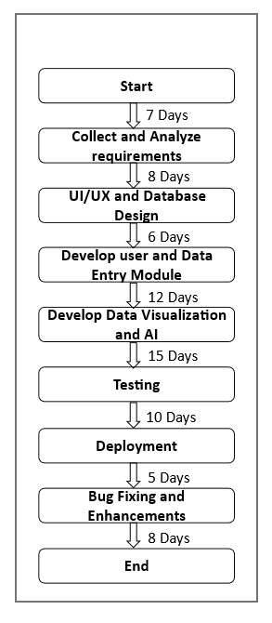

Experiment – 1.g: Draw E-R diagrams, DFD, CFD and structured charts for the project.
ER DIAGRAM

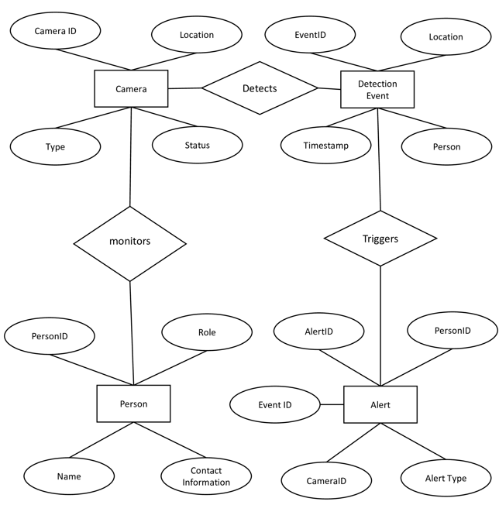

DFD-Level 0

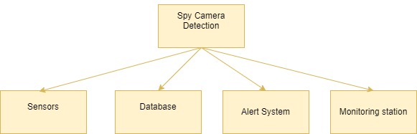
DFR-Level 1

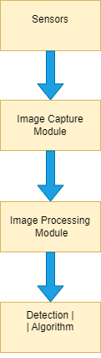

Experiment – 1.h: Design of Test cases based on requirements and design.
Module 1
Project Name | Spy Camera Detection
Module Name | User Management
Reference Document | Glucose Measurement Requirements Specification (GMRS) v1.1
Created by | U Venkat, M Suresh, V Shiva, K Rajesh
Date of creation | May 5, 2024
Date of review | May 20, 2024
Reviewed by | Jane Smith

Module | Test Case ID | Description | Preconditions | Test Steps | Expected Results | Actual Results | Status
User Management | UM001 | User login with valid credentials | User account exists | 1. Open the application.  2. Enter valid credentials.  3. Click login | User successfully logs in. | User successfully logged in. | Pass
User Management | UM002 | User login with invalid credentials | User account exists | 1. Open the application.  2. Enter invalid credentials.  3. Click login. | Login fails with an error message. | Login failed with an mistake message | Pass
User Management | UM003 | User logout | User is logged in | 1. Click the logout button. | User is logged out and redirected to the login screen. | User was logged out and redirected to login screen. | Pass

Module 2
Project Name | Spy Camera Detection
Module Name | Device management
Reference Document | Glucose Measurement Requirements Specification (GMRS) v1.1
Created by | U Venkat, M Suresh, V Shiva, K Rajesh
Date of creation | May 5, 2024
Date of review | May 20, 2024
Reviewed by | David warner

Module | Test Case ID | Description | Preconditions | Test Steps | Expected Results | Actual Results | Status
Device Management | DM001 | Add new detection device | None | 1. Navigate to the device management section.  2. Add a new device.  3. Enter device details and save. | New device is added successfully | new device is added successfully | Pass
Device Management | DM002 | Remove detection device | Device exists in the system | 1. Navigate to the device management section.  2. Select a device.  3. Remove the device. | Device is removed successfully | Device was removed successfully | Pass

Module 3
Project Name | Spy Camera Detection
Module Name | User Management
Reference Document | Glucose Measurement Requirements Specification (GMRS) v1.1
Created by | U Venkat, M Suresh, V Shiva, K Rajesh
Date of creation | May 5, 2024
Date of review | May 20, 2024
Reviewed by | Shane warne

Module | Test Case ID | Description | Preconditions | Test Steps | Expected Results | Actual Results | Status
Detection Functionality | DF001 | Detect wired spy camera | Camera is connected to power supply | 1. Switch on the detector.  2. Sweep the detector around the room. | The detector identifies the presence of a wired camera | The detector identifies the presence of a wired camera | Pass
Detection Functionality | DF002 | Detect wireless spy camera | Camera is turned on and transmitting | 1. Switch on the detector.  2. Sweep the detector around the room. | The detector identifies the presence of a wireless camera | The detector identifies the presence of a wireless camera | Fail

Experiment – 2: Using UML/JAVA, design Abstract Factory design pattern.

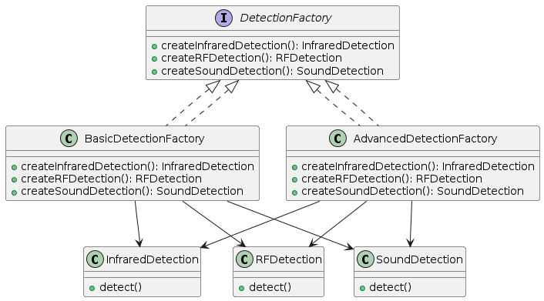

· Component (CameraDetectionMethod): Defines the interface for detection methods.
· Concrete Components (RFDetection, InfraredDetection, etc.): Implement specific detection
· Decorator (DetectionDecorator): Adds additional functionality to detection methods.
· Concrete Decorators (AdvancedRFDetectionDecorator, EnhancedInfraredDetectionDecorator): Extend functionalities of detection methods.
· Factory (DetectionFactory): Defines methods for creating different detection methods.
· Concrete Factories (BasicDetectionFactory, AdvancedDetectionFactory): Implement the creation of specific detection methods and their extended versions.
· Client: Uses factories to create and use detection methods

Experiment – 3: Using UML/JAVA, design Builder design pattern.
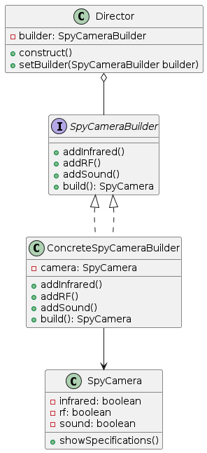

Concrete Components (RFDetection, InfraredDetection, etc.): Implement specific detection
Decorator (DetectionDecorator): Adds additional functional to detection methods.
Concrete Decorators (AdvancedRFDetectionDecorator, EnhancedInfraredDetectionDecorator): Extend functionalities of detection methods.
· Builder (SpyCameraDetectionBuilder): Configures and builds the SpyCameraDetectionSystem with selected methods and decorators.
· SpyCameraDetectionSystem: Represents the complex object that integrates various detection methods and configurations.
· Client: Uses the builder to configure the system and perform detection.

Experiment – 4: Using UML/JAVA, design facade design pattern.

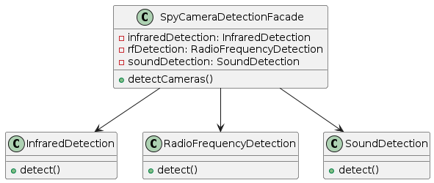

• Component (CameraDetectionMethod): Defines the interface for all detection methods.
• Concrete Components (RFDetection, InfraredDetection, etc.): Implement specific detection methods.
• Decorator (DetectionDecorator): Wraps a detection method to allow adding additional functionalities.
• Concrete Decorators (AdvancedRFDetectionDecorator, EnhancedInfraredDetectionDecorator): Extend functionalities of detection methods.
• Facade (SpyCameraDetectionFacade): Provides a simplified interface to perform both basic and advanced detections using various methods and their decorators.
• Client: Uses the SpyCameraDetectionFacade to interact with the detection system easily.

Experiment – 5: Using UML/JAVA, design Bridge design pattern.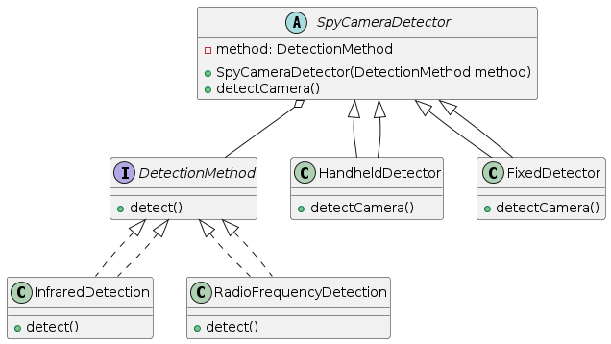
- Component (DetectionMethod): Defines the interface for all detection methods.
- Concrete Components (RFDetection, InfraredDetection, etc.): Implement specific detection methods.
- Abstraction (CameraDetection): Maintains a reference to DetectionMethod and provides an abstract method for detection.
- Refined Abstraction (AdvancedCameraDetection): Implements the abstract method using the specific detection method.
- Client: Uses the CameraDetection abstraction to perform detection and can dynamically change detection methods.

Experiment – 6: Using UML/JAVA, design Decorator design pattern.

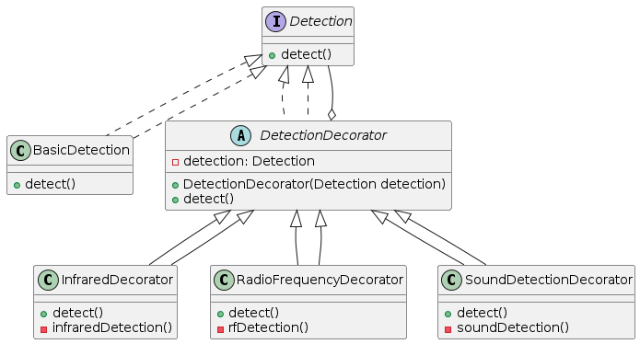

- Component (CameraDetection): Defines the interface for detection.
- Concrete Component (BasicDetection): Implements basic visual inspection.
- Decorator (DetectionDecorator): Wraps a CameraDetection object and delegates detection while allowing for extension.
- Concrete Decorators (RFDetectorDecorator, InfraredDetectorDecorator, etc.): Add specific detection functionalities.
- Client: Uses decorators to extend the base detection functionality dynamically.

