**Spring 2023**

**Nikita Gaurihar**

**NUID - 002980962**

**Spring 2023**

CSYE7280 User Experience Design and Testing



Assignment 02

**Under the guidance of Professor Vishal Chawla**

**Read the Lyft case study below:**

[**https://uxdesign.cc/lyft-re-design-case-study-3df099c0ce45 (Links to an external site.)**](https://uxdesign.cc/lyft-re-design-case-study-3df099c0ce45 (Links%20to%20an%20external%20site.))

**Elaborate and create a report for the following  based on your understanding (please do not copy directly from the case study)**

1. **Overview of the case study**
2. **Reasons for the redesign (at least 5 points)**
3. **What were the solutions for the issues faced? (At least 5 points)**
4. **Your key takeaways (3 points)**
5. **Improvements  you could provide (at least 2)**

**Solution:**

* **Overview of the case study**

The ‘Lyft redesign – an UX Case study’ talks about the process and the approach they followed while making the modifications of the Lyft application, focusing the user experience point of view. The author speaks about the useful design insights while working on the research followed by the A/B testing emphasizing the Lyft App redesign plan. Further, the case study explains how business value can be generated using Lyft’s redesign goals and Lyft’s design principles that follows Maslow’s hierarchy of needs. In addition to the success analysis, the author also talked about how important it is to understand the feedback of the consumer and be empathetic towards them.

* **Reasons for the redesign**

1. The locations of the action buttons and functionality of the app weren’t designed considering the user experience approach.
2. The color coding and the ergonomics were not appealing, thus making the users feel more confused and complicated.
3. The car icons were not animated and directional, hence wasn’t helpful for layman people or first-time users to understand whether the car was coming in the right direction.
4. Information about the driver wasn’t satisfactorily displayed. Also, the functionalities like ‘Ride Cancellation’, ‘Contact Driver’, etc. weren’t easily accessible, thus lacking transparency and creating confusion.
5. The cost of ride, Estimated Time of Arrival and destination were simple but important functionalities that every transport should provide, thus making users more reliable on the app.

* **What were the solutions for the issues faced?**

1. The color coding must be soothing and simple and the template must be consistent throughout the application.
2. The buttons and important information should be accessible easily and must be located within a finger’s reach.
3. Not only the car’s icon must be directional and must be moving in accordance with the real time connectivity with the google maps, but also the cars must be color coded that tells the category of the ride, i.e., Shared, Lyft XL, Lux, Lux Black, etc.
4. It’s preferred to provide information of the driver, vehicle, ETA of the ride to and from, cost, etc. to the user before booking the ride, thus maintaining transparency.
5. Also, the information to split, cancel ride, contact driver must be available in bold font to help user access it seamlessly in case the user changes his mind.

* **Your key takeaways**

1. It is really important to understand the product from the user’s point of view and hence it becomes crucial to gather feedback of the product from the consumer so that the UI/UX designer understand the short comings of the product. Some constructive criticism might help in expanding the business values.
2. While designing a product, it is essential to put ourselves in the user’s shoe and understand his needs. Since we are developing products to make consumer’s life easy, it becomes crucial to be empathetic to design a better user experience.
3. Not only this, a deep dive into the product’s usability and functionality is necessary. A thorough research becomes the backbone for any product redevelopment.

* **Improvements you could provide:**

1. **Color coding the category of the ride:**

Although the Cars are made directional and moving in accordance with the real time connectivity with the google maps, they can be color coded to indicate the kind of ride, such as Shared, Lyft XL, Lux, Lux Black, etc. Please refer fig(a) for the reference.

1. **Fixing the main option tab:**

Once the user starts to book the ride, the main options tab which is available at the home page in the left top corner with 3 horizontal bars is no longer available. For some reason if the user wants to access the options like the ‘ride history’ or ‘gift cards’, he has to go back and again access the same. It would be easy for the user to keep the main options tab fixed for a better user experience. Please refer fig(b) and fig(c) for the reference.

**Fig(a): Color coding the category of the ride:**

**Fig(b): Main options tab available at home page**

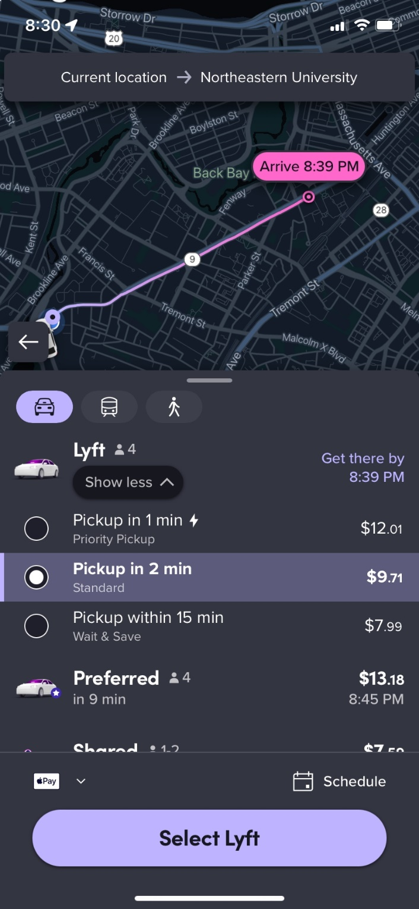

**Fig(c): Main options tab vanishes as the user starts to book a ride**