|  |  |  |  |  |  |  |
| --- | --- | --- | --- | --- | --- | --- |
| **PROJECT RUBRIC**  **IT 403 – ELECTIVE 5 (WEB SYSTEMS AND TECHNOLOGIES 3)** | | | | | **SCORE**  **161** | |
| **STUDENT NO.** | **LAST NAME** | | **FIRST NAME** | | | **MIDDLE INITIAL** |
| 2021100977 | CARRILLO | | JANELLA CHRISTINE | | | L |
| **STUDENT NO.** | **LAST NAME** | | **FIRST NAME** | | | **MIDDLE INITIAL** |
| 2021102028 | FANUGAN | | NICKO HAZZEAN | | | P |
| **STUDENT NO.** | **LAST NAME** | | **FIRST NAME** | | | **MIDDLE INITIAL** |
| 2021101797 | DOMINGO | | ROSANA ROSE | | | I |
| **STUDENT NO.** | **LAST NAME** | | **FIRST NAME** | | | **MIDDLE INITIAL** |
| 2021101993 | FABIAN | | JOSHUA EMIL | | | R. |
| **STUDENT NO.** | **LAST NAME** | | **FIRST NAME** | | | **MIDDLE INITIAL** |
| 2021106153 | SULIT | | JOHN EZEKIEL | | | E |
| **STUDENT NO.** | **LAST NAME** | | **FIRST NAME** | | | **MIDDLE INITIAL** |
| 2021103133 | MANALO | | MARY GRACE | | | C |
| **STUDENT NO.** | **LAST NAME** | | **FIRST NAME** | | | **MIDDLE INITIAL** |
| 2021104365 | SAMANIEGO | | REY MIGUEL | | | A |
| **STUDENT NO.** | **LAST NAME** | | **FIRST NAME** | | | **MIDDLE INITIAL** |
| 2021102251 | GARCIA | | ALEXIS | | |  |
| **STUDENT NO.** | **LAST NAME** | | **FIRST NAME** | | | **MIDDLE INITIAL** |
| 2021100749 | BUENDIA | | DANIELA MHAEY | | | F |
| **STUDENT NO.** | **LAST NAME** | | **FIRST NAME** | | | **MIDDLE INITIAL** |
| 2021106045 | SANGRIA | | JOAQUIN | | | A |
| **COURSE, YEAR, and SECTION** | | **DATE/TIME OF CHECKING**  **(mm/dd/yyyy hh:mm am/pm)** | | **INSTRUCTOR** | | |
| BSIT 4E-G2 | | 01/03/2025 10:00AM | | MR. GABRIEL M. GALANG | | |

QUIZ WEB APPLICATION

|  |  |  |  |  |  |  |
| --- | --- | --- | --- | --- | --- | --- |
| **INSTRUCTION:** Build a quiz app where the users can create quizzes (teachers) and take quizzes (students). Maximize the use of the Python Django web framework. | | | | | | |
| **COMMON FEATURES** | | | | | | |
| **1** | **Layout**. The layout must be consistent throughout the  whole web app, easy to navigate, and with proper alerts and prompt messages. | **20** | **15** | **10** | **5** | **1** |
| **2** | **Account Registration**. Users shall register accounts before using the web app. Allow the user to provide a username and email address (both shall be validated for entry duplication). | **10** | **8** | **5** | **3** | **1** |
| **3** | **Log In and Log Out**. Allow the user to choose from a username or email when logging in. Confirm before  logging out. | **10** | **8** | **5** | **3** | **1** |
| **4** | **User Profile**. Users must be able to edit or delete their accounts. Changing the password shall ask for the old password, and the new password, and confirm the new  password. | **15** | **12** | **8** | **4** | **1** |
| **TEACHER FEATURES** | | | | | | |
| **5** | **Class Management**. A teacher must be able to manage classes. A teacher can create a class and invite students to join the class. This feature limits the number of students  who can access a quiz specifically given to them in their class. | **30** | **22** | **15** | **7** | **1** |
| **6** | **Quiz Creation and Grade Viewing**. The teacher can create a quiz of multiple choice, true or false, and identification. When creating a quiz, there must be an assigned class. Provide an option for a schedule (date and time) when taking the quiz. Additionally, provide a timer a teacher can set on the length of taking the quiz. The  created quiz must have an automatic checking that stores  the correct answers to each question. After taking the quiz, the teacher can generate a report (downloadable) on the student’s grades on the quiz. | **30** | **22** | **15** | **7** | **1** |
| **7** | **Data Banking**. To ensure that the teacher has selections on the questions they may use on their quizzes, data banking must be implemented. Every time the teacher creates a quiz, all questions will be stored in the bank. Bank questions will also be suggested upon creating a  quiz. | **25** | **19** | **13** | **6** | **1** |
| **STUDENT FEATURES** | | | | | | |
| **8** | **Class Joining**. The student must be able to join a class created by the teacher. The teacher must supply a code to join the class. | **20** | **15** | **10** | **5** | **1** |
| **9** | **Class Quizzes**. The student must be able to take a  scheduled quiz within a given time limit. | **20** | **15** | **10** | **5** | **1** |
| **10** | **Scores and Correct Items**. After submitting the quiz, the student must see their score. Viewing the correct and incorrect items must be enabled by the teacher before the students can see them. | **20** | **15** | **10** | **5** | **1** |
| **ADDITIONAL FEATURES**  ***NOTE:*** *Additional features will only be considered if all items listed above received a score rather than 1.* | | | | | | |
| **AF1** | **Logging in via Google/Facebook**. Provide an option to log in using existing accounts from Google or Facebook. | **20** | **15** | **10** | **5** | **1** |
| **AF2** | **Anti-Cheating**. The quiz app must be integrated with several measures to prevent cheating. Some measures are setting the browser to full screen, detecting if using second screen, detecting changing of windows (Alt+Tab),  and others. | **30** | **22** | **15** | **7** | **1** |

|  |  |  |
| --- | --- | --- |
| **Legend** | **Description** | **Comment** |
| **1** | Poor | The item is not working. Item is not  available for evaluation. |
| **7/6/5/4/3** | Needs Improvement | The item works but has several errors. Errors include:   1. No Data Validation 2. Data is not correctly displayed 3. Data is not correctly updated 4. The session is not handled correctly |
| **15/13/10/8/5** | Satisfactory | The item works but has no data validation. The session is implemented correctly.  Errors include:   1. No Data Validation 2. No Data Duplication Validation |
| **22/19/15/12/**  **8** | Very Satisfactory | The item works well; no bugs are found. The transaction is implemented via Web  development frameworks. The data format is validated correctly, and there is no data  duplication. |
| **30/25/20/15/**  **10** | Excellent | The item works well, no bugs are found,  and has data validation. |

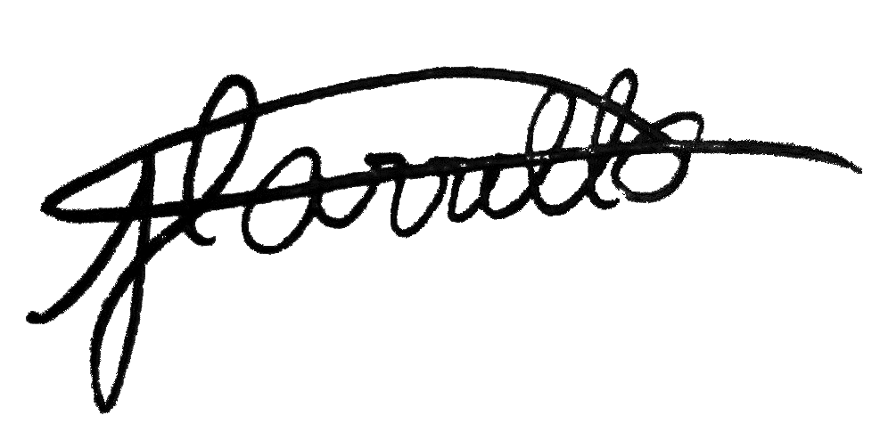**Submitted by:**

**CARRILLO, JANELLA CHRISTINE L. BUENDIA, DANIELA MHAEY F.**

(Signature over Printed Name of the Leader) (Signature over Printed Name)

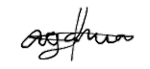

 **FANUGAN, NICKO HAZZEAN P. GARCIA, ALEXIS**

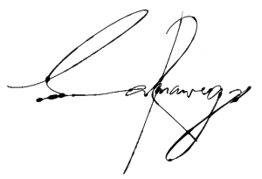(Signature over Printed Name) (Signature over Printed Name)



**SAMANIEGO, REY MIGUEL A. MANALO, MARY GRACE C.**

(Signature over Printed Name) (Signature over Printed Name)

**DOMINGO, ROSANA ROSE I. SULIT, JOHN EZEKIEL E.** 

(Signature over Printed Name) (Signature over Printed Name)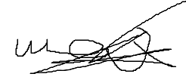

**FABIAN, JOSHUA EMIL R. SANGRIA, JOAQUIN A.** (Signature over Printed Name) (Signature over Printed Name) 

# Submitted to:

**Mr. Gabriel M. Galang, MSIT, GK-CDPO, PCEP, CPE, CLE**

*Instructor III*

College of Information and Communications Technology Bulacan State University

*Certified Data Protection Officer | Certified Python, JavaScript, Java, C++, and C Programmer*