Title Page
- Project Title: Breast Tumor Classification with Random Forest + Pattern Segmentation

- Team Name / Cohort: Individual Capstone Project

- Team Members + Roles: Nilesh Shirke — Individual Project

- Dataset: UCI Breast Cancer Wisconsin (Diagnostic)

- Model: Random Forest Classifier (single algorithm)


- Executive Summary
  - Objective: To classify breast tumor observations as Malignant (M) or Benign (B) using a Random Forest Classifier on the UCI Breast Cancer Wisconsin (Diagnostic) dataset.

  - Approach: Random Forest Classifier with hyperparameter tuning, threshold analysis, final evaluation, and K-Means + hierarchical clustering.

  - Key results (test set): Accuracy: 96.49%, ROC-AUC: 99.74%, Recall (M): 90.48%, Precision: 100.00%, F1 Score: 95.00%.

  - Operational interpretation: The results show strong classification performance on the held-out test set. The model correctly identified all benign observations and 19 of 21 malignant observations, with 2 malignant observations classified as benign.

  - Top recommendations:

  - Continue threshold analysis using validation data, with attention to malignant recall and false negatives.

  - Investigate the two false-negative cases and assess model robustness using repeated stratified validation.

  - Use K-Means and hierarchical clustering as exploratory pattern-analysis tools, not as clinical diagnostic categories.

Problem Definition and Success Metrics
  - Target definition: Malignant (M) or Benign (B), encoded as M = 1 and B = 0.

What errors mean:

    - False Negative (M predicted B): A malignant observation incorrectly classified as benign. This is an important error because the model may fail to identify a malignant case.

    - False Positive (B predicted M): A benign observation incorrectly classified as malignant. This can lead to unnecessary follow-up or additional review.

  - Primary metrics (and why): ROC-AUC, Recall (M), and F1 Score are used as primary metrics to assess overall discrimination, malignant-case detection, and the balance between precision and recall.

  - Decision threshold: 0.50. This threshold was selected using validation-set threshold analysis because lower thresholds did not improve malignant recall, while higher thresholds reduced malignant recall.

Dataset Overview and Quality Checks
  - Dataset facts: 569 instances, 30 real-valued diagnostic features, no missing values, and a binary classification target (Malignant/Benign).

  - Feature origin: The 30 diagnostic features were computed from digitized fine needle aspirate (FNA) images..

Quality checks performed:

    - The ID column was removed from the model features
- duplicates checked

- class distribution reported (Benign (B): 357 (62.74%) and Malignant (M): 212 (37.26%).)

- any outlier handling policy (Statistical outliers were identified using the IQR method; no observations were removed because the outliers were treated as valid data points rather than data errors.)
- Data Preparation and Split Strategy
  - Preprocessing steps: The ID column was removed, the diagnosis target was encoded as B = 0 and M = 1, and no additional transformations were applied to the features.

  - Split method: stratified Train/Validation/Test

    - Split ratio: 80% / 10% / 10% ratio and random seed 42.

    - Random seed:
  - Leakage prevention: The validation and test sets were kept separate from model training and hyperparameter tuning, ensuring that no information from these sets influenced the training process.

Feature Handling
  - Feature set used: All 30 diagnostic features were retained for model training, with the ID column excluded.

  - Scaling: Feature scaling was not required for the Random Forest model; StandardScaler was applied to the features for the clustering analysis.

  - Feature list appendix:The final training feature set consisted of 30 diagnostic measurements: mean, standard error (SE), and worst values for radius, texture, perimeter, area, smoothness, compactness, concavity, concave points, symmetry, and fractal dimension

Model Development (Random Forest Classifier)
  - Model overview: Random Forest was selected because it can capture non-linear patterns in tabular data and provides a robust ensemble-based classification approach.

Training setup:

    - A fixed random state = 42 was used to ensure reproducible model training and evaluation results.)

    - Class imbalance was handled using class_weight="balanced" in the final tuned Random Forest model.

- Hyperparameter Tuning and Final Configuration
  - Tuning method: GridSearchCV

  - Search space: The tuning grid included n estimators, max_depth, min_samples_split, min_samples_leaf, max_features, and class_weight, using the parameter values specified in the project requirements.

  - Selection criterion: ROC-AUC was used as the primary selection criterion, with emphasis on protecting malignant-case recall.

  - Final hyperparameters (table):

Parameter | Final Value
n_estimators | 200
max_depth | 5
min_samples_split | 2
min_samples_leaf | 1
max_features | sqrt
class_weight | balanced

Final Evaluation (Test Set Results)
Provide both a results table and interpretation.

Metrics table
Metric | Value
Accuracy | 96.49%
Precision | 100.00%
Recall (Sensitivity for M) | 90.48%
F1 Score | 95.00%
ROC-AUC | 99.74%
  - Confusion matrix + explanation

    - Confusion Matrix: [[36, 0], [2, 19]]

    - The model correctly classified 36 benign and 19 malignant observations. It produced 0 false positives and 2 false negatives.

ROC curve

    - The ROC curve shows the model's ability to distinguish between benign and malignant observations across different classification thresholds.
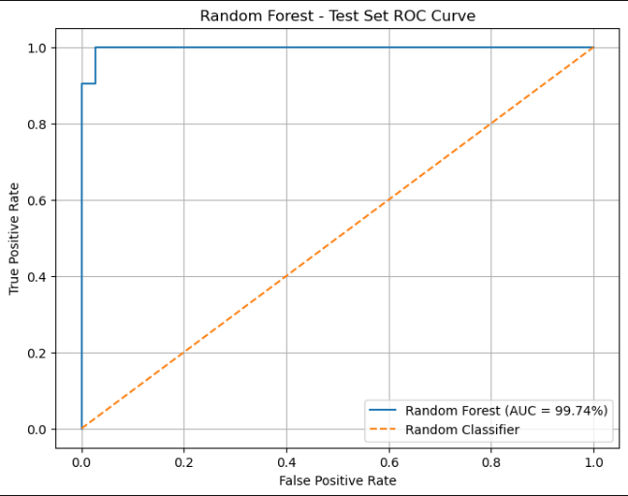

    - The ROC-AUC value of 99.74% indicates strong separation between benign and malignant observations on the held-out test set.

Threshold decision

    - Threshold used: 0.50

    - The 0.50 threshold was selected because lower thresholds did not improve malignant recall, while higher thresholds reduced malignant recall.

Error Analysis

- The two false-negative cases had size-related features such as radius, perimeter, and area that were closer to the benign pattern than the malignant pattern.

No false-positive cases were observed in the final test set; all 36 benign observations were correctly classified as benign.

- Two hard cases were identified: test observations 385 and 86, both malignant cases that were incorrectly predicted as benign.

- Mitigations / next steps:
- Continue threshold analysis on validation data to assess whether malignant recall can be improved while controlling false positives.
- Investigate the two false-negative cases and review their feature patterns to understand why they were difficult to classify.
- Use repeated stratified validation to assess the stability and robustness of the model's performance.

- Clustering: Diagnostic Pattern Segmentation
  - Preprocessing for clustering: The 30 diagnostic features were standardized using StandardScaler before clustering so that features with different numerical scales contributed comparably.

  - Method 1: K-means

    - The elbow method was evaluated for K values from 2 to 10, and K = 5 was selected as the practical elbow point for the clustering analysis.

  - Method 2: Hierarchical clustering

    - Hierarchical clustering was performed using Ward linkage, and the dendrogram was cut to obtain 5 clusters for comparison with the K-Means analysis.

  - Cluster cards (minimum 3 clusters):
Cluster 0 — Cluster size: 204 observations
- Top distinguishing features: Perimeter SE, concave points (mean), perimeter (worst), area (mean), and concavity (mean).
- M/B mix: 185 Benign (B, 90.69%) and 19 Malignant (M, 9.31%).

- Non-clinical interpretation: This cluster represents a predominantly benign pattern group with relatively fewer malignant observations based on the available diagnostic features.

Cluster 1 — Cluster size: 161 observations

- Top distinguishing features: Perimeter SE, concave points (mean), perimeter (worst), area (mean), and concavity (mean).

- M/B mix: 153 Benign (B, 95.03%) and 8 Malignant (M, 4.97%).

- Non-clinical interpretation: This cluster represents a predominantly benign pattern group with a small proportion of malignant observations based on the available diagnostic features.

Cluster 2 — Cluster size: 99 observations

- Top distinguishing features: Perimeter SE, concave points (mean), perimeter (worst), area (mean), and concavity (mean).

- M/B mix: 0 Benign (B, 0.00%) and 99 Malignant (M, 100.00%).

- Non-clinical interpretation: This cluster contains only malignant-labeled observations in the dataset and represents a distinct feature-pattern group; this clustering result is exploratory and not a clinical diagnostic category.

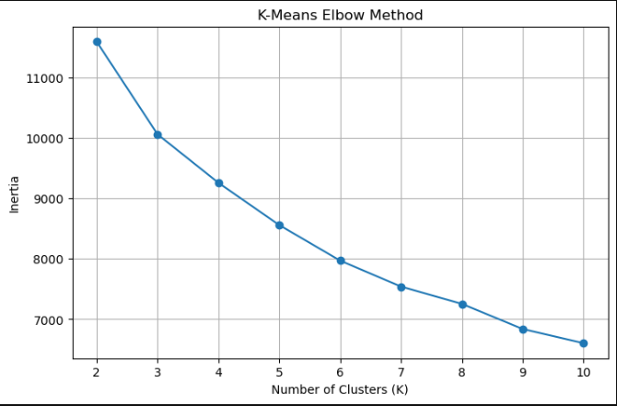

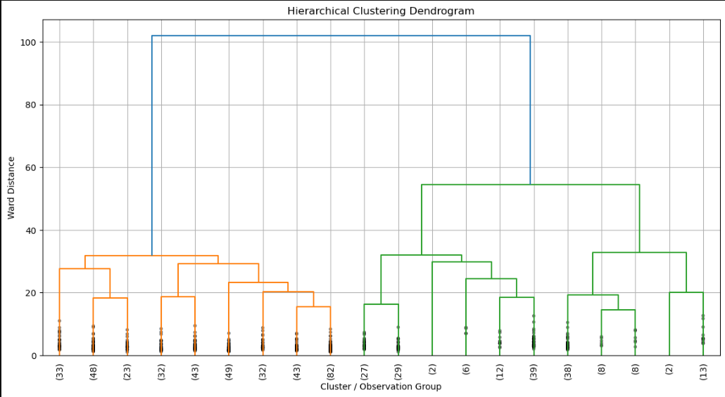

Recommendations and Limitations

Recommendations-

- Continue threshold analysis using the validation set to assess whether malignant recall can be improved while controlling false positives.

- Investigate the two false-negative cases and review their feature patterns to understand why they were difficult to classify.

- Use repeated stratified validation to assess the stability and robustness of the model’s performance.

Limitations

- The dataset contains 569 observations from the UCI WDBC dataset, so the model’s performance may not generalize to other datasets or populations. The project is for learning and demonstration only and does not establish clinical validity.

Future Work

- Expand the dataset and evaluate the model on additional data to assess generalization and robustness.
- Explore additional feature-analysis and clustering techniques to identify stable, non-clinical diagnostic pattern groups
- Evaluate model calibration and threshold stability on future validation data to support more reliable probability-based decisions.

Appendix
- 30 diagnostic features were used for model training, excluding the ID column and diagnosis target.
radius_mean,texture_mean, perimeter_mean, area_mean, smoothness_mean, compactness_mean, concavity_mean, concave_points_mean, symmetry_mean, fractal_dimension_mean
radius_se, texture_se, perimeter_se, area_se, smoothness_se, compactness_se, concavity_se, concave_points_se, symmetry_se, fractal_dimension_se
radius_worst, texture_worst, perimeter_worst, area_worst, smoothness_worst, compactness_worst, concavity_worst, concave_points_worst, symmetry_worst, fractal_dimension_worst

Rank | n_estimators | max_depth | min_samples_split | min_samples_leaf | max_features | class_weight | CV ROC-AUC
1 | 200 | 5 | 2 | 1 | sqrt | balanced | 99.15%

- Additional plots

