

**1**

Wireframe Documentation Amazon Sales Data Analysis

Date: 12/7/2024

Neel Gokhale



**2**

# Contents

1. Sales analysis 3
   1. Key Insight Cards 3
   2. Top 5 most sold items 4
   3. Revenue by Country 4
   4. Monthly Sales Trends 5



**3**

# Sales analysis

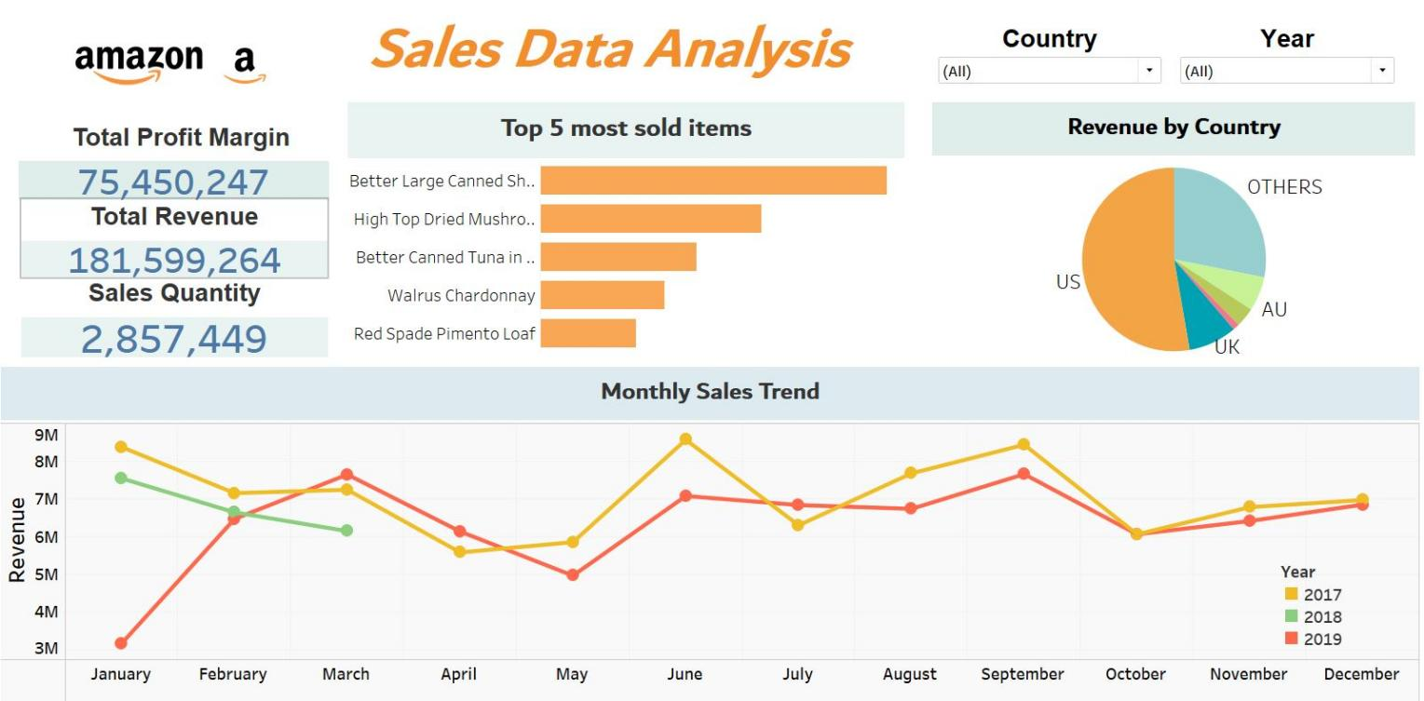

## Cards

The cards show the Total profit margin, Total Revenue and the Sales quantity for all years and all countries. They can be filtered for specific year/years and specific country/countries by using the filters available on top left.

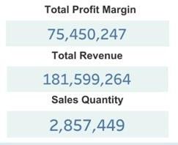



**4**

## Top 5 Most Sold Items

The bar chart shows the top 5 most sold items on amazon.

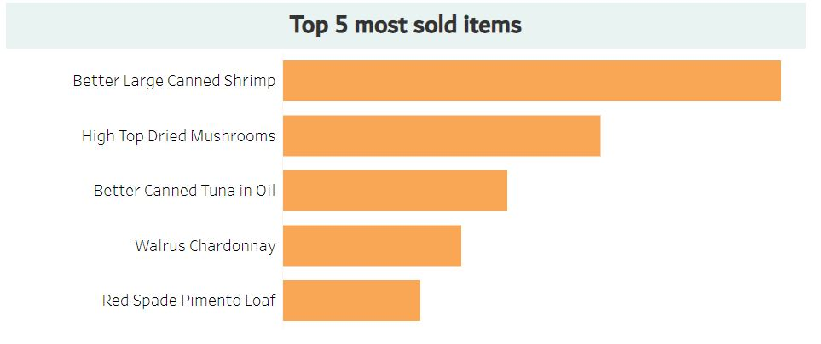

## Revenue by Country

The Pie chart shows the revenue generated by each country.

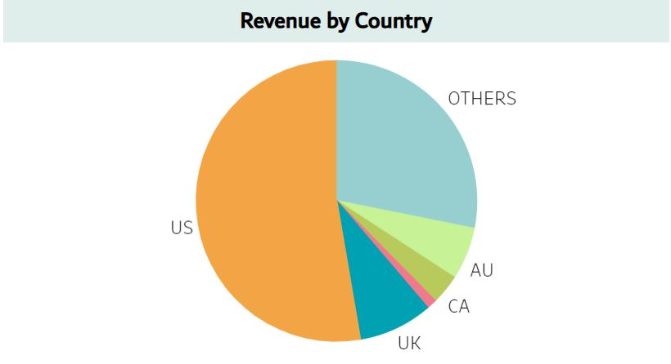



**5**

## Monthly Sales Trends for 2017, 2018, 2019

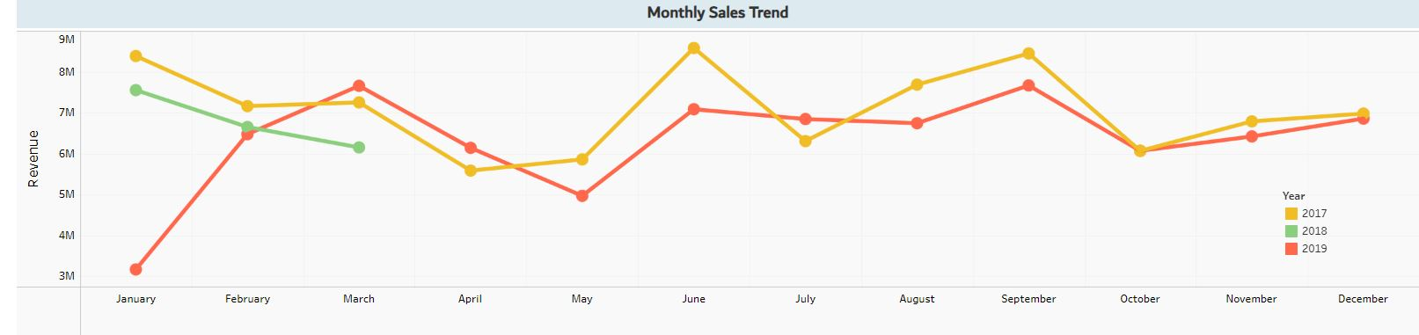

* 1. Filters

The filters can be used to see specific data. For example, Total revenue generated by US in 2019.

