DAY 3

Understanding motherboards - http://www.gigabyte.com/products/product-page.aspx?pid=3849#ov

http://www.tigerdirect.com/applications/SearchTools/item-details.asp?EdpNo=344430&Sku=G452-0139

2. Go over the specifications of the board and its main features.

Activity 1:
Label all the components of the motherboard as per the diagram specs from last day and the specifications provided on the website http://www.gigabyte.com/products/product-page.aspx?pid=3849#sp.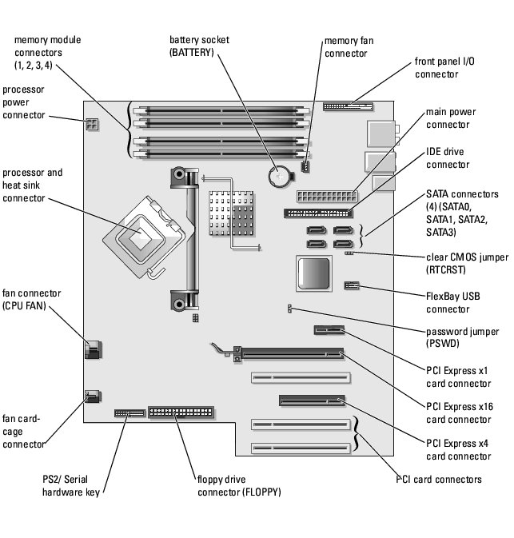
Activity 2: Draw a motherboard use Paint or any drawing tools. Label at least ten components on your diagram.

COMPUTER PARTS: The Big Four

COMPONENT: RAM

Stands For:
What Does It Do?

Analogy:
Big Manufacturers and Prices:
Other Notes:

COMPONENT: HARD DRIVE

What Does It Do?

How Does it Work?
Analogy:
Other Notes:
Biggest Sizes you Could Find Online (with prices):

COMPONENT: CPU

Stands For:
What Does It Do?

How Does it Work?
Analogy:
Fastest You Could Find Online and pricing:

COMPONENT: MOTHERBOARD

What Does It Do?

How Does it Work?
Analogy:
Manufacturers and most expensive you can find:

