3.2 Reporting Requirements:

5 Total Subgroups
Total Values:
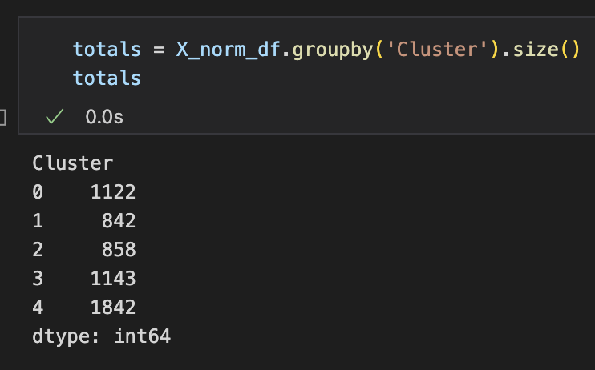
Number of y=1:
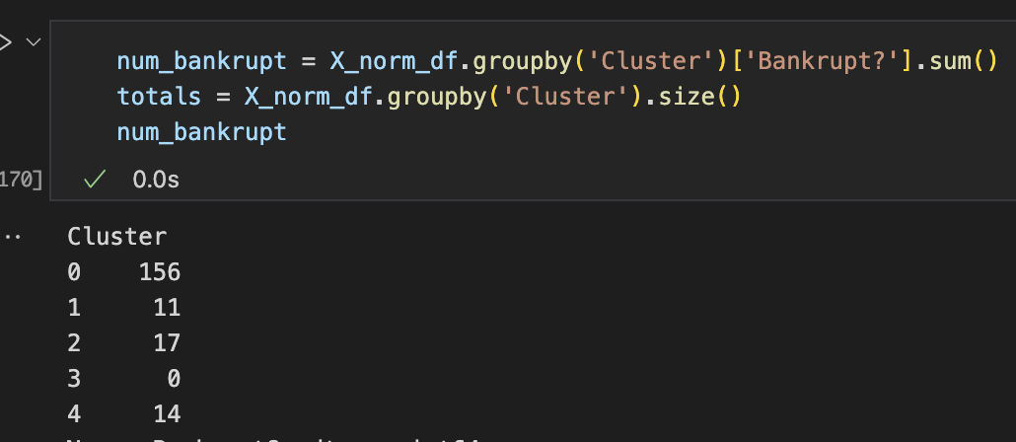
Number of y=0:
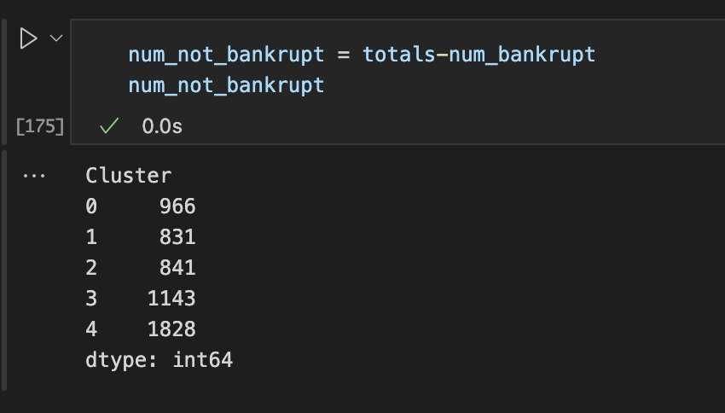

Characteristics of Clusters Based on Distribution:
Cluster 0: Median ROA, operating gross margin and cash-flow measures all sit below zero, while the median debt-ratio is around zero; both working-capital/total-assets and cash/total-assets medians are negative, and fixed-asset turnover and expense/assets medians hover at zero.

Cluster 1: Profitability and cash-flow medians cluster at zero, the median debt-ratio is below zero, and both working-capital/total-assets and cash/total-assets have positive medians; expense/assets is slightly positive and fixed-asset turnover remains near zero.

Cluster 2: ROA, net-value-per-share and operating-profit-per-person medians are just above zero but cash-flow medians lie just below; the median debt-ratio is positive, while cash-liquidity ratios (cash/total-assets and cash/current-liability) are negative and turnover sits around zero.

Cluster 3: All core profitability and cash-flow medians are clearly above zero, the median debt-ratio falls below zero, and both working-capital/total-assets and cash/total-assets medians are positive; expense/assets is modestly above zero and turnover centers near the midline.

Cluster 4: Nearly every metric (profitability, cash flow, leverage, liquidity, turnover, and expense ratios) has a median effectively at zero, with IQRs and whiskers balanced on both sides of the midline.

Cluster Correlations with Bankruptcy:
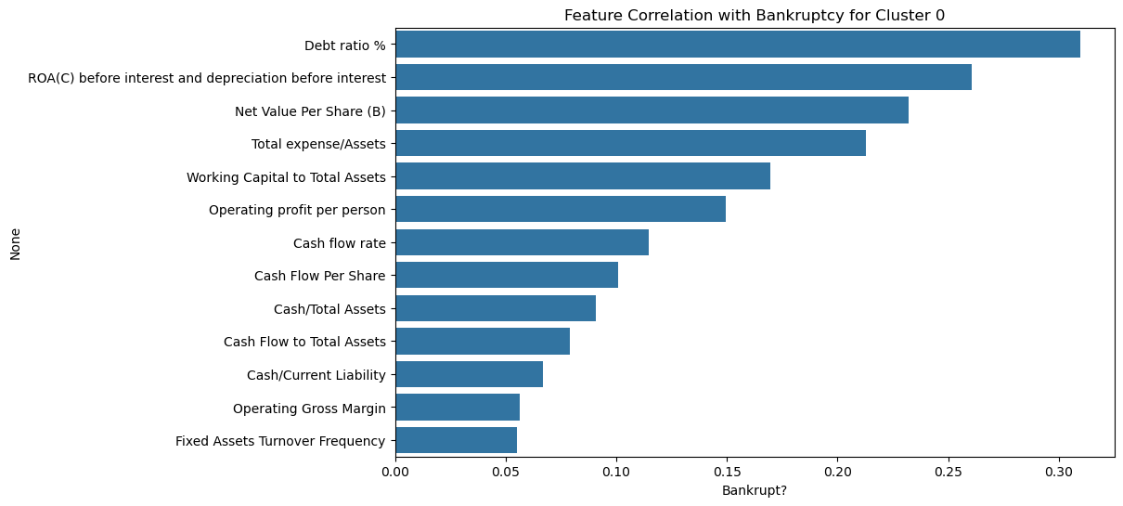
The most important features seem to be Debt Ratio %, ROA(C) before interest and depreciation before interest, and Net Value Per Share (B)
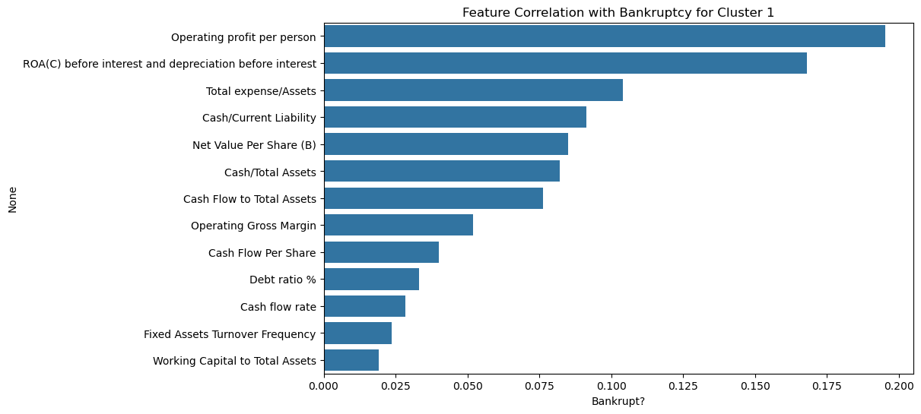
The most important features seem to be Operating Profit per Person, ROA(C) before interest and depreciation before interest, and Total expsense/Assets.
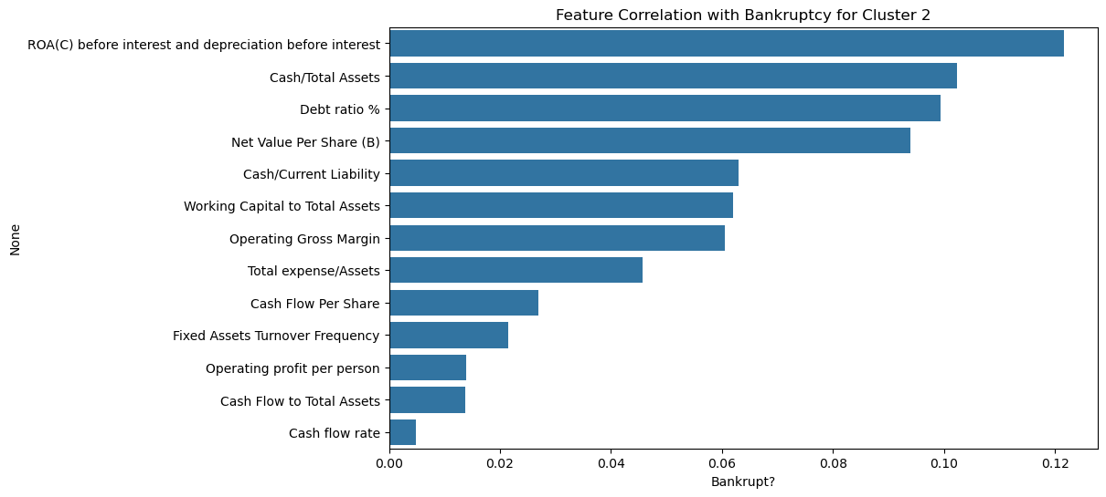
The most important features seem to be ROA(C) before interest and depreciation before interest, Cash/Total Assets, and Debt ratio %
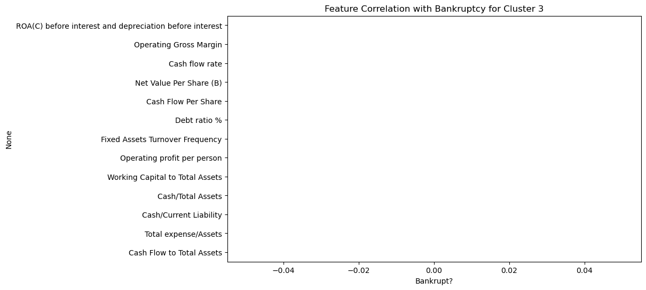
There are no important features in this cluster since there are no bankrupt companies in the cluster.
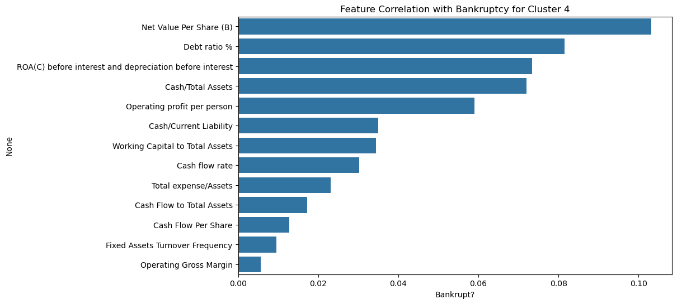
The most important features here seem to be Net Value Per Share (B), ROA(C) before interest and depreciation before interest, Debt Ratio %.

Overall, across all clusters (besides cluster 3), ROA(C) before interest and depreciation before interest seems to be the most important feature, as it has been in the top 3 more correlated feature with bankruptcy across all clusters. The next most important feature seems to be Debt ratio % as it is in the top 3 features among 3 out of the 4 clusters. Finally, the third more important feature seems to be Net Value Per Share (B), with it being top 3 in 2 out of the 4 clusters, and in another cluster, it is the 4th more correlated feature.

Subgroup ID | Name of Student | Average accuracy score of base models [TT(TF)] | Accuracy score meta model [TT(TF)] | N_features
0 | Katherine Shagalov | 0.81 [126(30)] | 0.81 [127(29)] | 7
1 | Neel Patel | 1.00[11(0)] | 1.00[11(0)] | 4
2 | Jorge Ponce | 0.85 [14.4(2.6)] | 0.82 [14(3)] | 13
3 | Constant | 1.00 [0(0)] | 1.00 [0(0)] | 0
4 | Mahad Rana | 0.99 [14(0)] | 1.00 [14(0)] | 5
team |  | 0.96 [165.4(32.6)] | 0.93 [166(32)] | 5.4391
Calculation for Weighted Average of Features:
Cluster
0 1122/5807 * 7 = 1.3525
1 842/5807 * 4 = 0.5799
2 858/5807 * 13 = 1.9207
3 1143/5807 * 0 = 0
4 1842/5807 * 5 = 1.5860
1.3525 + 0.5799 + 1.9207 + 0 + 1.5860 = 5.4391

Confusion Matrix for Subgroup 0:
Random Forest:
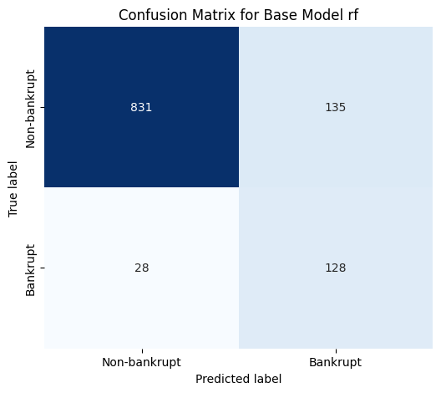
Extra Trees:
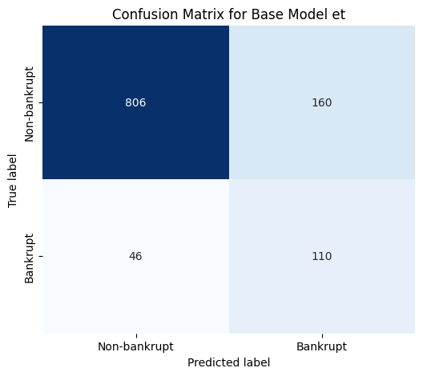

KNN:
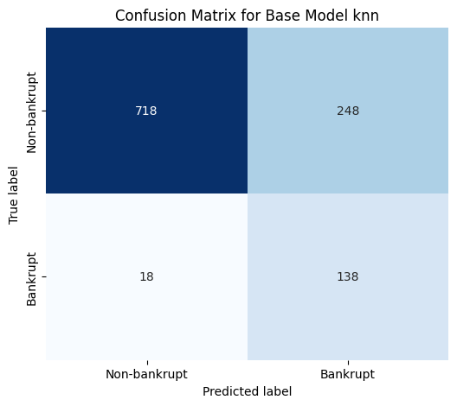

Decision Trees:
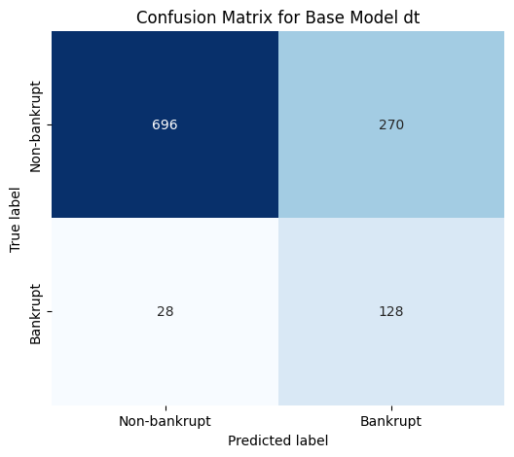

Meta Model:
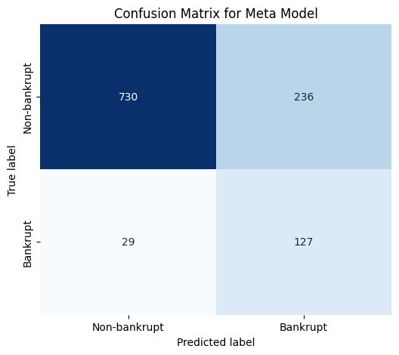
Confusion Matrix for Subgroup 1:

Bagging Classifier:

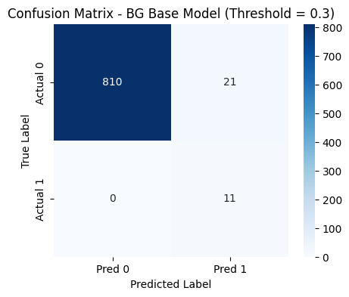

Extra Tree Classifier:

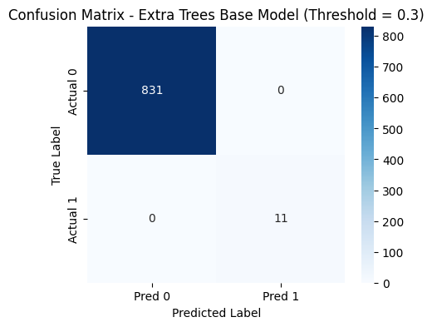

Gradient Boosting:

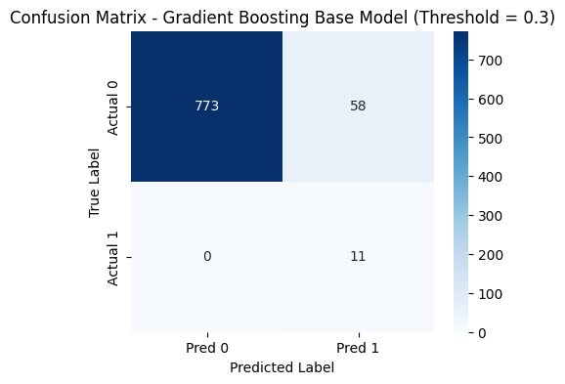

KNN:
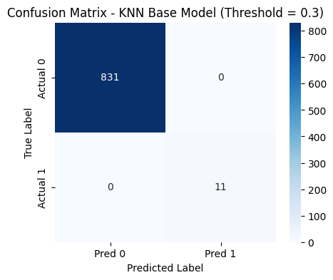

Meta Model:

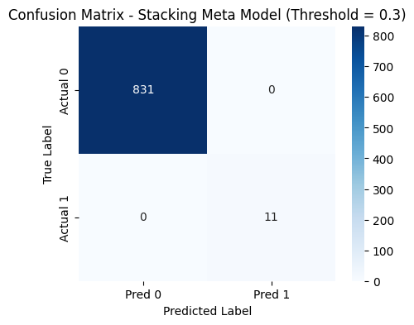
Confusion Matrix for Subgroup 2:
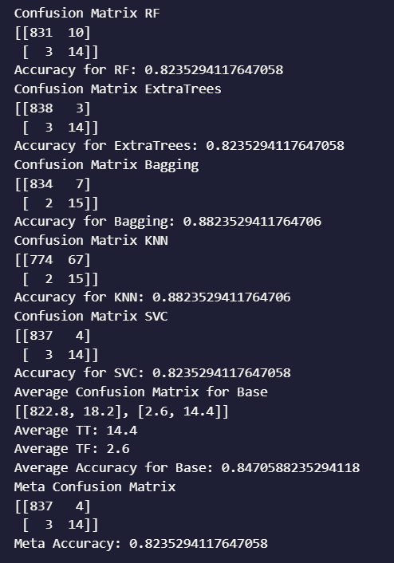

Confusion Matrix for Subgroup 4:
K-Nearest Neighbors:
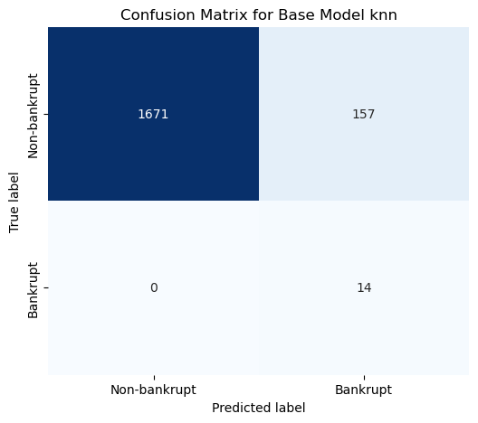
SVM:
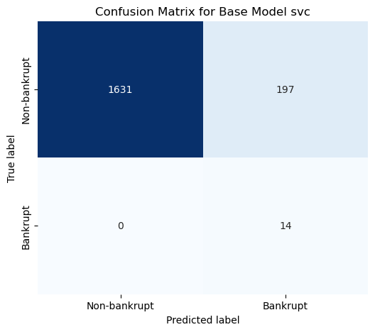
Decision Trees:
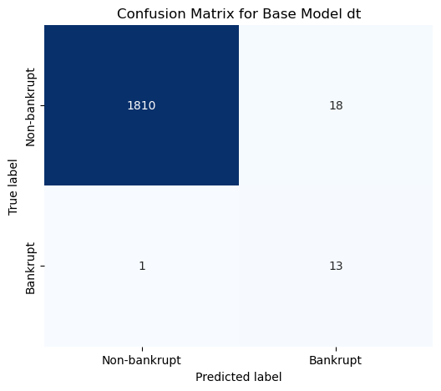

Extra Trees:
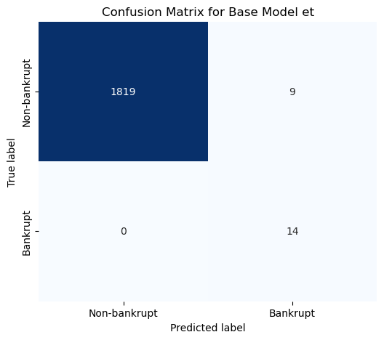
Random Forest:

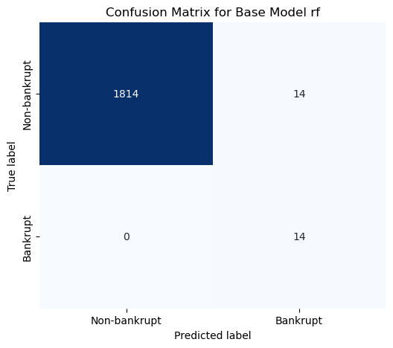
Meta Model:
