**Rec Shokubutsu: A Plant Identification Application**

**A PROJECT REPORT**

***Submitted by***

**NEEL MADHAB ROY**

**19BCS6064**

***in partial fulfillment for the award of the degree of***

**BACHELOR OF ENGINEERING**

**IN**

**ARTIFICIAL INTELLIGENCE AND MACHINE LEARNING**



**Chandigarh University**

August 2022



**BONAFIDE CERTIFICATE**

Certified that this project report **Rec Shokubutsu: A Plant Identification Application** is the bonafide work of **Neel Madhab Roy** who carried out the project work under my/our supervision.

**SIGNATURE**

**Dr. U. Hariharan**

**SIGNATURE**

**Mr. Ajay Pal Singh**

INTERNAL EXAMINER EXTERNAL EXAMINER

**TABLE OF CONTENTS**

List of Figures i

List of Tables ii

Abstract iii

Graphical Abstract iv

Abbrevations v

Symbols vi

Chapter 1.  4

1.1 5

1.2

1.2.1

1.3

1.3.1

1.3.2

Chapter 2.

2.1

2.2

Chapter 3.

**Chapter 4. ………………………….………………………………………...**

**Chapter 5. ……………………………………………………………………**

References (If Any)

List of Figures

Figure 3.1 ………………………………………………………………………………….

**Figure 3.2 ………………………………………………………………………………….**

**Figure 4.1 …………………………………………………………………………….……**

List of Tables

Table 3.1 ………………………………………………………………………………….

**Table 3.2 ………………………………………………………………………………….**

**Table 4.1 …………………………………………………………………………….……**

**DECLARATION**

I, **Neel Madhab Roy** student of **‘Computer Science Engineering in Artificial Intelligence and Machine Learning’**, **Session: 2019-23**, Department of Computer Science and Engineering, Apex Institute of Technology, Chandigarh University, Punjab, hereby declare that the work presented in this Project Work entitled ‘**Rec Shokubutsu: A Plant Identification Application’** is the outcome of our own bona fide work and is correct to the best of our knowledge and this work has been undertaken taking care of Engineering Ethics. It contains no material previously published or written by another person nor material which has been accepted for the award of any other degree or diploma of the university or other institute of higher learning, except where due acknowledgment has been made in the text

Date – 01/11/22 Neel Madhab Roy

Place: Chandigarh 19BCS6064

**ACKNOWLEDGEMENT**

I have taken efforts in this project. However, it would not have been possible without the kind support and help of many individuals and organizations. I would like to extend my sincere thanks to all of them. I am highly indebted to Mr. Ajay Pal Singh for their guidance and constant supervision as well as for providing necessary information regarding the project & also for their support in completing the project. I would like to express my gratitude towards my parents and my department for their kind co-operation and encouragement which help me in completion of this project

THANKS AGAIN TO ALL WHO HELPED

**ABSTRACT**

Plants are the backbone of all life and there are about 40 million plant species on Earth providing us with oxygen, food and many essential products helping for the existence of human life. Species knowledge is important for biodiversity conservation as well. Identification of plants by conventional approach is complex, time consuming, and frustrating tor non experts due to the use of botanical terms. This project uses convolutional neural network models to perform plant species identification using simple leaves images of plants, through deep learning methodologies. Training of the model was performed by using a dataset of 184 distinct classes of plant containing 7744 plant species images. The aim of the project is to develop an application that helps people to identify plant species using simples’ leaves images of plants without begin concerned about the knowledge of botany (study of plants). This will help us to identification of new or rare plant species to improve the balance in the ecosystem. We are going to implement these by building our own CNN model on 184 distinct plant species. The deep learning model with conventional neural network is going to be implemented using Tensorflow and will be used in the application using an API.

**CHAPTER 1**

**INTRODUCTION**

**1.1 Problem Definition**

The diversity of plant species plays a very important role in various areas such as foodstuff, medical science, industrial growth, and environment protection. Many productive activities of all human beings depend on plants as it provides a lot of food and some necessaries. It also helps to maintain the balance of carbon dioxide and oxygen in the atmosphere. It is estimated that more than half of the world's medicines come from natural plant synthesis, and 1/4 of them are extracted directly from plants or plants are the sole raw materials. To this end, plants are of central importance to natural resources conservation. Plant species identification provides significance information about the categorization of plants and its characteristics.

However, manual interpretation is not precise since it involves individual's visual perception. Sampling and capturing digital leaf images are convenient which involves texture features that help in determining a specific pattern. The most important feature to distinguish among plant species are venation and shape of a leaf [6].

**1.2 Project Overview**

This project aims at accurate and effective development of an application that helps people to identify plant species using simples plant leaves image without begin concerned about the knowledge of botany (study of plants). This application will help us to identification of new or rare plant species to improve the balance in the ecosystem. We are going to implement these by building our own CNN model on 184 distinct classes of plant species containing 7744 plant species images. The deep learning model with conventional neural network is going to be implemented using Tensorflow and will be used in the application using an API

**1.3 Software Specification**

The following software specification are required for the successful completion of the proposed project:

* Python 3.7 or higher
* Jupyter/Colab Notebook
* Numpy, Scikit-Learn, Deep Learning and other machine learning libraries
* TensorFlow/Keras deep learning framework
* Flask web development framework
* VSCode code editor for editor for editing the python script

**1.4 Hardware Specification**

The hardware specifications required for the proposed project includes:

* A minimum of 8GB RAM and GPU with at least 2GB VRAM
* A minimum of 20GB hard drive space
* Internet connection for accessing online GPU such as Kaggle or Google Colab

**CHAPTER 2**

**LITERATURE REVIEW**

Sk Mahmudal Hassan et al. [2] in their research paper have proposed a novel depth=separable convolution neural network which in low in computation cost as compared to standard Convolution neural network model which require a large number of parameters and higher computation cost. Author used four different deep learning models (Inception V3, InceptionResnetV2, MobileNetV2 and EfficientNetB0) for the detection of plant diseases. Author achieved best accuracy of 99.56% in EfficientNetB0 model and the MobileNetV2 architecture is an optimized deep convolution neural network that limits the parameter number and operations as much as possible. The author concluded their paper by comparison of other deep learning approaches to their implemented deep learning models which has better predictive ability in terms of both accuracy and loss.

J. Banzi and T. Abayo et al. [1] in their research paper have implemented a CNN with integration of LSTM on top. The proposed CNN technique has been applied to classify 100 plant species with several state-of-the-art model architecture. The author attained 95.06% success rate in identifying the plant species. They also mentioned the resultant of CNN-LSTM model accuracy are far better than normal CNN model. The author has concluded their paper by discussing how it can be expanded to support and integrated plant species identification system to operate in real ecosystem services.

Skanda H N et al. [3] in their research paper they propose 2 methods for plant identification. First one is leaves can be identifies using digital fingerprint, by scanning the leaf by lasers different depth points can be marked and connected to form an image which can be plotted against a graph. The area enclosed by graph from the unique digital fingerprint of the leaf which can be used to recognize the plant. The second one is Leaf recognition can be done by tracing its outline on a digital screen such as a camera. The author has concluded their paper by discussing the challenges and future scope for plant identification.

**2.1 Literature Review Summary**

Table 2.1: Literature review summary

|  |  |  |  |  |
| --- | --- | --- | --- | --- |
| Year of Publication | Title | Author | Methodology | Reference |
| 2021 | Plant Species Identification from Leaf Image Using Deep Learning Models | J. Banzi and T. Abayo | CNN – LSTM architecture | [1] |
| 2021 | Identification of Plant-Leaf Disease Using CNN and Transfer-Learning Approach | Sk Hassan, Kumar Maji, Jasinski M., Leonowicz Z. & Jasinska E | Transfer Learning Approach | [2] |
| 2019 | Plant Identification Methodologies using Machine Learning Algorithms. | Skanda H N, S karanth, Suvijith S, & Swathi K S | Machine Learning Algorithms | [3] |

**CHAPTER 3**

**3.1 PROBLEM FORMULATION**

The number of species of macro-organisms on the planet is estimated at about 10 million. This staggering diversity and the need to better understand it led inevitably to the development of classification schemes called biological taxonomies. Unfortunately, in addition to this enormous diversity, the traditional identification and classification workflows are both slow and error-prone; classification expertise is in the hands of a small number of expert taxonomists and to make things worse, the number of taxonomists has steadily declined in recent years. However, identification of plants by conventional keys is complex, time consuming, and due to the use of specific botanical terms frustrating for non-experts. This creates a hard to overcome hurdle for novices interested in acquiring species knowledge, therefore become not just a long-time desire but a need to better understand, use, and save biodiversity.

Moreover, Plant identification is not exclusively the job of botanists and plant ecologists. It is required or useful for large parts of society, from professionals (such as landscape architects, foresters, farmers, conservationists, and biologists) to the general public (like ecotourists, hikers, and nature lovers). But the identification of plants by conventional means is difficult, time consuming, and (due to the use of specific botanical terms) frustrating for novices. This creates a hard-to-overcome hurdle for novices interested in acquiring species knowledge.

identifying the plants [5].

So, identifying the plants correctly is out of reach of an ordinary person as it requires specialized knowledge and only the experts of botanical background are able to pull off this task. In addition to that even botanists do not have knowledge of all the existing plants in this world for there is an unlimited number of plant species. Hence the task of plant identification is limited to a very small number of people. There are enormous plant species in the world, which is nearly 390,000 in numbers, and each year, new species are reported in different parts of the world [4]. Plants are very different from one another hence requiring in depth taxonomic knowledge to identify and assign them to a particular species. Many activities such as studying the flora of a particular area, investigation of the endangered species, discovering new plant species depends profoundly upon precise and accurate dentification skills. With this, the need for automated identification of plant species is increasing but unfortunately, the number of plant systematics experts are limited.

**3.2 OBJECTIVES**

The purposed work is aimed to carry out work leading to the development of the web application which will have the feature to identify plants based on the leaf image provided by the user.

This project aims at accurate and effective development of an application that helps people to identify plant species using simples plant leaves image without begin concerned about the knowledge of botany (study of plants). This application will help us to identification of new or rare plant species to improve the balance in the ecosystem. We are going to implement these by building our own CNN model on 184 distinct classes of plant species containing 7744 plant species images. The deep learning model with conventional neural network is going to be implemented using Tensorflow and will be used in the application using an API.

**3.3 METHODOLOGY**

The following methodology will be followed to achieve the objectives defined for proposed research work:

1. A detailed study and analysis of the leafsnap datasets will be carried out in order to make conventional neural network model.
2. Pre-processing will be done on datasets: such as image resizing, image rescaling and data augmentation.
3. A CNN model is implemented with 2 dense layers.
4. The model is to be trained for 50 epochs with ‘adam’ optimizer and ‘accuracy’ as a metrics.
5. On achieving the desired results, the visualizations and a comparison between training accuracy with validation accuracy and training loss with validation loss is done.
6. Used FAST API as a backend for deployment and testing through postman.
7. The web application is created to access the model and identify the plant through plant leaves.

**CHAPTER 4**

**4.1 RESULT AND DISCUSSION**

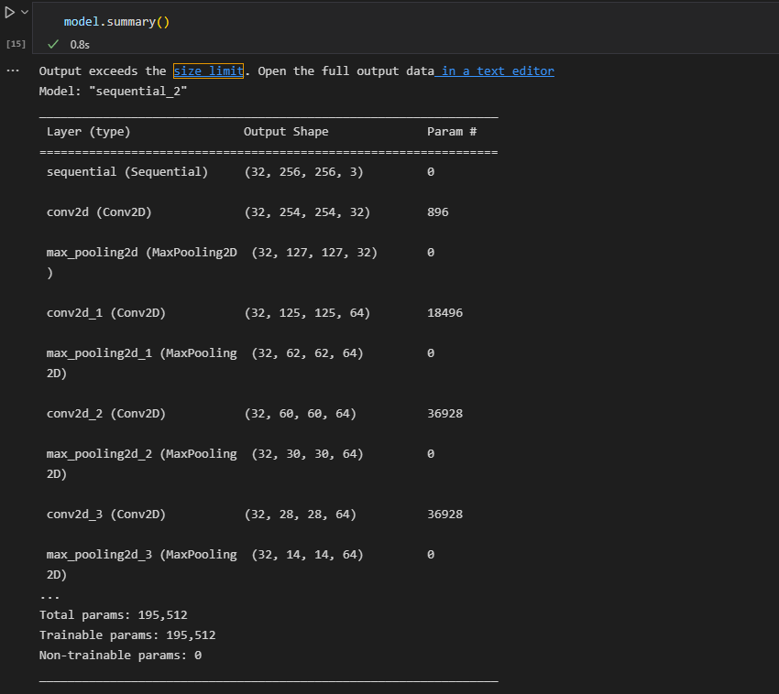

**MODEL SUMMARY**

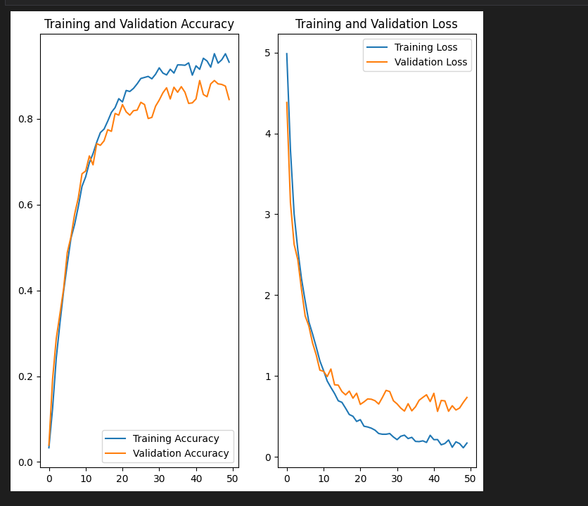

**PLOT GRAPH BETWEEN TRAINING ACCURACY – VALIDATION ACCURACY AND TRAINING LOSS – VALIDATION LOSS**

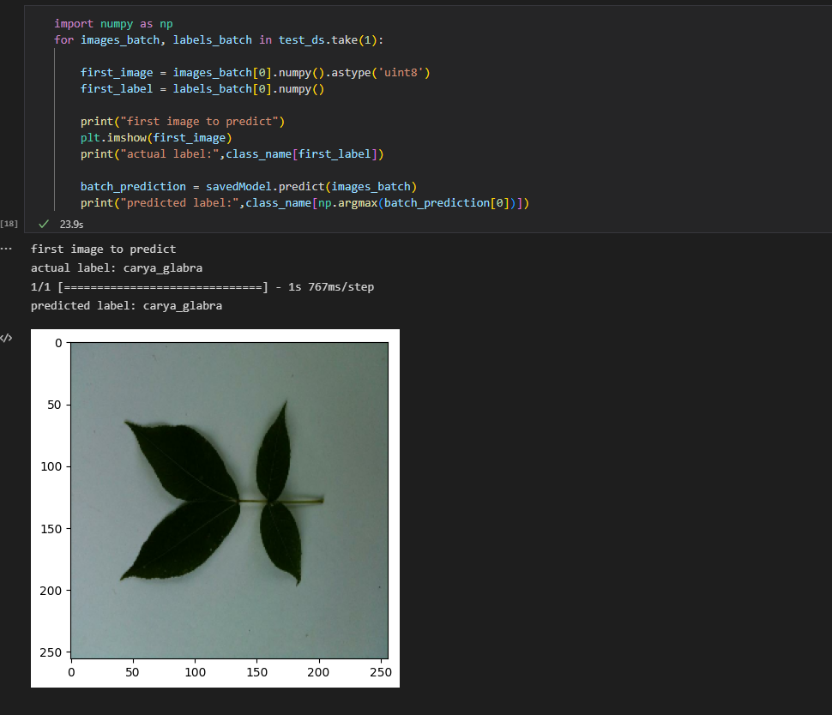

**SAMPLE TESTING OF AN IMAGE USING TRAINED MODEL**

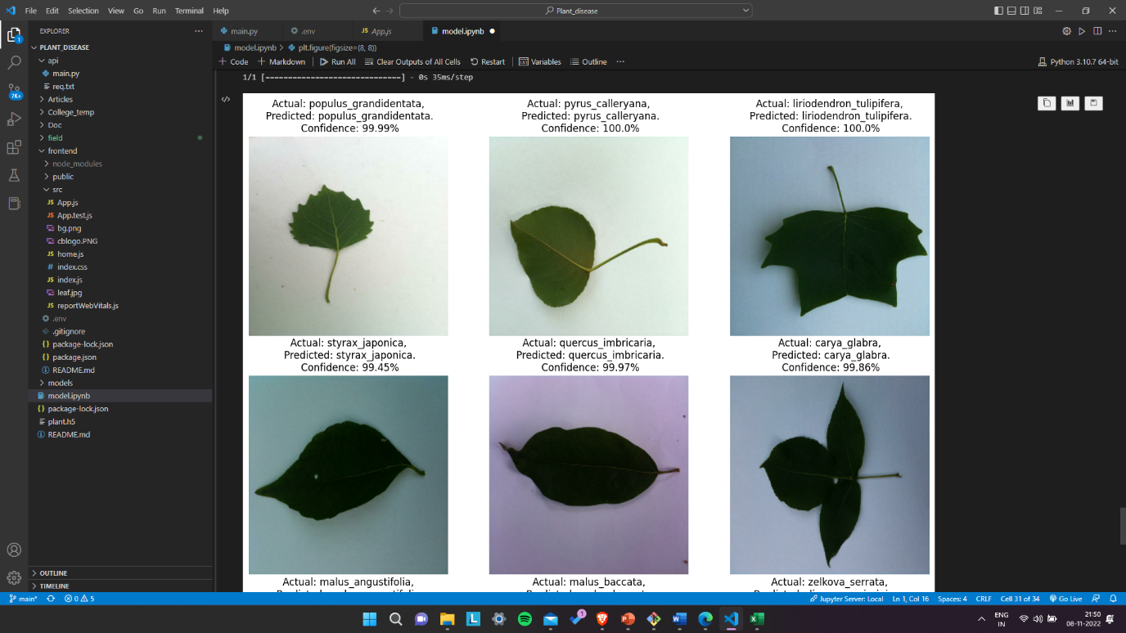

**SAMPLE OUTPUT OF SOME LEAFS**

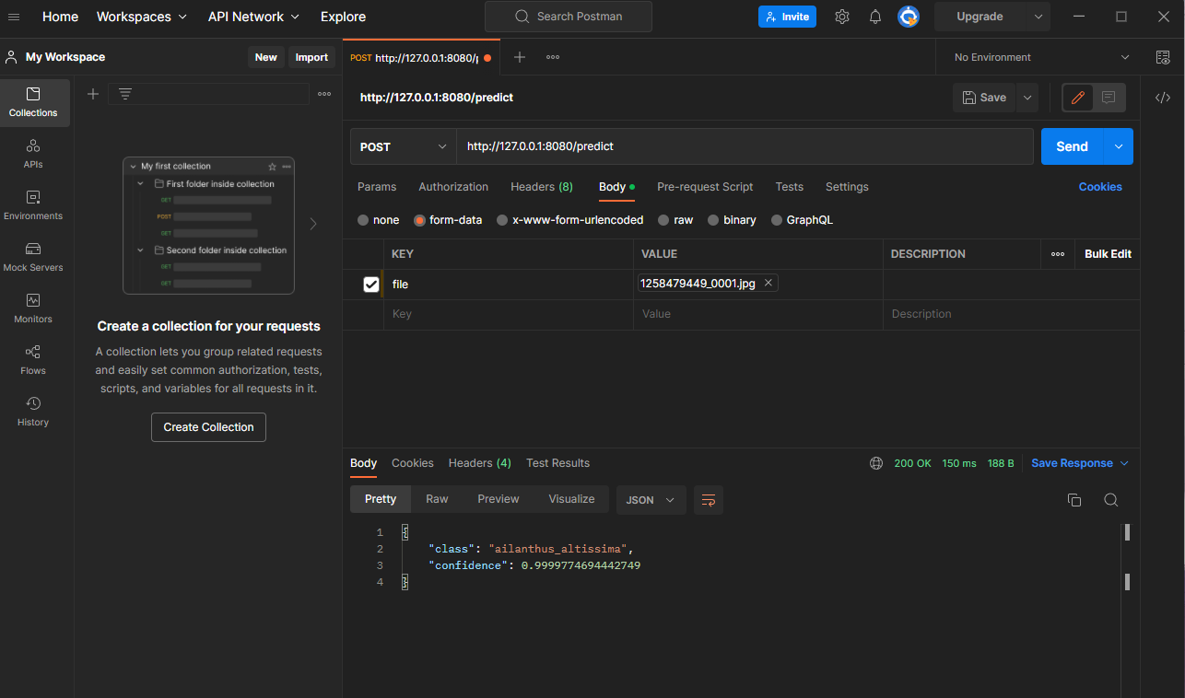

**TESTING USING POSTMAN**



**CODE SNAPSORT**

**SOME SAMPLE OUTPUTS**

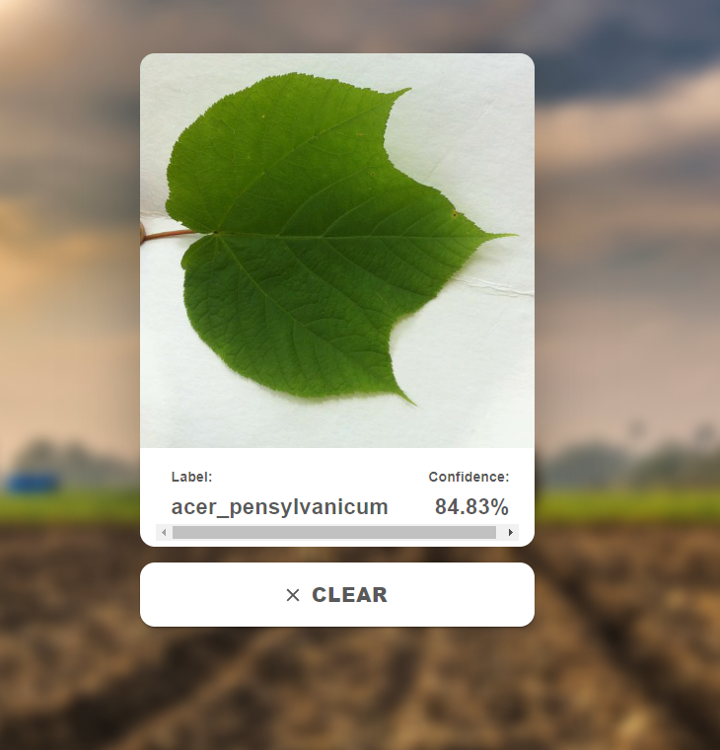

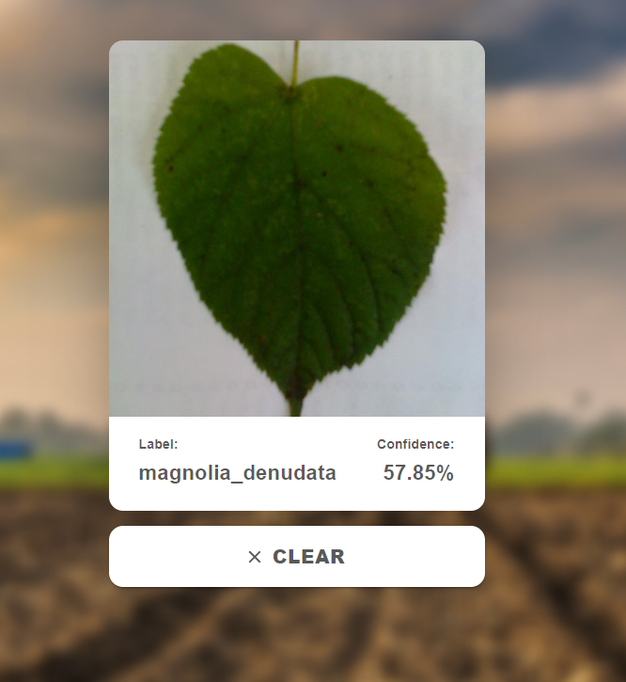

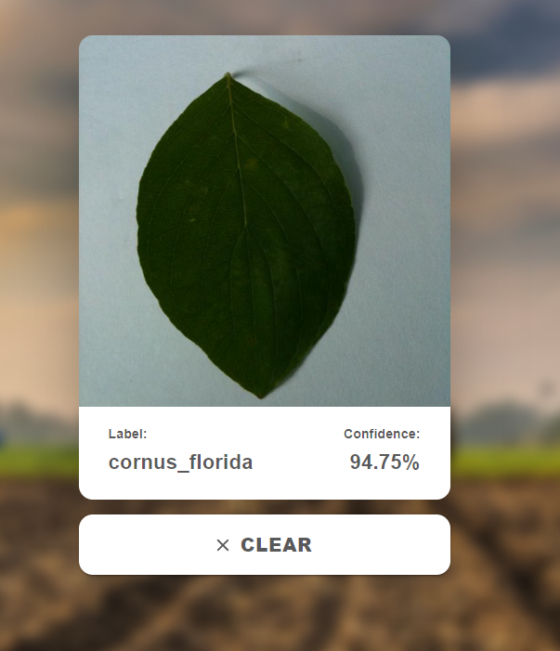

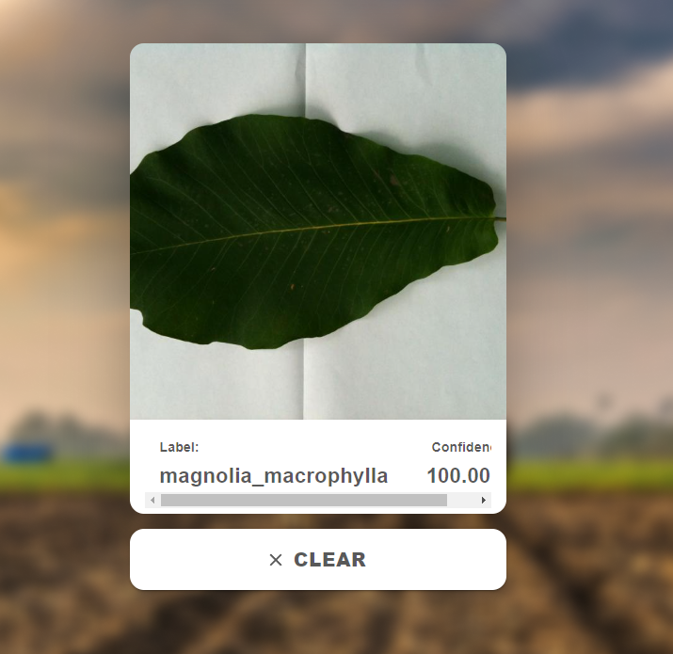

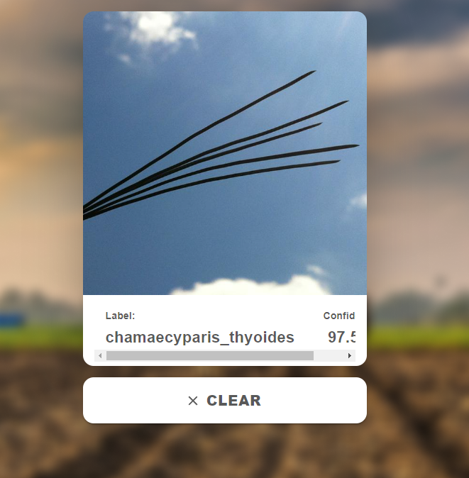

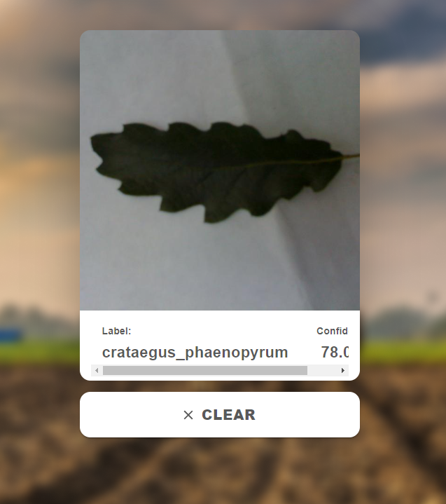

**4.2 CONCLUSION**

* Developed an application that helps people to identify plant species using simples plant leaves image without begin concerned about the knowledge of botany (study of plants).
* The Identification performance of the models will be good enough to be used in web application for effective use.
* The end result of this project is a web application.

**4.3 FUTURE SCOPE**

There are enormous plant species in the world, which is nearly 390,000 in numbers, and each year, new species are reported in different parts of the world. Plants are very different from one another hence requiring in depth taxonomic knowledge to identify and assign them to a particular species. Many activities such as studying the flora of a particular area, investigation of the endangered species, discovering new plant species depends profoundly upon precise and accurate dentification skills. With this, the need for automated identification of plant species is increasing. We need more research in this field.

**5 REFRENCES**

1. Banzi J. & Abayo T. (2021). Plant Species Identification from Leaf Image Using Deep Learning Models. ArXiv, Tranzania Journal of Forestry and Nature Conservation Vol 90.
2. Sk Hassan, Kumar Maji, Jasinski M., Leonowicz Z. & Jasinska E. (2021). Identification of Plant-Leaf Disease Using CNN and Transfer-Learning Approach. ArXiv, electronics10121388.
3. Skanda H N, S karanth, Suvijith S, & Swathi K S (2019). Plant Identification Methodologies using Machine Learning Algorithms. ArXiv, ISSN: 2278-0181 Vol 8.
4. Kaur S. & Kaur P. (2019). Plant Species Identification based on Plant Leaf Using Computer Vision and Machine Learning Techniques. Journal of Multimedia Information System, CC BY-NC 4.0.
5. Waldchen, J., Rzanny, M., Seeland, M., & Mader P. (2018). Automated Plant species Identification – Trends and future directions. Journal, pcbi, 1005993.
6. Waldchen J. & Mader P. (2018). Plant Species Identification Using Computer Vision Techniques: A Systematic Literature Review, Archives of Computational Methods in Engineering.