Work Integrated Learning Programmes
M.Tech Software Engineering



Introduction to DevOps
Assignment 1
Implementing Automated CI/CD Pipelines for
ACEest Fitness & Gym

By:
Name: Neel Gujar
BITS ID: 2025tm93111
Course: Introduction to DevOps (CSIZG514/SEZG514)
Assignment: Assignment 1
GitHub Repository:
https://github.com/Neel2211/ACEest-Fitness-Gym
Contents
1. Executive Summary 5
2. Project Objective 5
3. Application Overview 5
Features Implemented 5
Screenshot 1: Flask Application Running 6
Screenshot 2: Application Response 6
4. Version Control Strategy 7
Version Evolution Table 7
Feature Branches 7
Screenshot 3: Branches 8
Screenshot 4: Commit History 8
5. Unit Testing using Pytest 9
Test Coverage 9
Screenshot 5: Pytest 9
Test Execution Flow 10
6. Docker Containerization 10
Screenshot 6: Docker Build 10
Screenshot 7: Docker Run 11
Screenshot 8: Application response from container 11
7. GitHub Actions CI/CD Pipeline 12
CI/CD Flow Diagram 12
CI/CD Stages Executed 13
Screenshot 9: GitHub Actions Overview 13
Screenshot 10: Workflow details 16
8. Jenkins Build & Quality Gate 16
Jenkins Workflow 16
Screenshot 11: Jenkins Pipeline Configuration 18
Screenshot 12: Automatic Jenkins Trigger: Build started by SCM change 19
Screenshot 13: Environment Validation 19
Screenshot 14: Dependency Installation 20
Screenshot 15: Pytest Execution 20
Screenshot 16: Build Success 21
9. Release Management, Rollback and Hotfix Strategy 22
Release Validation Workflow 22
Screenshot 17: Incremental Version Builds 24
Screenshot 18: Release Failure 24
Screenshot 19: Rollback Success 25
Screenshot 20: Hotfix Success 26
10. Repository Structure 27
Screenshot 21: Repository Structure 28
GitHub Repository: https://github.com/Neel2211/ACEest-Fitness-Gym 28
11. Project Documentation (README.md) 28
README Contents 28
Screenshot 22: README Overview 29
Screenshot 23: README CI/CD Workflow 30
Screenshot 24: README Setup Instructions 30
12. Prayogshala Usage 31
13. Demonstration Video 31
Recording Link 32
https://drive.google.com/file/d/1l4DHBIS_2Sm9bUAmZvb_it4-PuaAsBy-/view?usp=sharing 32
14. Conclusion 32

GitHub Repository Link:
https://github.com/Neel2211/ACEest-Fitness-Gym
Recording Link
https://drive.google.com/file/d/1l4DHBIS_2Sm9bUAmZvb_it4-PuaAsBy-/view?usp=sharing

1. Executive Summary
This project implements a complete DevOps workflow for the ACEest Fitness & Gym application. The original ACEest application evolved through multiple incremental versions and was migrated to a Flask-based web application. Modern DevOps practices were applied including Git-based version control, automated unit testing using Pytest, Docker-based containerization, Continuous Integration using GitHub Actions, and build automation using Jenkins. The objective was to establish a reliable software delivery workflow that ensures code quality, repeatability, and deployment consistency.

2. Project Objective
The objective of this project is to:
- Develop a Flask-based fitness management application
- Implement version control using Git and GitHub
- Create a comprehensive Pytest test suite
- Containerize the application using Docker
- Implement CI/CD using GitHub Actions
- Configure Jenkins as a build validation environment
- Demonstrate incremental software evolution using branching and versioning

3. Application Overview
The ACEest Fitness & Gym application provides APIs for managing fitness-related activities.

Features Implemented
- Client Management
- Membership Tracking
- Fitness Program Generation
- Workout Management
- REST API Endpoints

Screenshot 1: Flask Application Running
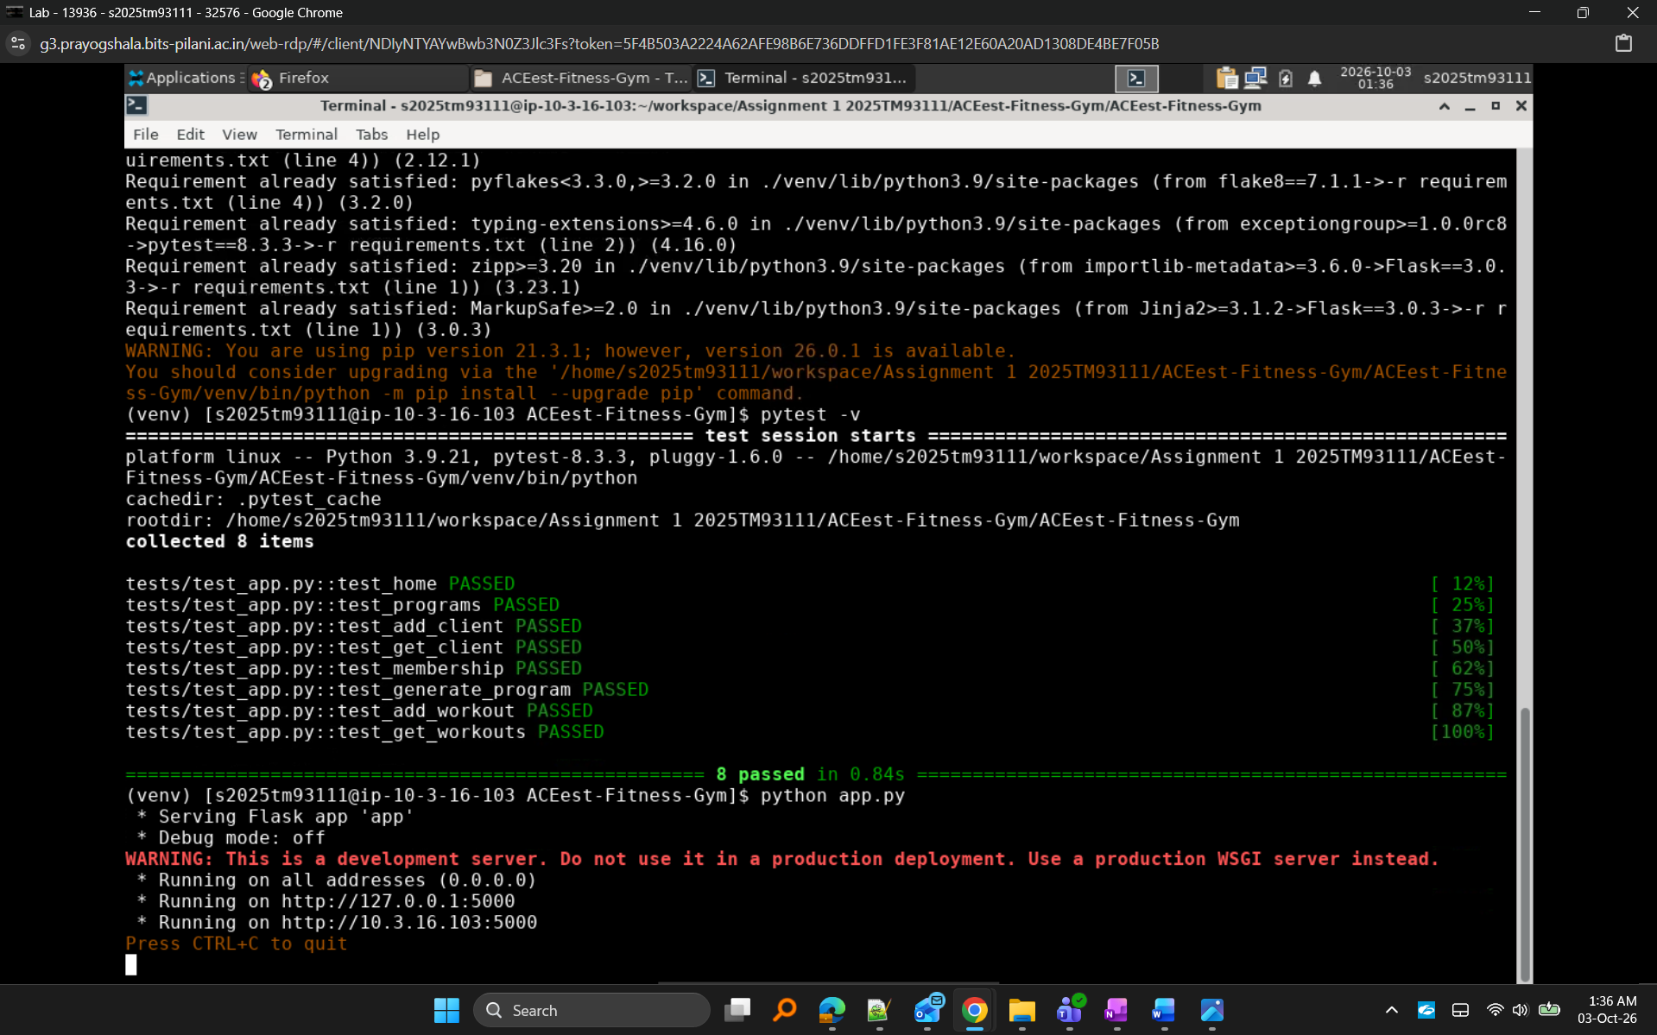
Figure 1. Flask application successfully running.

Screenshot 2: Application Response
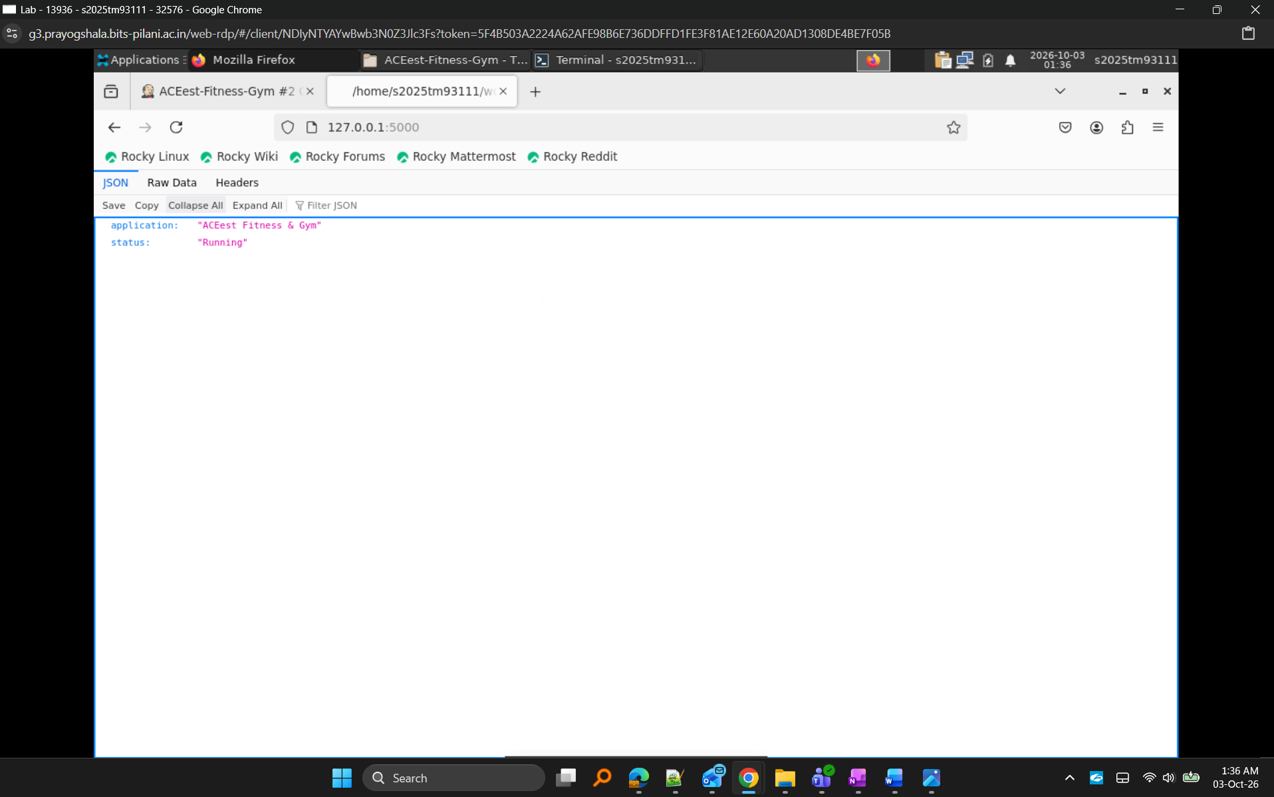
Figure 2. Flask application API response.

4. Version Control Strategy
To demonstrate version control maturity and software evolution, the supplied ACEest application versions were maintained using dedicated Git branches. Additional feature branches were used to isolate major DevOps enhancements. This approach follows industry Git workflows and enables controlled software evolution.

Version Evolution Table
Version | Description
v1.0 | Initial gym management application
v1.1 | Enhanced client management
v1.1.2 | Improved fitness program management
v2.0.1 | Workout tracking functionality
v2.1.2 | Enhanced workout workflow
v2.2.1 | Progress monitoring improvements
v2.2.4 | Reporting and metrics enhancements
v3.0.1 | Membership management
v3.1.2 | Dashboard enhancements
v3.2.4 | Final integrated desktop application

Feature Branches
- feature-flask
- feature-testing
- feature-docker
- feature-cicd
- feature-jenkins

Screenshot 3: Branches
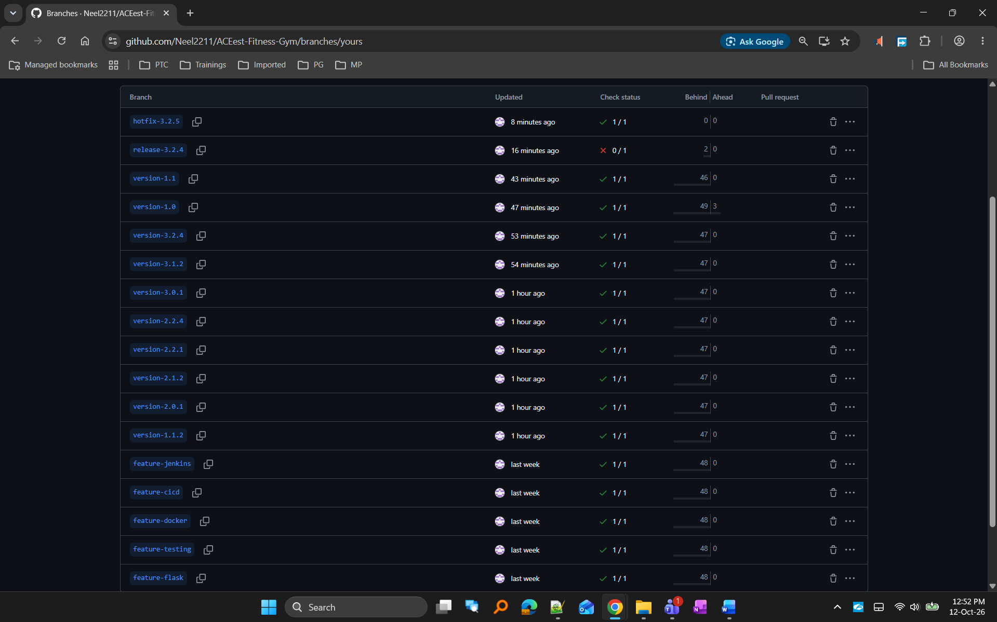
Figure 3. Version branches and feature branches maintained in GitHub.

Screenshot 4: Commit History
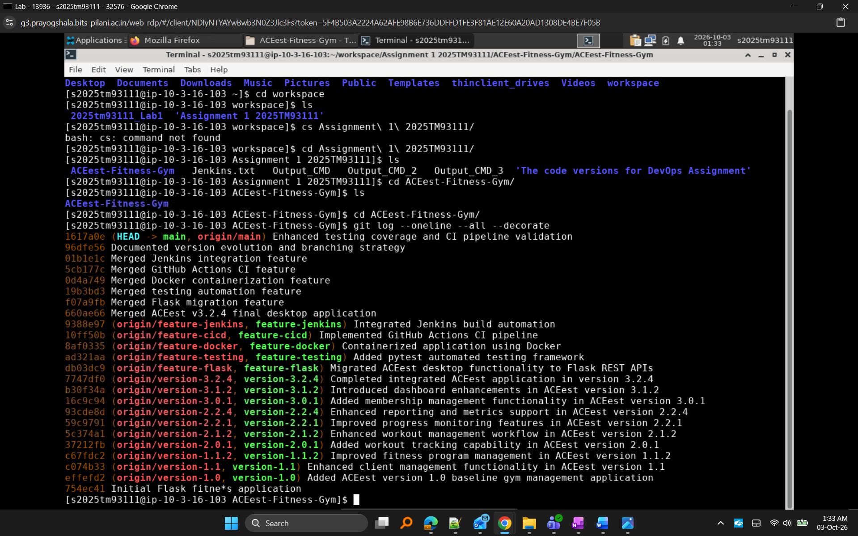
Figure 4. Meaningful commit history demonstrating incremental development

5. Unit Testing using Pytest
Pytest was integrated to perform automated validation of the Flask application before entering the build stage. Multiple test cases were developed to verify endpoint functionality and application behavior.

Test Coverage
- Home Endpoint
- Programs Endpoint
- Add Client
- Get Client
- Membership Endpoint
- Program Generation
- Add Workout
- Get Workouts

Screenshot 5: Pytest
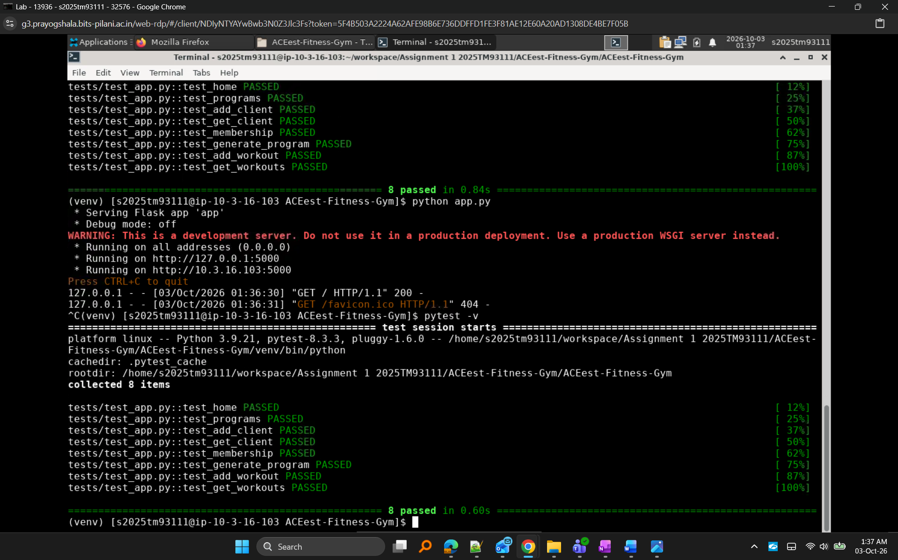
Figure 5. Pytest execution validating application functionality.

Test Execution Flow
Application Code
↓
Pytest Test Suite
↓
Endpoint Validation
↓
Pass / Fail Results

6. Docker Containerization
Docker was used to package the Flask application and its dependencies into a portable runtime environment. This eliminates dependency and environment inconsistencies and supports reproducible execution.

Screenshot 6: Docker Build
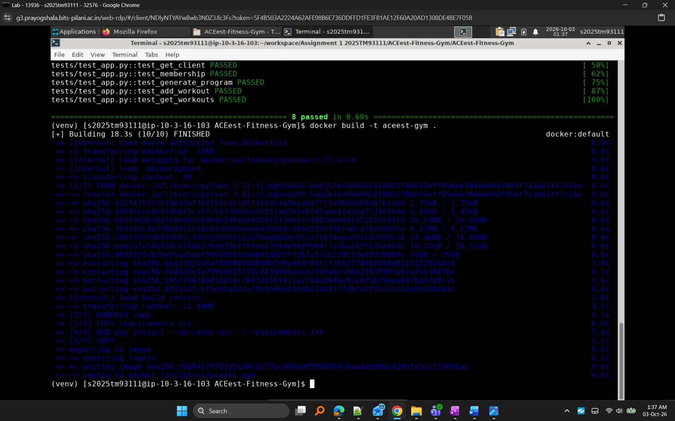
Figure 6. Docker image creation process.

Screenshot 7: Docker Run
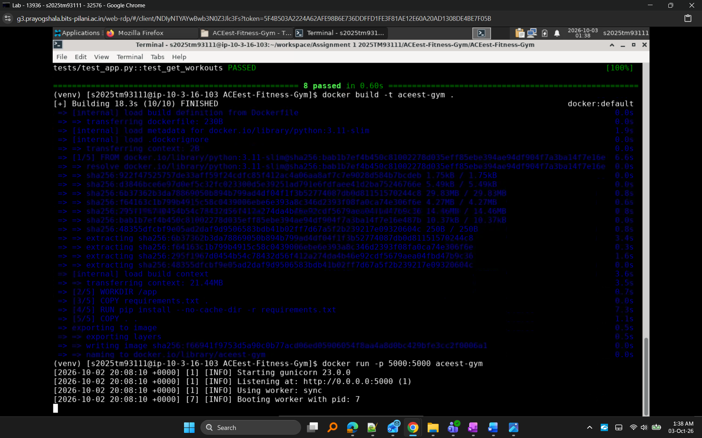
Figure 7. Application execution inside Docker container.

Screenshot 8: Application response from container
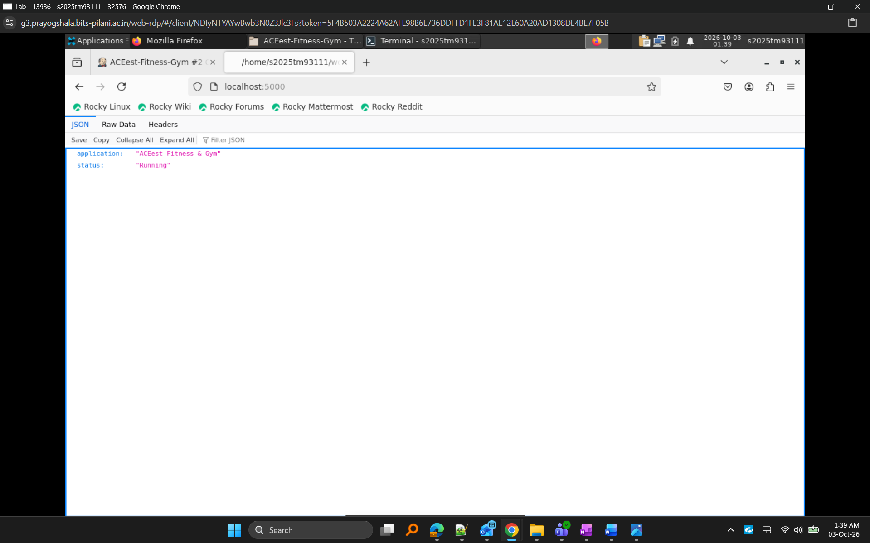
Figure 8. Flask application running inside Docker

7. GitHub Actions CI/CD Pipeline
GitHub Actions was configured to automatically execute continuous integration tasks whenever code is pushed to the repository.
The workflow performs:
Dependency Installation
↓
Lint Validation
↓
Pytest Execution
↓
Docker Image Creation
↓
Containerized Testing

CI/CD Flow Diagram
Developer Push
↓
GitHub Repository
↓
GitHub Actions Trigger
↓
Build & Lint
↓
Pytest Validation
↓
Docker Build
↓
Container Testing
↓
Successful Workflow

CI/CD Stages Executed
- Source Code Checkout
- Dependency Installation
- Build & Lint Validation
- Pytest Execution
- Docker Image Build
- Containerized Test Execution

Screenshot 9: GitHub Actions Overview
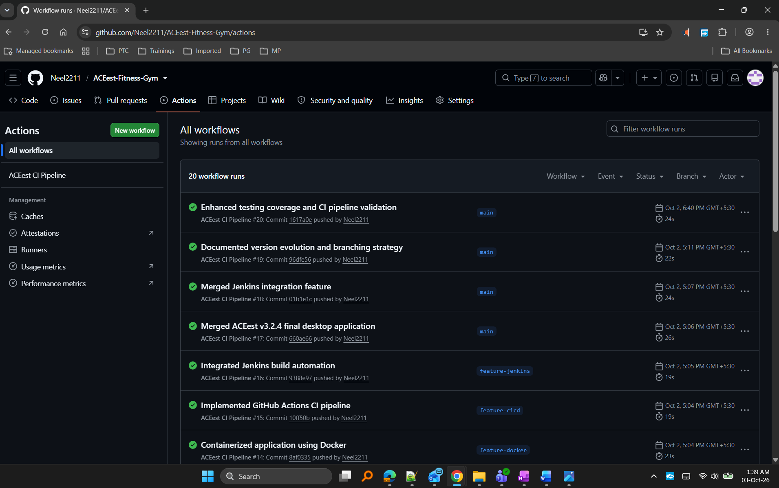
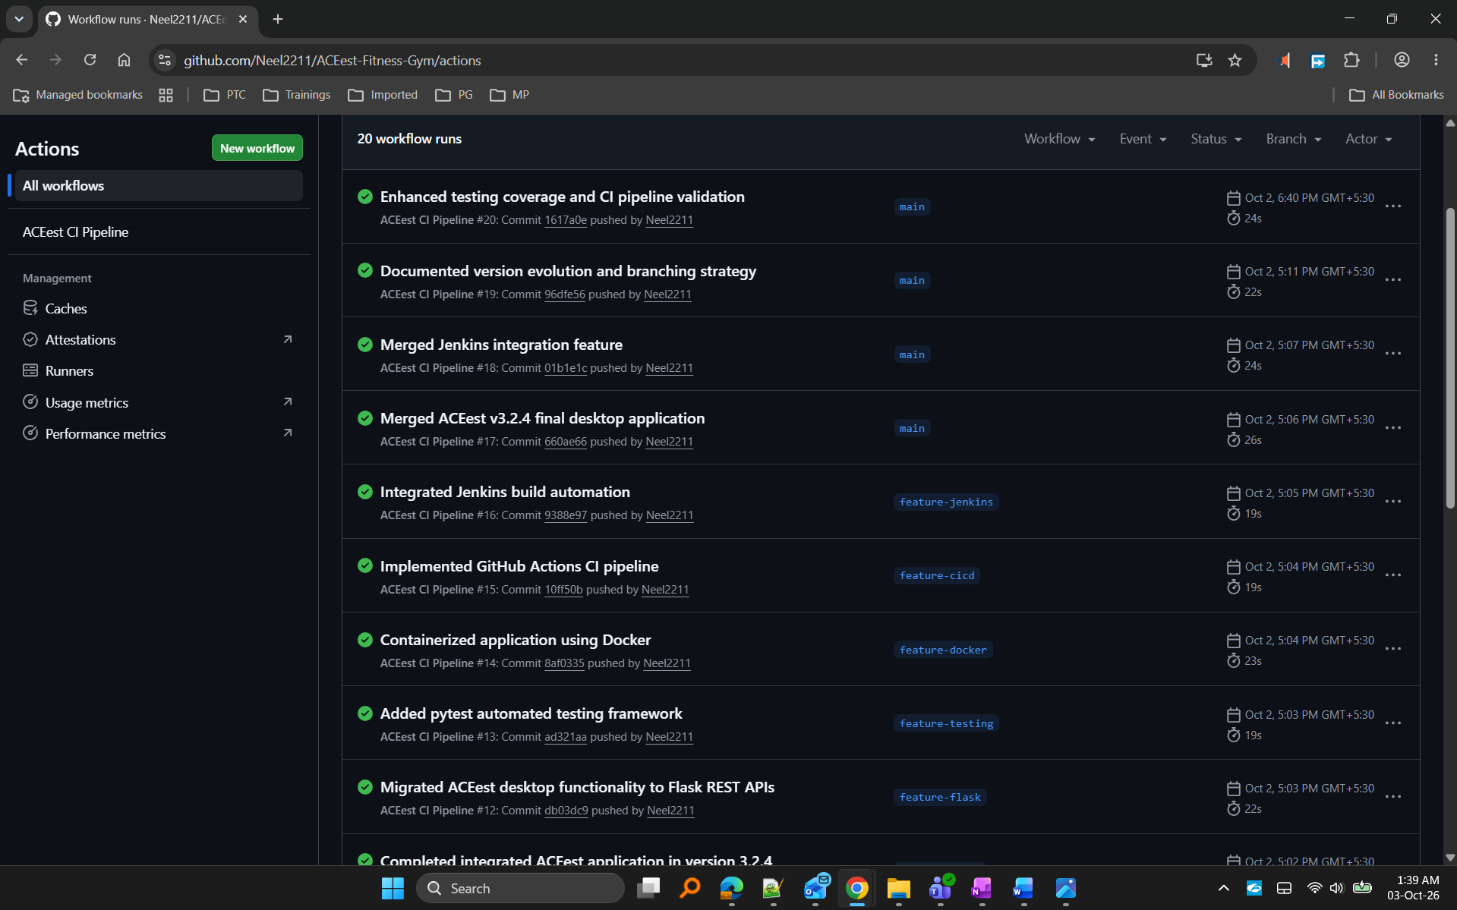
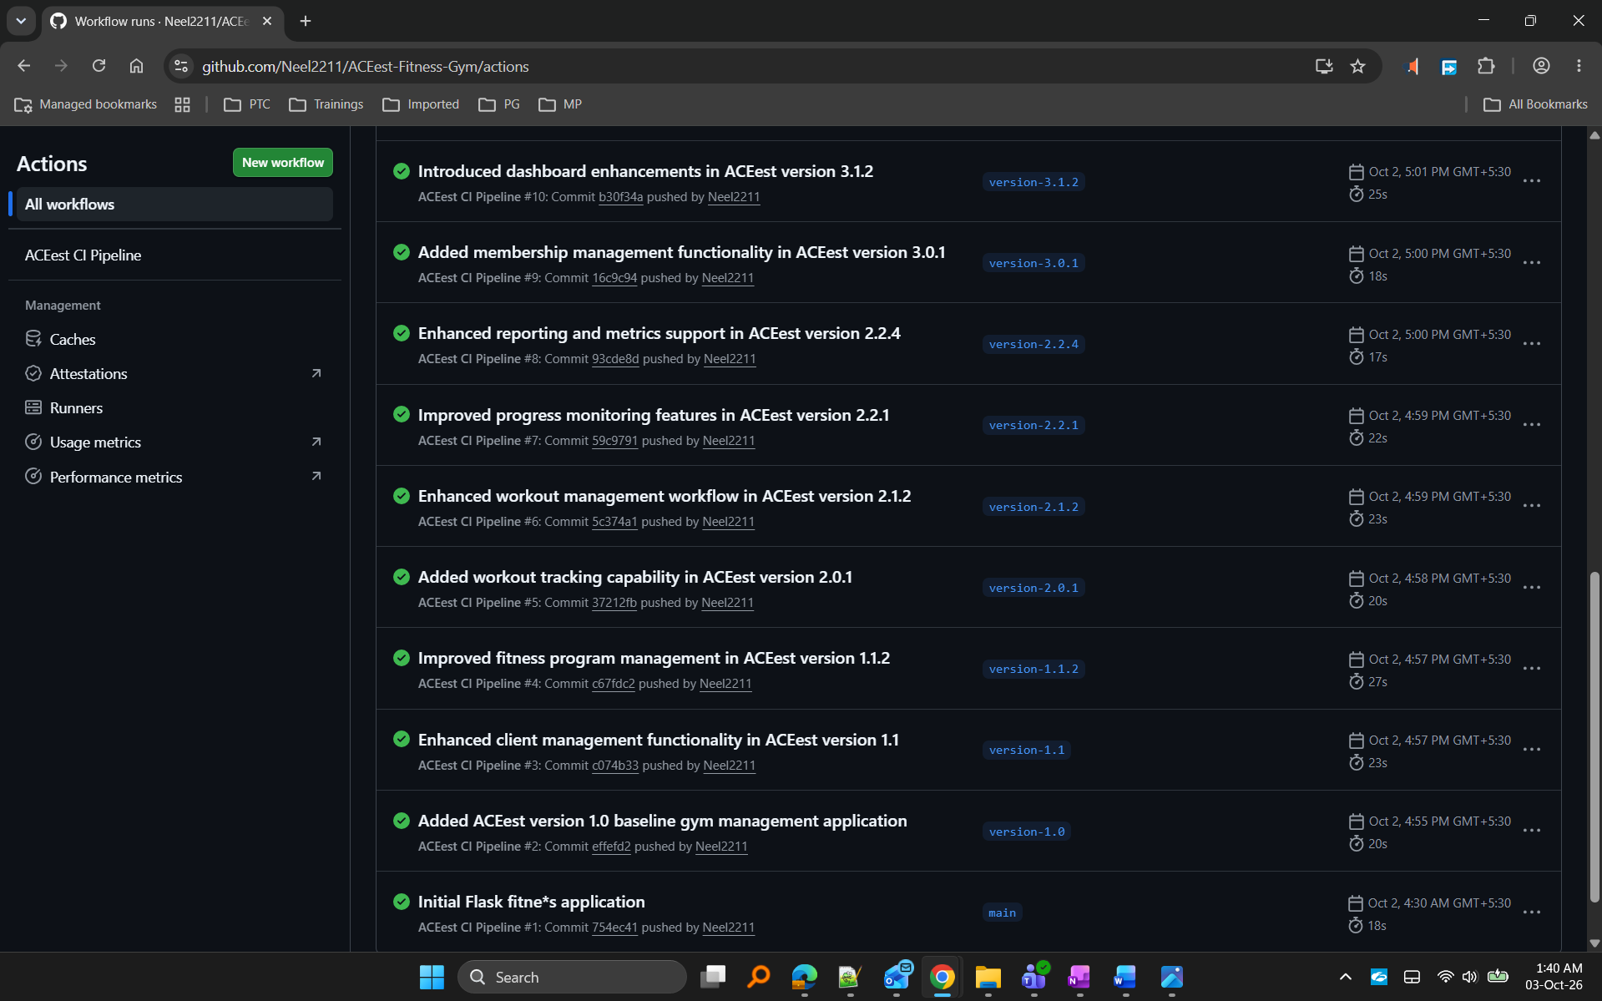
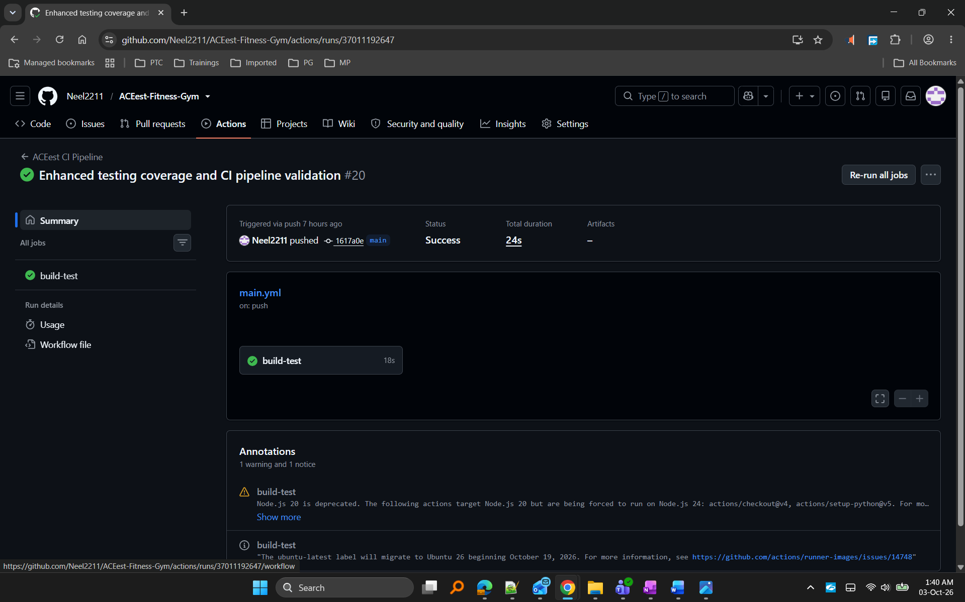
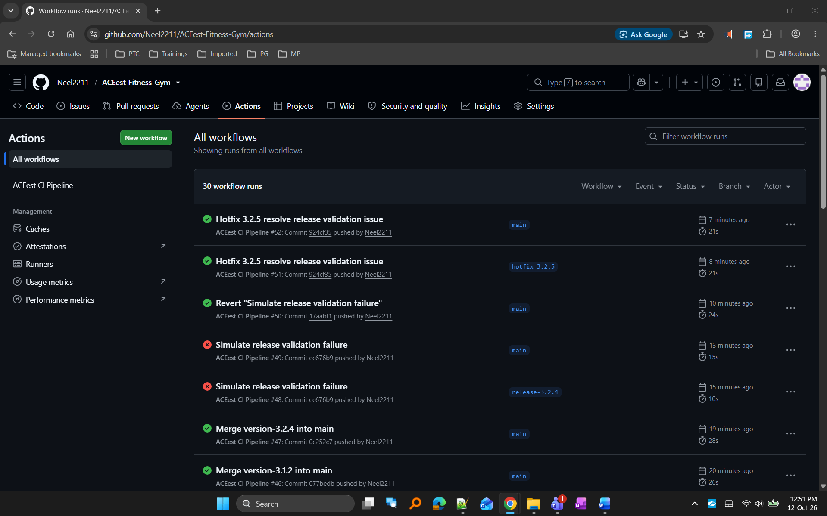
Figure 9. Successful GitHub Actions workflow runs

Screenshot 10: Workflow details
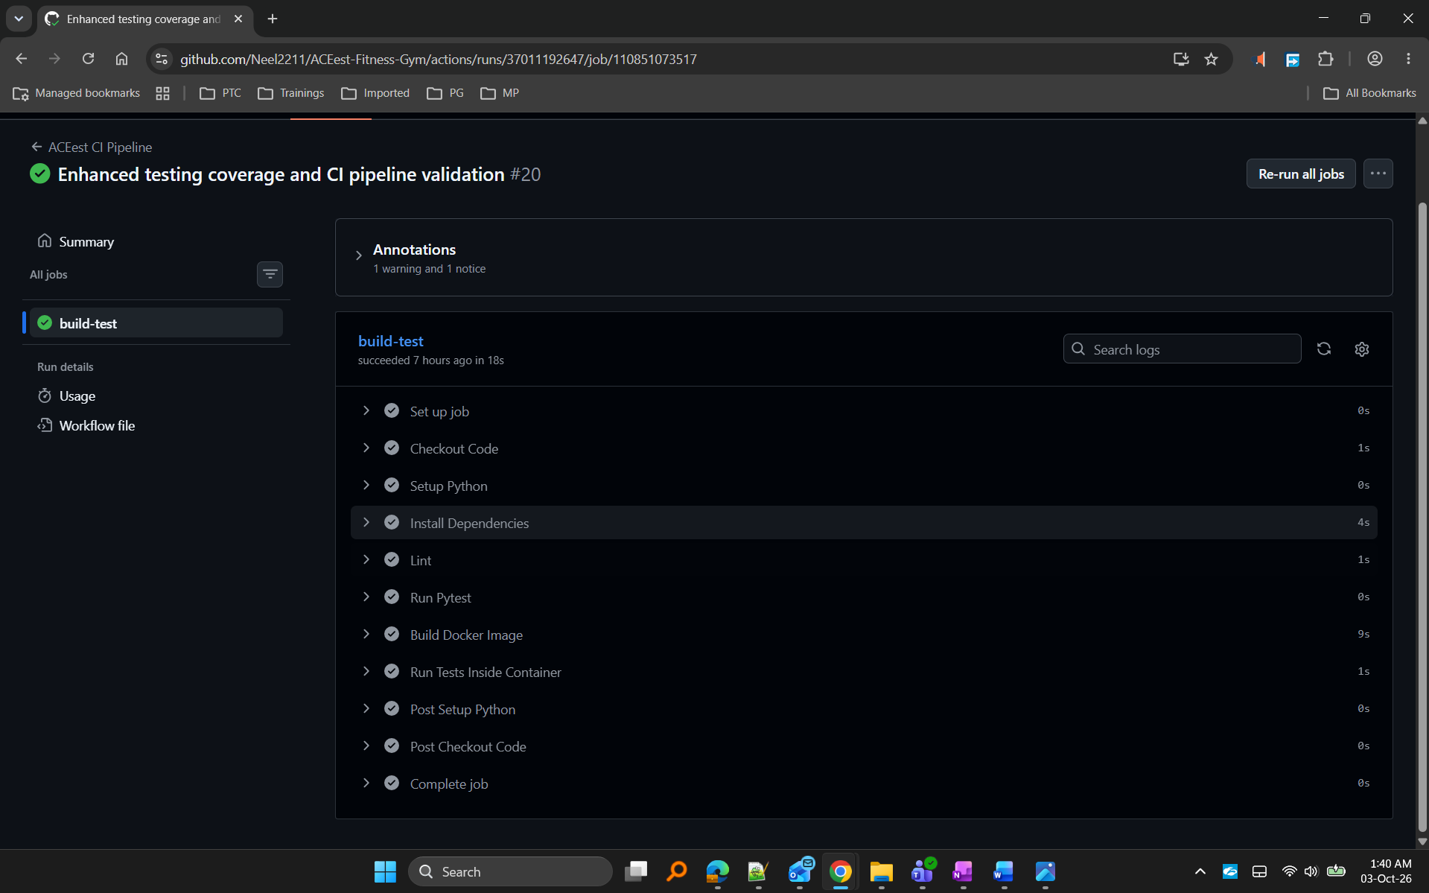
Figure 10. Build, Lint, Testing and Docker stages.

8. Jenkins Build & Quality Gate
Jenkins was configured as a secondary build validation environment. The pipeline automatically detects source code changes using SCM polling, retrieves the latest code from GitHub, validates the execution environment, installs project dependencies, and executes the automated Pytest suite. This provides a quality gate before release promotion and ensures that changes are validated in a controlled build environment.
Jenkins was configured with SCM polling to automatically trigger builds whenever changes were pushed to the monitored branch. This enabled continuous validation of version promotions, release candidates, rollback operations, and hotfix implementations.

Jenkins Workflow
GitHub Repository
↓
SCM Polling
↓
Automatic Jenkins Trigger
↓
Environment Validation
↓
Install Dependencies
↓
Run Pytest
↓
Build Validation
↓
SUCCESS / FAILURE

Screenshot 11: Jenkins Pipeline Configuration
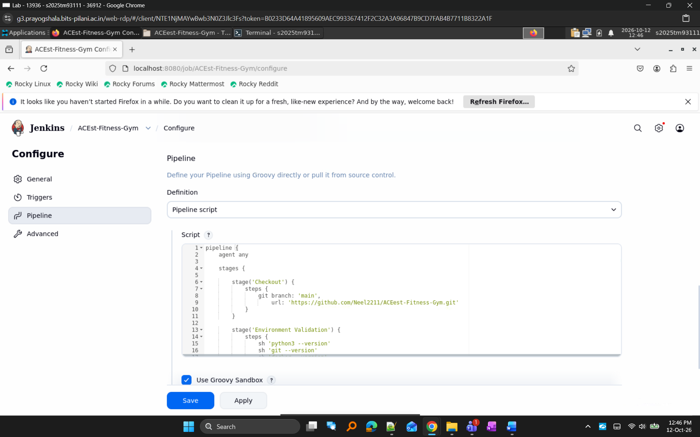
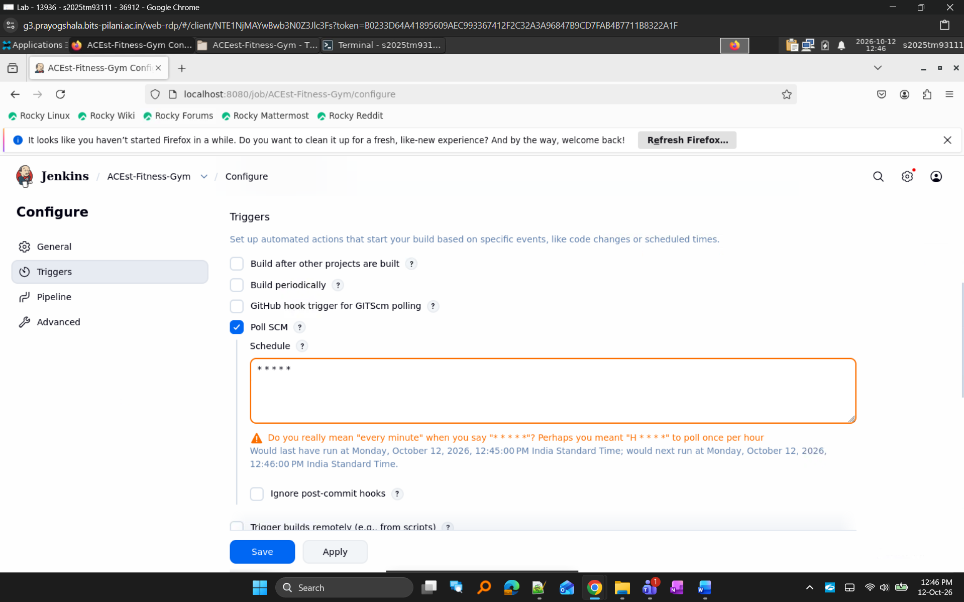
Figure 11. Jenkins pipeline configuration used for build validation, dependency installation, and automated testing.

Screenshot 12: Automatic Jenkins Trigger: Build started by SCM change
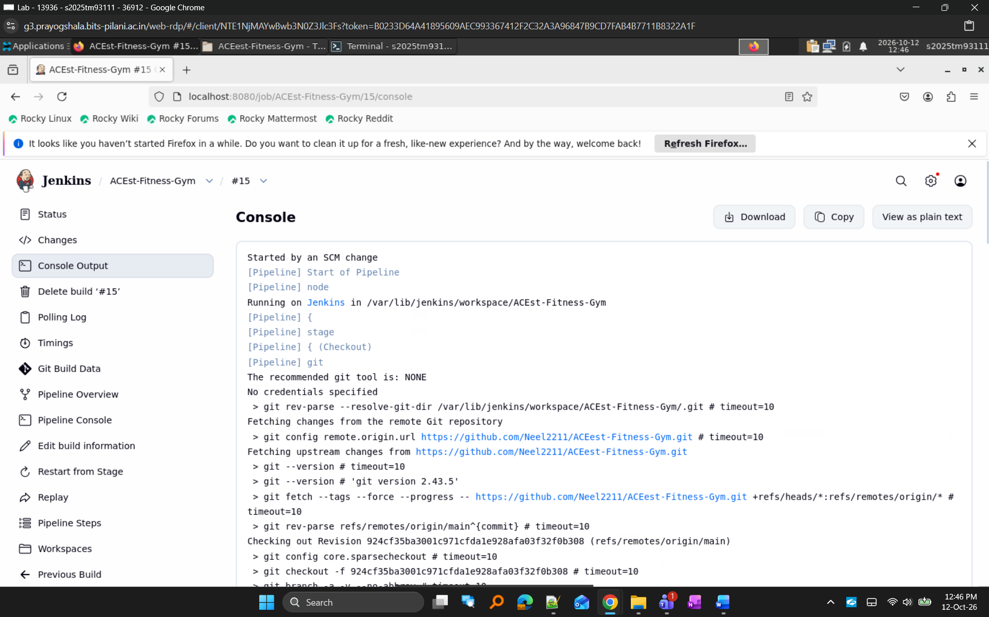
Figure 12. Jenkins automatically triggered following a source code push.

Screenshot 13: Environment Validation
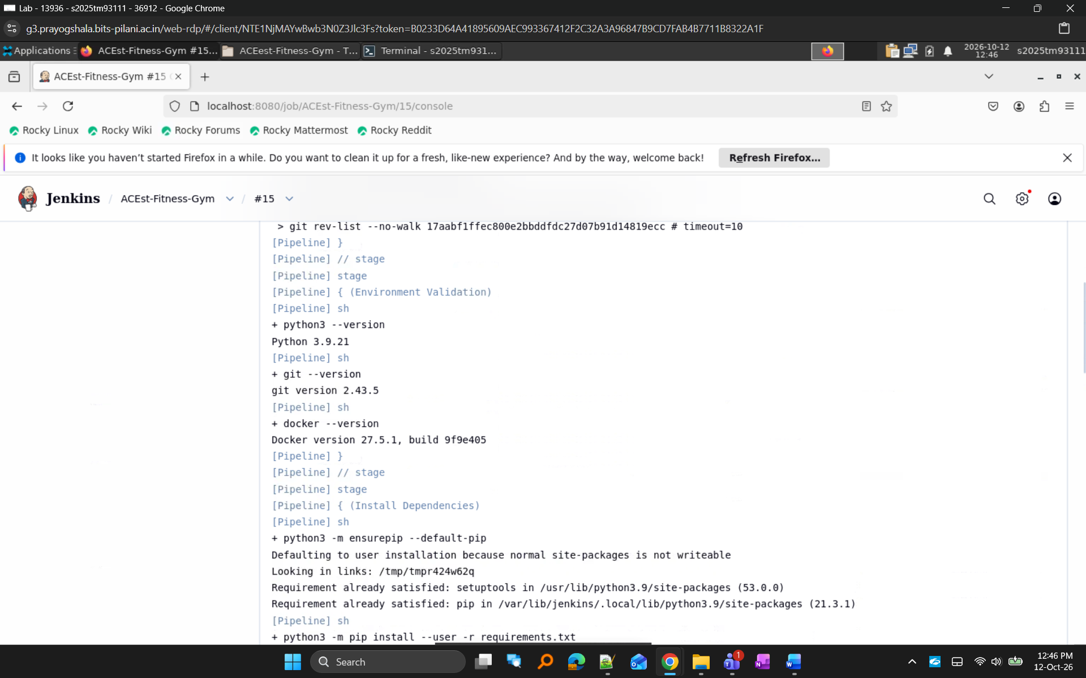
Figure 13. Jenkins environment validation confirming Python, Git, and Docker availability.

Screenshot 14: Dependency Installation
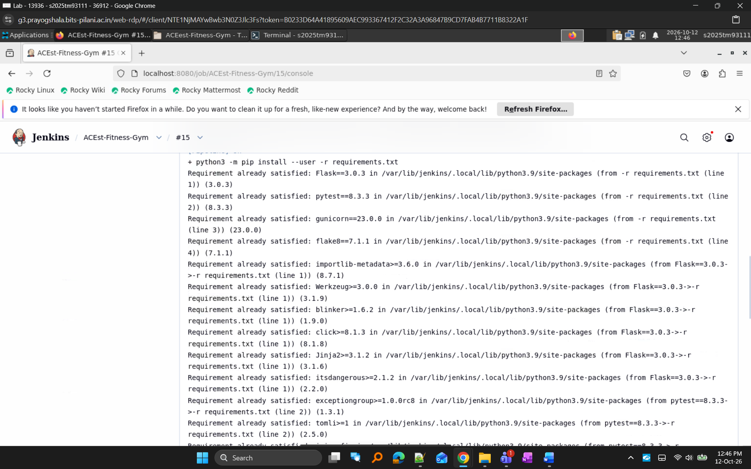
Figure 14. Jenkins building the application environment and installing project dependencies

Screenshot 15: Pytest Execution
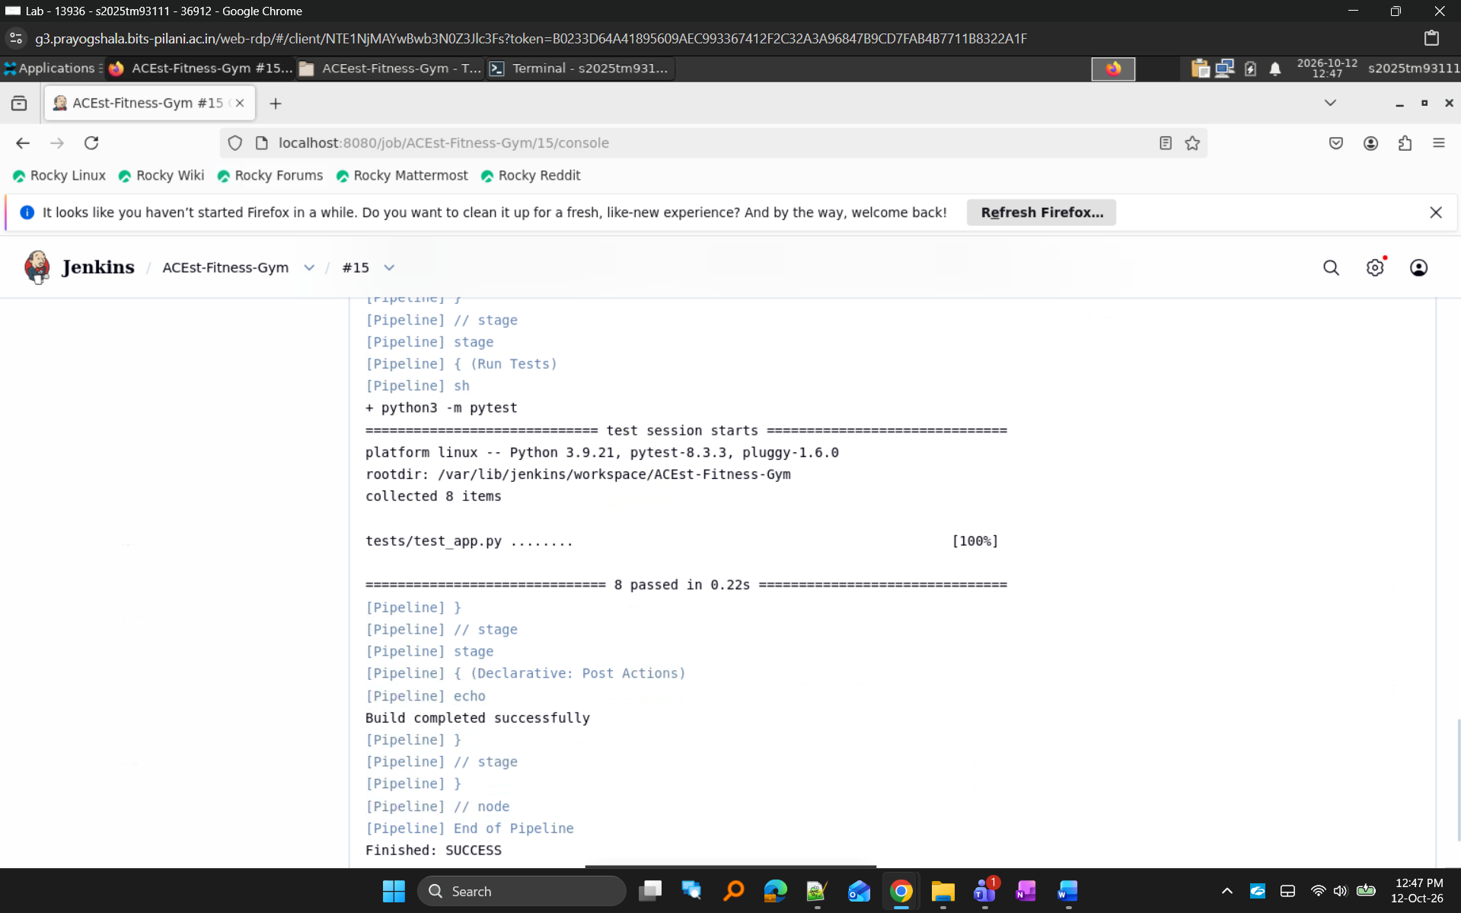
Figure 15. Jenkins executing automated Pytest validation with all test cases passing successfully

Screenshot 16: Build Success
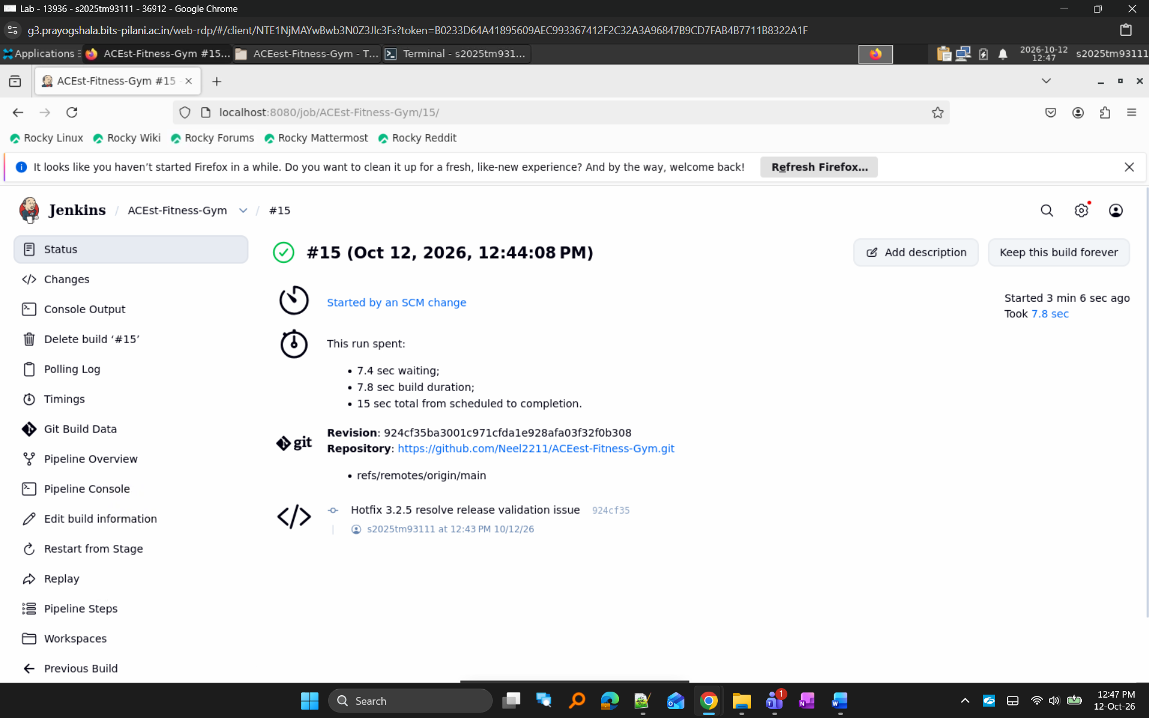
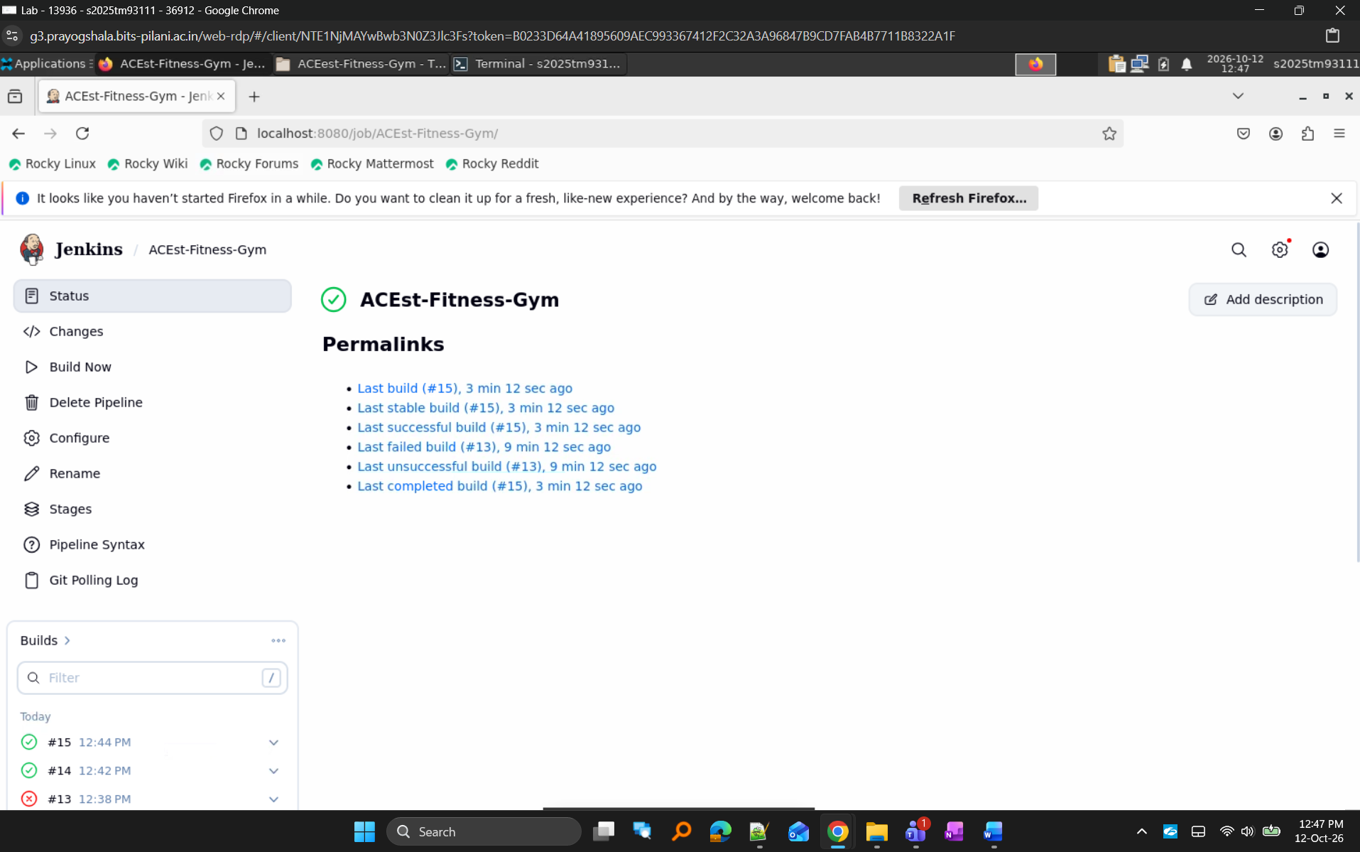
Figure 16. Successful Jenkins BUILD execution and quality gate validation

9. Release Management, Rollback and Hotfix Strategy
As part of the DevOps workflow, multiple ACEest release versions were incrementally promoted and validated through Jenkins. Each version was merged into the main branch and automatically validated through SCM-triggered Jenkins builds. This simulated a real-world release management workflow.
A release validation failure was intentionally introduced in the release branch to demonstrate Jenkins build validation, rollback strategy, and hotfix implementation.

Release Validation Workflow
Version-1.0
↓
Automatic Jenkins Build
↓
SUCCESS
Version-1.1
↓
Automatic Jenkins Build
↓
SUCCESS
Version-1.1.2
↓
Automatic Jenkins Build
↓
SUCCESS
...
Version-3.2.4
↓
Automatic Jenkins Build
↓
SUCCESS
Release-3.2.4
↓
Validation Failure
↓
FAILED BUILD
Rollback
↓
Automatic Jenkins Build
↓
SUCCESS
Hotfix-3.2.5
↓
Automatic Jenkins Build
↓
SUCCESS

Screenshot 17: Incremental Version Builds
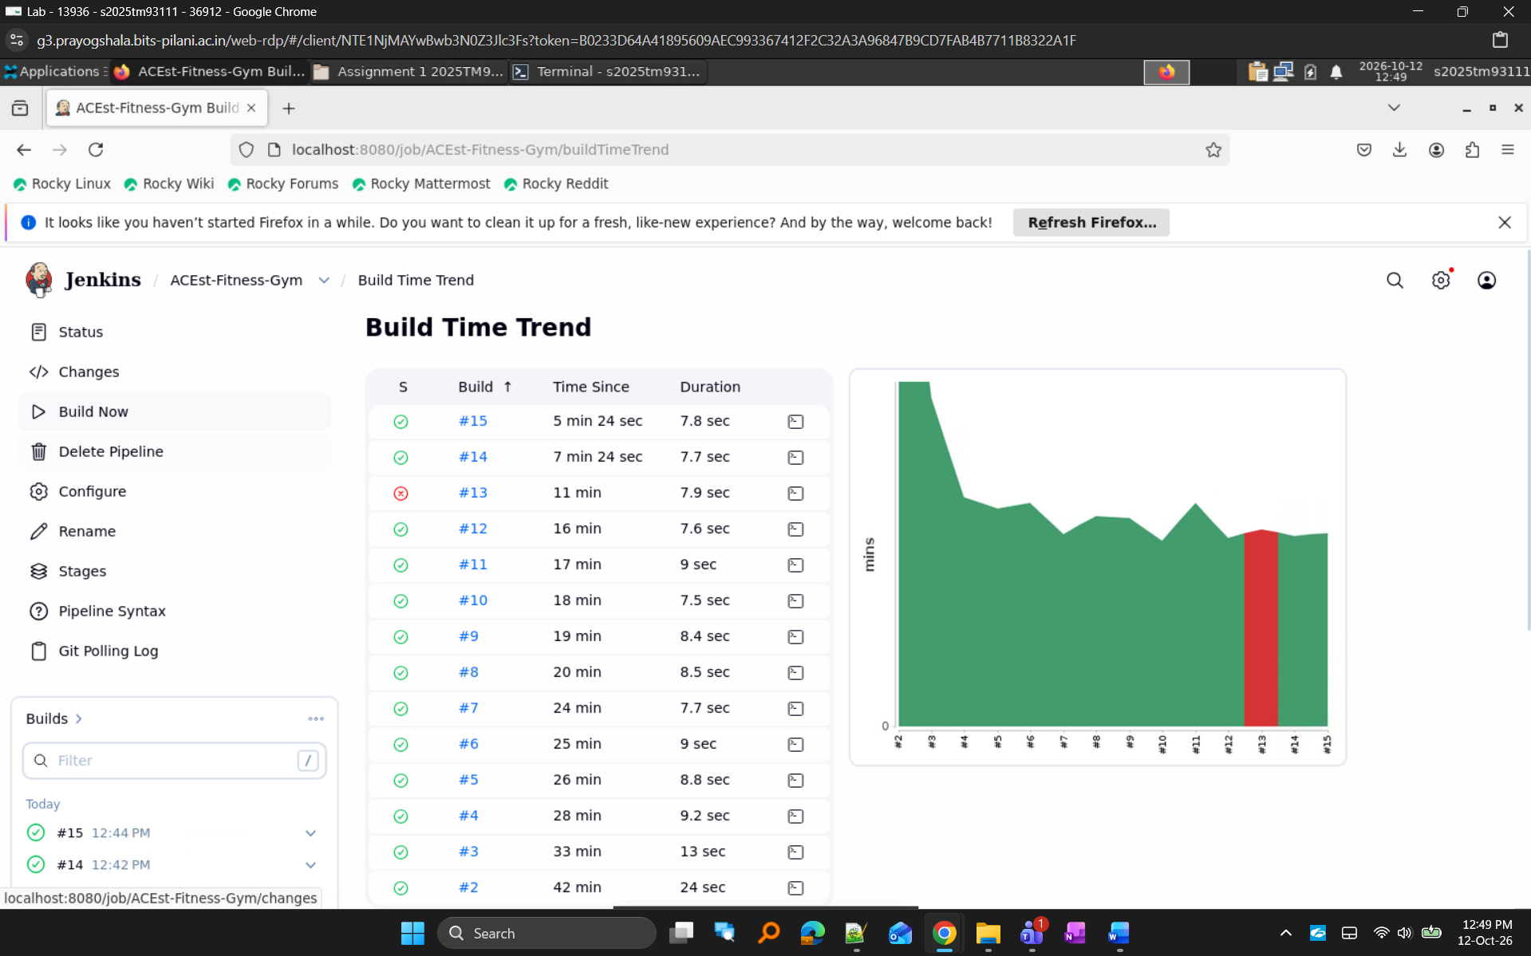
Figure 17. Multiple version releases validated through automatic Jenkins builds.

Screenshot 18: Release Failure
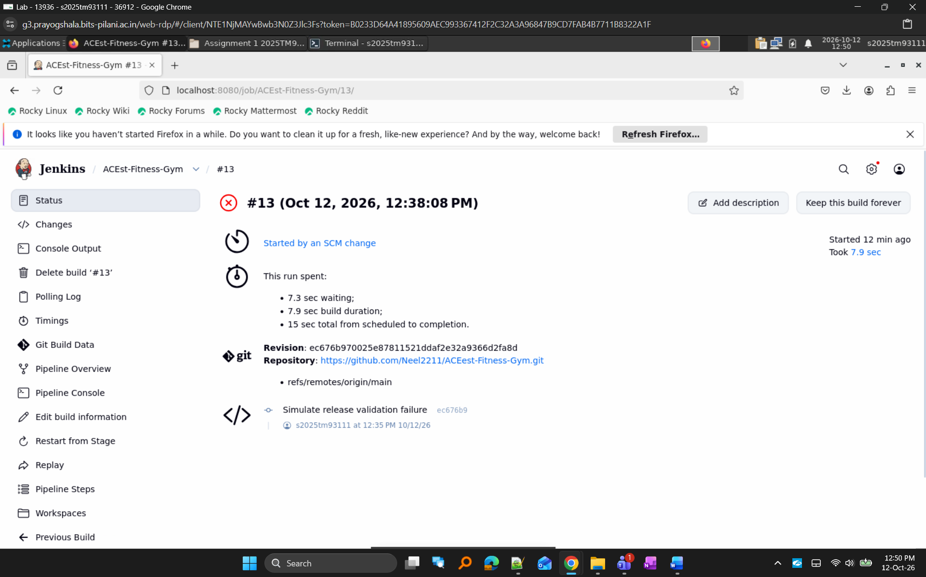
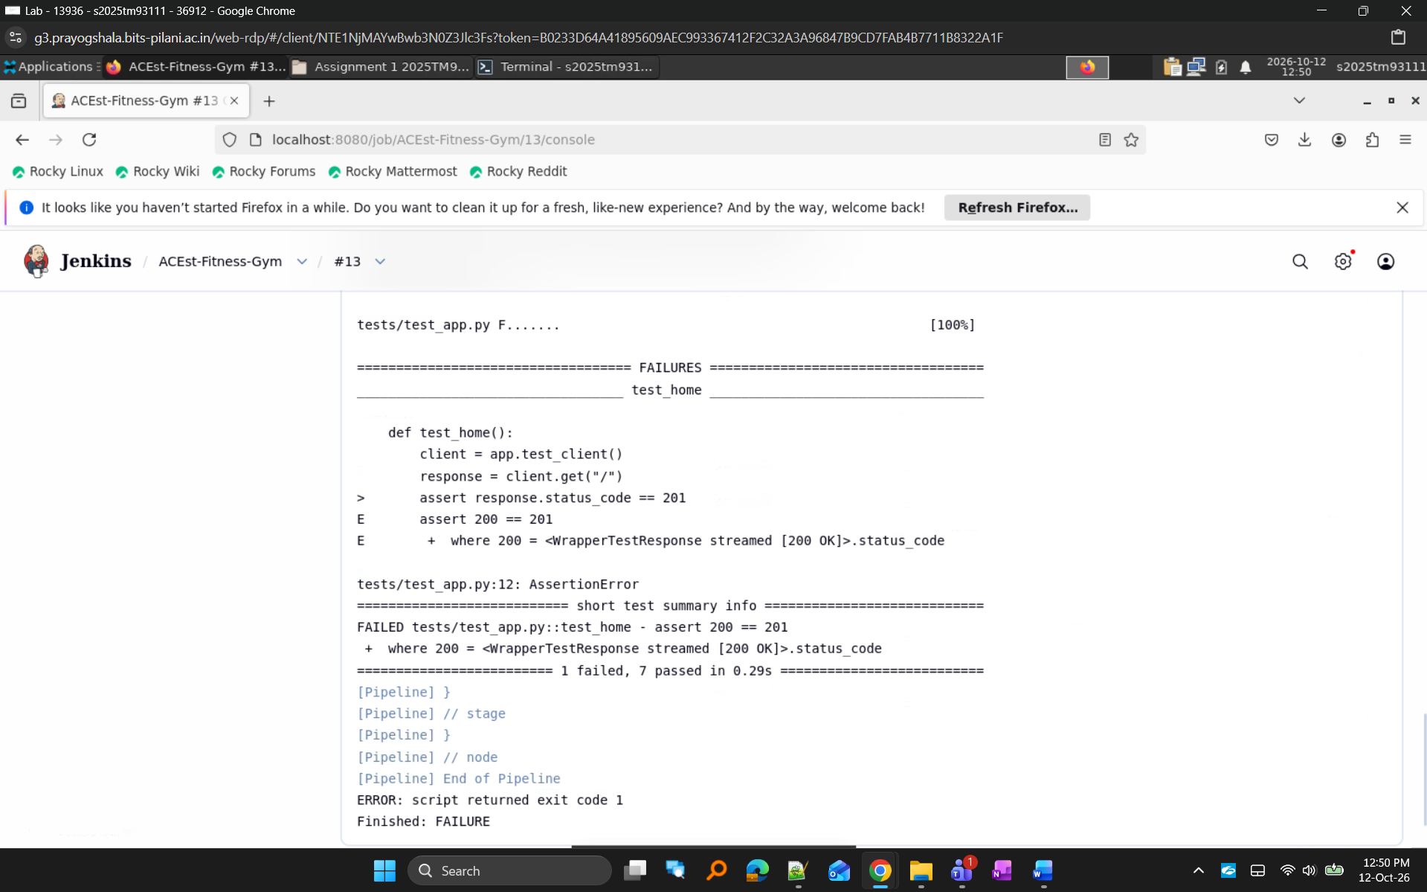
Figure 18. Jenkins detecting validation failure in release-3.2.4.
Jenkins successfully detected the release validation issue and prevented the faulty release from progressing further in the pipeline.

Screenshot 19: Rollback Success
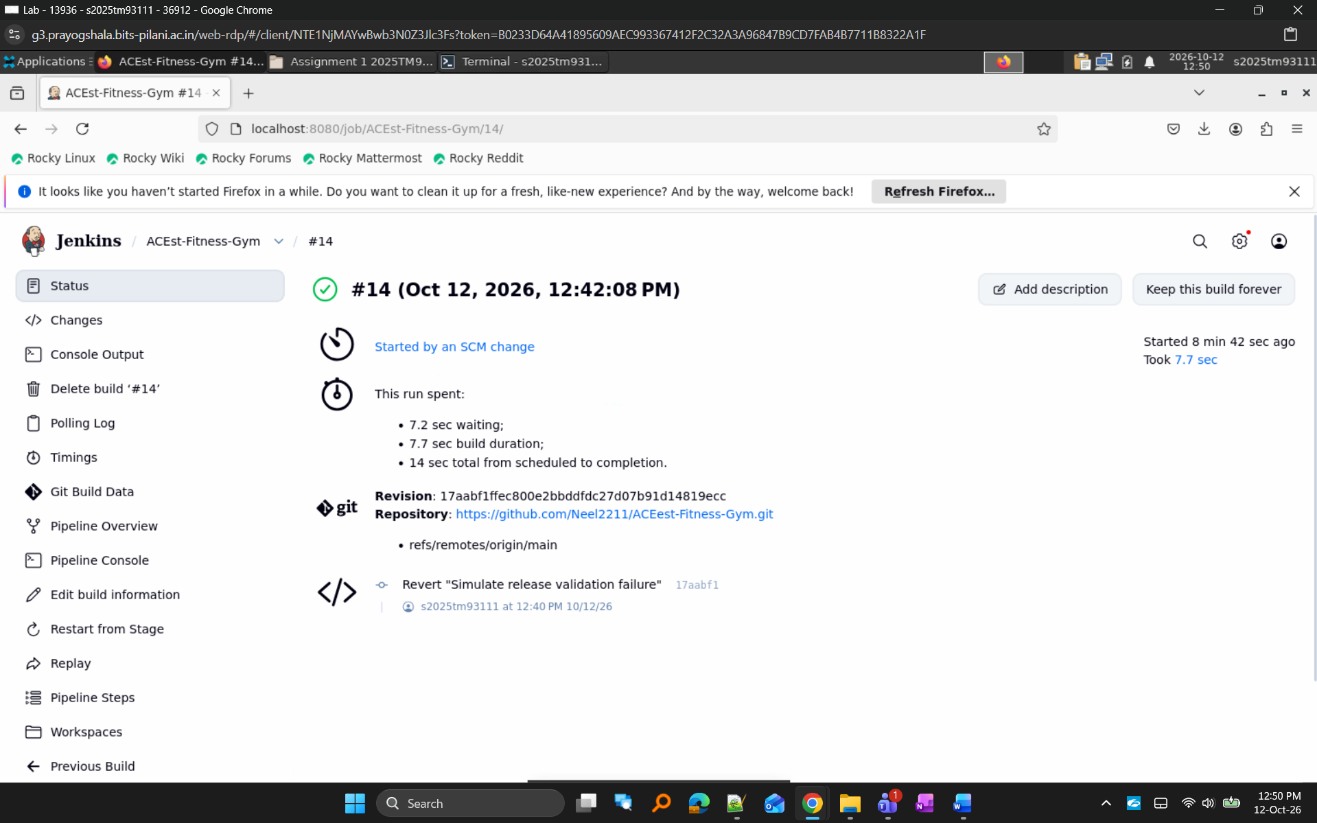
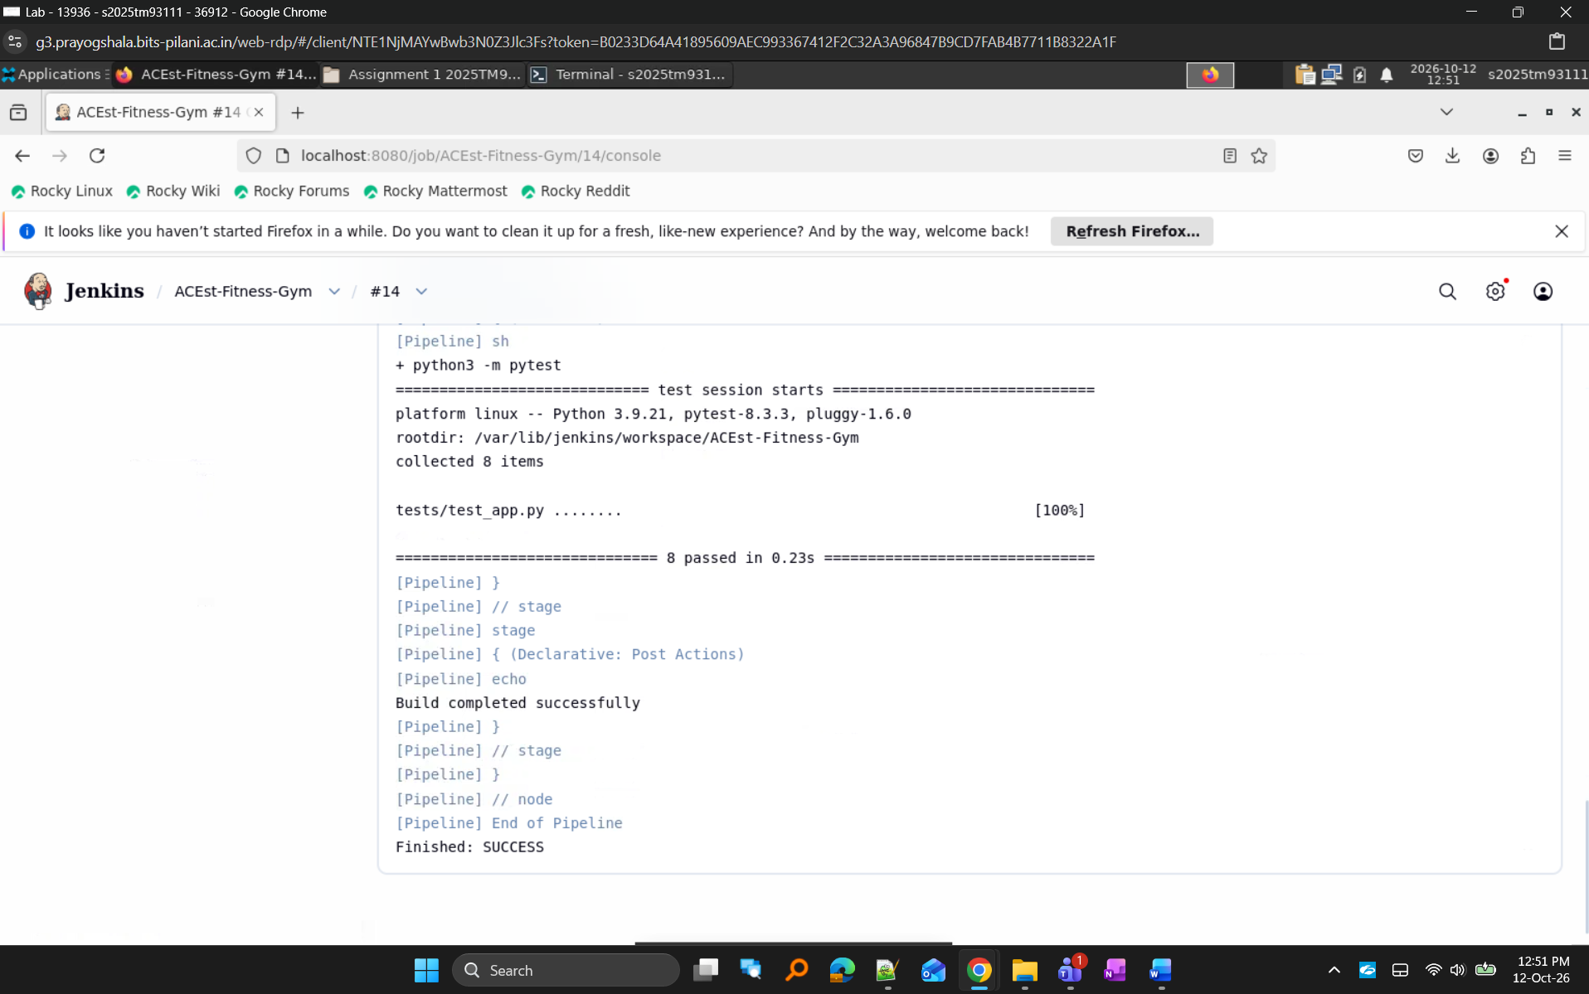
Figure 19. Successful rollback to a stable release version.
The rollback operation restored the application to the last known stable release and the Jenkins build completed successfully.

Screenshot 20: Hotfix Success
Figure 20. Successful validation of hotfix-3.2.5 through the automated CI/CD pipeline

10. Repository Structure
ACEest-Fitness-Gym/
│
├── app.py
├── requirements.txt
├── Dockerfile
├── Jenkinsfile
├── README.md
│
├── tests/
│ └── test_app.py
│
├── legacy_versions/
│ ├── Aceestver-1.0.py
│ ├── ...
│ └── Aceestver-3.2.4.py
│
└── .github/
└── workflows/
└── main.yml

Screenshot 21: Repository Structure
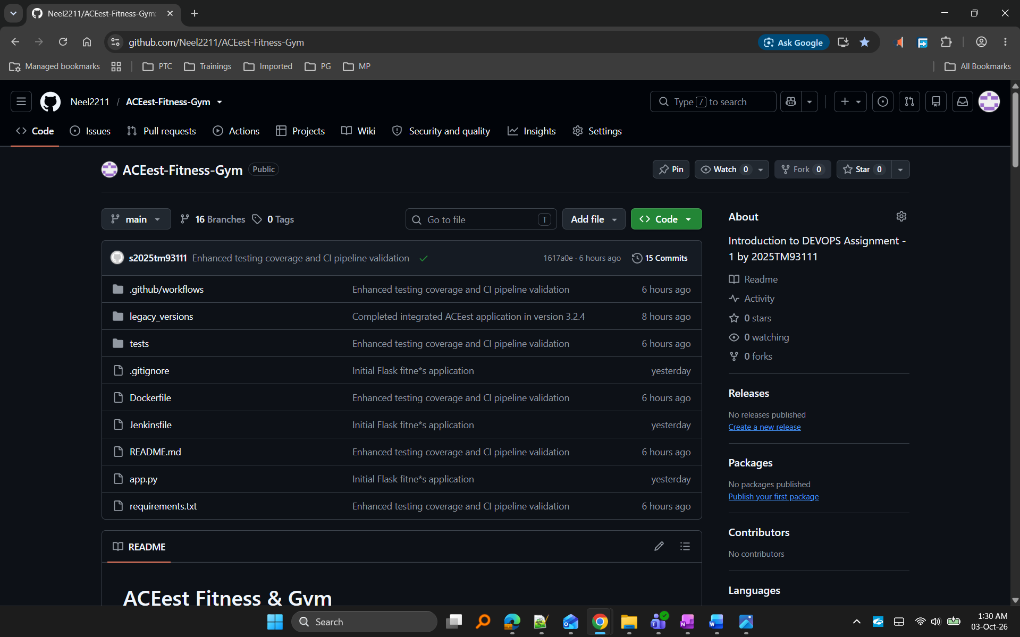
Figure 21. Project repository structure

GitHub Repository: https://github.com/Neel2211/ACEest-Fitness-Gym

11. Project Documentation (README.md)
Description
A professional README.md file was created to support project onboarding and maintenance. The document provides setup instructions, testing procedures, Docker execution steps, CI/CD workflow details, Jenkins integration information, repository structure, and version evolution details. This ensures that other developers can easily understand, build, test, and maintain the project.

README Contents
The README includes:
- Project Overview
- Technology Stack
- Repository Structure
- Local Setup Instructions
- Application Execution Instructions
- Pytest Execution Steps
- Docker Build and Run Commands
- GitHub Actions Workflow Overview
- Jenkins Integration Overview
- Version Evolution Strategy
- API Endpoints

Screenshot 22: README Overview
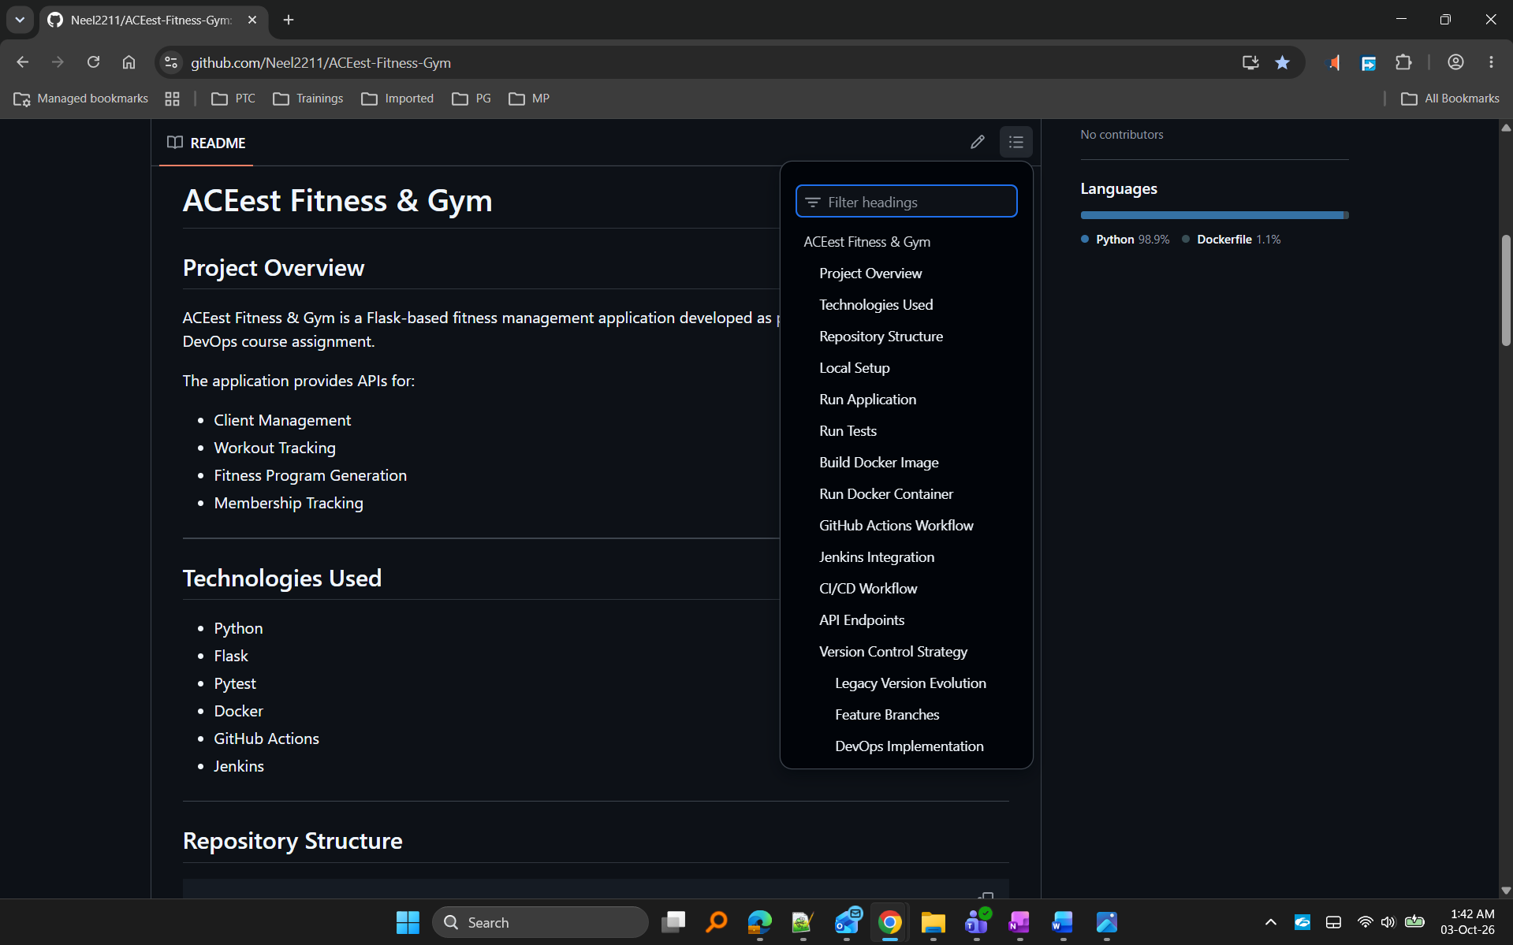
Figure 22. Project README documentation

Screenshot 23: README CI/CD Workflow
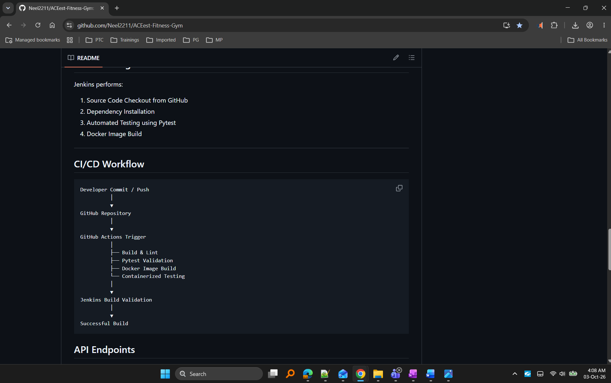
Figure 23. CI/CD workflow documented in README

Screenshot 24: README Setup Instructions
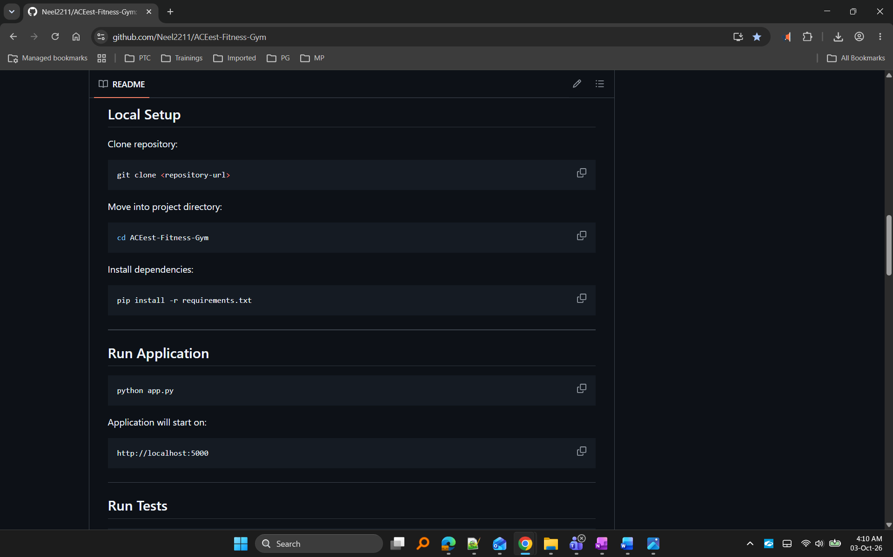
Figure 24.Installation, execution, and testing instructions documented in README.

12. Prayogshala Usage
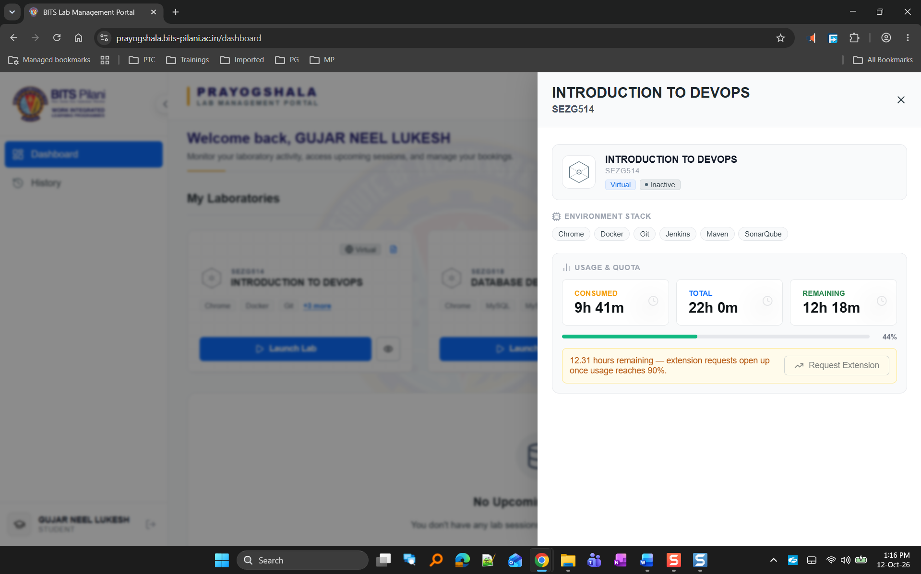
Figure 25. Prayogshala Usage

13. Demonstration Video
A demonstration video was recorded to showcase:
- Git version control strategy
- Incremental version builds
- Jenkins automatic build triggering using SCM polling
- GitHub Actions workflow execution
- Release failure scenario
- Rollback strategy
- Hotfix implementation

Recording Link
https://drive.google.com/file/d/1l4DHBIS_2Sm9bUAmZvb_it4-PuaAsBy-/view?usp=sharing

14. Conclusion
The ACEest Fitness & Gym project successfully demonstrates an end-to-end DevOps workflow including application development, version control, automated testing, Docker containerization, CI/CD automation, Jenkins-based build verification, release validation, rollback, and hotfix strategies. Multiple version releases were incrementally validated through SCM-triggered Jenkins builds, while failed-release, rollback, and hotfix workflows demonstrated practical release management concepts used in modern DevOps environments.

