Q 5.2

Accuracy on test data = 71.5405 %

Q 5.3

1. Accuracy and time taken for different C values

**Accuracy Training Time**

53.1250 0.3552

53.1250 0.4570

53.1250 0.4546

53.1250 0.4619

55.9896 0.3748

60.2865 0.4095

61.4583 0.3630

66.2760 0.3759

69.6615 0.5283

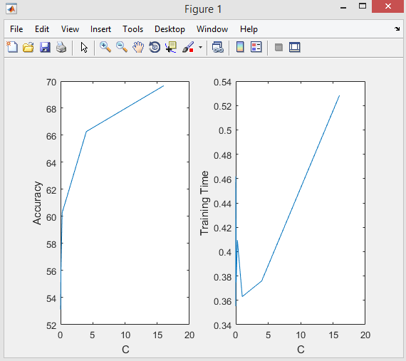

It can be seen from the above observation that as C value increases, accuracy goes on increasing and training time first increases, then decreases but eventually goes on increasing.

1. C = 16 gives the best accuracy. So C=4^2 (16) is chosen.
2. Accuracy of test data when C=4^2 is 73.1070 %

Q 5.4 Time and Accuracy

**Accuracy Training Time**

53.1250 0.3898

53.1250 0.0879

53.1250 0.1028

53.1250 0.0871

55.4688 0.0871

58.9844 0.0856

60.6771 0.0852

64.4531 0.0834

67.4479 0.0895

1. It can be seen form the above calculated values that accuracies for LIBSVM are equal to or less than Q5.3 accuracies for different

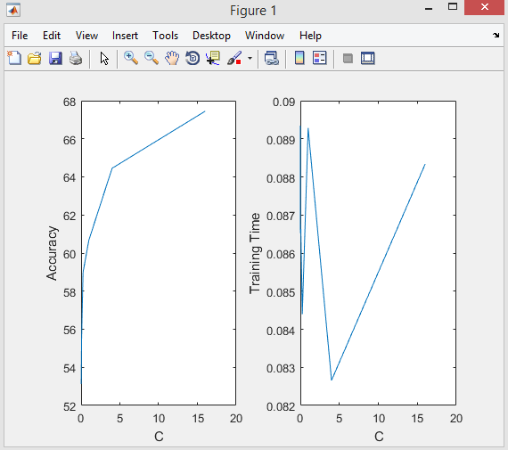

Thus, it can be observed from the above calculated values that LIBSVM is very much faster than our own implementation.

Q 5.5

Q 5.5:

1. **Accuracies for degree 1,2 & 3**

53.1250 53.1250 53.1250

53.1250 53.1250 53.1250

53.1250 53.1250 53.1250

54.8177 53.1250 53.1250

58.5938 56.3802 53.1250

60.8073 58.4635 56.7708

64.9740 60.9375 59.2448

67.0573 65.1042 60.5469

69.4010 70.5729 65.1042

71.7448 72.7865 71.0938

72.1354 74.3490 72.2656

**Time for degree 1, 2 & 3**

0.0937 0.0900 0.0879

0.0870 0.0905 0.0885

0.1010 0.0898 0.0886

0.0872 0.0900 0.0888

0.0850 0.0923 0.0889

0.0826 0.0872 0.0889

0.0831 0.0961 0.0856

0.0911 0.0836 0.0835

0.1068 0.0870 0.0829

0.2493 0.1020 0.0853

0.5492 0.2079 0.1153

**Plot of Accuracy and Time for different C and Gamma values**

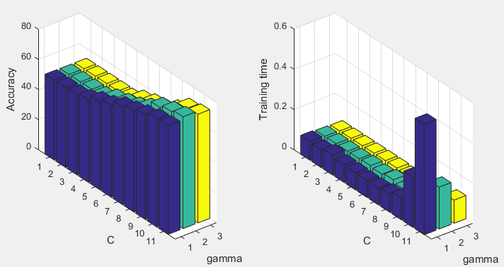

Best Accuracy is 74.3490 % for degree 2 and C = 4^7.

Accuracy of test data for model trained on this vale of C and gamma is **53.0026 %**

1. RBF Kernel:

For accuracies and training time for different combinations of C and Gamma values refer to Matlab. Size of data will be (110 x 4).

Col1 = C value

Col2 = Gamma value

Col3 = Accuracy

Col4 = Training Time

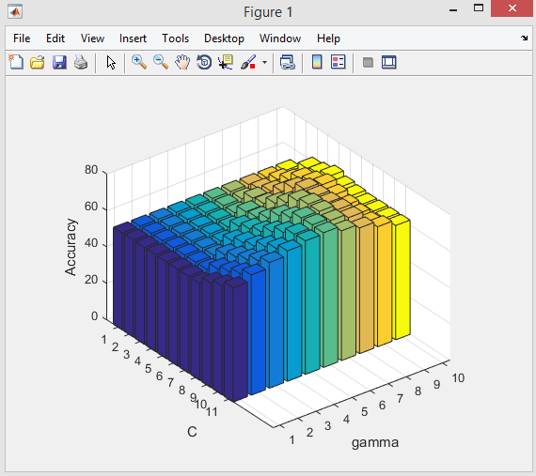

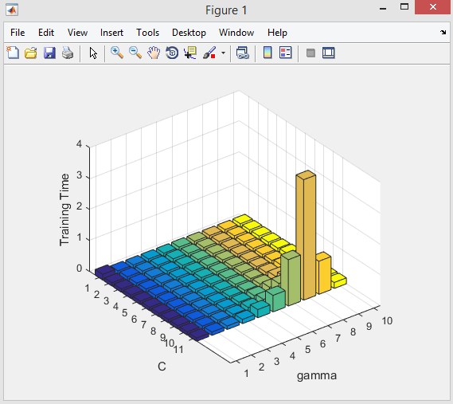

Value of C and Gamma (gamma/d) for best accuracy of **74.2188 %** is **4^6** and **0.0534**

Accuracy of test data for model trained on this vale of C and gamma is **61.8799 %**

Hence, it can be seen that RBF kernel has better accuracy than Polynomial kernel and hence RBF kernel should be chosen with above value of kernel parameters.

Q 6



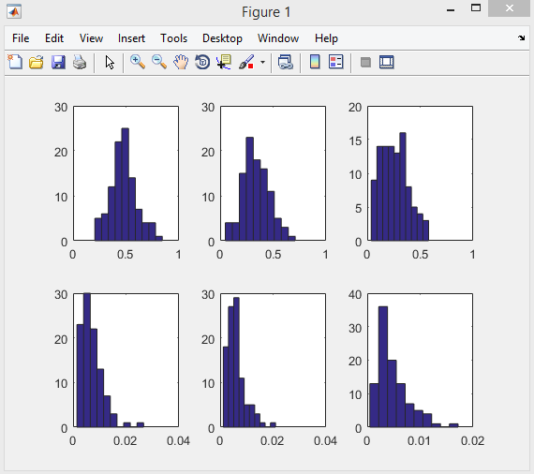

**Bias Values:**

0.4775

0.3419

0.2577

0.0069

0.0060

0.0048

**Variance Values:**

0

9.9532e-33

0.0841

0.3349

0.3359

0.3371



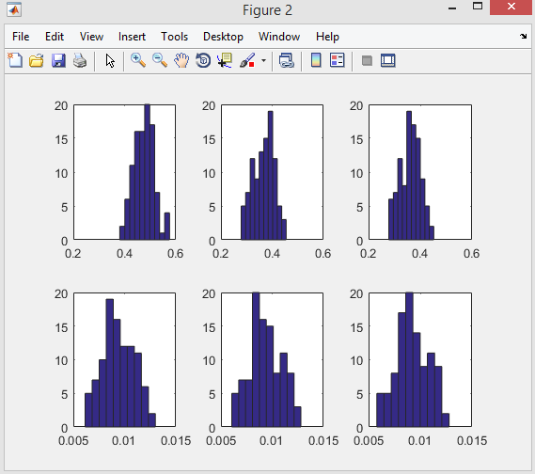

**Bias values:**

0.4754

0.3675

0.3623

0.0094

0.0093

0.0092

**Variance values:**

0

7.9292e-31

0.0052

0.3580

0.3581

0.3582

c. It can be seen from the above values that bias decreases and variance increases with increasing model complexity and sample size.

d.

**Bias values for different values of lambda:**

0.0130

0.0994

0.3662

0.7202

**Variance values for different values of lambda**

0.29065

0.09209

0.00679

0.00015

As λ goes on increasing, bias^2 goes on increasing and variance goes on decreasing. This is the effect of regularization parameter on the training.