Localisation of a Mobile Robot in a Known Environment Using AMCL
Module: CSIP5202 – AI for Mobile Robots
Coursework Title: Localisation in a Known Environment (IMR-Localisation)
Localisation Method: Adaptive Monte Carlo Localisation (AMCL)
Student Name: Neel Anadkat
P-Number: P2943206
Tutor: Dr Aboozar Taherkhani
University: De Montfort University
Submission Date: 30 January 2026

Introduction
Localisation refers to the process through which the mobile robot establishes its location and heading in a familiar surrounding. It is a mandatory condition of navigation and self-operating. In the coursework, localisation is done with an in-built ROS package Adaptive Monte Carlo Localisation (AMCL). Occupancy grid map is one saved in advance and probabilistic algorithms are applied to predict the position of the robot.
Localisation Technique
AMCL is a localisation technique which is based on a filter in the form of a particle. The set of particles is used to represent the possible positions of the robot with each particle describing a potential pose. The data of odometry is utilized to foresee the motion of particles, whereas the laser scan data are utilized to decide the level of correspondence between each particle and the surrounding. When the robot is in motion, the unlikely particles are removed and the particle cloud will be concentrated to the actual position of the robot.
Software Implementation
The ROS Noetic system and TurtleBot3 simulator were used to implement the system. The Gazebo simulation environment had a TurtleBot3 Burger robot launched. The map server node was used to load a pre-existing map that was published to the /map topic. The localisation was implemented by AMCL node subscribing to /scan, /odom and /map topics.
Visualisation was done using RViz. The map and the cloud of particles and the estimated position of the robot were shown. The 2D Pose Estimate tool was used to come up with an initial pose estimate.
Testing and Results
The teleoperation of the robot was done through the keyboard. First of all, the cloud of particles was scattered over the map. The particles started to form a small bundle as the robot moved, and the sensor data obtained was more and more. This showed that there was localisation accuracy that increased with time.
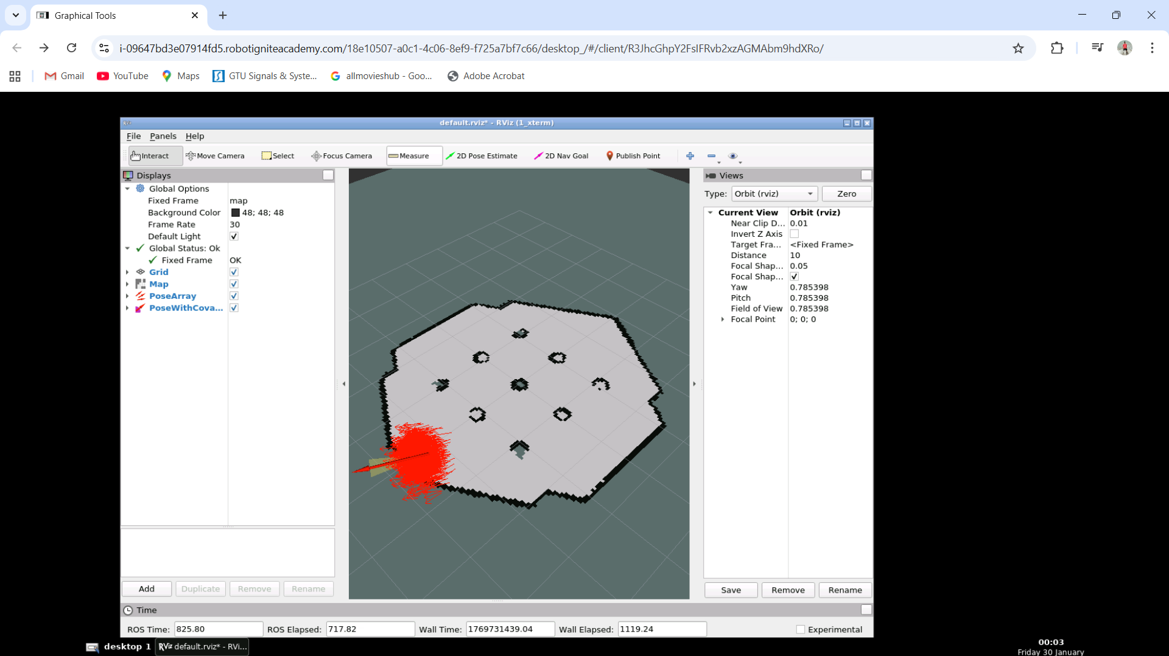
Figure 1: RViz visualisation of the AMCL particle cloud converting around the estimated position of the robot.
Conclusion
This coursework was able to estimate robot localisation in a known environment with AMCL package. The findings demonstrated that AMCL can give proper and consistent localisation in case there exist reliable map and sensor information. AMCL is also quicker and easier than SLAM-based methods because it does not need map generation.
Bibliography
Thrun, S., Burgard, W., & Fox, D. (2005). Probabilistic Robotics. MIT Press.
ROS Wiki. AMCL Package Documentation. wiki.ros.org/amcl.

