Creating a 2D Map of an Unknown Environment
(IMR-Mapping)
Module: CSIP5202 – AI for Mobile Robots
Coursework: IMR Mapping
Student Name: ________NEEL ANADKAT________________
P-Number: ____________P2943206____________
Tutor: Dr Aboozar Taherkhani
Submission Date: 26 January 2026

Introduction
This coursework provides the application of a 2D mapping system to a mobile robot that is going to work in an unknown environment. The task is to build a map with just the data of odometry and laser range sensor without the assistance of pre-built ROS mapping and navigation libraries. The implementation of the system is carried out using Python along with the ROS and tested within a simulated environment through Gazebo and RViz.
Map Construction Technique
The environment is represented using an occupancy grid technique. The environment is subdivided into grid cells which are fixed in size with each cell representing a small area in the real world. The data on the /odom topic is odometry which gives the position and orientation of the robot whereas the data on the /scan topic is laser scan that delivers the distance to the obstacles. Every legitimate laser scan is transformed to the world map frame out of the local frame of the robot through rotation and translation, depending on the pose of the robot. The relevant grid square is then indicated as occupied and the building of the map can be incrementally done as the robot moves.
Software Implementation
The system comprises of two ROS nodes the wandering behaviour node and the mapping node. The wandering node allows the robot to move around the environment, moving forward through an empty path to navigate and turning about when there are obstacles along the path. The mapping node subscribes to the laser scan and odometry topics and updates the occupancy grid on-the-fly and publishes the map through OccupancyGrid message type. The map is visualised in RViz as it is executed.
Testing and Results
A TurtleBot3 was tested on the mapping system in a Gazebo simulation with boundary walls and other internal obstacles. Information provided by the laser scanner on obstacles was merged with the occupancy grid as the robot moved around the environment. The map created in RViz correctly reflects the structure of the environment, including evident walls and obstacles, though there is a slight noise because of the restrictions of the sensor.
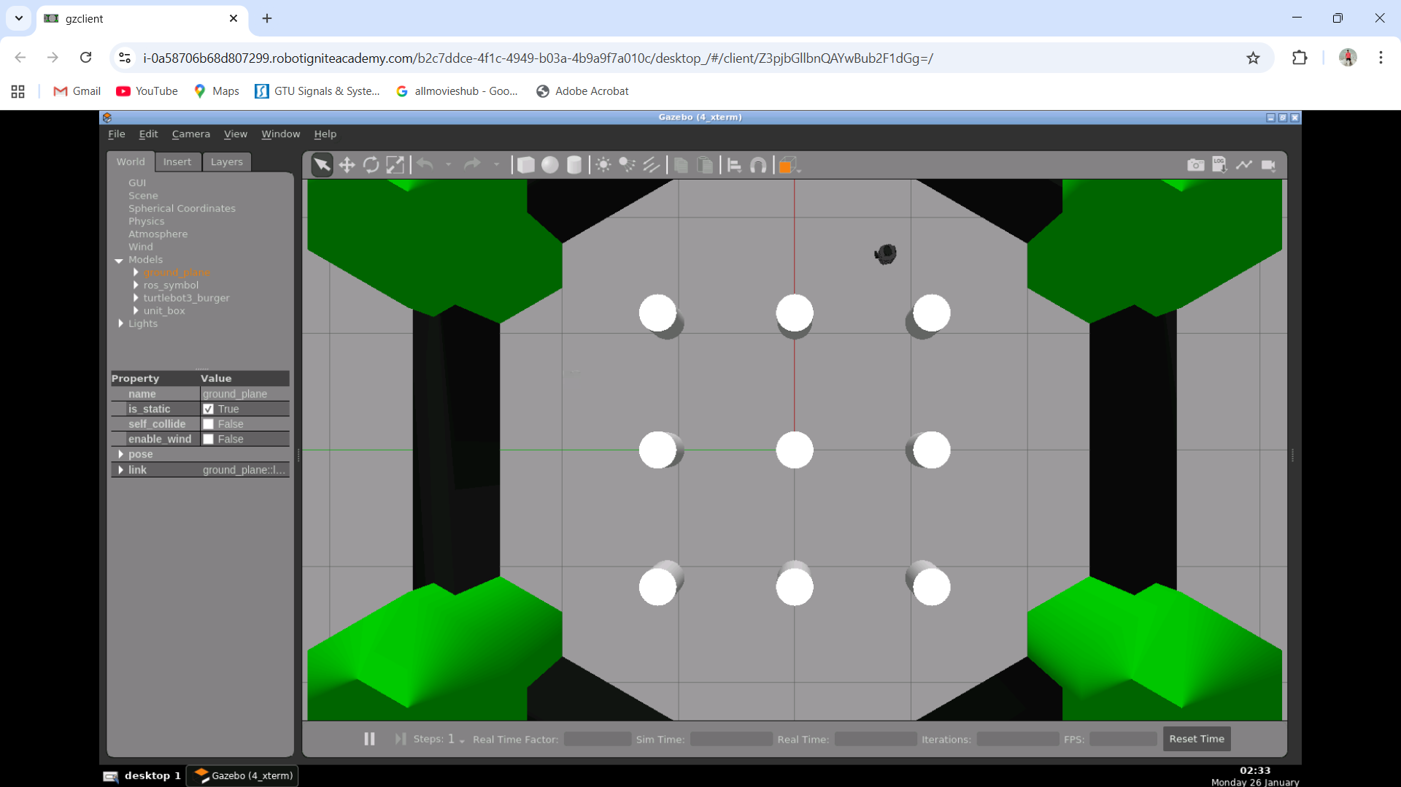

Figure 1: Simulation environment Gazebo where the experiment is carried out.
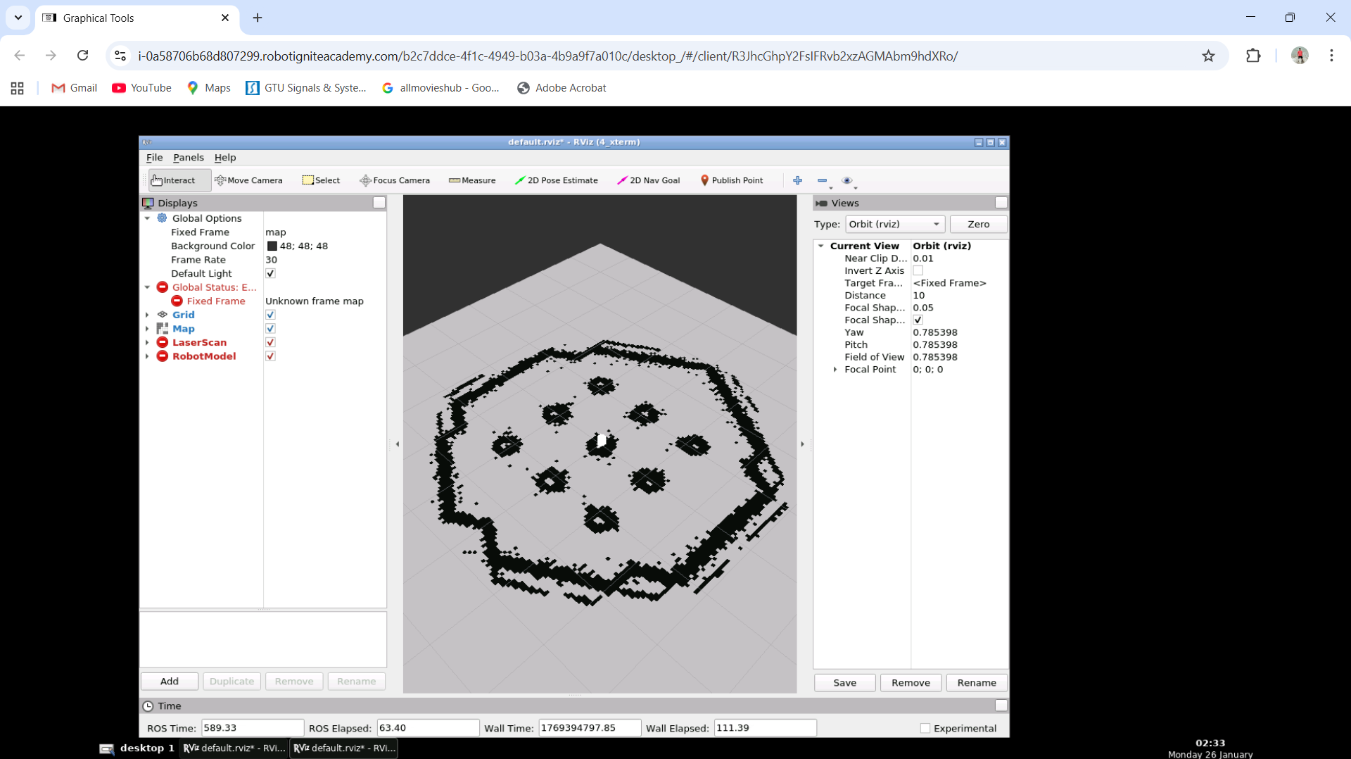

Fig. 2: Rviz generated occupancy grid map.
Conclusions
In this coursework, the simple yet helpful 2D occupancy grid mapping system based on odometry and laser scan data is shown. The method meets the requirements of the coursework and creates a decisive image of the environment. The developments to be made later are to make it less noisy or to update it probabilistically to enhance the accuracy of the maps.
Bibliography
Thrun, S., Burgard, W., & Fox, D. (2005). Probabilistic Robotics. MIT Press.
OccupancyGrid and LaserScan ROS Wiki Documentation: OccupancyGrid.

